#TASK_01

from OpenGL.GL import *

from OpenGL.GLUT import *

from OpenGL.GLU import *

import random

import math

bg_color=[1.0,1.0,1.0] # white background

rain_color= [0.0, 0.0, 0.0] # rain color black

rain_angle=90

def draw_points(x,y):

glPointSize(7)

glBegin(GL_POINTS)

if (bg_color[0]==1.0 and bg_color[1]==1.0 and bg_color[2]==1.0) :

glColor3f(1.0,0.0, 0.0) #red

else:

glColor3f(0.545,0.0,0.0)

glVertex2f(x,y)

glEnd()

def rain_droplets(x,y):

glLineWidth(2)

glBegin(GL_LINES)

number_of_layers = 8 # Number of layers of rain

number_of_droplets = 50 # Number of raindrops in each layer

for i in range(number_of_layers):

for j in range(number_of_droplets):

x = random.randint(1, 1000)

length = 20

y = 900 - (i * 100) # Adjust y position based on layer

x1 = x - length * math.cos(math.radians(rain_angle)) # Rain falls vertically

y1 = y - length

if rain_color[0] >= 0.5:

glColor3f(1.0, 1.0, 1.0)

else:

glColor(*rain_color)

glVertex2f(x, y)

glVertex2f(x1, y1)

glEnd()

def draw_triangle() :

glBegin(GL_TRIANGLES)

if (bg_color[0]==1.0 and bg_color[1]==1.0 and bg_color[2]==1.0) :

glColor3f(1.0,0.0, 0.0) #red

else:

glColor3f(0.545,0.0,0.0)

glVertex2f(300, 400)

glVertex2f(650, 400)

glVertex2f(470, 550)

glEnd()

def draw_lines() :

glLineWidth(3)

glBegin(GL_LINES)

if (bg_color[0]==1.0 and bg_color[1]==1.0 and bg_color[2]==1.0) :

glColor3f(1.0,0.0, 0.0) #red

else:

glColor3f(0.545,0.0,0.0)

#house Frame

glVertex2f(310, 400)

glVertex2f(310, 150)

glVertex2f(640, 400)

glVertex2f(640, 150)

glVertex2f(310, 150)

glVertex2f(640, 150)

#window

glVertex2f(480, 370)

glVertex2f(620, 370)

glVertex2f(480, 370)

glVertex2f(480, 305)

glVertex2f(620, 370)

glVertex2f(620, 305)

glVertex2f(480, 305)

glVertex2f(620, 305)

glVertex2f(550, 305)

glVertex2f(550, 370)

glVertex2f(480, 337.5)

glVertex2f(620, 337.5)

#door geometry

glVertex2f(340, 150)

glVertex2f(340, 275)

glVertex2f(400, 150)

glVertex2f(400, 275)

glVertex2f(340, 275)

glVertex2f(400, 275)

glEnd()

def iterate():

glViewport(0, 0, 1000, 1000)

glMatrixMode(GL_PROJECTION)

glLoadIdentity()

glOrtho(0.0, 1000, 0.0, 1000, 0.0, 1.0)

glMatrixMode(GL_MODELVIEW)

glLoadIdentity()

def background():

glClearColor(*bg_color, 1.0) # Set background color

glClear(GL_COLOR_BUFFER_BIT)

def specialKeyListener(key, x, y):

global rain_angle

if key == GLUT_KEY_LEFT:

rain_angle -= 10 # Adjust rain angle left by 10 degrees

print("Rain bent towards left")

elif key == GLUT_KEY_RIGHT:

rain_angle += 10 # Adjust rain angle right by 10 degrees

print("Rain bent towards right")

glutPostRedisplay()

def keyboardListener(key,x,y):

global bg_color, rain_color

if key==b'l':

if (bg_color[0]>=1.0 and bg_color[1]>=1.0 and bg_color[2]>=1.0) and (rain_color[0]<=0.0 and rain_color[1]<=0.0 and rain_color[2]<=0.0):

bg_color = [1.0, 1.0, 1.0] # White bg color

rain_color = [0.0, 0.0, 0.0] #Black rain

print("You are at the maximum brightness")

else:

bg_color[0]+=0.5

bg_color[1]+=0.5

bg_color[2]+=0.5

rain_color[0]-=0.5

rain_color[1]-=0.5

rain_color[2]-=0.5

print("Going to Light Mode")

if key==b'n':

if (bg_color[0]<=0.0 and bg_color[1]<=0.0 and bg_color[2]<=0.0) and (rain_color[0]>=1.0 and rain_color[1]>=1.0 and rain_color[2]>=1.0):

bg_color = [0.0, 0.0, 0.0] # Black bg

rain_color = [1.0, 1.0, 1.0] # White rain color

print("You are at the lowest brightness")

else:

bg_color[0]-=0.5

bg_color[1]-=0.5

bg_color[2]-=0.5

rain_color[0]+=0.5

rain_color[1]+=0.5

rain_color[2]+=0.5

print("Going to Dark Mode")

def showScreen():

glClear(GL_COLOR_BUFFER_BIT | GL_DEPTH_BUFFER_BIT)

glLoadIdentity()

iterate()

background()

draw_lines()

draw_triangle()

draw_points(385, 210)

rain_droplets(500, 10)

glutSwapBuffers()

def rain_timer(value):

glutTimerFunc(100, rain_timer, 0)

glutPostRedisplay()

glutInit()

glutInitDisplayMode(GLUT_RGBA)

glutInitWindowSize(1000, 1000)

glutInitWindowPosition(0, 0)

wind = glutCreateWindow(b"Mayeesha Mahbub 21201462 Lab01 Task01")

glutDisplayFunc(showScreen)

glutSpecialFunc(specialKeyListener)

glutKeyboardFunc(keyboardListener)

glutTimerFunc(100, rain_timer, 0) # Start rain timer

glutMainLoop()

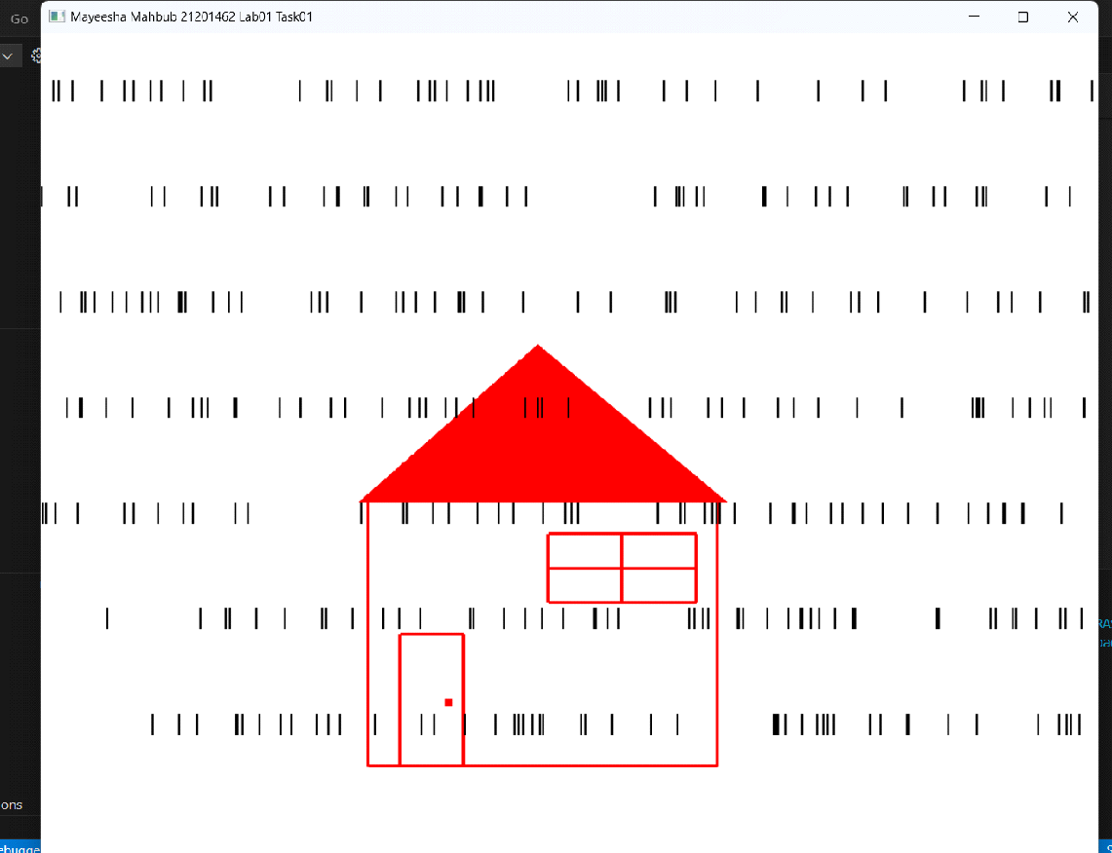

#TASK_02

from OpenGL.GL import *

from OpenGL.GLUT import *

from OpenGL.GLU import *

import random

point = []

box_left_position = 0

box_width = 900

box_bottom_position = 0

box_height = 700

point_size = 14

point_speed = 0.05

clicked_left_mouse = False

clicked_left_mouse1 = None

initial_time = 0

spacebar = False

colors = []

def draw_point():

global clicked_left_mouse, initial_time, spacebar

glEnable(GL_POINT_SMOOTH)

glPointSize(point_size)

glBegin(GL_POINTS)

for i in range(len(point)):

x, y, color, direction_x, direction_y = point[i]

if spacebar:

direction_x = 0

direction_y = 0

clicked_left_mouse = False

if clicked_left_mouse and not spacebar:

current_time = glutGet(GLUT_ELAPSED_TIME)

time_diff = (current_time - initial_time) % 900

if time_diff < 100:

color = (0.0, 0.0, 0.0)

else:

original_color = colors[i]

color = original_color

glColor3f(*color)

glVertex2f(x, y)

# Updating point position based on direction and speed

x += point_speed * direction_x

y += point_speed * direction_y

# Reflect points when they hit the borders

if x < box_left_position + point_size:

x = box_left_position + point_size

direction_x = -direction_x

if x > box_width - point_size:

x = box_width - point_size

direction_x = -direction_x

if y < box_bottom_position + point_size:

y = box_bottom_position + point_size

direction_y = -direction_y

if y > box_height - point_size:

y = box_height - point_size

direction_y = -direction_y

point[i] = (x, y, color, direction_x, direction_y)

glEnd()

def create_random_point(x, y):

if box_left_position < x < box_width and box_bottom_position < y < box_height:

# Random colors for generated points

r, g, b = (random.random(), random.random(), random.random())

color = (r, g, b)

# Random direction in diagonals

direction_x = random.choice([-1, 1])

direction_y = random.choice([-1, 1])

point.append((x, y, color, direction_x, direction_y))

colors.append(color)

def mouseListener(button, state, x, y):

global clicked_left_mouse, initial_time, spacebar

if spacebar:

return

if button == GLUT_RIGHT_BUTTON and state == GLUT_DOWN:

create_random_point(x,700 - y)

print("New point added")

if button == GLUT_LEFT_BUTTON and state == GLUT_DOWN:

if clicked_left_mouse == False:

clicked_left_mouse = not clicked_left_mouse

print("Blinking Function Turned On")

else:

clicked_left_mouse = not clicked_left_mouse

print("Blinking Function Turned Off")

def specialKeysListener(key, x, y):

global point_speed, clicked_left_mouse, spacebar

if key == GLUT_KEY_UP:

point_speed += 0.005

print("Speed Increased")

elif key == GLUT_KEY_DOWN:

if point_speed<=0:

point_speed=0

print("Speed limit reached")

else:

point_speed -= 0.005

print("Speed Decreased")

def keyboardListener(key, x, y):

global spacebar, point_speed, clicked_left_mouse, clicked_left_mouse1

if key == b" ":

spacebar = not spacebar

if spacebar:

clicked_left_mouse1 = clicked_left_mouse

clicked_left_mouse = False

for i in range(len(point)):

x, y, color, direction_x, direction_y = point[i]

direction_x = 0

direction_y = 0

point[i] = (x, y, color, direction_x, direction_y)

print("Point Staus: Freeze")

else:

clicked_left_mouse = clicked_left_mouse1

clicked_left_mouse1 = None

for i in range(len(point)):

direction_x = random.choice([-1, 1])

direction_y = random.choice([-1, 1])

point[i] = (point[i][0], point[i][1], point[i][2], direction_x, direction_y)

print("Point Staus: Moving")

def draw_box():

glLineWidth(2)

glBegin(GL_LINES)

glVertex2f(box_width, box_height)

glVertex2f(box_left_position, box_height)

glVertex2f(box_left_position, box_height)

glVertex2f(box_left_position, box_bottom_position)

glVertex2f(box_width, box_bottom_position)

glVertex2f(box_left_position, box_bottom_position)

glVertex2f(box_width, box_bottom_position)

glVertex2f(box_width, box_height)

glEnd()

def iterate():

glMatrixMode(GL_PROJECTION)

glLoadIdentity()

glOrtho(0, 900, 0, 700, -1, 1)

glMatrixMode(GL_MODELVIEW)

glLoadIdentity()

def display():

glClear(GL_COLOR_BUFFER_BIT)

glLoadIdentity()

iterate()

glColor3f(1.0, 1.0, 1.0)

draw_box()

draw_point()

glutSwapBuffers()

glutInit()

glutInitDisplayMode(GLUT_RGBA)

glutInitWindowSize(900, 700)

glutCreateWindow(b"21201462 Mayeesha Mahbub Lab01 Task02")

glutDisplayFunc(display)

glutMouseFunc(mouseListener)

glutSpecialFunc(specialKeysListener)

glutKeyboardFunc(keyboardListener)

glutIdleFunc(display)

glutMainLoop()

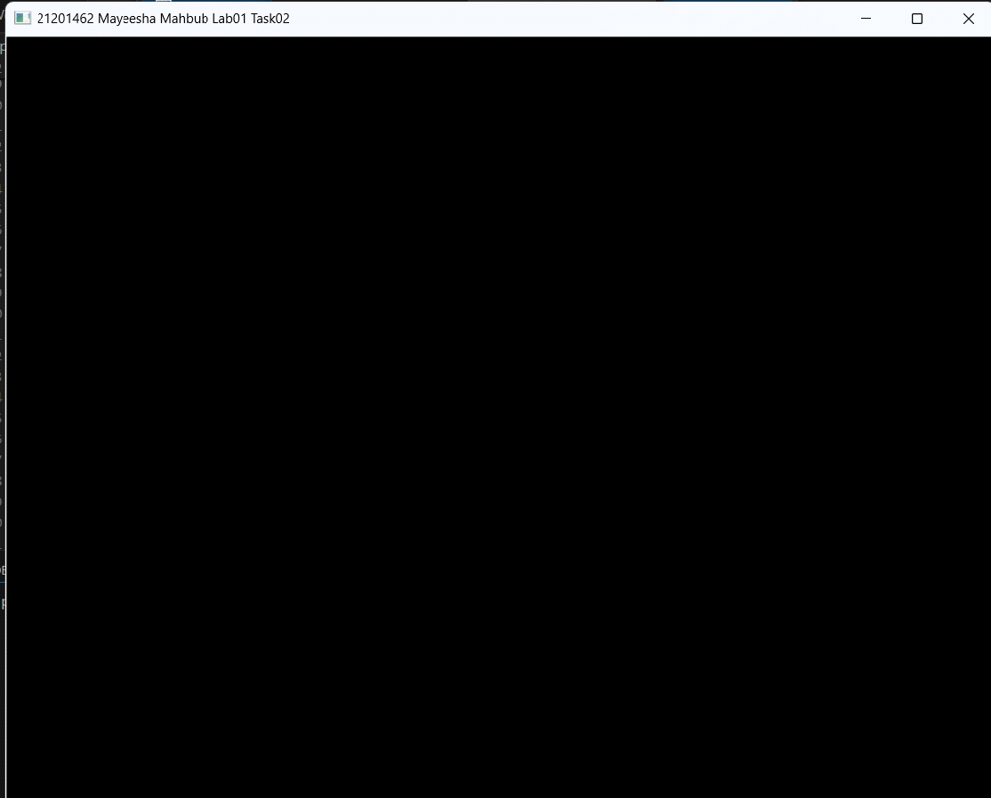

# I couldn't finished the task 2 and having multiple errors .