C++作业三
姓名：李畅 学号：2012329620003
班级：12级计算机科学与技术1班

- 完善上一次关于验证类成员空间分配的程序，增加验证静态成员（包括静态数据成员和静态成员函数）空间分配情况的内容。
#include<iostream>
#include<stdlib.h>
using namespace std;
class C{
public:
int m1;
void f(){}
static int m2;
static void s(){};
};
int C::m2=1;
void main(){
C obj1,obj2;
cout<<"the size of obj1 is "<<sizeof(obj1)<<endl; //1
cout<<"the starting address of obj1 is "<<&obj1<<endl; //2
cout<<"the memory allocation of obj1 is listed blow:"<<endl; //3
cout<<"data member m1: the address is "<<&obj1.m1<<"the size is "<<sizeof(obj1.m1)<<endl; //4
cout<<"data member m2: the address is "<<&obj1.m2<<"the size is "<<sizeof(obj1.m2)<<endl; //5
cout<<"member function f: the address is ";
printf("%p\n",&C::f); //6
cout<<"member function s: the address is ";
printf("%p\n\n",&C::s); //7

cout<<"the size of obj2 is "<<sizeof(obj2)<<endl; //8
cout<<"the starting address of obj2 is "<<&obj2<<endl; //9
cout<<"the memory allocation of obj2 is listed blow:"<<endl; //10
cout<<"data member m1: the address is "<<&obj2.m1<<"the size is "<<sizeof(obj2.m1)<<endl; //11
cout<<"data member m2: the address is "<<&obj2.m2<<" the size is "<<sizeof(obj2.m2)<<endl; //12
cout<<"member function f: the address is ";
printf("%p\n",&C::f); //13
cout<<"member function s: the address is ";
printf("%p\n\n",&C::s); //14
system("pause");
}
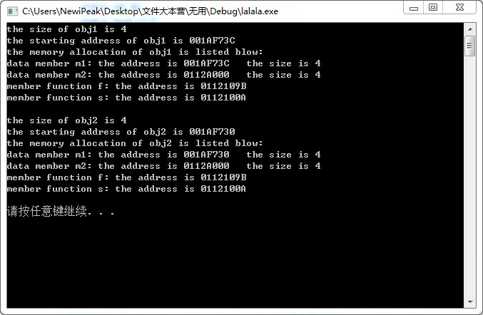
- 从语句1和语句8的执行结果可以看出，同一个类的不同对象所占内存空间大小是一样的，为其数据成员所占空间的总和，而成员函数在对象中是不占用任何空间的。
- 从语句2和语句4以及语句8和语句10的执行结果可以看出，对象的地址即是类中首个数据成员的地址。
- 从语句4和语句5及语句11和语句12的执行结果可以看出，数据成员在内存中的存储顺序是按其在类中声明顺序分配的。
- 从语句6、7和语句13、14以及执行结果可以看出，同一个类的不同对象的成员函数所占空间是独立于对象之外的，而且函数地址是相同的，也就是这些不同对象的成员函数代码空间是共享的，是属于这个类的，而不是某一个对象的。

- 用C++实现单件模式，即设计一个类，该类仅允许被实例化一次
#ifndef __SINGLETON__
#define __SINGLETON__
class Singleton {
public:
static Singleton *getInstance();
private:
Singleton();
Singleton(const Singleton &s);
void operator=(const Singleton &rhs);
static Singleton *instance;
};

#endif

- 分析下面程序中的错误
class X{
private:
int a=0;
int &b;
const int c;
void setA(int i){a=i;}
X (int i){a=i;}
public:
int X(){a=b=c=0;}
X(int i,int j,int k){a=i;b=j;c=k;}
static void setB(int k){b=k;}
set C(int k) const{c=c+k;}
};
void main(){
X x1;
X x2(3);
X x3(1,2,3);
x1.setA(3);
}
错误：
- 第三行中只有静态常量整型数据成员才可以在类中初始化
- 第七行中必须在构造函数基/成员初始值设定项列表中初始化
- 第十一行中静态成员函数不能访问非静态成员
- 第十二行中常量成员函数不可以修改数据成员的值

- 读程序，写出程序运行结果
（1）、
#include<iostream.h>
#include<string.h>
class X{
int a;char *b; float c;
public:
X(int x1,char *x2,float x3):a(x1),c(x3){
b=new char[sizeof(x2)+1];
strcpy(b,x2);
}
X():a(0),b("X::X()"),c(10){}
X(int x1,char *x2="X::X(...)",int x3=10):a(x1),b(x2),c(x3){}
X(const X&other){
a=other.a;
b="X::X(const X &other)";
c=other.c;}
void print(){
cout<<"a="<<a<<"\t"<<"b="<<b<<"\t"<<"c="<<c<<endl;
}
};
void main(){
X *A=new X(4,"X::X(int,char,float)",32);
X B,C(10),D(B);
A->print();
B.print(); C.print(); D.print();
}
结果：
a=4 b=X::X(int,char,float) c=32
a=0 b=X::X() c=10
a=10 b=X::X(…) c=10
a=0 b=X::X(const X &other) c=10
- 、
#include<iostream>
using std::cout;
using std::endl;
class Implementation{
public:
Implementation(int v){value=v;}
void setValue(int v){value=v;}
int getValue() const{return value;}
private:
int value;};
class Interface{
public:
Interface(int);
void setValue(int);
int getValue() const;
private:
Implementation *ptr;
};
Interface::Interface(int v):ptr(new Implementation(v)){}
void Interface::setValue(int v){ptr->setValue(v);}
int Interface::getValue() const{return ptr->getValue();}
void main(){
Interface i(5);
cout<<i.getValue()<<endl;
i.setValue(10);
cout<<i.getValue()<<endl;
system("PAUSE");
}
结果：5
10
- 、
#include<iostream>
using namespace std;
class A{
int x;
public:
A():x(0){cout<<"constructor A() called..."<<endl;}
A(int i):x(i){cout<<"X"<<x<<"\tconstructor..."<<endl;}
~A(){cout<<"X"<<x<<"\tdestructor..."<<endl;}
};
class B{
int y;
A X1;
A X2[3];
public:
B(int j):X1(j),y(j){cout<<"B"<<j<<"\tdestructor..."<<endl;}
~B(){cout<<"B"<<y<<"\tdestructor..."<<endl;}
};
void main(){
A X1(1),X2(2);
B B1(3);
system("PAUSE");
}
结果：
X1 constructor…
X2 constructor…
X3 constructor…
constructor A()called…
constructor A()called…
constructor A()called…
B3 destructor…
- 设计一个整型链表类list,能够实现链表节点的插入（insert）、删除（delete）,以及链表数据的输出操作（print）。

class Node
{
int a[30];
Node * Next;
public:
Node();
void SetText(int*);
void SetNext(Node*);
Node* GetNext();
int* GetText();
};
class LIST
{
private:
Node *Handle;
public:
LIST();
~LIST();
void Insert(Node*);
void Delete(Node*);
void print();

};

#include "LIST.h"
#include <iostream>
using namespace std;
Node::Node()
{
Next=NULL;
}
void Node::SetNext(Node*pN)
{
Next=pN;
}
void Node::SetText(int* text)
{
strcpy_s(a,text);
}
int* Node::GetText()
{
return a;
}
Node* Node::GetNext()
{
return Next;
}
LIST::LIST()
{
Handle=NULL;
}
LIST::~LIST()
{
Node* pN,*pCurrent;
for(pCurrent=Handle;pCurrent!=NULL;pCurrent=pN)
{
pN=pCurrent->GetNext();
delete pCurrent;
}
}
void LIST::Insert(Node* toAdd)
{
Node* pN=new Node();
pN->SetNext(NULL);
pN->SetText(toAdd);
if(Handle==NULL)
Handle=pN;
else
{
Node* pCurrent=Handle;
while(pCurrent->GetNext()!=NULL)
pCurrent=pCurrent->GetNext();
pCurrent->SetNext(pN);
}
}

void LIST::print()
{
Node* pN=Handle;
while(pN!=NULL)
{
cout<<pN->GetText()<<endl;
pN=pN->GetNext();
}
}

