C++作业五
姓名：李畅 学号：2012329620003
班级：12级计算机科学与技术1班

- 读程序，写出程序运行的结果。
（1）
#include<iostream>
#include<stdlib.h>
using namespace std;
class Base{
protected:
int n;
public:
Base (int m){n=m++; }
virtual void g1(){cout<<"Base::g1()..."<<n<<endl;g4();}
virtual void g2(){cout<<"Base::g2()..."<<++n<<endl;g3();}
virtual void g3(){cout<<"Base::g3()..."<<++n<<endl;g4();}
virtual void g4(){cout<<"Base::g4()..."<<++n<<endl;}
};
class Derive:public Base{
int j;
public:
Derive(int n1,int n2):Base(n1){j=n2;}
void g1(){cout<<"Deri::g1()..."<<++n<<endl;g2();}
void g3(){cout<<"Deri::g2()..."<<++n<<endl;g4();}
};
void main(){
Derive Dobj(1,0);
Base Bobj=Dobj;
Bobj.g1 ();
cout<<"---------------"<<endl;
Base *bp=&Dobj;
bp->g1();
cout<<"---------------"<<endl;
Base &bobj2=Dobj;
bobj2.g1();
cout<<"---------------"<<endl;
Dobj.g1();
system("pause");
}

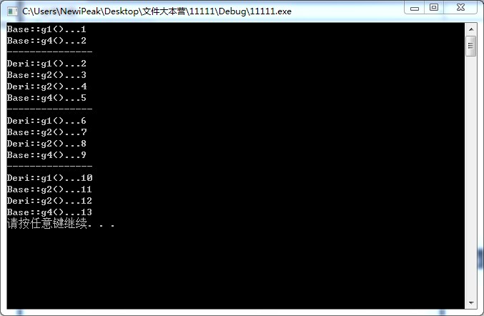

（2）
#include <iostream>
#include<stdlib.h>
using namespace std;
class Shape{
public:
virtual double area(){return 0;}
virtual void print()=0;
};
class Circle:public Shape{
protected:
double r;
public:
Circle(double x):r(x){}
double area(){return 3.14*r*r;}
void print(){cout<<"Circle:r="<<r<<"\t area="<<area()<<endl;}
};
class Cylinder:public Circle{
double h;
public:
Cylinder(double r,double x):Circle(r),h(x){}
double area(){return 2*3.14*r*r+2*3.14*h;}
};
void shapeArea(Shape &s){cout<<s.area()<<endl;}
void shapePrint(Shape *p){p->print();}
void main(){
Shape *s[3];
s[0]=&Circle(10);
s[1]=&Cylinder(20,100);
for(int i=0;i<2;i++){
shapeArea(*s[i]);
shapePrint(s[i]);
}
system("pause");
}
注意：本例有意不在Cylinder类中重载纯虚函数print（），因此需要仔细分析shapePrint（s[1]）的输出结论。

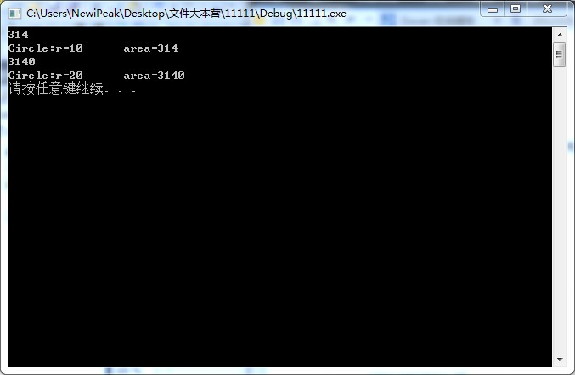

(3)
#include <iostream>
#include<stdlib.h>
using namespace std;
class A{
public:
void virtual f(){cout<<"f() in class A"<<endl;}
};
class B:public A{
public:
void f(){cout<<"f() in class B"<<endl;}
void fb(){cout<<"normal function fb\n";}
};
class C:public A{
public :
void f(){cout<<"f() in class C"<<endl;}
void fc(){cout<<"normal function fc "<<endl;}
};
void f(A* p){
p->f();
if(typeid(*p)==typeid(B)){
B* bp=dynamic_cast<B *>(p);
bp->fb();
}
if(typeid(*p)==typeid(C)){
C* bc=dynamic_cast<C *>(p);
bc->fc();
}
}
void main(){
A *pa;B b; C c;
pa=&b;f(pa);
pa=&c;f(pa);
system("pause");
}

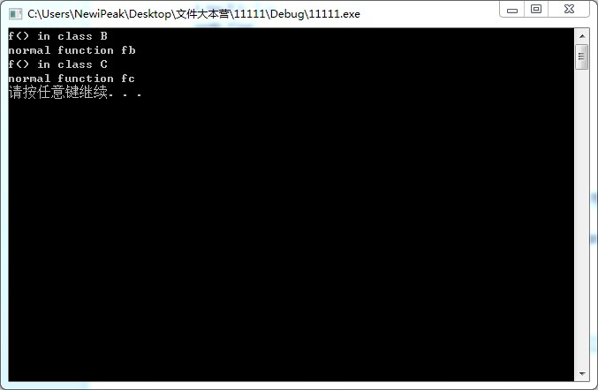

二、用抽象类设计计算二维平面图形面积的程序，在基类TDshape中设计纯虚函数area()和printname()，area()用于计算几何图形的面积，printname()打印输出几何图形的类名，如Triangle类的对象就打印输出定义area()和printname()的具体实现代码，如图5-9所示。要求编写TDshape为接口的函数，借以访问具体类如Triangle和Rectangle类的成员函数Area(),printName().
#include<iostream>
#include<stdlib.h>
using namespace std;
class TDshape{
public:
void virtual area()=0;
void virtual printName()=0;
};
class Triangle:public TDshape{
double width,height;
public:
void area()
{
cout<<"面积是:"<<width*height*0.5<<endl;
}
void printName()
{
cout<<"图形名称是Triangle"<<endl;
}
void setWidth(double a,double b)
{
width=a;height=b;
}
double getWidth()
{
return width;
}
};
class Rectangle:public TDshape{
double width,height;
public:
void area()
{
cout<<"面积是:"<<width*height<<endl;
}
void printName()
{
cout<<"图形名称是Rectangle"<<endl;
}
void setHeight(double a,double b)
{
width=a;height=b;
}
double getHeight()
{
return width;
}
};
void main()
{
do{
double a,b;
TDshape *TD;
cout<<endl;
cout<<"请选择要进行操作的图形"<<endl;
cout<<"1:三角形 2:矩形"<<endl;
cout<<endl;
char op;
cin>>op;
switch(op)
{
case'1':
{
Triangle T;
cout<<"请输入三角形的底和高:"<<endl;
cin>>a>>b;
T.setWidth(a,b);
TD=&T;
TD->area();
TD->printName();
break;
}
case'2':
{
Rectangle R;
cout<<"请输入矩形的宽和高:"<<endl;
cin>>a>>b;
R.setHeight(a,b);
TD=&R;
TD->area();
TD->printName();
break;
}
}
cout<<endl;
system("pause");
}while(true);
}

