C++作业六
姓名：李畅 学号：2012329620003
班级：12级计算机科学与技术1班

- 读程序，写出程序运行结果。
（1）
#include<iostream>
using namespace std;
class ABC{
int a,b,c;
public:
ABC(int x,int y,int z):a(x),b(y),c(z){}
friend ostream &operator<<(ostream &out,ABC& f);
};
ostream &operator<<(ostream &out,ABC& f){
out<<"a="<<f.a<<endl<<"b="<<f.b<<endl<<"c="<<f.c<<endl;
return out;
}
void main(){
ABC obj(10,20,30);
cout<<obj;
system("pause");
}
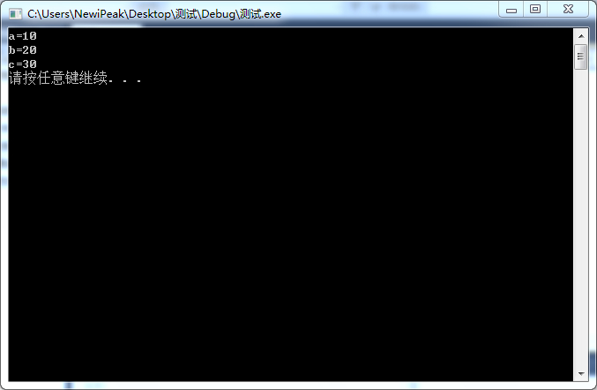

（2）
#include<iostream>
#include<string>
using namespace std;
class X{
private:
char *s;
public:
X(char *b){
s=new char[sizeof(b)+1];
strcpy(s,b);
}
~X(){delete s;}
void display(){ cout<<"s="<<s<<endl;}
};
void main(){
X x1("ok");
X X2(x1);
X x3=x1;
X2.display();
x3.display();
system("pause");
}
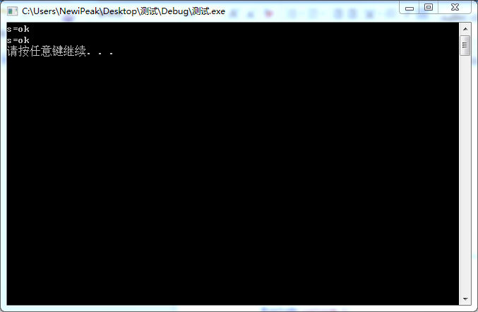

（3）
#include <iostream>
using namespace std;
class Number{
int n;
public:
Number(int x):n(x){}
Number& operator++(){ ++n;return *this;}
Number& operator++(int){ n++; return *this;}
friend Number &operator--(Number &o);
friend Number &operator--(Number o,int);
void display(){cout<<"This Number is: "<<n<<endl;}
};
Number &operator--(Number &o){ --o.n;return o;}
Number &operator--(Number o,int){o.n--;return o;}
void main(){
Number N1(10);
++ ++ ++N1;
N1.display();
N1++;
N1.display();
--N1;
N1.display();
N1-- -- --;
N1.display();
system("pause");
}
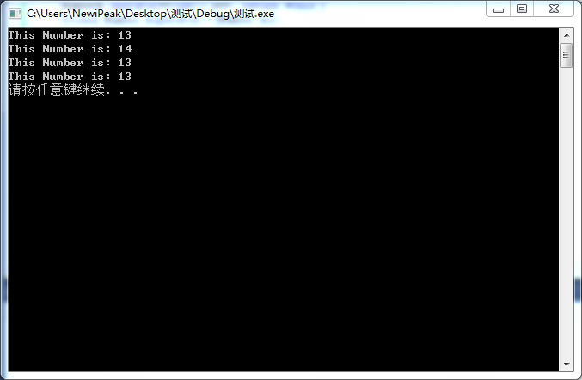

（4）
#include<iostream>
using namespace std;
class Student{
private:
char *name;
int age;
double Money;
public:
Student(char *n="NoKnow",int Age=17,double Mey=1000.998):age(Age),Money(Mey){
name=new char[sizeof(n)+1];
strcpy(name,n);
}
operator char*(){ return name;}
operator int(){return age;}
operator double(){return Money;}
};
void main(){
Student s1("阿瓦尔古丽",19,280000.998);
char *Name=s1;
int Age=s1;
double Money =s1;
cout<<Name<<"\t"<<Age<<"\t"<<Money<<endl;
Student s2("武昌鱼");
Name=s2;Age=s2;Money=s2;
cout<<Name<<"\t"<<Age<<"\t"<<Money<<endl;
system("pause");
}
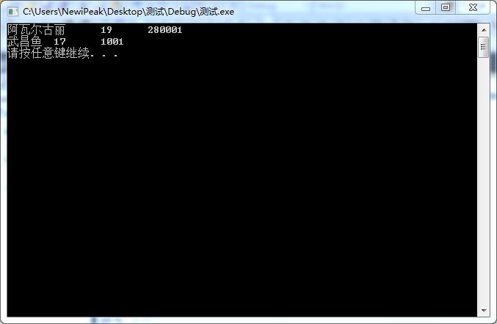

- 设计一个计数器类calculator，它只有一个用于计数的数据成员count，该计数器的有效计数范围为0-65535，实现计数器的前自增，后自增，前自减，后自减，两个计数器相加减等运算。

#include"iostream"
#include"math.h"
using namespace std;
class Calculator{
private:
public:
int choice;
double count;
Calculator(){};
Calculator(double a):count(a){};
double getcount(){
return count;
}
Calculator& operator++();
Calculator& operator++(int);
Calculator& operator--();
Calculator& operator--(int);
Calculator& operator+(Calculator b);
Calculator& operator-(Calculator b);
};
Calculator& Calculator::operator++(){
++count;
cout<<"前自增结果为："<<count<<endl ;
return *this;
}
Calculator& Calculator::operator++(int){
count=count++;
cout<<"后自增结果为："<<count<<endl;
return *this;
}
Calculator& Calculator::operator--(){
count=--count;
cout<<"前自减结果为:"<<count<<endl;
return *this;
}
Calculator& Calculator::operator--(int){
count=count--;
cout<<"后自减结果为:"<<count<<endl;
return *this;
}
Calculator& Calculator::operator+(Calculator b){
cout<<"请输入第二个计算器的结果"<<endl;
cin>>b.count;
count=count+b.count;
cout<<"两个计算器结果相加为："<<count<<endl ;
return *this;
}
Calculator& Calculator::operator-(Calculator b){
cout<<"请输入第二个计算器的结果"<<endl;
cin>>b.count;
count=count-b.count;
cout<<"两个计算器结果相减为："<<count<<endl ;
return *this;
}
void main()
{
Calculator a,b;
cout<<"请输入计算器显示的结果"<<endl;
cin>>a.count;
if (a.count>65535||a.count<0) {
cout<<"计算超出可用范围,请在0-65535内重新输入"<<endl;
cin>>a.count;
}
cout<<"***************************"<<endl;
cout<<"请输入要进行的运算："<<endl;
cout<<"1、前自增"<<endl;
cout<<"2、后自增"<<endl;
cout<<"4、后自减"<<endl;
cout<<"5、两个计算器结果相加"<<endl;
cout<<"6、两个计算器结果相减"<<endl;
cout<<"***************************"<<endl;
cin>>a.choice;
while(1){
switch(a.choice){
case 1:a.operator++();
break;
case 2:a.operator++(1);
break;
case 3:a.operator--();
break;
case 4:a.operator--(1);
break;
case 5:a.operator+(b);
break;
case 6:a.operator-(b);
break;
}
cout<<"***************************"<<endl;
cout<<"请输入要进行的运算："<<endl;
cout<<"1、前自增"<<endl;
cout<<"2、后自增"<<endl;
cout<<"4、后自减"<<endl;
cout<<"5、两个计算器结果相加"<<endl;
cout<<"6、两个计算器结果相减"<<endl;
cout<<"***************************"<<endl;
cin>>a.choice;
}
system("pause");
}

