108 《多媒体技术与应用》 实验报告 2008～2009

浙江理工大学

《Java程序设计》

实验报告
2020 ～2021 学年第2 学期

学 院 | 信息学院
班 级 | 19计算机科学与技术（1）
姓 名 | 梅雨欣
学 号 | 2019329621004
任课教师 | 孙麒  （上课时间：周一6-8 节）

《Java程序设计》实 验 报 告（五）
实验名称: Java网络编程 | 实验地点：10-413
所使用的工具软件及环境：
环境：Windows 8.1;jdk 1.8;
工具：eclipse

实验目的：
网络编程
实验内容：
网络编程

提示:
socket、port
源程序：
LoginInerface
package Code;

import java.awt.BorderLayout;
import java.awt.EventQueue;

import javax.swing.JFrame;
import javax.swing.JPanel;
import javax.swing.border.EmptyBorder;

import com.mysql.cj.conf.ConnectionUrlParser.Pair;

import javax.swing.JButton;
import javax.swing.JTextField;
import javax.swing.JLabel;
import javax.swing.JOptionPane;

import java.awt.event.ActionListener;
import java.sql.Connection;
import java.sql.DriverManager;
import java.sql.ResultSet;
import java.sql.Statement;
import java.util.ArrayList;
import java.awt.event.ActionEvent;

public class LoginInterface extends JFrame {

private JPanel contentPane;
private JTextField PasswordText;
private JTextField IDText;

static LoginInterface frame = new LoginInterface();
/**
* Launch the application.
*/
public static void main(String[] args) {
EventQueue.invokeLater(new Runnable() {
public void run() {
try {
frame.setVisible(true);
frame.setTitle("登录界面");
} catch (Exception e) {
e.printStackTrace();
}
}
});
}

/**
* Create the frame.
*/
public LoginInterface() {
setTitle("\u767B\u5F55\u754C\u9762");
setDefaultCloseOperation(JFrame.EXIT_ON_CLOSE);
setBounds(100, 100, 395, 258);
contentPane = new JPanel();
contentPane.setBorder(new EmptyBorder(5, 5, 5, 5));
setContentPane(contentPane);
contentPane.setLayout(null);

JButton loginButton = new JButton("\u767B\u5F55");
loginButton.addActionListener(new ActionListener() {
public void actionPerformed(ActionEvent e) {
String id=IDText.getText();
String password=PasswordText.getText();

ArrayList< Pair<String,String> > v=Sqlcheck();

boolean flag=false;

for(int i=0;i<v.size();i++) {

if( (v.get(i).left.equals(id)) && (v.get(i).right.equals(password)) ) {
System.out.println(v.get(i).left+" "+v.get(i).right);
flag=true;
}
}

if(flag==true) {
JOptionPane.showMessageDialog(loginButton, "登录成功");
ChatInterface ml=new ChatInterface(id);
frame.dispose();
ml.setVisible(true);
ml.setTitle("聊天界面");
}
else {
JOptionPane.showConfirmDialog(loginButton, "登录失败");
}
}
});
loginButton.setBounds(137, 156, 97, 23);
contentPane.add(loginButton);

JLabel IdLabel = new JLabel("\u8D26\u53F7\uFF1A");
IdLabel.setBounds(58, 60, 58, 30);
contentPane.add(IdLabel);

JLabel PasswordLabel = new JLabel("\u5BC6\u7801\uFF1A");
PasswordLabel.setBounds(58, 103, 58, 30);
contentPane.add(PasswordLabel);

PasswordText = new JTextField();
PasswordText.setBounds(113, 103, 193, 30);
contentPane.add(PasswordText);
PasswordText.setColumns(10);

IDText = new JTextField();
IDText.setBounds(113, 60, 193, 30);
contentPane.add(IDText);
IDText.setColumns(10);
}

public ArrayList< Pair<String,String> > Sqlcheck() {
ArrayList< Pair<String,String> > v=new ArrayList< Pair<String,String> >();

try {
Class.forName("com.mysql.cj.jdbc.Driver");
}catch(Exception e) {
e.printStackTrace();
}

try {
Connection connect=DriverManager.getConnection("jdbc:mysql://localhost/mysql","root","5426466");
Statement stmt=connect.createStatement();
ResultSet rs=stmt.executeQuery("select * from test");
while(rs.next()) {
String user=rs.getString("Account");
String password=rs.getString("Password");
Pair<String,String> temp=new Pair<String,String>(user,password);
v.add(temp);//将用户和密码加入vector
}
}catch(Exception e) {
e.printStackTrace();
}
return v;
}

}

ChatInterface
package Code;

import java.awt.BorderLayout;
import java.awt.EventQueue;
import java.io.BufferedReader;
import java.io.ByteArrayInputStream;
import java.io.IOException;
import java.io.InputStream;
import java.io.InputStreamReader;
import java.nio.charset.Charset;
import java.sql.Connection;
import java.sql.DriverManager;
import java.sql.ResultSet;
import java.sql.Statement;
import java.text.SimpleDateFormat;
import java.util.Date;

import javax.swing.JFrame;
import javax.swing.JPanel;
import javax.swing.border.EmptyBorder;

import Code.UdpFileReceiver;
import Code.UdpFileSender;
import Code.UdpReceiver;
import Code.UdpSender;

import javax.swing.JButton;
import javax.swing.JTextField;
import javax.swing.JLabel;
import javax.swing.SwingConstants;
import javax.swing.JTextArea;
import java.awt.event.ActionListener;
import java.awt.event.ActionEvent;
import javax.swing.UIManager;
import java.awt.Font;

public class ChatInterface extends JFrame {

private JPanel contentPane;
static JTextField SendBox = new JTextField();
static JTextArea GetBox = new JTextArea();

private String username;
private int MySendPort; // 发送消息的端口
private String toIP; // 发送到哪个IP
private int toPort; // 发送到哪个端口号
private int MyReceiverport; // 接收消息端口
private int MyFiletoport;
private int MyFilegetport;

UdpSender u1;
UdpReceiver u2;
UdpFileReceiver fr1;
private JTextArea pathtext;

public ChatInterface(String id) {
setTitle("\u804A\u5929\u7CFB\u7EDF");

this.username=id;

setDefaultCloseOperation(JFrame.EXIT_ON_CLOSE);
setBounds(100, 100, 568, 538);
contentPane = new JPanel();
contentPane.setBorder(new EmptyBorder(5, 5, 5, 5));
setContentPane(contentPane);
contentPane.setLayout(null);

JButton btnNewButton = new JButton("\u53D1\u9001");
btnNewButton.addActionListener(new ActionListener() {
public void actionPerformed(ActionEvent e) {

try {
u1.setReader(GetSendBoxText(username));
} catch (Exception e1) {
e1.printStackTrace();
}
}
});
btnNewButton.setBounds(460, 412, 76, 66);
contentPane.add(btnNewButton);

SendBox.setBounds(14, 412, 432, 66);
contentPane.add(SendBox);
SendBox.setColumns(10);
GetBox.setFont(new Font("宋体", Font.PLAIN, 16));
GetBox.setEditable(false);

GetBox.setBounds(14, 50, 522, 299);
contentPane.add(GetBox);

JButton btnNewButton_1 = new JButton("\u56FE\u7247");
btnNewButton_1.addActionListener(new ActionListener() {
public void actionPerformed(ActionEvent e) {
String path=pathtext.getText();
sendphoto(path);
}
});
btnNewButton_1.setBounds(462, 362, 74, 37);
contentPane.add(btnNewButton_1);

pathtext = new JTextArea();
pathtext.setBounds(14, 362, 432, 37);
contentPane.add(pathtext);

JTextField FriendName = new JTextField();
FriendName.setEditable(false);
FriendName.setFont(new Font("Monospaced", Font.BOLD, 16));
FriendName.setText(username);
FriendName.setHorizontalAlignment(JTextField.CENTER);
FriendName.setBackground(UIManager.getColor("Button.background"));
FriendName.setBounds(179, 13, 177, 29);
contentPane.add(FriendName);

init();
chat();
}

public void init() {
//获得数据库中该用户的端口等信息
try {
Class.forName("com.mysql.cj.jdbc.Driver"); //加载MYSQL JDBC驱动程序
}catch(Exception e) {
e.printStackTrace();
}
try {
Connection connect=DriverManager.getConnection("jdbc:mysql://localhost/mysql","root","5426466");
//mysql为表名，可以在MySQL命令行用show tables显示
Statement stmt=connect.createStatement();

ResultSet rs=stmt.executeQuery("select * from test");

while(rs.next()) {
if(rs.getString("Account").equals(username)) {
this.MySendPort=rs.getInt("MySendPort"); //获得本地用于发送的端口
this.MyReceiverport=rs.getInt("MyRecevierPort"); //本地的消息接收端口
this.toIP=rs.getString("ToIP"); //获得要发送到的IP地址
this.toPort=rs.getInt("Toport"); //获得发送到的端口地址
this.MyFiletoport=rs.getInt("FileSendport"); //获得发送的图片端口
this.MyFilegetport=rs.getInt("Filegetport"); //获得接收图片的端口
break;
}
}
}catch(Exception e) {
e.printStackTrace();
}
}

public void chat() {

u1=new UdpSender(this.MySendPort,this.toIP,this.toPort);
new Thread(u1).start();

u2=new UdpReceiver(this.MyReceiverport,"陌生人");
new Thread(u2).start();

///接收图片的线程
fr1=new UdpFileReceiver(this.MyFilegetport,username);
new Thread(fr1).start();
}

static public BufferedReader GetSendBoxText(String name) throws Exception {

SimpleDateFormat df = new SimpleDateFormat("yyyy-MM-dd HH:mm:ss");//设置日期格式
String Charset = (name + " " + df.format(new Date()) + "："+SendBox.getText()+"\r\n");
InputStream is = new ByteArrayInputStream( Charset.getBytes( ) );
InputStreamReader reader = new InputStreamReader(is);
BufferedReader ireader=new BufferedReader(reader);

System.out.println("InputStreamReader:reader="+reader);
System.out.println("BufferedReader:ireader="+ireader);
String data = null;
return ireader;
}

/*发送图片*/
public void sendphoto(String path) {
UdpFileSender fs=new UdpFileSender(path,this.MyFiletoport);
fs.run();
}
}

TalkClient
package Code;

public class TalkClient {
public static void main(String[] arges) {
new Thread(new UdpSender(2222,"localhost",4444)).start();;////friend从2222端口发到seriver4444端口
new Thread(new UdpReceiver(3333,"server")).start();///friend从3333端口接收server消息
}
}

TalkServer
package Code;

public class TalkServer {
public static void main(String[] arges) {
new Thread(new UdpSender(1,"localhost",3333)).start();;///server从1111端口发送到friend的3333端口
new Thread(new UdpReceiver(4444,"friend")).start();///server从4444接收friend的消息
}
}

UdpFileReceiver
package Code;

import java.io.File;
import java.io.FileInputStream;
import java.io.FileNotFoundException;
import java.io.FileOutputStream;
import java.io.IOException;
import java.io.OutputStream;
import java.net.DatagramPacket;
import java.net.DatagramSocket;
import java.net.ServerSocket;
import java.net.Socket;
import java.net.SocketException;
import java.util.ArrayList;
import java.util.Random;

/*接收端*/
public class UdpFileReceiver implements Runnable {

private DatagramSocket socket=null;
private int port;
private String name;

public UdpFileReceiver(int port,String name) {
this.port=port; //文件传输接收端口
this.name=name; //建立文件夹名
try {
socket=new DatagramSocket(port); //从哪个端口接收
}catch(SocketException e) {
e.printStackTrace();
}
}

public void run() {
while(true) {
byte[] container=new byte[30720];
DatagramPacket packet=new DatagramPacket(container,0,container.length);
try {
socket.receive(packet); //阻塞式接受包裹
} catch (IOException e) {
e.printStackTrace();
}

System.out.println("开始接收文件");

Random random=new Random();

///接收到的文件保存目录
File file = new File("D:\\"+name+"datas"+"\\"+random.nextInt()+".jpg");

FileOutputStream fos=null;
try {
fos = new FileOutputStream(file);
} catch (FileNotFoundException e) {
e.printStackTrace();
}

byte[] data=new byte[30720];
data=packet.getData();

try {
fos.write(data,0,data.length);
} catch (IOException e) {
e.printStackTrace();
}

System.out.println("接收成功");

try {
fos.close();
} catch (IOException e) {
e.printStackTrace();
}

}
}}

UdpFileSender
package Code;

import java.io.*;
import java.net.*;

///发送端
public class UdpSender implements Runnable {

DatagramSocket socket=null;
volatile BufferedReader reader=null;

private int fromPort; // 来自哪里的端口号
private String toIP; // 发送到哪个IP
private int toPort; // 发送到哪里的端口号。

public UdpSender(int fromPort,String toIP,int toPort) {
this.fromPort=fromPort;
this.toIP=toIP;
this.toPort=toPort;

try {
socket=new DatagramSocket(fromPort);
}catch(Exception e) {
e.printStackTrace();
}
}

public void setReader(BufferedReader reader) {
this.reader=reader;
}

@Override
public void run() {
while(true) {
try {

if(this.reader==null) continue;

String data=null;
data=this.reader.readLine();

if(data==null) continue;
System.out.println("发送信息成功");

byte[] datas=data.getBytes();
DatagramPacket packet=new DatagramPacket(datas,0,datas.length,new InetSocketAddress(this.toIP,this.toPort));

byte[] d=packet.getData();
String receiverData=new String(d,0,d.length);
ChatInterface.GetBox.append(receiverData + "\n");
ChatInterface.SendBox.setText("");

socket.send(packet);
System.out.println();

if(datas.toString().equals("再见") || datas.toString().equals("bye")) {
break;
}

}catch(Exception e) {
e.printStackTrace();
}
}
socket.close();
}
}

UdpReceiver
package Code;
import java.io.*;
import java.net.*;

///接收端
public class UdpReceiver implements Runnable {

private DatagramSocket socket=null;
private int port;
private String msgFrom;

public UdpReceiver(int port,String msgFrom) {
this.port = port;
this.msgFrom = msgFrom;

try {
socket = new DatagramSocket(port); //从哪个端口接收
}catch(SocketException e) {
e.printStackTrace();
}
}

public void run() {

while(true) {

byte[] container = new byte[1024];
DatagramPacket packet = new DatagramPacket(container,0,container.length);

try {
socket.receive(packet); //阻塞式接受包裹
} catch (IOException e) {
e.printStackTrace();
}

byte[] data=packet.getData();
String receiverData=new String(data,0,data.length);
ChatInterface.GetBox.append(receiverData + "\n");
ChatInterface.SendBox.setText("");

if(receiverData.equals("再见") || receiverData.equals("bye")) {
break; //断开连接
}
}
socket.close();
}
}

UdpSender
package Code;

import java.io.*;
import java.net.*;

///发送端
public class UdpSender implements Runnable {

DatagramSocket socket=null;
volatile BufferedReader reader=null;

private int fromPort; // 来自哪里的端口号
private String toIP; // 发送到哪个IP
private int toPort; // 发送到哪里的端口号。

public UdpSender(int fromPort,String toIP,int toPort) {
this.fromPort=fromPort;
this.toIP=toIP;
this.toPort=toPort;

try {
socket=new DatagramSocket(fromPort);
}catch(Exception e) {
e.printStackTrace();
}
}

public void setReader(BufferedReader reader) {
this.reader=reader;
}

@Override
public void run() {
while(true) {
try {

if(this.reader==null) continue;

String data=null;
data=this.reader.readLine();

if(data==null) continue;
System.out.println("发送信息成功");

byte[] datas=data.getBytes();
DatagramPacket packet=new DatagramPacket(datas,0,datas.length,new InetSocketAddress(this.toIP,this.toPort));

byte[] d=packet.getData();
String receiverData=new String(d,0,d.length);
ChatInterface.GetBox.append(receiverData + "\n");
ChatInterface.SendBox.setText("");

socket.send(packet);
System.out.println();

if(datas.toString().equals("再见") || datas.toString().equals("bye")) {
break;
}

}catch(Exception e) {
e.printStackTrace();
}
}
socket.close();
}
}

实验结果：
调用mysql表中用户账号数据登录。
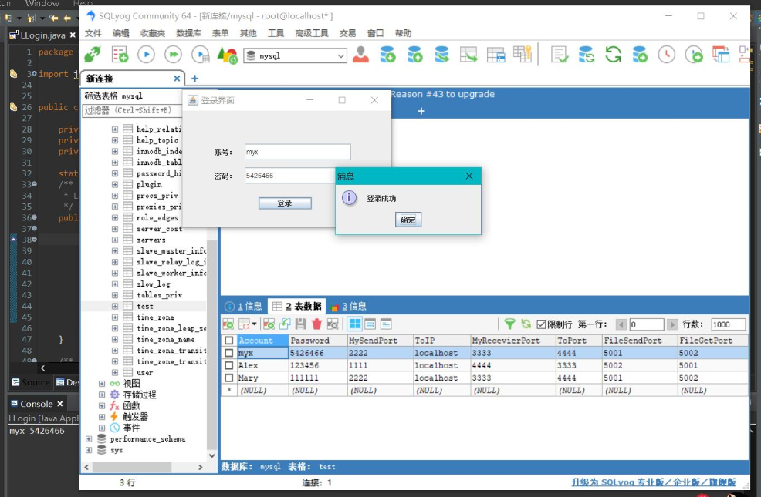

登录用户聊天界面：
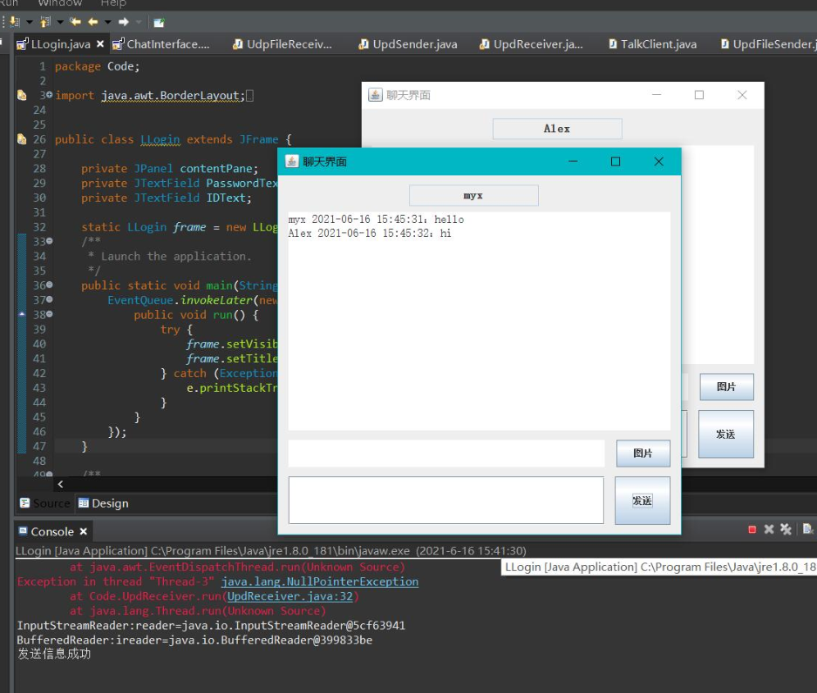

传输文件到用户数据文件夹
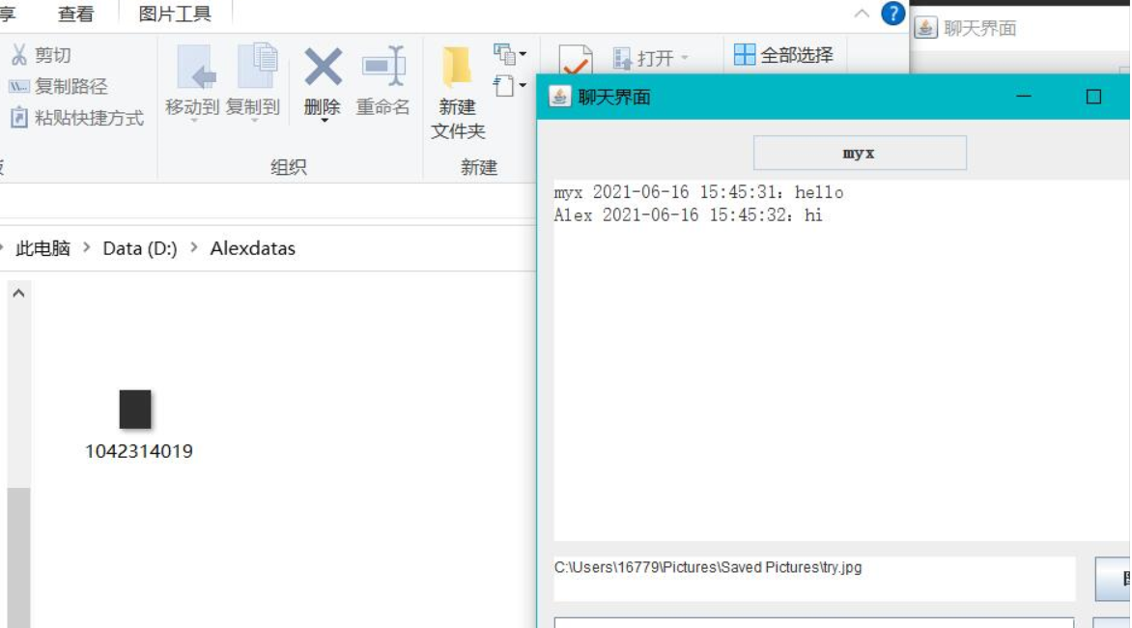

心得与体会：
- 掌握java的Socket的操作：
创建Socket
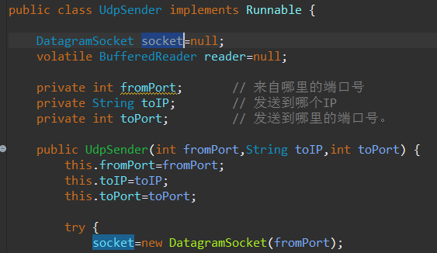
打开连接到Socket的输入/输出流
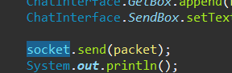
按协议对Socket进行读/写操作
关闭Socket
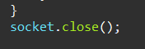
- 了解TCP/UDP：
TCP传输效率不如UDP传输效率高
UDP操作简单，而且只需要较少的监护，本次实验即采用UDP通信
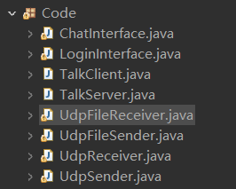
- 使用DatagramPacket数据包：
