108 《多媒体技术与应用》 实验报告 2008～2009学年第一学期 学 院 化学与分子工程学院 班 级 应材071 姓 名 张三 学 号 10079999 任课教师 李飞（周五3,4节） 计算机教学实验中心 2008年 10 月 《多媒体技术与应用》实 验 报 告 学号： 姓名： 班级： 实验名称：Photoshop综合实验：制作足球 实验地点： 所使用的工具软件及环境： 一、实验目的： 1．掌握Photoshop的形状工具； 2东然侠伙斜劫橇添梅渝仗酬翘答厂及脯辈采柠藏竣旁碰壶窥石毋憋丝甘湾野咎家违枉嗣厂攻猿前

浙江理工大学

《Java程序设计》

实验报告
2020 ～2021 学年第2 学期

学 院 | 信息学院
班 级 | 19计算机科学与技术（1）
姓 名 | 梅雨欣
学 号 | 2019329621004
任课教师 | 孙麒  （上课时间：周一6-8 节）

《Java程序设计》实 验 报 告（三）
实验名称: Java文件 | 实验地点：10-413
所使用的工具软件及环境：
环境：Windows 8.1;jdk 1.8;
工具：eclipse

实验目的：
学习多线程
实验内容：
学习多线程。

提示:
Runnable接口继承重写run()
源程序：
TankClient.java
import java.util.ArrayList;
import java.awt.*;
import java.awt.event.*;
import java.util.List;
import javax.swing.JOptionPane;

public class TankClient extends Frame implements ActionListener {

private static final long serialVersionUID = 1L;
public static final int Fram_width = 800, Fram_length = 600;
public static boolean printable = true;

MenuBar jmb = null;
Menu jm1 = null, jm2 = null, jm3 = null;
MenuItem jmi1 = null, jmi2 = null, jmi3 = null, jmi4 = null, jmi5 = null;
Image screenImage = null;

Tank homeTank = new Tank(300, 560, true, Direction.STOP, this);
Home home = new Home(373, 545, this);

List<River> theRiver = new ArrayList<River>();
List<Tank> tanks = new ArrayList<Tank>();
List<BombTank> bombTanks = new ArrayList<BombTank>();
List<Bullets> bullets = new ArrayList<Bullets>();
List<Tree> trees = new ArrayList<Tree>();
List<CommonWall> homeWall = new ArrayList<CommonWall>();
List<CommonWall> otherWall = new ArrayList<CommonWall>();
List<MetalWall> metalWall = new ArrayList<MetalWall>();

//重写update方法，将窗体上的图形画在图片对象上，再一次性显示
public void update(Graphics g) {
//截取窗体所在位置的图片
screenImage = this.createImage(Fram_width, Fram_length);

Graphics gps = screenImage.getGraphics(); //获取截取的画布
Color c = gps.getColor();
gps.setColor(Color.LIGHT_GRAY);
gps.fillRect(0, 0, Fram_width, Fram_length); //清楚上一步图像，相当于clearRect(0,0,width,height)
gps.setColor(c);
paint(gps); //把画布传给绘制
g.drawImage(screenImage, 0, 0, null); //将接下来图片加载到窗体画布
}

// 绘制坦克、子弹、地图
public void paint(Graphics g) {

Color c = g.getColor();
g.setColor(Color.RED);

if (tanks.size() == 0 && home.isLive() && homeTank.isLive()) {
Font f = g.getFont();
g.setFont(new Font("TimesRoman", Font.BOLD, 60));
g.drawString("WIN ", 310, 300);
bullets.clear();
g.setFont(f);
}

if (homeTank.isLive() == false) {
Font f = g.getFont();
g.setFont(new Font("TimesRoman", Font.BOLD, 60));
g.drawString("LOSE", 310, 300);
tanks.clear();
bullets.clear();
g.setFont(f);
}

g.setColor(c);

for (int i = 0; i < theRiver.size(); i++) { // 画河流
River r = theRiver.get(i);
r.draw(g);
}

for (int i = 0; i < theRiver.size(); i++) {
River r = theRiver.get(i);
homeTank.collideRiver(r); //自己坦克碰到河流效果
r.draw(g);
}

home.draw(g); // 画home
homeTank.draw(g); // 画自己坦克

for (int i = 0; i < bullets.size(); i++) { // 每个子弹
Bullets m = bullets.get(i);
m.hitTanks(tanks); // 打到坦克
m.hitTank(homeTank); // 打到自己坦克
m.hitHome(); // 打到家

for (int j = 0; j < metalWall.size(); j++) { // 打到金属墙
MetalWall mw = metalWall.get(j);
m.hitWall(mw);
}

for (int j = 0; j < otherWall.size(); j++) { // 打到其他墙
CommonWall w = otherWall.get(j);
m.hitWall(w);
}

for (int j = 0; j < homeWall.size(); j++) { // 打到家墙
CommonWall cw = homeWall.get(j);
m.hitWall(cw);
}

m.draw(g);
}

for (int i = 0; i < tanks.size(); i++) {
Tank t = tanks.get(i);

for (int j = 0; j < homeWall.size(); j++) { // 坦克撞到家里的墙
CommonWall cw = homeWall.get(j);
t.collideWithWall(cw);
cw.draw(g);
}

for (int j = 0; j < otherWall.size(); j++) { // 坦克撞到其他墙
CommonWall cw = otherWall.get(j);
t.collideWithWall(cw);
cw.draw(g);
}

for (int j = 0; j < metalWall.size(); j++) { // 坦克撞到金属墙
MetalWall mw = metalWall.get(j);
t.collideWithWall(mw);
mw.draw(g);
}

for (int j = 0; j < theRiver.size(); j++) { // 坦克撞到河
River r = theRiver.get(j);
t.collideRiver(r);
r.draw(g);
}

t.collideWithTanks(tanks); // 撞到坦克
t.collideHome(home);
t.draw(g);
}

for (int i = 0; i < trees.size(); i++) { // 画树
Tree tr = trees.get(i);
tr.draw(g);
}

for (int i = 0; i < bombTanks.size(); i++) { // 画爆炸
BombTank bt = bombTanks.get(i);
bt.draw(g);
}

for (int i = 0; i < otherWall.size(); i++) { // 画其他墙
CommonWall cw = otherWall.get(i);
cw.draw(g);
}

for (int i = 0; i < metalWall.size(); i++) { // 画金属墙
MetalWall mw = metalWall.get(i);
mw.draw(g);
}

homeTank.collideWithTanks(tanks);
homeTank.collideHome(home);

for (int i = 0; i < metalWall.size(); i++) { // 撞金属墙
MetalWall w = metalWall.get(i);
homeTank.collideWithWall(w);
w.draw(g);
}

for (int i = 0; i < otherWall.size(); i++) { // 撞其他墙
CommonWall cw = otherWall.get(i);
homeTank.collideWithWall(cw);
cw.draw(g);
}

for (int i = 0; i < homeWall.size(); i++) { // 自己坦克撞到家
CommonWall w = homeWall.get(i);
homeTank.collideWithWall(w);
w.draw(g);
}

}

public TankClient() {
// 创建菜单及菜单选项
jmb = new MenuBar();
jm1 = new Menu("游戏");
jm2 = new Menu("暂停/继续");
jm3 = new Menu("帮助");
jm1.setFont(new Font("TimesRoman", Font.BOLD, 15));
jm2.setFont(new Font("TimesRoman", Font.BOLD, 15));
jm3.setFont(new Font("TimesRoman", Font.BOLD, 15));

jmi1 = new MenuItem("开始新游戏");
jmi2 = new MenuItem("退出");
jmi3 = new MenuItem("暂停");
jmi4 = new MenuItem("继续");
jmi5 = new MenuItem("游戏说明");
jmi1.setFont(new Font("TimesRoman", Font.BOLD, 15));
jmi2.setFont(new Font("TimesRoman", Font.BOLD, 15));
jmi3.setFont(new Font("TimesRoman", Font.BOLD, 15));
jmi4.setFont(new Font("TimesRoman", Font.BOLD, 15));
jmi5.setFont(new Font("TimesRoman", Font.BOLD, 15));

jm1.add(jmi1);
jm1.add(jmi2);
jm2.add(jmi3);
jm2.add(jmi4);
jm3.add(jmi5);

jmb.add(jm1);
jmb.add(jm2);
jmb.add(jm3);

jmi1.addActionListener(this);
jmi1.setActionCommand("NewGame");
jmi2.addActionListener(this);
jmi2.setActionCommand("Exit");
jmi3.addActionListener(this);
jmi3.setActionCommand("Stop");
jmi4.addActionListener(this);
jmi4.setActionCommand("Continue");
jmi5.addActionListener(this);
jmi5.setActionCommand("help");

this.setMenuBar(jmb); // 菜单Bar放到JFrame上
this.setVisible(true);

for (int i = 0; i < 10; i++) { // 家布局
if (i < 4)
homeWall.add(new CommonWall(350, 580 - 21 * i, this));
else if (i < 7)
homeWall.add(new CommonWall(372 + 22 * (i - 4), 517, this));
else
homeWall.add(new CommonWall(416, 538 + (i - 7) * 21, this));
}

for (int i = 0; i < 32; i++) { // 普通墙布局
if (i < 16) {
otherWall.add(new CommonWall(220 + 20 * i, 300, this));
otherWall.add(new CommonWall(500 + 20 * i, 180, this));
otherWall.add(new CommonWall(200, 400 + 20 * i, this));
otherWall.add(new CommonWall(500, 400 + 20 * i, this));
} else if (i < 32) {
otherWall.add(new CommonWall(220 + 20 * (i - 16), 320, this));
otherWall.add(new CommonWall(500 + 20 * (i - 16), 220, this));
otherWall.add(new CommonWall(220, 400 + 20 * (i - 16), this));
otherWall.add(new CommonWall(520, 400 + 20 * (i - 16), this));
}
}

for (int i = 0; i < 20; i++) { // 金属墙布局
if (i < 10) {
metalWall.add(new MetalWall(140 + 30 * i, 150, this));
metalWall.add(new MetalWall(600, 400 + 20 * (i), this));
} else if (i < 20)
metalWall.add(new MetalWall(140 + 30 * (i - 10), 180, this));
else
metalWall.add(new MetalWall(500 + 30 * (i - 10), 160, this));
}

for (int i = 0; i < 4; i++) { // 树布局
if (i < 4) {
trees.add(new Tree(0 + 30 * i, 360, this));
trees.add(new Tree(220 + 30 * i, 360, this));
trees.add(new Tree(440 + 30 * i, 360, this));
trees.add(new Tree(660 + 30 * i, 360, this));
}
}

theRiver.add(new River(85, 100, this));

for (int i = 0; i < 8; i++) { // 初始化坦克出现位置
Tank t = new Tank(150 + 70 * i, 40, false, Direction.D, this);
tanks.add(t);
new Thread(t).start();
}

this.setSize(Fram_width, Fram_length);
this.setLocation(380, 50);
this.setTitle("坦克大战————myx");
this.addWindowListener(new WindowAdapter() { //接收窗口事件的抽象适配器类
public void windowClosing(WindowEvent e) {
System.exit(0);
}
});
this.setResizable(false); //不允许修改窗体大小
this.setBackground(Color.BLACK);
this.setVisible(true);
this.addKeyListener(new KeyMonitor()); //键盘监听
new Thread(homeTank).start();
new Thread(new PaintThread()).start();
}

public static void main(String[] args) {
new TankClient();
}

//重绘线程不断地刷新界面，消除闪烁
private class PaintThread implements Runnable {
public void run() {
while (printable) {
repaint();
try { //模拟延时
Thread.sleep(50);
} catch (InterruptedException e) {
e.printStackTrace();
}
}
}
}

//键盘监听
private class KeyMonitor extends KeyAdapter {
public void keyReleased(KeyEvent e) {
homeTank.keyReleased(e);
}

public void keyPressed(KeyEvent e) {
homeTank.keyPressed(e);
}
}

public void actionPerformed(ActionEvent e) {
if (e.getActionCommand().equals("NewGame")) {
printable = false;
Object[] options = { "确定", "取消" };
int response = JOptionPane.showOptionDialog(this, "您确认要开始新游戏？", "",
JOptionPane.YES_OPTION, JOptionPane.QUESTION_MESSAGE, null, options, options[0]);
if (response == 0) {

printable = true;
this.dispose();
new TankClient();
} else {
printable = true;
new Thread(new PaintThread()).start(); // 线程启动
}

} else if (e.getActionCommand().endsWith("Stop")) {
printable = false;

} else if (e.getActionCommand().equals("Continue")) {
if (!printable) {
printable = true;
new Thread(new PaintThread()).start(); // 线程启动
}

} else if (e.getActionCommand().equals("Exit")) {
printable = false;
Object[] options = {"确定", "取消"};
int response = JOptionPane.showOptionDialog(this, "您确认要退出吗", "", JOptionPane.YES_OPTION, JOptionPane.QUESTION_MESSAGE, null, options, options[0]);
if (response == 0) {
System.out.println("退出");
System.exit(0);
} else {
printable = true;
new Thread(new PaintThread()).start(); // 线程启动
}

} else if (e.getActionCommand().equals("help")) {
printable = false;
JOptionPane.showMessageDialog(null, "用↑ ↓→ ← 控制方向\nF键发射，R键重新开始", "提示", JOptionPane.INFORMATION_MESSAGE);
this.setVisible(true);
printable = true;
new Thread(new PaintThread()).start(); // 线程启动
}
}
}
BombTank.java
import java.awt.Graphics;
import java.awt.Image;
import java.awt.Toolkit;

public class BombTank {
private int x, y;
private boolean live = true; // 初始状态为活着的
private TankClient tc;
private static Toolkit tk = Toolkit.getDefaultToolkit();

private static Image[] imgs = { // 爆炸效果图
tk.getImage(BombTank.class.getClassLoader().getResource("images/1.gif")),
tk.getImage(BombTank.class.getClassLoader().getResource("images/2.gif")),
tk.getImage(BombTank.class.getClassLoader().getResource("images/3.gif")),
tk.getImage(BombTank.class.getClassLoader().getResource("images/4.gif")),
tk.getImage(BombTank.class.getClassLoader().getResource("images/5.gif")),
tk.getImage(BombTank.class.getClassLoader().getResource("images/6.gif")),
tk.getImage(BombTank.class.getClassLoader().getResource("images/7.gif")),
tk.getImage(BombTank.class.getClassLoader().getResource("images/8.gif")),
tk.getImage(BombTank.class.getClassLoader().getResource("images/9.gif")),
tk.getImage(BombTank.class.getClassLoader().getResource("images/10.gif")), };

int step = 0;

public BombTank(int x, int y, TankClient tc) {
this.x = x;
this.y = y;
this.tc = tc;
}

public void draw(Graphics g) { // 画爆炸
if (!live) { // 坦克消失后删除爆炸图
tc.bombTanks.remove(this);
return;
}

if (step == imgs.length) {
live = false;
step = 0;
return;
}

g.drawImage(imgs[step], x, y, null);
step++;
}
}
Bullets.java
import java.awt.*;
import java.util.HashMap;
import java.util.List;
import java.util.Map;

public class Bullets{
public static int speedX = 15, speedY = 15;
public static final int width = 10, length = 10;

private int x, y;
Direction diretion;

private boolean good;
private boolean live = true;
private TankClient tc;

private static Toolkit tk = Toolkit.getDefaultToolkit();
private static Image[] bulletImages = null;
private static Map<String, Image> imgs = new HashMap<String, Image>(); // Map-方向&子弹

static {
bulletImages = new Image[] { // 不同方向的子弹
tk.getImage(Bullets.class.getClassLoader().getResource("images/bulletL.gif")),
tk.getImage(Bullets.class.getClassLoader().getResource("images/bulletU.gif")),
tk.getImage(Bullets.class.getClassLoader().getResource("images/bulletR.gif")),
tk.getImage(Bullets.class.getClassLoader().getResource("images/bulletD.gif")),
};

imgs.put("L", bulletImages[0]);
imgs.put("U", bulletImages[1]);
imgs.put("R", bulletImages[2]);
imgs.put("D", bulletImages[3]);
}

public Bullets(int x, int y, Direction dir) {
this.x = x;
this.y = y;
this.diretion = dir;
}

public Bullets(int x, int y, boolean good, Direction dir, TankClient tc) {
this(x, y, dir);
this.good = good;
this.tc = tc;
}

private void move() {
switch (diretion) {
case L:
x -= speedX; // 子弹不断向左进攻
break;

case U:
y -= speedY;
break;

case R:
x += speedX; // 字段不断向右
break;

case D:
y += speedY;
break;

case STOP:
break;
}

if (x < 0 || y < 0 || x > TankClient.Fram_width || y > TankClient.Fram_length)
live = false;
}

public void draw(Graphics g) {
if (!live) {
tc.bullets.remove(this);
return;
}

switch (diretion) {
case L:
g.drawImage(imgs.get("L"), x, y, null);
break;

case U:
g.drawImage(imgs.get("U"), x, y, null);
break;

case R:
g.drawImage(imgs.get("R"), x, y, null);
break;

case D:
g.drawImage(imgs.get("D"), x, y, null);
break;
}

move();
}

public boolean isLive() {
return live;
}

public Rectangle getRect() {
return new Rectangle(x, y, width, length);
}

public boolean hitTanks(List<Tank> tanks) { // 子弹打坦克
for (int i = 0; i < tanks.size(); i++) {
if (hitTank(tanks.get(i))) { // 每个坦克调用hitTank
return true;
}
}
return false;
}

public boolean hitTank(Tank t) { // 子弹打坦克
if (this.live && this.getRect().intersects(t.getRect()) && t.isLive() && this.good != t.isGood()) {
BombTank e = new BombTank(t.getX(), t.getY(), tc);
tc.bombTanks.add(e);

t.setLive(false);
this.live = false;

return true; // 射击成功，返回true
}

return false;
}

public boolean hitWall(CommonWall w) { // 子弹打CommonWall
if (this.live && this.getRect().intersects(w.getRect())) {
this.live = false;
this.tc.otherWall.remove(w); // 子弹打到CommonWall墙上时则移除此击中墙
this.tc.homeWall.remove(w);

return true;
}

return false;
}

public boolean hitWall(MetalWall w) { // 子弹打金属墙（不能穿越金属墙
if (this.live && this.getRect().intersects(w.getRect())) {
this.live = false;

return true;
}

return false;
}

public boolean hitHome() { // 子弹打家
if (this.live && this.getRect().intersects(tc.home.getRect())) {
this.live = false;
this.tc.home.setLive(false); // 家受一枪死亡

return true;
}

return false;
}
}
CommonWall.java
import java.awt.*;

public class CommonWall {
public static final int width = 20, length = 20;
int x, y;

TankClient tc;
private static Toolkit tk = Toolkit.getDefaultToolkit();
private static Image[] wallImags = null;

static {
wallImags = new Image[] {
tk.getImage(CommonWall.class.getResource("Images/commonWall.gif")), };
}

public CommonWall(int x, int y, TankClient tc) {
this.x = x;
this.y = y;
this.tc = tc;
}

public void draw(Graphics g) {
g.drawImage(wallImags[0], x, y, null);
}

public Rectangle getRect() { //构造指定参数的长方形实例
return new Rectangle(x, y, width, length);
}
}
Direction.java
public enum Direction {
L, //left
U, //up
R, //right
D, //down
STOP
}
Home.java
import java.awt.Color;
import java.awt.Font;
import java.awt.Graphics;
import java.awt.Image;
import java.awt.Rectangle;
import java.awt.Toolkit;

public class Home {
private int x, y;
public static final int width = 30, length = 30;
private boolean live = true;
private TankClient tc;

private static Toolkit tk = Toolkit.getDefaultToolkit();
private static Image[] homeImags = null;
static {
homeImags = new Image[] { tk.getImage(CommonWall.class.getResource("Images/home.jpg")), };
}

public Home(int x, int y, TankClient tc) {
this.x = x;
this.y = y;
this.tc = tc;
}

public void gameOver(Graphics g) {
tc.tanks.clear();
tc.metalWall.clear();
tc.otherWall.clear();
tc.bombTanks.clear();
tc.theRiver.clear();
tc.trees.clear();
tc.bullets.clear();
tc.homeTank.setLive(false);
Color c = g.getColor();
g.setColor(Color.RED);
Font f = g.getFont();
g.setFont(new Font(" ", Font.BOLD, 40));
g.drawString("LOSE", 220, 250);
g.drawString("GAME OVER", 220, 300);
g.setFont(f);
g.setColor(c);
}

public void draw(Graphics g) {

if (live) {
g.drawImage(homeImags[0], x, y, null);

for (int i = 0; i < tc.homeWall.size(); i++) {
CommonWall w = tc.homeWall.get(i);
w.draw(g);
}
} else
gameOver(g);
}

public boolean isLive() {
return live;
}

public void setLive(boolean live) {
this.live = live;
}

public Rectangle getRect() {
return new Rectangle(x, y, width, length);
}
}
MetalWall.java
import java.awt.Graphics;
import java.awt.Image;
import java.awt.Rectangle;
import java.awt.Toolkit;

public class MetalWall {
public static final int width = 30, length = 30;
private int x, y;
TankClient tc;
private static Toolkit tk = Toolkit.getDefaultToolkit();
private static Image[] wallImags = null;
static {
wallImags = new Image[] { tk.getImage(CommonWall.class
.getResource("Images/metalWall.gif")), };
}

public MetalWall(int x, int y, TankClient tc) {
this.x = x;
this.y = y;
this.tc = tc;
}

public void draw(Graphics g) {
g.drawImage(wallImags[0], x, y, null);
}

public Rectangle getRect() {
return new Rectangle(x, y, width, length);
}
}
River.java
import java.awt.Graphics;
import java.awt.Image;
import java.awt.Rectangle;
import java.awt.Toolkit;

public class River {
public static final int riverWidth = 40;
public static final int riverLength = 100;//静态全局变量
private int x, y;
TankClient tc ;

private static Toolkit tk = Toolkit.getDefaultToolkit();
private static Image[] riverImags = null;

static {
riverImags = new Image[]{tk.getImage(CommonWall.class.getResource("Images/river.jpg"))};
}

public River(int x, int y, TankClient tc) {
this.x = x;
this.y = y;
this.tc = tc;
}

public void draw(Graphics g) {
g.drawImage(riverImags[0],x, y, null);
}

public static int getRiverWidth() {
return riverWidth;
}

public static int getRiverLength() {
return riverLength;
}

public int getX() {
return x;
}

public void setX(int x) {
this.x = x;
}

public int getY() {
return y;
}

public void setY(int y) {
this.y = y;
}
public Rectangle getRect() {
return new Rectangle(x, y, riverWidth, riverLength);
}
}
Tank.java
import java.awt.*;
import java.awt.event.*;
import java.util.*;

public class Tank implements Runnable {
public static int speedX = 10, speedY = 10;
public static final int width = 35, length = 35; // 坦克大小
private Direction direction = Direction.STOP; // 初始化状态为静止
private Direction Kdirection = Direction.U; // 初始化方向为向上
TankClient tc;

private int x, y;
private int oldX, oldY;
private boolean good = true;
private boolean live = true; // 活着

private static Random r = new Random();
private int step = r.nextInt(10) + 5 ; // 随机数模拟坦克的移动路径
private boolean bL = false, bU = false, bR = false, bD = false;

private static Toolkit tk = Toolkit.getDefaultToolkit();// 控制面板
private static Image[] tankImags = null; // 存储全局静态
static {
tankImags = new Image[] {
tk.getImage(BombTank.class.getResource("Images/tankD.gif")),
tk.getImage(BombTank.class.getResource("Images/tankU.gif")),
tk.getImage(BombTank.class.getResource("Images/tankL.gif")),
tk.getImage(BombTank.class.getResource("Images/tankR.gif")), };
}

public Tank(int x, int y, boolean good) {
this.x = this.oldX = x;
this.y = this.oldY = y;
this.good = good;
}

public Tank(int x, int y, boolean good, Direction dir, TankClient tc) {
this(x, y, good);
this.direction = dir;
this.tc = tc;
}

public void draw(Graphics g) {
if (!live) {
if (!good) {
tc.tanks.remove(this); // 删除无效tank
}
return;
}

switch (Kdirection) { //根据方向选择坦克的图片
case D:
g.drawImage(tankImags[0], x, y, null);
break;

case U:
g.drawImage(tankImags[1], x, y, null);
break;
case L:
g.drawImage(tankImags[2], x, y, null);
break;

case R:
g.drawImage(tankImags[3], x, y, null);
break;
}

move(); //调用move函数
}

void move() {

this.oldX = x;
this.oldY = y;

switch (direction) { //选择移动方向
case L:
x -= speedX;
break;
case U:
y -= speedY;
break;
case R:
x += speedX;
break;
case D:
y += speedY;
break;
case STOP:
break;
}

if (this.direction != Direction.STOP) this.Kdirection = this.direction;

//防止走出规定区域
if (x < 0) x = 0;
if (y < 40) y = 40;
//超过区域则恢复到边界
if (x + Tank.width > TankClient.Fram_width) x = TankClient.Fram_width - Tank.width;
if (y + Tank.length > TankClient.Fram_length) y = TankClient.Fram_length - Tank.length;

if (!good) {
Direction[] directons = Direction.values();
if (step == 0) {
step = r.nextInt(12) + 3; //随机路径
int rn = r.nextInt(directons.length);
direction = directons[rn]; //随机方向
}
step--;

if (r.nextInt(40) > 38)//随机控制敌人开火
this.fire();
}
}

private void changToOldDir() {
x = oldX;
y = oldY;
}

public void keyPressed(KeyEvent e) { //接受键盘事件
int key = e.getKeyCode();
switch (key) {
case KeyEvent.VK_R: //按R重新开始游戏
tc.tanks.clear();
tc.bullets.clear();
tc.trees.clear();
tc.otherWall.clear();
tc.homeWall.clear();
tc.metalWall.clear();
tc.homeTank.setLive(false);
if (tc.tanks.size() == 0) { //当在区域中没有坦克时，就出来坦克
for (int i = 0; i < 20; i++) {
if (i < 9) //设置坦克出现的位置
tc.tanks.add(new Tank(150 + 70 * i, 40, false, Direction.R, tc));
else if (i < 15)
tc.tanks.add(new Tank(700, 140 + 50 * (i -6), false, Direction.D, tc));
else
tc.tanks.add(new Tank(10, 50 * (i - 12), false, Direction.L, tc));
}
}

if (!tc.home.isLive()) tc.home.setLive(true);

tc.homeTank = new Tank(300, 560, true, Direction.STOP, tc);
new TankClient();
break;

case KeyEvent.VK_RIGHT:
bR = true;
break;

case KeyEvent.VK_LEFT:
bL = true;
break;

case KeyEvent.VK_UP:
bU = true;
break;

case KeyEvent.VK_DOWN:
bD = true;
break;
}
decideDirection(); //确定移动方向
}

void decideDirection() {
if (!bL && !bU && bR && !bD) //右移
direction = Direction.R;

else if (bL && !bU && !bR && !bD) //左移
direction = Direction.L;

else if (!bL && bU && !bR && !bD) //上移
direction = Direction.U;

else if (!bL && !bU && !bR && bD) //下移
direction = Direction.D;

else if (!bL && !bU && !bR && !bD)
direction = Direction.STOP; //没有按键，保持不动
}

public void keyReleased(KeyEvent e) {
switch (e.getKeyCode()) {
case KeyEvent.VK_F:
fire();
break;

case KeyEvent.VK_RIGHT:
bR = false;
break;

case KeyEvent.VK_LEFT:
bL = false;
break;

case KeyEvent.VK_UP:
bU = false;
break;

case KeyEvent.VK_DOWN:
bD = false;
break;
}

decideDirection(); //释放键盘后确定移动方向
}

public Bullets fire() {
if (!live) return null;

int x = this.x + Tank.width / 2 - Bullets.width / 2;
int y = this.y + Tank.length / 2 - Bullets.length / 2;
Bullets m = new Bullets(x, y + 2, good, Kdirection, this.tc); //没有给定方向时，向原来的方向开火
tc.bullets.add(m);
return m;
}

public Rectangle getRect() {
return new Rectangle(x, y, width, length);
}

public boolean isLive() {
return live;
}

public void setLive(boolean live) {
this.live = live;
}

public boolean isGood() {
return good;
}

public boolean collideWithWall(CommonWall w) { //撞普通墙
if (this.live && this.getRect().intersects(w.getRect())) {
this.changToOldDir();
return true;
}
return false;
}

public boolean collideWithWall(MetalWall w) { //撞金属墙
if (this.live && this.getRect().intersects(w.getRect())) {
this.changToOldDir();
return true;
}
return false;
}

public boolean collideRiver(River r) { //撞到河
if (this.live && this.getRect().intersects(r.getRect())) {
this.changToOldDir();
return true;
}
return false;
}

public boolean collideHome(Home h) { //撞到家
if (this.live && this.getRect().intersects(h.getRect())) {
this.changToOldDir();
return true;
}
return false;
}

public boolean collideWithTanks(java.util.List<Tank> tanks) { //撞到坦克
for (int i = 0; i < tanks.size(); i++) {
Tank t = tanks.get(i);
if (this != t) {
if (this.live && t.isLive() && this.getRect().intersects(t.getRect())) {
this.changToOldDir();
t.changToOldDir();
return true;
}
}
}
return false;
}

public int getX() {
return x;
}

public int getY() {
return y;
}

@Override
public void run() {
while (true) {
move();
if (isLive()) break;

try {
Thread.sleep(50);
} catch (InterruptedException e) {
e.printStackTrace();
}
}
}
}
Tree.java
import java.awt.Graphics;
import java.awt.Image;
import java.awt.Toolkit;

public class Tree {
public static final int width = 30, length = 30;
int x, y;
TankClient tc ;
private static Toolkit tk = Toolkit.getDefaultToolkit();
private static Image[] treeImags = null;
static {
treeImags = new Image[]{tk.getImage(CommonWall.class.getResource("Images/tree.gif"))};
}

public Tree(int x, int y, TankClient tc) {
this.x = x;
this.y = y;
this.tc = tc;
}

public void draw(Graphics g) {
g.drawImage(treeImags[0],x, y, null);
}
}

实验结果：
操作方法：
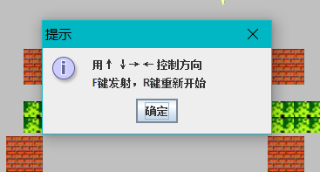
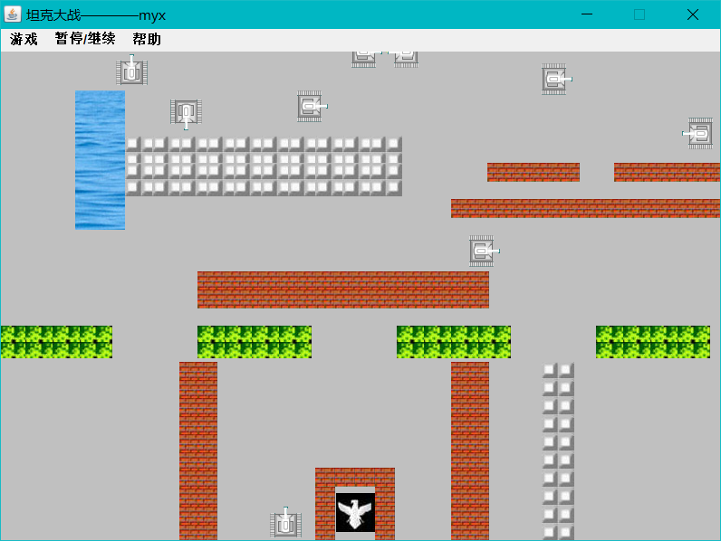

WIN：
消灭所有敌方坦克：
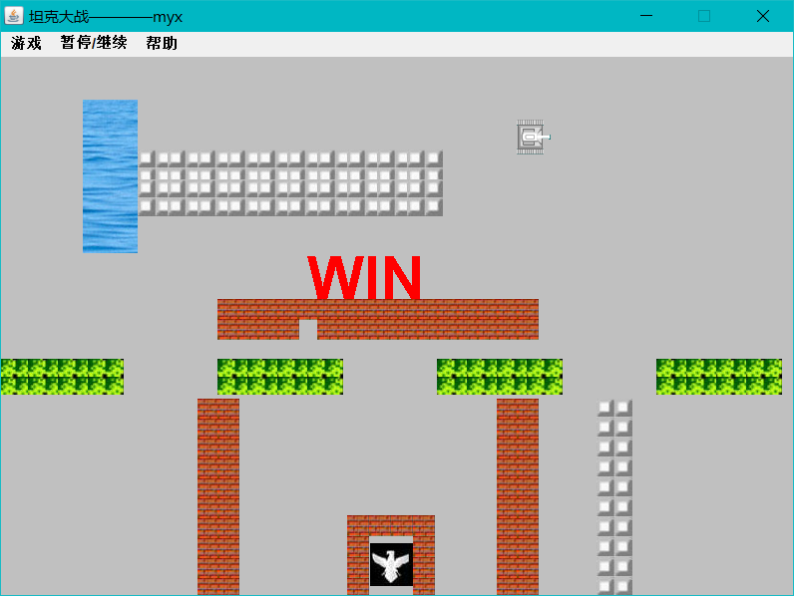

LOSE：
①被敌方坦克击中：
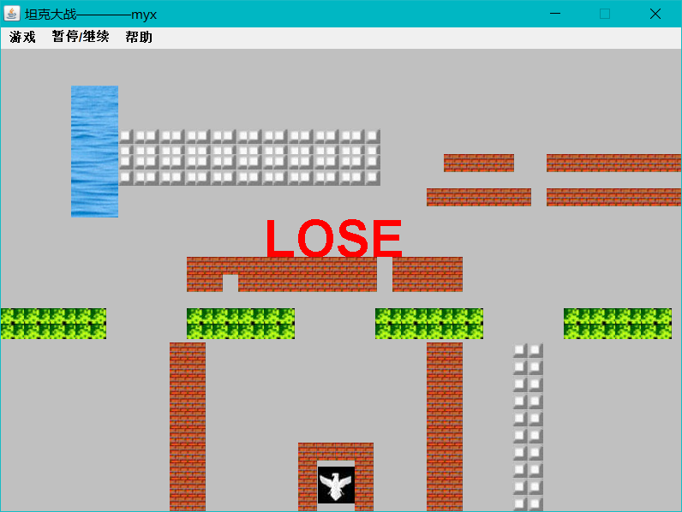
②家被击中：（同时显示GAME OVER）
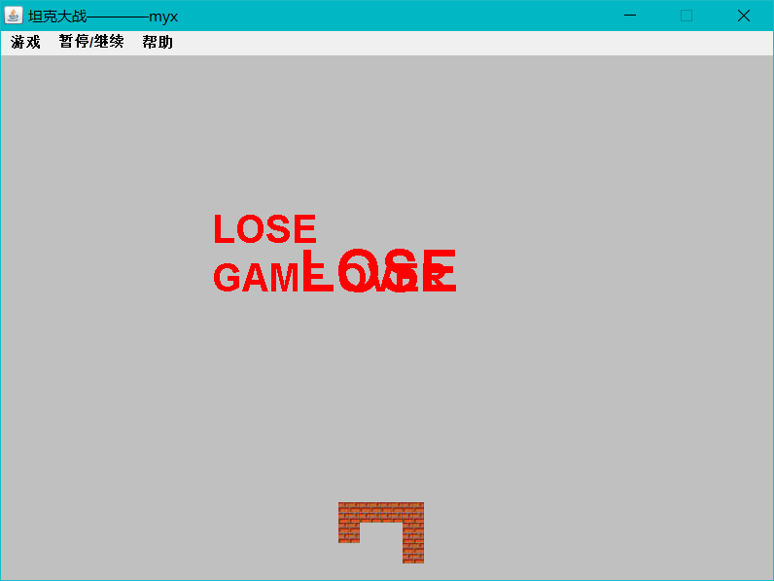

其他：
Menu Bar：
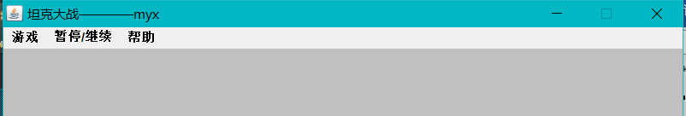
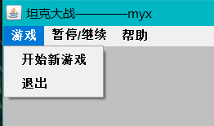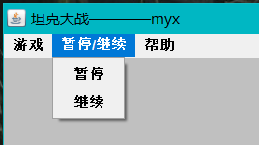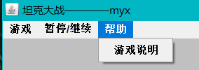
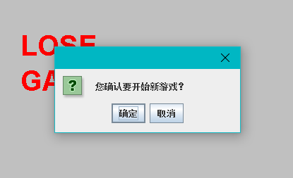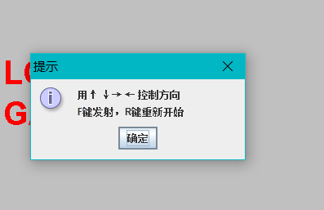

心得与体会：
- 掌握多线程的使用步骤：
①Tank类继承Runnable接口：
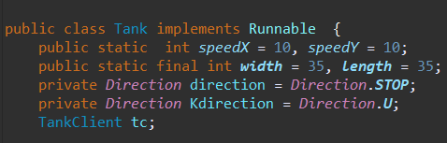
②重写run()方法：
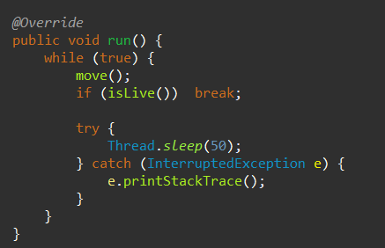
③开始线程：
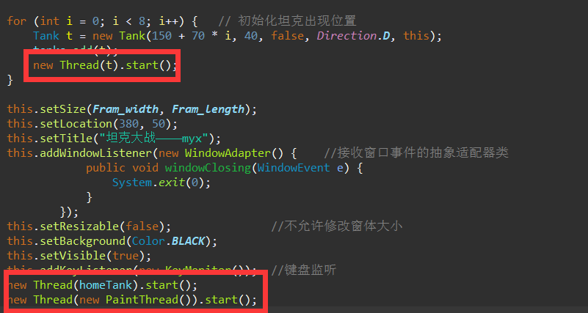
- 了解线程状态：
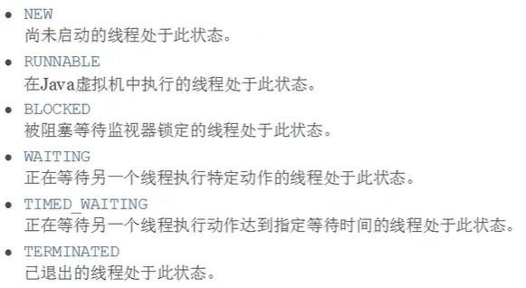
- 双缓冲机制：
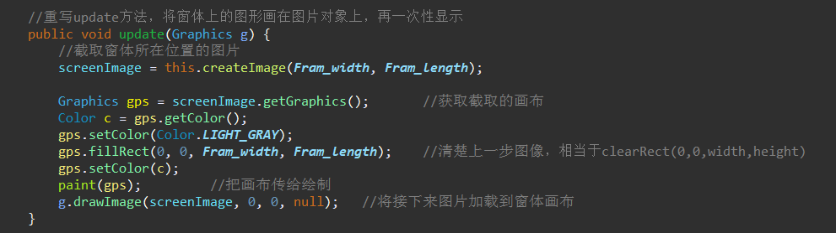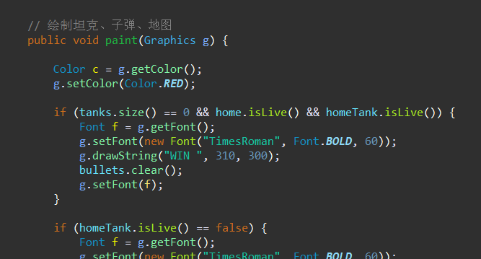
- 重绘线程防止图片闪烁：
