**任课教师：张涵翠、霍戌文**

**《数据库系统实训》**

**（2021-2022学年第2学期）**

**实**

**验**

**报**

**告**

**学号：2019329621004**

**姓名：梅雨欣**

**班级：19计算机科学与技术1班**

**实验四：视图**

**第二十二章---视图**

**第一部分：样例库的应用**

**1）**CREATE VIEW productcustomers AS

SELECT cust_name,cust_contact,prod_id

FROM customers,orders,orderitems

WHERE customers.cust_id = orders.cust_id

AND orderitems.order_num = orders.order_num;

SELECT cust_name,cust_contact

FROM productcustomers

WHERE prod_id = 'TNT2' ;

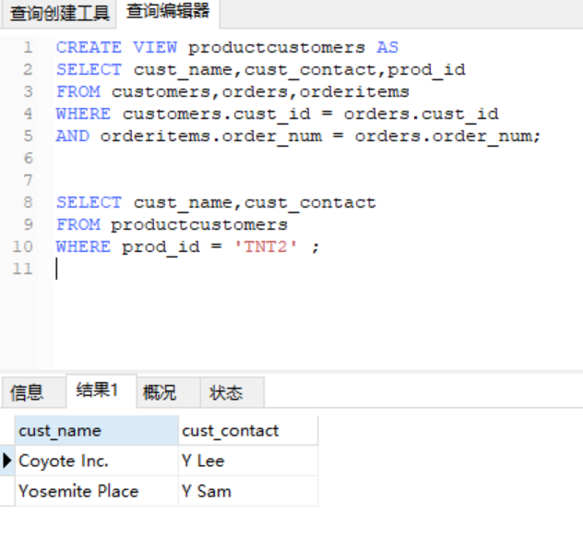

**2）**CREATE VIEW vendorlocations AS

SELECT Concat(RTrim(vend_name),' (',RTrim(vend_country),')')

AS vend_title

FROM vendors

ORDER BY vend_name;

SELECT * from vendorlocations

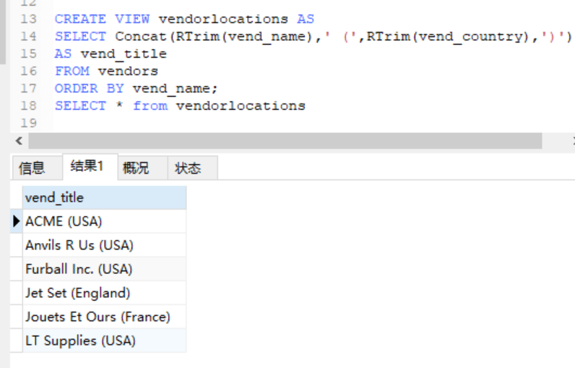

**3）**CREATE VIEW customeremaillist AS

SELECT cust_id,cust_name,cust_email FROM customers

WHERE cust_email IS NOT NULL;

select * from customeremaillist

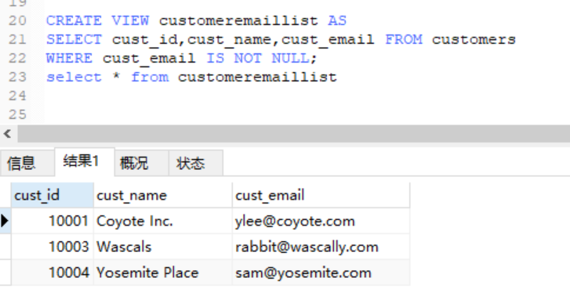

**4）**CREATE VIEW orderitemsexpanded AS

SELECT order_num,prod_id,quantity,item_price,

quantity * item_price as expanded_price

FROM orderitems;

select * from orderitemsexpanded where order_num=20005

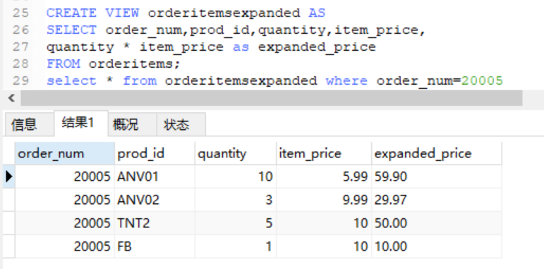

**第二部分：所选课题数据库的应用**

CREATE VIEW tcc AS  
SELECT teacher.teacherName,student.studentName  
FROM teacher,student,tc,cs  
WHERE teacher.teacherId=tc.teacherId AND tc.courseId=cs.courseId AND cs.studentId = student.studentId

select * from tcc

