**任课教师：张涵翠、霍戌文**

**《数据库系统实训》**

**（2021-2022学年第2学期）**

**实**

**验**

**报**

**告**

**学号：2019320621004**

**姓名：梅雨欣**

**班级：19计算机科学与技术（1）班**

**实验九：触发器**

1. **--使用触发器**

**第一部分：样例库的应用**

**1）INSERT 触发器**

|  |
| --- |
| CREATE TABLE orders_log(  change_id int NOT NULL AUTO_INCREMENT,  changed_on datetime NOT NULL ,  change_type char(1) NOT NULL ,  order_num int NOT NULL ,  PRIMARY KEY (change_id)  ) ENGINE=INNODB;  drop trigger if exists neworder;  DELIMITER //  CREATE TRIGGER neworder AFTER INSERT ON orders  FOR EACH ROW  BEGIN  INSERT INTO orders_log(changed_on, change_type, order_num)  VALUES(Now(),'A', NEW.order_num);  END //  DELIMITER ; |

**执行结果：**

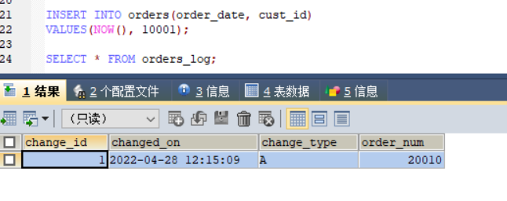

**2）DELETE触发器**

|  |
| --- |
| CREATE TABLE archive_orders  (  order_num int NOT NULL,  order_date datetime NOT NULL ,  cust_id int NOT NULL  ) ENGINE=InnoDB;  drop trigger if exists deleteorder;  DELIMITER //  CREATE TRIGGER deleteorder AFTER DELETE ON orders  FOR EACH ROW  BEGIN  INSERT INTO orders_log(changed_on, change_type, order_num)  VALUES(Now(),'D', OLD.order_num);  INSERT INTO archive_orders(order_num, order_date, cust_id)  VALUES(OLD.order_num, OLD.order_date, OLD.cust_id);  END //  DELIMITER ; |

**执行结果：**

|  |
| --- |
| DELETE FROM orders WHERE order_num ='20010';  SELECT * FROM orders_log;  SELECT * FROM archive_ orders; |

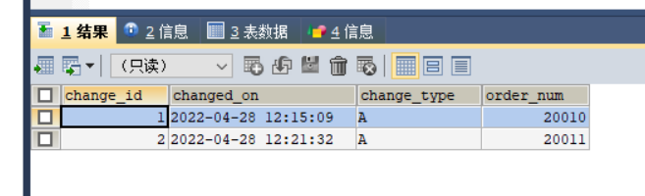

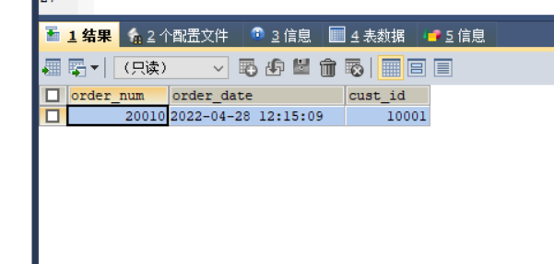

**3）UPDATE触发器**

|  |
| --- |
| drop trigger if exists updateorders;  DELIMITER //  CREATE TRIGGER updateorders BEFORE UPDATE ON orders  FOR EACH ROW  BEGIN  INSERT INTO orders_log(changed_on, change_type, order_num)  VALUES(Now(),'U', OLD.order_num);  SET NEW.ORDER_DATE = NOW();  END //  DELIMITER ;  UPDATE orders SET order_date='2022-04-28 08:56:01' WHERE cust_id='10005';  SELECT * FROM orders_log;  SELECT * FROM orders; |

**执行结果：**

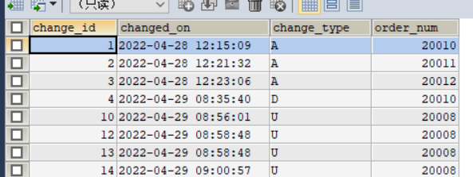

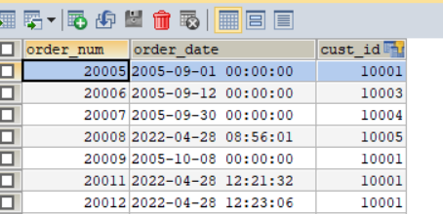

**第二部分：所选课题数据库的应用**

**1）INSERT 触发器**

|  |
| --- |
| CREATE TABLE cars_log  (  change_id int NOT NULL AUTO_INCREMENT,  changed_on datetime NOT NULL ,  change_type char(1) NOT NULL ,  car_number varchar(20) NOT NULL ,  PRIMARY KEY (change_id)  ) ENGINE=INNODB;  drop trigger if exists newcar;  DELIMITER //  CREATE TRIGGER newcar AFTER INSERT ON cars  FOR EACH ROW  BEGIN  INSERT INTO cars_log(changed_on, change_type, car_number)  VALUES(Now(),'A', NEW.car_number);  END //  DELIMITER ; |

**执行结果：**

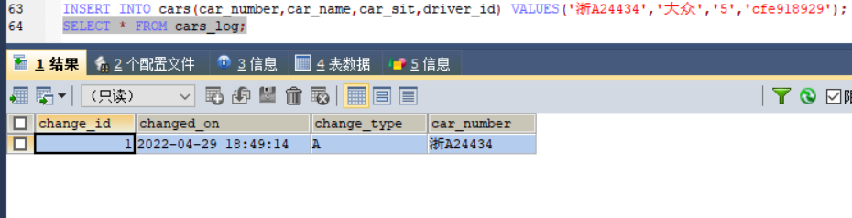

**2）DELETE触发器**

|  |
| --- |
| CREATE TABLE archive_car  (  car_number varchar(20) NOT NULL primary key,  car_name varchar(20) NOT NULL ,  car_sit varchar(20) NOT NULL ,  driver_id varchar(20) not null  ) ENGINE=InnoDB;  drop trigger if exists deletecar;  DELIMITER //  CREATE TRIGGER deletecar BEFORE DELETE ON cars  FOR EACH ROW  BEGIN  INSERT INTO cars_log(changed_on, change_type, car_number)  VALUES(Now(),'D', OLD.car_number);  INSERT INTO archive_car(car_number, car_name, car_sit,driver_id)  VALUES(OLD.car_number, OLD.car_name, OLD.car_sit,OLD.driver_id);  END //  DELIMITER ;  delete from cars WHERE car_number ='川S1EF34';  SELECT * FROM cars_log;  SELECT * FROM archive_car; |

**执行结果：**

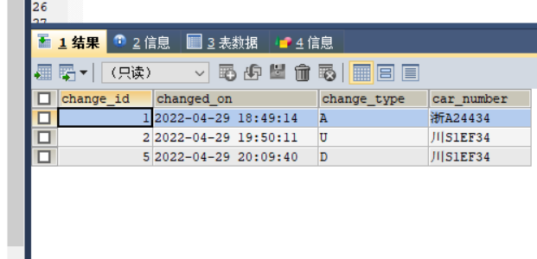

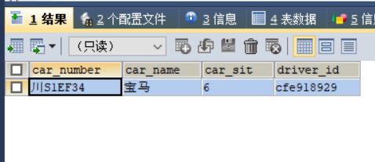

**3）UPDATE触发器**

|  |
| --- |
| DELIMITER //  CREATE TRIGGER updatecars BEFORE UPDATE ON cars  FOR EACH ROW  BEGIN  INSERT INTO cars_log(changed_on, change_type, car_number)  VALUES(Now(),'U', OLD.car_number);  END //  DELIMITER ;  UPDATE drive.cars SET car_sit='6' WHERE car_number='川S1EF34';  SELECT * FROM cars_log;  SELECT * FROM cars; |

**执行结果：**

