**任课教师：张涵翠、霍戌文**

**《数据库系统实训》**

**（2021-2022学年第2学期）**

**实**

**验**

**报**

**告**

**学号：2019329621004**

**姓名：梅雨欣**

**班级：19计算机科学与技术（1）班**

**实验七：游标**

**第二十四章---游标**

**第一部分：样例库的应用**

**（一）应用举例**

**1、创建表**

|  |
| --- |
| CREATE TABLE IF NOT EXISTS `store` (  `id` INT(11) NOT NULL AUTO_INCREMENT,  `name` VARCHAR(20) NOT NULL,  `count` INT(11) NOT NULL DEFAULT '1',  PRIMARY KEY (`id`)  ) ENGINE=INNODB DEFAULT CHARSET=latin1 AUTO_INCREMENT=7; |

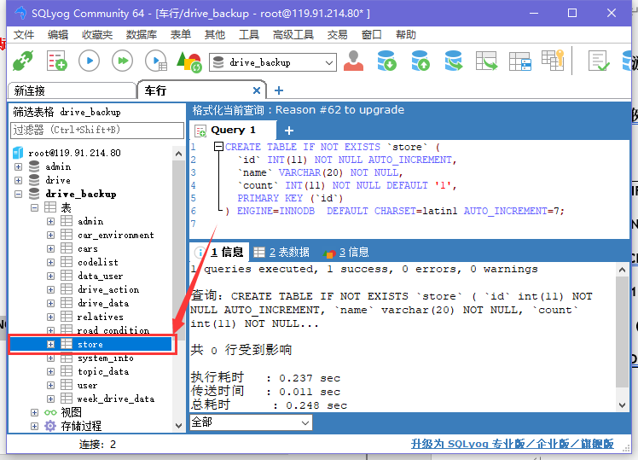

**2、插入记录**

|  |
| --- |
| INSERT INTO `store` (`id`, `name`, `count`) VALUES  (1, 'android', 15),  (2, 'iphone', 14),  (3, 'iphone', 20),  (4, 'android', 5),  (5, 'android', 13),  (6, 'iphone', 13); |

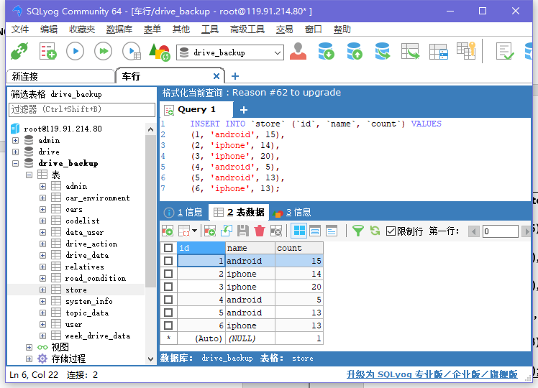

**3、创建存储过程与游标**

|  |
| --- |
| DELIMITER  DROP PROCEDURE IF EXISTS StatisticStore;  CREATE PROCEDURE StatisticStore()  BEGIN  DECLARE c INT;  DECLARE n VARCHAR(20);  DECLARE total INT DEFAULT 0;  DECLARE done INT DEFAULT FALSE;  DECLARE cur CURSOR FOR SELECT NAME,COUNT FROM store WHERE NAME = 'iphone';  DECLARE CONTINUE HANDLER FOR NOT FOUND SET done = TRUE;  SET total = 0;  OPEN cur;  read_loop:LOOP  FETCH cur INTO n,c;  IF done THEN  LEAVE read_loop;  END IF;  SET total = total + c;  END LOOP;  CLOSE cur;  SELECT total;  END; |

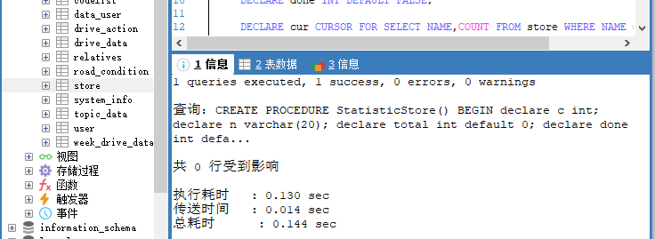

**4、调用存储过程**

存储过程处理完成后，游标就消失，因为它局限于存储过程。如果不明确关闭游标，MYSQL将会在到达END语句时自动关闭它。（隐含关闭）

|  |
| --- |
| CALL StatisticStore(); |

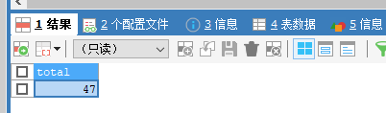

**（二）样例库举例**

**1、创建游标**

|  |
| --- |
| DELIMITER  DROP PROCEDURE IF EXISTS processorders;  CREATE PROCEDURE processorders()  BEGIN  DECLARE ordernumbers CURSOR  FOR  SELECT order_num FROM orders;  END; |

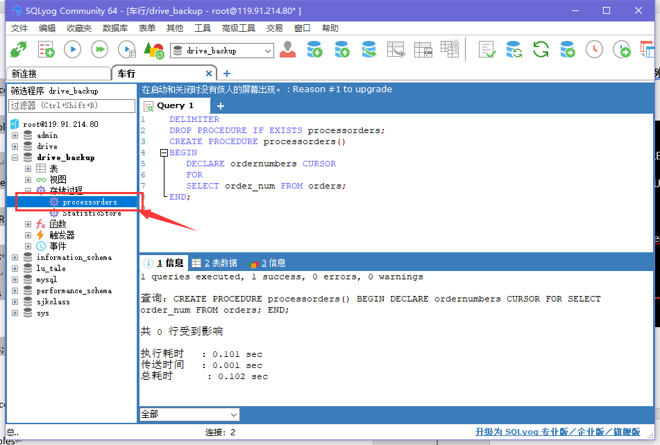

**2、打开和关闭游标**

|  |
| --- |
| OPEN ordernumbers;  CLOSE ordernumbers; |

**3、使用游标数据**

|  |
| --- |
| DELIMITER  DROP PROCEDURE IF EXISTS processorders;  CREATE PROCEDURE processorders()  BEGIN  DECLARE o INT;  DECLARE ordernumbers CURSOR  FOR  SELECT order_num FROM orders;  OPEN ordernumbers;  FETCH ordernumbers INTO o;  SELECT O;  CLOSE ordernumbers;  END; |

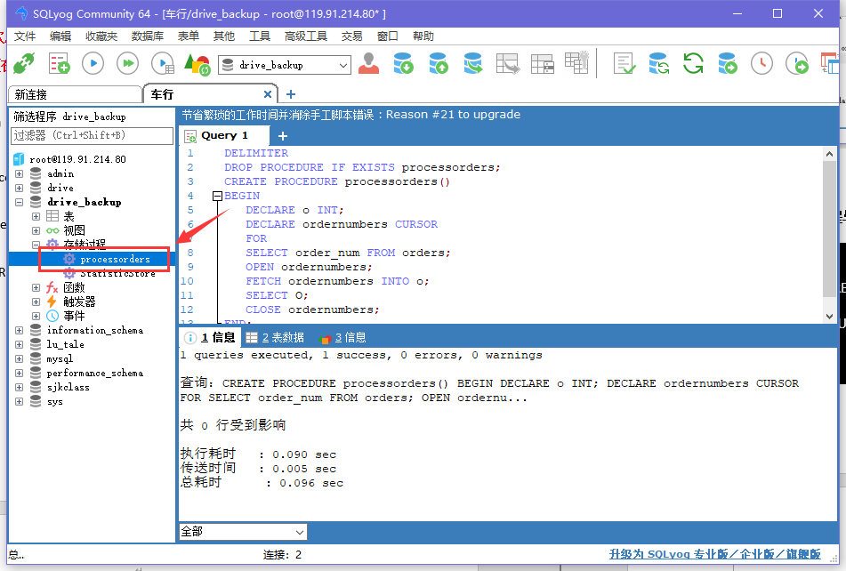**调用：**

|  |
| --- |
| CALL processorders(); |

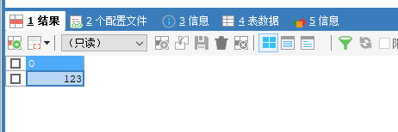

**4、循环检索数据**

|  |
| --- |
| DELIMITER  DROP PROCEDURE IF EXISTS processorders;  CREATE PROCEDURE processorders()  BEGIN  DECLARE done BOOLEAN DEFAULT 0;  DECLARE o INT;  DECLARE ordernumbers CURSOR  FOR  SELECT order_num FROM orders;  DECLARE CONTINUE HANDLER FOR SQLSTATE '02000' SET done=1;  OPEN ordernumbers;  REPEAT  FETCH ordernumbers INTO o;  SELECT o;  UNTIL done END REPEAT;  CLOSE ordernumbers;  END; |

**调用：**

|  |
| --- |
| CALL processorders(); |

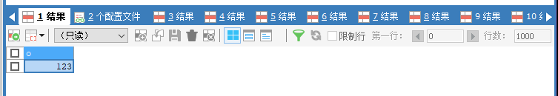

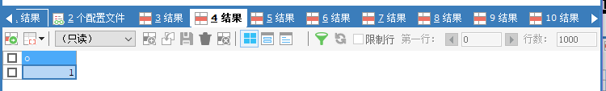

**5、循环处理数据**

|  |
| --- |
| DELIMITER  DROP PROCEDURE IF EXISTS processorders;  CREATE PROCEDURE processorders()  BEGIN  DECLARE done BOOLEAN DEFAULT 0;  DECLARE o INT;  DECLARE t DECIMAL(8,2);  DECLARE ordernumbers CURSOR  FOR  SELECT order_num FROM orders;  DECLARE CONTINUE HANDLER FOR SQLSTATE '02000' SET done=1;  CREATE TABLE IF NOT EXISTS ordertotals  (order_num INT, total DECIMAL(8,2));  OPEN ordernumbers;  REPEAT  FETCH ordernumbers INTO o;  CALL ordertotal(o, 1, t);  INSERT INTO ordertotals(order_num, total)  VALUES(o, t);  UNTIL done END REPEAT;  CLOSE ordernumbers;  END; |

**调用：**

|  |
| --- |
| CALL processorders(); |

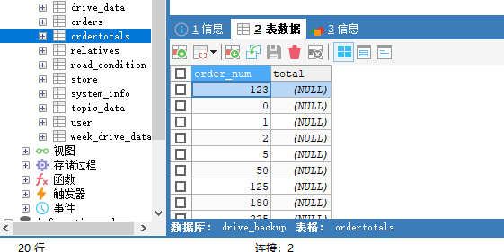

**第二部分：所选课题数据库的应用**

**1、使用游标数据**

|  |
| --- |
| DELIMITER //  CREATE PROCEDURE processorders()  BEGIN  -- Declare local variables  DECLARE o varchar(20);  -- Declare the cursor  DECLARE ordernumbers CURSOR FOR SELECT phone FROM drive.user;  -- Open the cursor  OPEN ordernumbers;  -- Get order number  FETCH ordernumbers INTO o;  SELECT o;  -- Close the cursor  CLOSE ordernumbers;  END //  DELIMITER ;  call processorders(); |

**查询结果：**

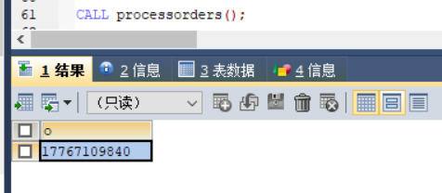

**2、循环检索数据**

|  |
| --- |
| DROP PROCEDURE IF EXISTS processorders;  DELIMITER //  CREATE PROCEDURE processorders()  BEGIN  -- Declare local variables  DECLARE done BOOLEAN DEFAULT 0;  DECLARE phone1 varchar(20);  -- Declare the cursor  DECLARE phones CURSOR  FOR  SELECT phone FROM drive.user;  -- Declare continue handler  DECLARE CONTINUE HANDLER FOR SQLSTATE '02000' SET done=1;  -- Open the cursor  OPEN phones;  -- Loop through all rows  REPEAT  -- Get order number  FETCH phones INTO phone1;  SELECT phone1;  -- End of loop  UNTIL done END REPEAT;  -- Close the cursor  CLOSE phones;  END //  DELIMITER ;  call processorders(); |

**查询结果：**

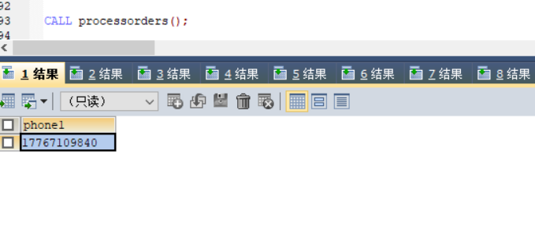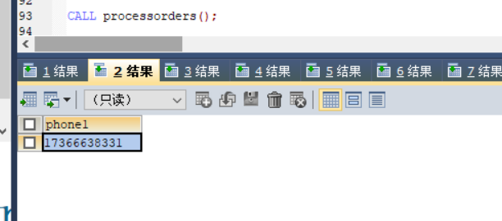

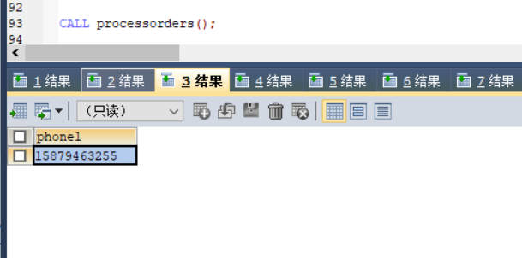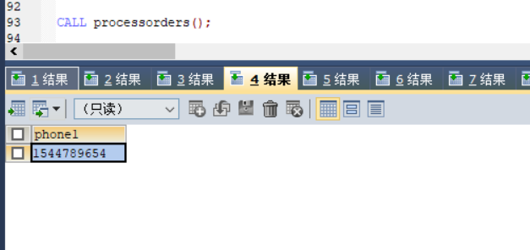

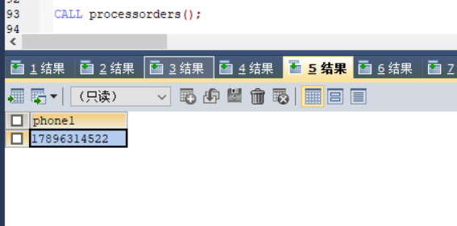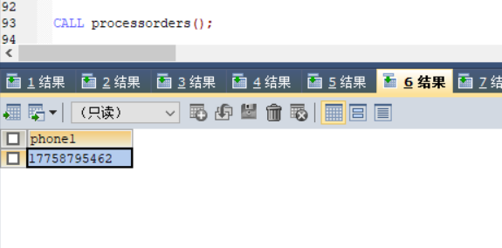

**3、循环处理数据**

|  |
| --- |
| SET GLOBAL log_bin_trust_function_creators=TRUE;  USE drive;  DROP PROCEDURE IF EXISTS processorders;  DELIMITER //  CREATE PROCEDURE processorders()  BEGIN  -- Declare local variables  DECLARE done BOOLEAN DEFAULT 0;  DECLARE o varchar(20);  DECLARE t int;  -- Declare the cursor  DECLARE phones CURSOR  FOR  SELECT phone FROM drive.user;  -- Declare continue handler,SQLSTATE '02000' 是一个“未找到”条件  DECLARE CONTINUE HANDLER FOR SQLSTATE '02000' SET done=1;  -- Create a table to store the results  CREATE TABLE IF NOT EXISTS agetotals(phone varchar(20), total int);  -- Open the cursor  OPEN phones;  -- Loop through all rows  REPEAT  -- Get order number  FETCH phones INTO o;  -- Get the total for this order  CALL ordertotal(o,t);  -- Insert order and total into ordertotals  INSERT INTO agetotals(phone, total)  VALUES(o,t);  -- End of loop  UNTIL done  END REPEAT;  -- Close the cursor  CLOSE phones;  END //  DELIMITER ;  call processorders();  SELECT DISTINCTROW *  FROM agetotals order by phone; |

**执行结果：**

