Motiva Autos SQL
Data Analysis
PostgreSQL Case Study on Automotive Sales, Customers and Product
Performance
Mariam Adetoyi
PROJECT OVERVIEW
Motiva Autos SQL Data Analysis is a PostgreSQL-based data analytics project focused on extracting business insights from an automotive sales database. The project uses SQL to explore customer information, vehicle inventory, and sales transactions in order to answer business questions around customer activity, vehicle performance, revenue generation, high-value customers, and product pricing.
Unlike dashboard projects that focus mainly on visual reporting, this project demonstrates the ability to work directly with a relational database. The analysis shows how SQL can be used to retrieve records, filter data, join related tables, calculate business metrics, group results, use aggregate functions, and apply subqueries to answer real-world business questions.
The project was completed using PostgreSQL and pgAdmin 4.
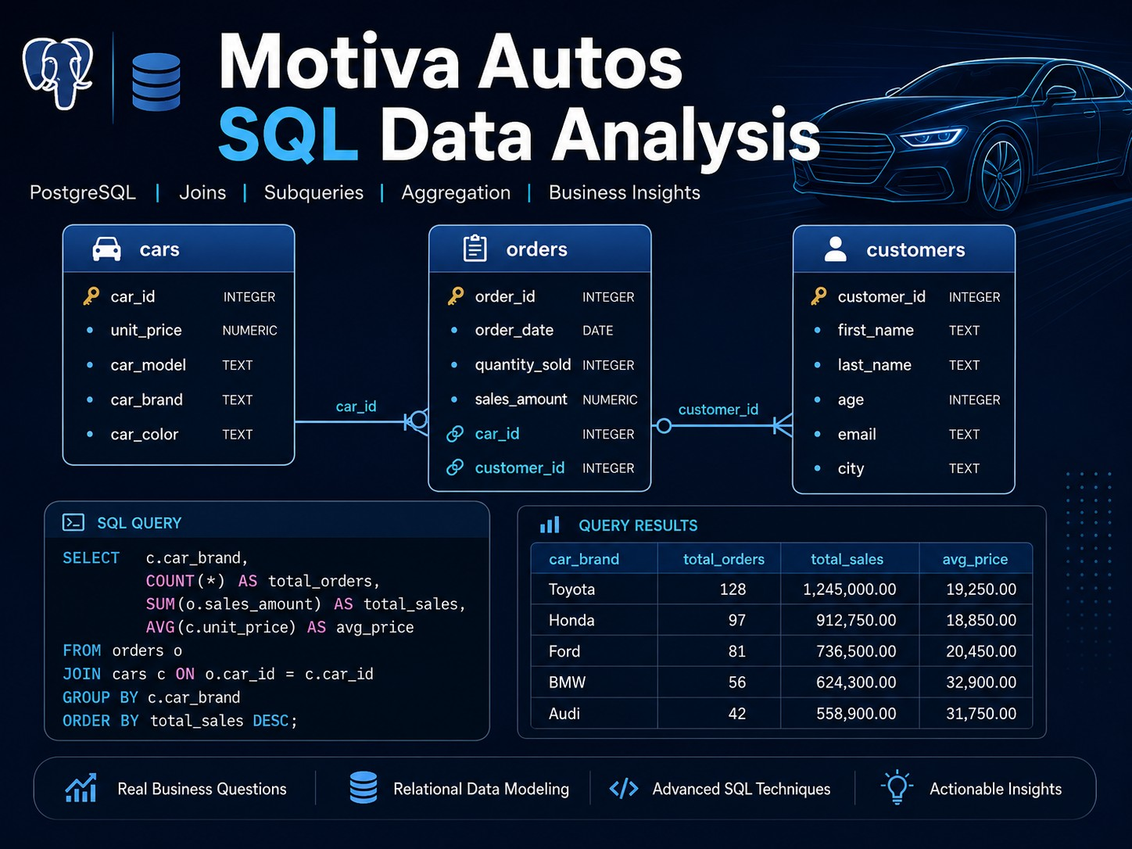Project cover image showing the Motiva Autos schema, SQL query panel, query output, and business analysis focus.
Business Problem
Motiva Autos stores customer, car, and order information in a relational database. However, raw database tables alone do not immediately show useful business insights. The business needs to understand customer activity, product sales performance, revenue patterns, high-value buyers, and inventory pricing.
Key Business Questions
- Which customers have placed orders?
- How many orders has each customer made?
- Which cars have been sold?
- Which cars generated the most revenue?
- Which customers spent more than the average order revenue?
- What is the most expensive car in the inventory?
- How can sales, customer, and product data be connected using SQL?
This project answers these questions by using SQL to transform raw relational data into business-ready information.
Tools and Skills Used
Category | Details
Database System | PostgreSQL
Database Tool | pgAdmin 4
Language | SQL
Core Skills | Filtering, sorting, joins, grouping, aggregation, HAVING, subqueries, and business data extraction

The Motiva Autos database contains three main tables: cars, customers, and orders. The orders table is the central transaction table because it links customers to the cars they purchased.

Database Schema
Schema Tables
Table | Column | Purpose
cars | car_id | Unique identifier for each car
cars | unit_price | Price of the car
cars | car_model | Model of the car
cars | car_brand | Brand/manufacturer of the car
cars | car_color | Colour of the car
customers | customer_id | Unique identifier for each customer
customers | first_name, last_name | Customer name fields
customers | age, email, city | Customer demographic and contact fields
orders | order_id | Unique identifier for each order
orders | order_date | Date the order was placed
orders | quantity_sold | Number of units sold in the order
orders | sales_amount | Revenue generated from the order
orders | car_id, customer_id | Foreign keys linking orders to cars and customers

Table Relationship
The database follows a relational structure:
customers.customer_id -> orders.customer_id cars.car_id -> orders.car_id
This structure allows SQL joins to answer business questions that require fields from more than one table. For example, customer order analysis requires customers to be joined to orders, while vehicle revenue analysis requires cars to be joined to orders.

Schema Image
The schema image below shows the Motiva Autos database model in pgAdmin. It highlights the three main tables and the relationship lines connecting orders to cars and customers.
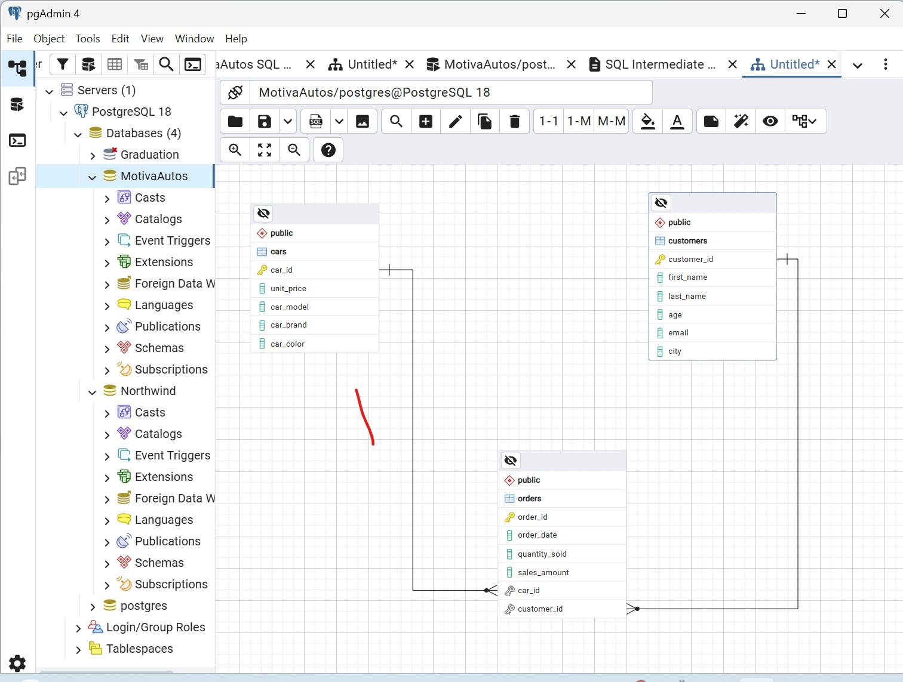
Motiva Autos database schema in pgAdmin, showing cars, customers, orders, and their relationships.
The orders table connects to the cars table using car_id and connects to the customers table using customer_id. This makes orders the central table for sales and customer transaction analysis.

Analysis Process
The SQL analysis followed a structured approach to make sure every query answered a clear business question.Step 1: Understand the Business Question
The expected output was clarified before writing each query. For example, customer-focused questions required customer fields, while revenue questions required sales data from the orders table.
Step 2: Identify the Required Tables
Each question was mapped to the table or tables that contained the required data. Some questions used one table, while others required joins across multiple tables.
Step 3: Check the Table Relationship
For multi-table questions, primary and foreign key relationships were checked before selecting the join logic.
Step 4: Choose the Correct SQL Technique
The analysis used filtering, sorting, grouping, joins, aggregate functions, HAVING, and subqueries depending on the question.
Step 5: Refine the Query Output
Aliases, calculated fields, grouping, and ordering were added to make the final outputs more readable and business-friendly.

SQL Analysis Breakdown

1. Data Exploration
The first step was to view the main tables and understand the available fields.
SELECT *
FROM orders;
FROM cars;
SELECT *
FROM customers;
SELECT *

2. Vehicle Price Exploration
SELECT car_model, unit_price
FROM cars;
This query returns the car model and unit price from the cars table. It is useful for reviewing available vehicle models and their prices.
3. Distinct Value Analysis
SELECT DISTINCT city
FROM customers;
SELECT DISTINCT car_color
FROM cars;
These queries identify the unique customer cities and available car colours. This helps the business understand customer distribution and product variety.
SQL Analysis Breakdown
Count Analysis
SELECT COUNT(order_id) AS total_orders
FROM orders;
SELECT COUNT(customer_id) AS total_customers
FROM customers;
SELECT COUNT(car_id) AS total_cars
FROM cars;
SELECT COUNT(DISTINCT city) AS unique_customer_cities
FROM customers;
These queries provide a high-level overview of orders, customers, car records, and geographic spread.
Filtering with WHERE
SELECT *
FROM customers
WHERE city = 'San Diego';
SELECT *
FROM cars
WHERE unit_price > 30000;
Filtering allows the business to focus on specific customer locations or price segments, such as customers in a selected city or cars above a price threshold.
Filtering, Sorting and Text Search
AND / OR Logic
SELECT *
FROM cars
WHERE car_brand = 'Mercedes-Benz'
AND unit_price > 50000;
SELECT *
FROM cars
WHERE car_brand = 'Mercedes-Benz'
OR unit_price > 50000;
ORDER BY and LIMIT
SELECT *
FROM cars
ORDER BY unit_price DESC
LIMIT 3;
This returns the three most expensive cars and supports premium inventory analysis.
BETWEEN, IN and ILIKE
SELECT *
FROM customers
WHERE age BETWEEN 25 AND 35;
SELECT *
FROM customers
WHERE city IN ('Chicago', 'Austin', 'Boston');
SELECT *
FROM cars
WHERE car_brand ILIKE '%oyo%';
These techniques support customer segmentation, location-based filtering, and flexible text searching for brands or names.
Aggregate Analysis
Aggregate functions were used to summarise revenue, orders, age, and price metrics.
SELECT SUM(sales_amount) AS total_revenue
FROM orders;
SELECT COUNT(DISTINCT order_id) AS total_orders
FROM orders;
SELECT ROUND(AVG(age)) AS avg_age
FROM customers;
SELECT ROUND(AVG(sales_amount), 2) AS avg_sales_amount
FROM orders;
SELECT MAX(unit_price) AS max_price
FROM cars;
SELECT MIN(unit_price) AS min_price
FROM cars;
These queries create summary measures that can help the business understand total revenue, order volume, average customer age, average order value, and the highest and lowest car prices.
Calculated Field Example
SELECT car_model, unit_price, (unit_price * 0.2) + unit_price AS updated_price
FROM cars;
This query calculates a new price after a 20% increase, showing how SQL can be used for business calculations and pricing scenarios.
Case Study Questions
Q1: Customers Who Have Placed Orders
Business question: Provide the full name, email address, and total orders for customers who have placed an order.
SELECT
c.first_name || ' ' || c.last_name AS full_name,
c.email, COUNT(o.order_id) AS total_orders
FROM customers c
JOIN orders o
ON c.customer_id = o.customer_id GROUP BY
c.first_name,
c.last_name,
c.email
ORDER BY total_orders DESC;
This query uses an inner join because the question only asks for customers who have placed orders. It combines customer names, counts each customer order, and sorts the output by order volume.
Business value: Motiva Autos can use the output to identify active customers, repeat buyers, and candidates for follow-up campaigns.
Q2: Cars Ordered with Revenue and Units Sold
SELECT cr.car_id, cr.car_model, cr.car_brand, SUM(o.sales_amount) AS total_revenue,
SUM(o.quantity_sold) AS total_quantity_sold
FROM cars cr
JOIN orders o
ON cr.car_id = o.car_id GROUP BY cr.car_id, cr.car_model, cr.car_brand
ORDER BY total_revenue DESC;
This query joins cars to orders, calculates revenue and quantity sold per vehicle, and sorts the results by revenue.
Case Study Questions
Q3: Customers Spending Above Average Revenue
Business question: Find customers who have spent more than the average sales revenue across all orders.
SELECT
c.customer_id,
c.first_name || ' ' || c.last_name AS full_name,
c.email, SUM(o.sales_amount) AS total_spent
FROM customers c
JOIN orders o
ON c.customer_id = o.customer_id GROUP BY
c.customer_id,
c.first_name,
c.last_name,
c.email HAVING SUM(o.sales_amount) > (
SELECT AVG(sales_amount)
FROM orders
)
ORDER BY total_spent DESC;
The subquery calculates the average sales amount across all orders. The HAVING clause then compares each customer's total spending to that benchmark.
Business value: The output identifies high-value customers who may be suitable for loyalty campaigns or premium offers.
Q4: Most Expensive Car by Unit Price
SELECT *
FROM cars
WHERE unit_price = (
SELECT MAX(unit_price)
FROM cars
);
This query uses a subquery to find the maximum car price and returns the full details of the matching vehicle.
Corrections and Improvements
Correction 1: Missing FROM Clause
The original SQL file included a total revenue query that was missing the FROM clause. The corrected query is shown below.
SELECT SUM(sales_amount) AS total_revenue
FROM orders;

Correction 2: GROUP BY Field
The vehicle revenue query originally repeated cr.car_model and omitted cr.car_brand. The corrected GROUP BY clause is:
GROUP BY cr.car_id, cr.car_model, cr.car_brand
Key Findings Enabled by the Queries
- Active customers who have placed orders can be identified.
- Total orders per customer can be measured.
- Cars that generated sales can be listed.
- Revenue and quantity sold can be analysed by vehicle.
- Customers spending above average can be identified.
- The most expensive vehicle in the inventory can be retrieved.
- Customer cities, car colours, price bands, and age ranges can be explored.
Business Recommendations
1. Target Active Customers
Customers who have already placed orders should be considered for follow-up communication, loyalty offers, and retention campaigns.
2. Prioritise High-Revenue Cars
Cars generating the highest total revenue should be prioritised in marketing, stock planning, and sales conversations.
3. Monitor High-Value Customers
Customers who spend above the average sales amount should be treated as high-value customers and considered for personalised offers or premium services.
4. Use Price Band Analysis for Inventory Strategy
Filtering cars by price range can help the business understand affordable, mid-range, and premium vehicle segments.
5. Use City Data for Local Campaigns
Customer city analysis can help Motiva Autos understand where demand is coming from and design more targeted local campaigns.
Conclusion
This project demonstrates how SQL can be used to convert a relational automotive sales database into practical business insight. The analysis connects customers, cars, and orders through primary and foreign key relationships, then uses SQL logic to answer sales, customer, and inventory questions.
The strongest part of the project is the analytical workflow: business question, required tables, table relationship, join logic, aggregation or subquery, business insight, and recommendation.

