**Architectural RAPL TPMI Interface**

**Introduction**

TPMI (Topology Aware Register and PM Capsule Interface), planned for future generations, is an architectural, PCIe-standards based model, where feature support is provided cleanly as a driver and not as part of the base OS.

Today’s (pre-TPMI) Intel® Xeon® processor platforms feature a RAPL interface that is defined through Model Specific Registers (MSR) and requires SW updates for new CPU generations. Linux kernel updates involving MSRs cannot be made until pertinent information is available publicly which can cause delays and increase resources required for customer programs.

With TPMI, Intel® Xeon® processors are moving to an architectural, driver-based model for RAPL, where feature support is provided cleanly as a driver and not as part of the base OS. The table below shows the benefit of shifting to an architectural implementation.

**Today vs. Future (green is preferred vs. red)**

|  |  |  |
| --- | --- | --- |
| **Comparison of solutions** | | |
| **OS Kernel vs. Driver** | | |
|  | OS Kernel | Driver |
| Deploy update w/o entire OS upgrade | No | Yes |
| Deploy update w/o system reboot | No | Yes |
|  |  |  |
| **MSR vs. MMIO Interface** | | |
|  | MSR | MMIO |
| Driver compatible enumeration | Partial | Yes |
| Driver compatible IRQ | No | Yes |
| Mappable access from ring 3 | No | Yes |
|  |  |  |

The goal of an architectural RAPL interface is to meet the following requirements:

* Enumerability
  + Standard device driver mechanism
  + Ability to enumerate RAPL multiple-domain topology
  + Ability to enumerate RAPL multiple-feature per domain
  + Driver can be reused gen to gen, update is optional
  + New feature can be added w/o confusing legacy driver
* Performance
  + Memory-mapping access at run-time
    - MSR is problematic; often locked by BIOS; ring 3 management daemon needs (slow) system call for MSR
  + Global memory-map includes all devices/domains in system
    - Every address is accessible from every CPU
* Security
  + OEM can configure what part of interface is exposed, R/W or R/O
  + Mapped pages include only RAPL related registers
    - Non-RAPL functions should be mapped & owned by a non-RAPL driver

To deliver the desired properties listed above, a design that uses a standard PCIe device interface with Vendor-Specific Extended Capabilities (VSEC) provides an excellent solution. VSEC is a PCI spec defined optional functionality where vendor specific capabilities can be exposed from a PCI express function. Using VSEC allows this feature to expose multiple capabilities within one PCI function. Consuming a PCI function for each feature/capability desired to expose to the OS would be too expensive for the CPU uncore and mesh resources.

The remainder of this document describes the use of TPMI, which is based on a PCIe VSEC design, to provide a flexible, extendable and software-PCIe-driver-enumerable MMIO interface for RAPL.

**Address Mapping**

The diagrams below showing example of several TPMI features. PCIe config space hosts the VSEC structure that contains TPMI VSEC_ID, base address pointer and other info. PFS structure describes each PM feature.

The numbers in the tables below are for illustrative purposes only.

[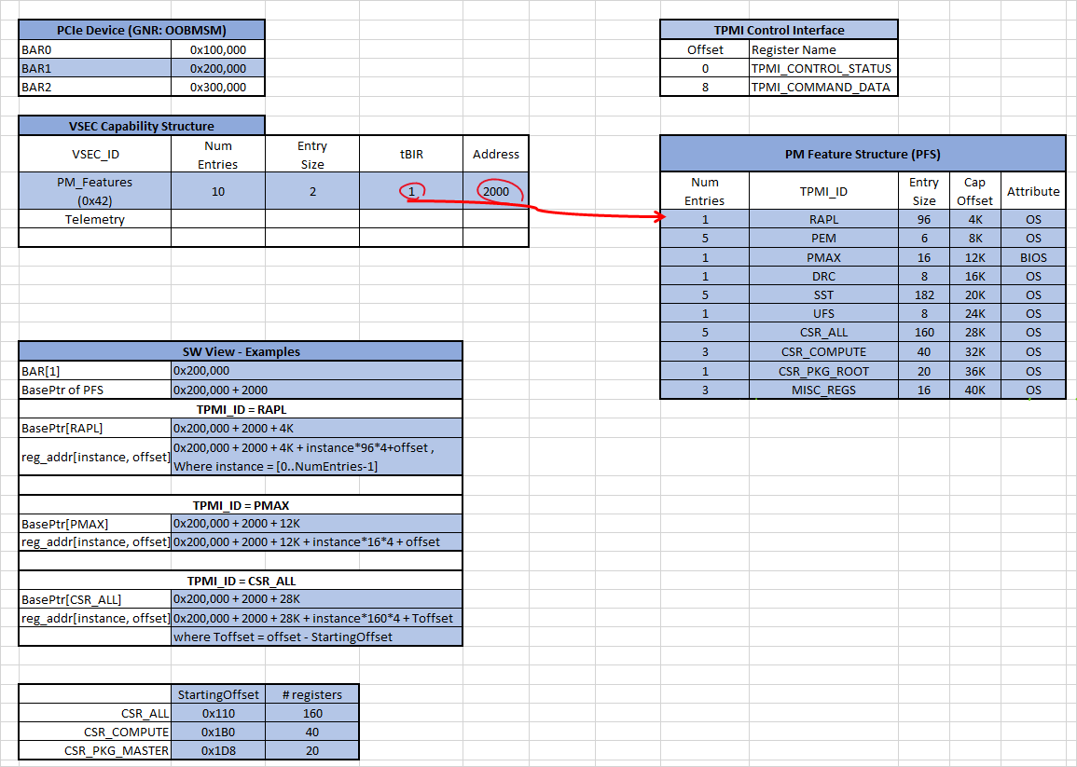](https://docs.intel.com/documents/pm_doc/src/server/GNR/Features/DVSEC%20MMIO/assets/Enumerated%20content.xlsx)

**TPMI Address mapping**

Each TPMI feature may claim a 4KB aligned, could potentially spread into multiple 4KB blocks, region in MMIO address space.

The definition of PFS and VSEC capability structures is available in [this](https://docs.intel.com/documents/pm_doc/src/server/GNR/Features/DVSEC%20MMIO/IC_tpmi.html#vsec-structure) HAS section.

**RAPL Discovery and Control**

SW and BIOS discover RAPL domains via the per domain HEADER register.

DOMAIN_HEADER.TYPE indicates the domain type, i.e. socket RAPL, DRAM RAPL, and platform RAPL, etc.

DOMAIN_HEADER.FLAGS indicates the feature/register supported within this domain.

SW and BIOS can set the LOCK bit in Power Limit registers to lock out PL and TW settings.

**RAPL Domain Registers**

This section describes the layout of RAPL TPMI registers. All registers of RAPL domains associated with one Punit are mapped to one MMIO space. The table below is a software view of the RAPL domain register array. Each domain consists of 128 bytes of registers starting with a 64b Domain Header and followed by a few, up to 15, 64b domain specific registers. The Domain Header specifies the type of domain (e.g. package RAPL, DRAM, system etc.), the domain index of its parent, and whether the specific feature is enabled or disabled. The parent domain index is configured by SoC to support hierarchical power management.

**TPMI RAPL Domain Register Map (**[**source**](https://docs.intel.com/documents/pm_doc/src/server/GNR/Features/RAPL_DVSEC/assets/RAPL_VSEC_sheets.xlsx)**)**

|  |  |  |  |  |
| --- | --- | --- | --- | --- |
| **Array of RAPL Domains** | | | | |
| Index | 32b | 32b | Comments / Usages | Byte Offset |
| 0 | DOMAIN_HEADER 0 | | describe the domain type/size/flags/etc. | 0 |
| RAPL Register 1 | | RAPL register 1 - 15 of this domain |
| RAPL Register 2 | |
| .... | |
| RAPL Register 15 | |
| 1 | DOMAIN_HEADER 1 | | describe the domain type/size/flags/etc. | 128 |
| RAPL Register 1 | | RAPL register 1 - 15 of this domain |
| RAPL Register 2 | |
| .... | |
| RAPL Register 15 | |
|  | ... | |  |  |
|  | ... | |  |  |
| N-1 | DOMAIN_HEADER (N-1) | | describe the domain type/size/flags/etc. | 128*(N-1) |
| RAPL Register 1 | | RAPL register 1 - 15 of this domain |
| RAPL Register 2 | |
| .... | |
| RAPL Register 15 | |

RAPL registers are architecturally-defined structure which are similar to the legacy MSR/CFG RAPL registers with some exceptions. Each domain register type is assigned an unique index as shown in the table below. Some of the domain registers (e.g. power unit, power limit info, etc.) are always present. And some may be ignored if its corresponding bitmask in the DOMAIN_HEADER.FLAGS is 0x0. RAPL domain register of different domain type can have different bitfield definition.

**Domain Register Index (**[**source**](https://docs.intel.com/documents/pm_doc/src/server/GNR/Features/RAPL_DVSEC/assets/RAPL_VSEC_sheets.xlsx)**)**

|  |  |
| --- | --- |
| **RAPL Domain**  **Register Index** | |
| Description | Index |
| Domain Header | 0 |
| Power Unit | 1 |
| Power Limit 1 | 2 |
| Power Limit 2 | 3 |
| Power Limit 3 | 4 |
| Power Limit 4 | 5 |
| PL Offsets | 6 |
| Energy Status | 7 |
| Perf Status | 8 |
| Power Info | 9 |
| Domain Info | 10 |
| Interrupt | 11 |
| Reserved | 12 |
| Reserved | 13 |
| Reserved | 14 |
| Reserved | 15 |

The sections below define the bit fields of each of these RAPL domain registers.

**Domain Header (idx 0)**

**Domain Header (**[**source**](https://docs.intel.com/documents/pm_doc/src/server/GNR/Features/RAPL_DVSEC/assets/RAPL_VSEC_sheets.xlsx)**)**

|  |  |  |  |  |  |
| --- | --- | --- | --- | --- | --- |
| **DOMAIN HEADER** | | | |  |  |
| **Field Name** | **Bits** | **Width** | **Access Type** | **Description** | **Default** |
| INTERFACE_VERSION | 7:0 | 8 | RO | Version number for this interface | 1 |
| TYPE | 15:8 | 8 | RO | package rapl, dram rapl, platform rapl, etc | 0 |
| SIZE | 23:16 | 8 | RO | units of 128 bytes | 1 |
| PARENT_DOMAIN_INDEX | 31:24 | 8 | RO | parent domain index number | 0 |
| FLAGS | 47:32 | 16 | RO | Bit mask of the supported domain register.  Pcode populates default setting.  SW use it to discover which register is valid in the RAPL register bank.  1: the corresponding register is valid. 0: register is invalid. | 0 |
| RESERVED | 63:48 | 16 | RO | Reserved | 0 |

RAPL TPMI supports multiple domain types as listed below.

Domain type is set to 0x0 to if the CPU doesn't support this RAPL domain.

**RAPL Domain Type Encoding (**[**source**](https://docs.intel.com/documents/pm_doc/src/server/GNR/Features/RAPL_DVSEC/assets/RAPL_VSEC_sheets.xlsx)**)**

|  |  |
| --- | --- |
| **domain**  **number** | **domain**  **name** |
| 0 | Invalid |
| 1 | system |
| 2 | package |
| 3 | reserved |
| 4 | memory |
| 5 | reserved |
| 6 | reserved |
| 7 | reserved |
| 8-255 | reserved |

**Power Unit (idx 1)**

**Power Unit (**[**source**](https://docs.intel.com/documents/pm_doc/src/server/GNR/Features/RAPL_DVSEC/assets/RAPL_VSEC_sheets.xlsx)**)**

|  |  |  |  |  |  |
| --- | --- | --- | --- | --- | --- |
| **POWER UNIT** | | | |  |  |
| **Field Name** | **Bits** | **Width** | **Access Type** | **Description** | **Default** |
| PWR_UNIT | 3:0 | 4 | RO | Power Units used for power control registers.  The actual unit value is calculated by 1 W / Power(2, PWR_UNIT).  The default value of 0x3 corresponds to 1/8 W. | 3 |
| RSVD1 | 5:4 | 2 | RO | reserved | 0 |
| ENERGY_UNIT | 10:6 | 5 | RO | Energy Units used for power control registers.  The actual unit value is calculated by 1 J / Power(2,ENERGY_UNIT).  The default value of 14 corresponds to Ux.14 number. | 0xE |
| RSVD2 | 11:11 | 1 | RO | reserved | 0 |
| TIME_UNIT | 15:12 | 4 | RO | Time Units used for power control registers.  The actual unit value is calculated by 1 s / Power(2,TIME_UNIT).  The default value of Ah corresponds to 976 usec. | 0xA |
| RSVD3 | 63:16 | 48 | RO | reserved | 0 |

**PL1, PL2 (idx 2,3)**

**Power Limit Control (**[**source**](https://docs.intel.com/documents/pm_doc/src/server/GNR/Features/RAPL_DVSEC/assets/RAPL_VSEC_sheets.xlsx)**)**

|  |  |  |  |  |  |
| --- | --- | --- | --- | --- | --- |
| **POWER LIMIT CONTROL 1 , 2** | | | |  |  |
| **Field Name** | **Bits** | **Width** | **Access Type** | **Description** | **Default** |
| PWR_LIM | 17:0 | 18 | RW_L | This field indicates the power limitation for the socket RAPL domain.  The unit of measurement is defined in POWER_UNIT[PWR_UNIT]. | 0 |
| TIME_WINDOW | 24:18 | 7 | RW_L | Indicates the length of time window over which the power limit will be used by the processor.  The time window is floating point number given by 2^Y * (1.0 + X / 4.0) * Time_Unit  X = TIME_WINDOW[6:5]; Y = TIME_WINDOW[4:0]; Time_Unit is defined in POWER_UNIT[TIME_UNIT].  The maximal time window is bounded by PL1_PL2_INFO[MAX_TW].  Socket RAPL PL2 TIME_WINDOW is not SW configurable. | 0 |
| RSVD | 61:25 | 37 | RW_L | Reserved | 0 |
| PWR_LIM_EN | 62:62 | 1 | RW_L | Enable(1) or Disable(0) | 0 |
| LOCK | 63:63 | 1 | RW_L | When set, all settings in this register are locked and are treated as Read Only until next reset. | 0 |

**PL4 (idx 5)**

**Power Limit Control (**[**source**](https://docs.intel.com/documents/pm_doc/src/server/GNR/Features/RAPL_DVSEC/assets/RAPL_VSEC_sheets.xlsx)**)**

|  |  |  |  |  |  |
| --- | --- | --- | --- | --- | --- |
| **POWER LIMIT CONTROL 4** | | | |  |  |
| Field Name | Bits | Width | Access Type | Description | Default |
| PWR_LIM | 17:0 | 18 | RW_L | This field indicates the power limitation. The default value is loaded from fuses. The unit of measurement is defined in POWER_UNIT[PWR_UNIT]. | 0 |
| RSVD | 61:18 | 44 | RW_L | RESERVED | 0 |
| PWR_LIM_EN | 62:62 | 1 | RW_L | Enable(1) or Disable(0) power limit | 0 |
| LOCK | 63:63 | 1 | RW_L | Lock until next reset as needed | 0 |

**Energy Status (idx 7)**

**Energy Status (**[**source**](https://docs.intel.com/documents/pm_doc/src/server/GNR/Features/RAPL_DVSEC/assets/RAPL_VSEC_sheets.xlsx)**)**

|  |  |  |  |  |  |
| --- | --- | --- | --- | --- | --- |
| **ENERGY STATUS** | | | |  |  |
| **Field Name** | **Bits** | **Width** | **Access Type** | **Description** | **Default** |
| ENERGY | 31:0 | 32 | RO_V | Total amount of energy consumed since last reset. This is a monotonic increment counter with auto wrap back to zero after overflow. | 0 |
| TIME | 63:32 | 32 | RO_V | Total time elapsed when the energy was last updated. This is a monotonic increment counter with auto wrap back to zero after overflow. Unit is 10ns. | 0 |

**Perf Status (idx 8)**

**Perf Status (**[**source**](https://docs.intel.com/documents/pm_doc/src/server/GNR/Features/RAPL_DVSEC/assets/RAPL_VSEC_sheets.xlsx)**)**

|  |  |  |  |  |  |
| --- | --- | --- | --- | --- | --- |
| **PERF STATUS** | | | |  |  |
| **Field Name** | **Bits** | **Width** | **Access Type** | **Description** | **Default** |
| PWR_LIMIT_THROTTLE_CTR | 31:0 | 32 | RO_V | Reports the number of times (accumulated throttled time) the Power limiting algorithm had to clip the power limit due to hitting the lowest power state available. | 0 |
| RSVD | 63:32 | 32 | RO_V | Reserved | 0 |

**PL Info (idx 9)**

**Power Limit Info (**[**source**](https://docs.intel.com/documents/pm_doc/src/server/GNR/Features/RAPL_DVSEC/assets/RAPL_VSEC_sheets.xlsx)**)**

|  |  |  |  |  |  |
| --- | --- | --- | --- | --- | --- |
| **Power Limit Info** | | | |  |  |
| **Field Name** | **Bits** | **Width** | **Access Type** | **Description** | **Default** |
| MAX_PL1 | 17:0 | 18 | RWL | Socket RAPL: The TDP package power of the package domain.  DRAM RAPL: The typical TDP Power of DRAM Domain.  Platform RAPL: The maximum Platform PL1 setting allowed.  The units for this value are defined in POWER_UNIT[PWR_UNIT]. | 0 |
| MIN_PL | 35:18 | 18 | RWL | Socket RAPL: The minimal package power setting allowed.  DRAM RAPL: The typical min power of DRAM Domain.  Platform RAPL: The minimal Platform power setting allowed.  The units for this value are defined in POWER_UNIT[PWR_UNIT]. | 0 |
| MAX_PL2 | 53:36 | 18 | RWL | Socket RAPL: The maximal package power setting allowed.  DRAM RAPL: The typical max power for DRAM Domain.  Platform RAPL: The maximal platform PL2 setting allowed.  The units for this value are defined in POWER_UNIT[PWR_UNIT]. | 0 |
| MAX_TW | 60:54 | 7 | RWL | The maximal time window allowed. Higher values will be clamped to this value.  The timing interval window is floating point number given by 2^Y * (1.0 + X / 4.0) * Time_Unit  X = MAX_TW[6:5], Y = MAX_TW[4:0]  Time_Unit is defined in POWER_UNIT[TIME_UNIT]. | 0 |
| RSVD | 62:61 | 2 | RWL | Reserved | 0 |
| LOCK | 63:63 | 1 | RWL | When set, all settings in this register are locked and are treated as Read Only until next reset. | 0 |

**Domain Info (idx 10)**

**Domain Info (**[**source**](https://docs.intel.com/documents/pm_doc/src/server/GNR/Features/RAPL_DVSEC/assets/RAPL_VSEC_sheets.xlsx)**)**

|  |  |  |  |  |  |
| --- | --- | --- | --- | --- | --- |
| **DOMAIN INFO** | | | |  |  |
| **Field Name** | **Bits** | **Width** | **Access Type** | **Description** | **Default** |
| ROOT | 0:0 | 1 | RWL | 1=The package is a domain root. 0=not a domain root. | 0 |
| DOMAIN_ID | 3:1 | 3 | RWL | The domain ID to which this package belongs to. | 0 |
| RSVD | 62:4 | 59 | RWL | Reserved | 0 |
| LOCK | 63:63 | 1 | RWL | When set to 1 the register is locked and becomes read-only until next reset. BIOS writes 1 to this bit after initializing the register. | 0 |

Note:

* Pcode for GNR family should only enable DOMAIN_INFO in the RAPL_DOMAIN_HEADER.FLAGS for Psys. i.e. Pcode should set(1) bit10 of RAPL_DOMAIN_HEADER.FLAGS for Psys, and clear(0) it for DRAM and Socket RAPLs.

**Register Layout Example**

The table below shows the name of RAPL registers and their respective TPMI Offsets of a SOC that supports Socket RAPL, DRAM RAPL and Platform RAPL. Note that the content here is for illustration purpose only, audience should refer to EDS or OSXML documentation for the specific SOC RAPL register layout.

[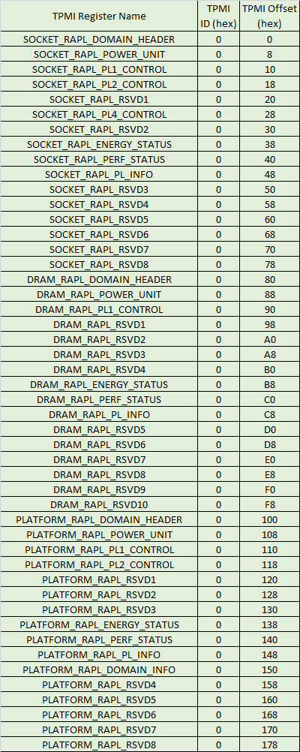](https://docs.intel.com/documents/pm_doc/src/server/GNR/Features/DVSEC%20MMIO/assets/TPMI_Data_Structures_GNRSRF.xlsx)

**Reference**

* The table below provides a register mapping of legacy RAPL MSR vs. TPMI.

|  |  |  |  |  |  |  |  |
| --- | --- | --- | --- | --- | --- | --- | --- |
| **MSR** | | | | | | **TPMI** | |
| Socket RAPL | DRAM RAPL | | | Platform RAPL | | RAPL | |
| Name | Address | Name | Address | Name | Address | Name | Index |
|  |  |  |  |  |  | Domain Header | 0 |
| PACKAGE_POWER_SKU_UNIT | 606h |  |  |  |  | Power Unit | 1 |
| PACKAGE_RAPL_LIMIT | 610h | DRAM_PLANE_POWER_LIMIT | 618h | PLATFROM_RAPL_LIMIT | 65Ch | Power Limit | 2,3,4,5 |
| PACKAGE_ENERGY_STATUS | 611h | DRAM_ENERGY_STATUS | 619h | PLATFORM_ENERGY_STATUS | 64Dh | Energy Status | 7 |
| PACKAGE_RAPL_PERF_STATUS  (PACKAGE_OVERFLOW_STATUS) | 613h | DRAM_PLANE_OVERFLOW_STATUS | 61Bh | PLATFORM_RAPL_PERF_STATUS | 666h | Perf Status | 8 |
| PACKAGE_POWER_SKU | 614h | DRAM_POWER_INFO | 61Ch | PLATFORM_POWER_INFO | 665h | Power Limit Info | 9 |