**Small Ads**

For sale: Electronic proofreading device. 50 EUR. Selling because I don’t ned it any moore. Call 555-7878.

Axeeh Xftbemhpg! Rhn pbee TEE itr yhk max Ftrhk’l bzghktgvx! Fnva ehox, Rnkb.

Cleaner required: St Hyphen’s Hospital Emergency Department. Must be good with blood. Call 555-2377

Lok – mkxd gksd dy coo iye dyxsqrd. Iyeb yppsmo kpdob cofox. Vyfo, Myx.

Colin And The Colons

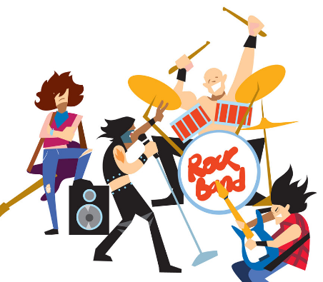

*by Pru Freed, Chief Reporter*

WORLD-FAMOUS rock band, Colin and The Colons, plays at the Sports Arena tomorrow night from 20:00.

The concert is a major coup for Emailtown, because such a big-name band usually plays at huge venues in European capital cities.

Hot from a recent tour of Japan, lead singer Colin Dwukropek said he was looking forward to performing in Emailtown.

“I’ve heard a lot about the place and it sounds like an exciting venue. We can’t wait to get on stage,” he said.

The band will perform all their big hits, including Fanfare For The Comma Man, Full Stop In The Name Of Love, Back In The Hyphen Life Again, and I’ve Got You Underscore My Skin.

Tickets went on sale at 09:00 yesterday and business has been booming, but concert organisers say there are still seats available.

To book, call the Sports Arena on 555-2323.

**BIG NAME BAND PLAYS THE ARENA!**

The Emailtown Examiner

Saturday, 31 December