**Alien Monster versus SuperHuman Soldiers**

*In a post-apocalyptic futuristic world, the entirety of earth's surface has been devastated. Only a fraction of the initial population of planet earth still survives in underground communities. The bravest among them are sent out every day to search the surface for survivors and resources. A dangerous task, because Drakans, huge Alien Monsters, roam the planet with nothing on their mind but the hunger for human blood.*

In this game the Oculus Rift User (ORU) will take on the role of a 16 ft tall acid-spitting Alien Monstrosity, with as only goal to kill and eat all the humans it can find, using its huge claws and spiky tail. The 1 to 4 other players are 7 ft tall, genetically engineered superhumans, covered in power armour and armed with a variety of Power Weapons, like laser rifles, plasma grenade launchers, chain swords and healing rays.

The Alien is individually stronger than any of the soldiers, but its power matches that of the superhuman team as a whole.

The ORU will use his Oculus Rift to look around the area, having the advantage of heatray vision to see through most objects, and will use some sort of remotes to walk around and attack. This could be in the form of wiimotes or through an xbox controller.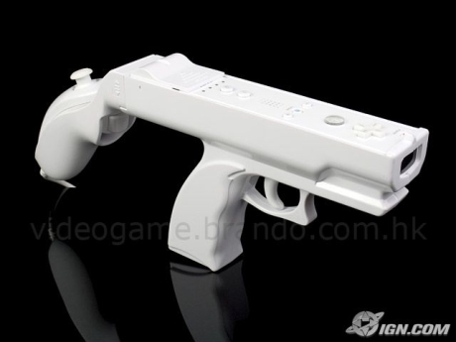

The other players will use several screens or a split screen option to view the world through their characters eyes. They can use the wiimote gun attachment to walk around and fire at the Alien. Teamwork is essential, as they will have to revive their fallen comrades, provide cover fire during engages and combine the complementary strengths of their weapons to take down the alien in its weak spots.

The game ends when all of the soldiers die, or the Alien is taken out. A final scoreboard will view the accomplishments of all players, such as hit percentage, allies saved, damage dealt and soldiers eaten.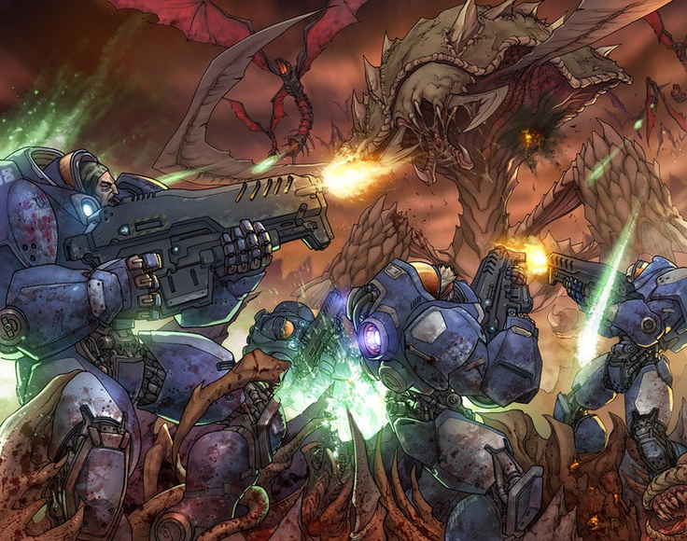

**Escape room**

All players are present in the same room, which they have to escape from together (story still has to be worked out).

The person with the Oculus Rift can look around in the room, and interact with the objects. The other players can follow what the Oculus Rift player sees through a shared or personal screen. They can tell or encourage the Oculus Rift player to take a look at certain interesting object, or tell the player if they saw something hidden or suspicious. When the Oculus Rift player interacts with the right objects, it can find puzzles or assignments that have to solved by the whole group.

Every player has a phone with NFC and there is a camera present (Kinect), which will be used to complete the puzzles and assignments. The assignments are supposed to be interactive, an example can be that they have to stand in certain positions, or that certain phones have to connect to certain NFC tags. When a puzzle or assignment is completed successfully, information (e.g. a code, new puzzle, secret room, key) is released which will help the group to escape the room.

The challenge will have an appropriate time limit, in which the players have to escape the room, otherwise they die. This will hopefully cause some panic and chaos, which will make the game more fun to play.

**Project Pacman**

The player with the oculus rift will be playing the role of Pacman. In the VR world he/she will be seeing a table in front of him with a miniature maze on top of it. You can compare this maze with a 3d version of the classic Pacman maze. This maze will contain high 3d elements which obscures the VR players vision unless he looks around them. For example a 3d tower in the middle of the maze which if the VR player wants to move his Pacman figure behind he is forced to look around it otherwise he can’t see where he is going.

The VR player will be the only player that can see his own Pacman figure and the enemy ghosts at all times. The goal of the VR player is to collect as many points by collecting pellets on the field and by surviving for as long as possible. The game will end when the VR player dies.

The non-VR players will play on either computers/tablets/phones and will play the role of the ghosts.

The ghosts will have a top down view of the virtual maze. Since it’s a top down view 3d objects that obscure the vision of the VR player won’t obscure the field for the ghosts. However unlike the VR player the ghost won’t be able to see the enemy Pacman. The ghosts can only see the VR player if the VR player is within the radius of one of the ghosts. So the ghost players will have to communicate with each other to find and trap the VR player. If one of the ghosts touches the VR player the VR player loses a life. If the VR player loses three lives the game will be over.

Power ups: There are two kinds of power ups. One for the VR player and one for the ghosts.

Examples for power ups for the VR player: The removal of 3d elements that obscure the VR players vision, A temporary speed upgrade, extra hit points, a version of the power pellet which temporarily reverses the rolls so the VR player has to tag and kill the ghosts(Of course during this period the ghosts will be able to see the Pacman figure and if one of the ghosts is killed it will respawn of course). Examples of power ups for the ghosts: a temporary speed up for all the ghosts, adding extra 3d elements that obscure the VR players vision and an increased radius for all the ghosts so that they can spot the VR player earlier.

Size of the maze: This depends on the amount of ghosts that can participate. 3 ghost players need a smaller maze than 8 ghost players.