
______________________________
Requirements Specification
______________________________

CTI Data Warehouse
Cybersecurity Threat Intelligence Data Warehouse with AI-Based Analytics
Vulnerability prioritization platform: ETL, data warehouse, Power BI, machine learning and Django
Prepared by:
Oumaima Hafiane
Imen Hichri
Program: 4th-year Engineering Cycle — Data Science & Artificial Intelligence (ING-4 SDIA)
Module: Development Project
Supervisor: Abdelaziz MENCHARI
Academic year: 2026 / 2027

1. Context and Problem Statement
Organizations must analyze a growing volume of cybersecurity information: vulnerabilities (CVE), evidence of exploitation, attack techniques, threat actors and indicators of compromise (IOC). This information is published by many public sources, in heterogeneous formats (REST APIs, JSON and CSV feeds, STIX bundles), and is often duplicated, incomplete or inconsistent.
Security teams, especially in small and medium organizations, face several concrete problems:
- CVE submissions grew by 263% between 2020 and 2025 according to NIST: no team can review every new vulnerability manually.
- Since 15 April 2026, NIST no longer enriches every CVE in the National Vulnerability Database (NVD). Only priority CVEs receive a CVSS score, a weakness type (CWE) and affected-product data, so many recent vulnerabilities arrive without any official severity.
- Severity alone is a poor prioritization signal: a critical CVSS score does not mean that a vulnerability is exploited, while exploitation evidence (CISA KEV catalog) and exploitation probability (FIRST EPSS) are published separately.
- Data is scattered across sources with different identifiers, formats and update frequencies. No single view links a vulnerability to the products an organization actually uses.
- Decision makers lack consolidated indicators: exposure of their products, exploited vulnerabilities, remediation delays.
- Open-source threat intelligence platforms (OpenCTI, MISP) are designed to collect and share intelligence; they are not historical analytical warehouses with custom prioritization models.
In this context, our project designs and implements a centralized Cybersecurity Threat Intelligence Data Warehouse. It collects public CTI data through an ETL pipeline, stores it in a dimensional model and turns it into decisions: Power BI dashboards for the CISO, a Django triage console for analysts, and machine learning models that estimate the severity and the exploitation likelihood of vulnerabilities.
Problem statement: how can heterogeneous public threat intelligence be collected, cleaned, integrated and analyzed to help a security team decide which vulnerabilities to fix first, including those that no longer receive an official severity score?
Reference scenario: the information security team of a fictitious Tunisian bank monitors about fifteen software products (firewalls, operating systems, databases, web servers). The security analyst triages alerts every day; the CISO approves a remediation plan every week.

2. Project Objectives
The project aims to achieve the following objectives:
- Collect cybersecurity data from eight public sources (CVE List V5, NVD API, CISA KEV, FIRST EPSS, MITRE CWE, MITRE ATT&CK, CTID mappings, abuse.ch ThreatFox) through an automated ETL pipeline.
- Clean, normalize, deduplicate, validate and enrich the data, with logged data-quality checks for every run.
- Design and load a dimensional data warehouse (constellation schema: three fact tables sharing conformed dimensions), refreshed by SQL from the operational schema, that supports SQL and OLAP analysis.
- Provide Power BI dashboards and KPIs that support the CISO's decisions: exposure, exploitation and remediation.
- Provide a Django web application (triage console) for analysts: search, enriched CVE record, product watchlist with name aliases, prioritized alerts with status history and weekly remediation plan.
- Predict the severity of CVEs that have no CVSS score (model M1) and the probability that a CVE becomes exploited, compared honestly with EPSS (model M2).
- Group threat actors (APT groups) by similar ATT&CK techniques (clustering, model M3).
- Keep the scope achievable in about 180 hours of work (two members, about 6 hours per week each, 15 weeks) through strict MoSCoW priorities.
- Manage the project with Scrum over four sprints aligned with the four official validations.

3. Project Scope

In scope
- Automated collection from the public sources listed in section 5 (APIs, bulk files, STIX bundles).
- Raw data staging, transformation, deduplication, validation and logging.
- Data warehouse in PostgreSQL (constellation schema with three fact tables), refreshed by SQL from the operational schema (ELT), and SQL/OLAP queries.
- Power BI Desktop reports connected to the warehouse, opened outside the Django console.
- Django triage console: authentication and roles, vulnerability search, enriched CVE record, watchlist with product aliases, prioritized alerts with status history, weekly remediation plan and pipeline monitoring.
- Machine learning: severity prediction (M1), exploitation prediction (M2) and APT group clustering (M3).
- Containerized environment (Docker Compose) and documentation (data dictionary, user guide).
- A frozen data snapshot for the final demonstration, so that the scenario does not depend on the CVEs published that week.

Out of scope
- Real-time streaming ingestion: the pipeline runs in batches, at least once a day.
- Private or paid threat intelligence feeds.
- Downloading, executing or analyzing malware samples: only metadata is used.
- Active scanning of networks or assets, and automatic patch deployment.
- Knowledge graph (Neo4j) and workflow orchestrator (Apache Airflow): moved to the perspectives.
- Native mobile application.
- IOC anomaly detection (former model M4) and the natural-language AI analyst (LLM): moved to the perspectives.
- abuse.ch URLhaus and Feodo Tracker feeds: only ThreatFox is integrated.
- Embedding Power BI reports in the Django console: it requires a Power BI Pro, Premium or Embedded licence, and “Publish to web” would make security data public.

4. Actors
The platform is used by three human actors and interacts with two system actors. Actors are the users of the platform in the reference scenario (the security team of the bank), not the members of the project team: during the validations and the final demonstration, the team uses one demo account per role (analyst1, ciso1, admin1).
Actor | Description | What they can do
Security analyst | Member of the security team in charge of daily vulnerability triage. Specializes the authenticated user. | Search vulnerabilities, view enriched CVE records, manage the product watchlist and its aliases, handle prioritized alerts (status, assignee, comment), prepare the weekly remediation plan, explore APT groups.
CISO | Chief Information Security Officer, the decision maker. Specializes the security analyst. | Everything the analyst can do, plus: view the decision dashboards (Power BI Desktop reports) and approve the weekly remediation plan or request changes.
Administrator | Technical manager of the platform. Specializes the authenticated user. | Manage users and roles, configure data sources, monitor the ETL pipeline (logs, quality checks), run it manually, activate a model version after reviewing its metrics.
Scheduler (system) | Time-based trigger (cron or Windows Task Scheduler). | Starts the ETL pipeline automatically every day.
External CTI sources (system) | Public providers of vulnerability and threat data. | Provide data through APIs, feeds and files (section 5).

5. Data Sources
Only public, legally usable sources are used. The access conditions below were verified in October 2026.
Source | Content | Access and constraints | Use in the project
CVE List V5 (CVE Program, GitHub) | Official repository of all published CVE records: description, affected products, scores provided by the CNA. | Free bulk download; daily baseline and hourly updates. Records published before 2023 may have inconsistent dates. | Reference list of vulnerabilities and affected products; CNA and CISA ADP scores. CISA ADP SSVC exploitation fields are never used as M2 features (label leakage).
NVD API 2.0 (NIST) | CVSS, CWE and CPE enrichment. | Free API key: 5 requests per 30 s without key, 50 with key. Since 15 April 2026, only priority CVEs are enriched. | Severity and weakness enrichment when available; historical CVSS labels for M1.
CISA KEV catalog | More than 1,700 vulnerabilities exploited in the wild (October 2026). | Free CSV and JSON, no authentication. | Exploitation label (M2), KPIs, prioritization.
FIRST EPSS | Daily probability of exploitation within 30 days for every published CVE (about 300,000). | Free CSV and API, no registration; daily historical files. | Prioritization input; EPSS of the same date as the M2 features for a fair benchmark.
MITRE ATT&CK (STIX 2.1, v19) | Tactics, techniques, threat groups and software. | Free download (GitHub). | Technique dimension; APT group clustering (M3).
MITRE CWE | Catalog of software weakness types. | Free download. | Weakness dimension.
CTID Mappings Explorer | Mappings between CVEs and ATT&CK techniques: original CVE mappings (2021) and KEV mappings (2025: about 800 mappings for more than 400 CVEs). | Free download. | CVE ↔ technique bridge table; coverage limited to mapped CVEs, mostly exploited ones.
abuse.ch ThreatFox | IOCs: IP addresses, domains, URLs, file hashes, malware families. | Free; a free Auth-Key is required. | IOC fact table and threat activity KPIs (Should). URLhaus and Feodo Tracker are left to the perspectives.
API keys (NVD, abuse.ch) are stored in environment variables and never committed to the repository.

6. Functional Requirements
This section describes what the system must do, organized by module. Each module references the related use cases of section 9 and gives its MoSCoW priority.

Module Authentication and Roles (UC01, UC11) — Must
- FR-01 Users log in with a username and a password; passwords are hashed by Django.
- FR-02 Three roles exist: ANALYST, CISO and ADMIN. The CISO has all analyst permissions.
- FR-03 Only the administrator creates accounts and assigns roles; every page and API endpoint checks the role.

Module Vulnerability Search and Enriched Record (UC07, UC08) — Must
- FR-04 Search vulnerabilities by CVE identifier, vendor, product, severity, KEV status and publication period.
- FR-05 The enriched CVE record shows the description, every CVSS score with its provider (NVD, CNA, CISA ADP), the effective severity, the EPSS score and percentile, the KEV entry (date added, due date, ransomware use), the CWE, the ATT&CK techniques and the latest ML predictions.
- FR-06 The effective severity follows the order NVD > CNA > CISA ADP > ML prediction; a predicted value is always labeled as predicted.

Module Watchlist and Alerts (UC09, UC05, UC20) — Must
- FR-07 The analyst maintains the organization's watchlist: normalized products (vendor, product) with a business criticality from 1 (low) to 4 (critical), and, for each product, the raw vendor and product names published by the CNAs (aliases).
- FR-08 After each pipeline run, the system matches the affected products of new or updated CVEs with the watchlist through the aliases and creates an alert when a watched product is affected (one alert per CVE and watchlist item). Unmatched vendor names are listed for review.
- FR-09 An alert has a status (NEW, IN_PROGRESS, FIXED, RISK_ACCEPTED, FALSE_POSITIVE), an assignee and a due date. Every status change is recorded with its author, its date and an optional comment.

Module Prioritization and Remediation Plan (UC04, UC06, UC03) — Must / Should
- FR-10 Each alert receives a priority score combining the effective severity, the exploitation likelihood (EPSS or model M2), the presence in the KEV catalog and the asset criticality. The weights are configurable and documented.
- FR-11 The prioritized list sorts open alerts by priority score, with filters on status, product, severity and KEV.
- FR-12 (Should) The analyst prepares a weekly remediation plan by selecting open alerts; the CISO approves it or requests changes with a comment. The preparer, the approval date and the approver are recorded.

Module Threat Intelligence Exploration (UC10) — Should / Could
- FR-13 (Could) Display APT groups with their aliases, ATT&CK techniques, malware and the cluster of similar groups (M3).
- FR-14 (Should) IOC statistics by malware family and threat type are analyzed in the Power BI threat activity page (FACT_IOC); no IOC page is built in the console.

Module ETL Pipeline and Data Quality (UC12, UC14, UC15–UC18, UC21) — Must
- FR-15 The administrator enables or disables sources and sets their update frequency; credentials are read from environment variables only.
- FR-16 The pipeline runs daily (scheduler) or on demand (administrator). For each source it extracts incremental data, stores a raw snapshot, then transforms, deduplicates, validates and loads it into the operational schema; after scoring and alert generation, the warehouse is refreshed by SQL (ELT).
- FR-17 Each run and each source task is logged: status (RUNNING, SUCCESS, PARTIAL, FAILED), extracted, loaded and rejected counts, quality report and error message. A failing source does not stop the others.
- FR-18 Loads are idempotent: running the same period twice creates no duplicates.

Module Data Warehouse and OLAP Analysis (UC21) — Must
- FR-19 The warehouse follows the constellation schema of section 11.2 (three fact tables sharing conformed dimensions), with an explicit grain for each fact table.
- FR-20 SQL/OLAP queries cover at least: vulnerability volume by day, month, quarter and year (roll-up and drill-down); distribution by vendor, product, CWE and severity; share of KEV vulnerabilities and delay between publication and KEV addition; most frequent ATT&CK techniques among exploited CVEs; open alerts and remediation delay by product, severity and status; IOC volume by malware family and threat type.

Module Decision Dashboards (UC02) — Must
- FR-21 Power BI Desktop reports connected to the warehouse present the KPIs below, with filters and drill-down (vendor → CWE → technique → CVE). They are opened outside the Django console: embedding them would require a Power BI Pro, Premium or Embedded licence.
- FR-22 KPIs: new CVEs per period; share of CVEs without any CVSS score; KEV vulnerabilities affecting the watchlist; open alerts by priority and status; mean time to remediate (alert creation to FIXED); overdue alerts; delay between publication and KEV addition; IOC volume by malware family; performance of M1 and M2 (macro-F1, PR-AUC, comparison with EPSS).

Module Machine Learning (UC13, UC19)
- FR-23 (M1, severity prediction — Must) Predict the CVSS severity class (and, as a secondary target, the CWE) of CVEs that have no score, from their description and metadata (TF-IDF with a linear SVM or logistic regression). Labels use a single CVSS version (3.x) to avoid mixing scales. Evaluation on a time-based split with macro-F1; indicative target: at least 0.70 on the most recent period. A baseline is built in sprint 1 to decide go/no-go early.
- FR-24 (M2, exploitation prediction — Should) Estimate the probability that a CVE enters the KEV catalog (gradient boosting on CVSS, CWE, vendor, age and text features). Features are frozen at the CVE publication date: CISA ADP SSVC exploitation fields and scores published later are excluded to avoid label leakage. With about 0.5% positive examples, evaluation uses PR-AUC and precision@k on a time-based split, compared with the EPSS score of the same date. The goal is an honest comparison, not to outperform EPSS, which stays in the priority score.
- FR-25 (M3, clustering — Could) Group APT groups by shared ATT&CK techniques (binary technique matrix, Jaccard distance, hierarchical clustering), evaluated with the silhouette score and a qualitative review of a few clusters with the supervisor.
- FR-26 Models are trained in notebooks and versioned with their metrics; the administrator activates the version used for scoring; each prediction stores the model version and a confidence value.

7. Non-Functional Requirements
- Performance: console pages respond in less than 2 seconds on the target dataset (about 300,000 CVEs); Power BI pages refresh in less than 10 seconds; an incremental daily run finishes in less than 30 minutes (the initial historical load may take longer).
- Data quality: unique CVE identifiers, valid ranges (CVSS 0–10, EPSS 0–1), referential integrity and duplicate removal are checked on every run; rejected rows are logged with a reason.
- Reliability and traceability: every run and task is logged with counts and errors; failures are visible on the monitoring page (UC14); loads are idempotent.
- Security: secrets in environment variables, never in Git; role-based access control on every page and endpoint; hashed passwords; Django protections against CSRF and SQL injection.
- Maintainability: one connector per source behind a common interface, so adding a source only requires a new connector and its mapping; modular, documented code; up-to-date data dictionary.
- Reproducibility: Docker Compose environment, pinned dependencies, fixed random seeds and versioned models.
- Usability: simple, responsive interface (desktop and tablet); predicted values clearly labeled.
- Legal and ethical compliance: public sources only; terms of use and rate limits respected; IOC values handled as data only (never visited or executed); no malware samples downloaded.

8. Technologies Used
The following table presents the technologies chosen for the project:
Component | Technology | Role
Programming language | Python 3.13 | ETL connectors, data processing, machine learning and web application.
Web framework | Django 6.1, Django REST Framework | Triage console, authentication and roles, REST API for alerts and predictions.
Web interface | Django templates, Bootstrap 5, Chart.js | Responsive pages and simple operational charts in the console.
Data processing | Pandas | Parsing, cleaning, normalization and transformation of the source data.
Database and warehouse | PostgreSQL | Operational schema (Django models) and analytical schema (constellation), refreshed by SQL.
Machine learning | scikit-learn | Classification (M1, M2) and clustering (M3).
Business intelligence | Power BI Desktop | Decision reports and KPIs connected to the warehouse, opened outside the console.
Scheduling | Django management commands, cron / Windows Task Scheduler | Daily execution of the ETL pipeline.
Environment | Docker Compose | Reproducible environment (PostgreSQL, Django, ETL).
Version control and Scrum board | Git, GitHub, GitHub Projects | Source code, pull requests, product and sprint backlogs.
Exploration | Jupyter Notebook | Data exploration and ML experiments.
Changes from the initial draft: Apache Airflow is replaced by scheduled Django commands to limit setup effort; Neo4j, IOC anomaly detection (M4) and the AI analyst move to the perspectives.

9. UML Diagrams
This section presents the use case and class diagrams. Identifiers in the class diagrams are in English to match the Django code.

9.1 Use case diagram — global view
The global diagram shows the three human actors, the two system actors and the 15 main use cases: authentication (UC01) and four functional packages. The CISO specializes the security analyst; the analyst and the administrator specialize the authenticated user. Actors are roles of the reference scenario, not members of the project team.
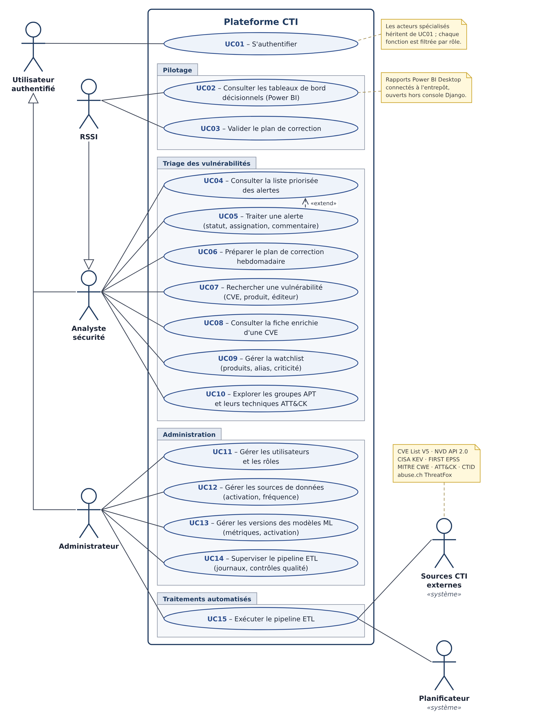
Figure 1 – Global use case diagram

9.2 Refinement of UC15 — Run the ETL pipeline
UC15 includes six steps, executed in order and logged for monitoring (UC14). Scoring (UC19) and alert generation (UC20) run before the warehouse refresh (UC21), so the reports always include the latest predictions and alerts.
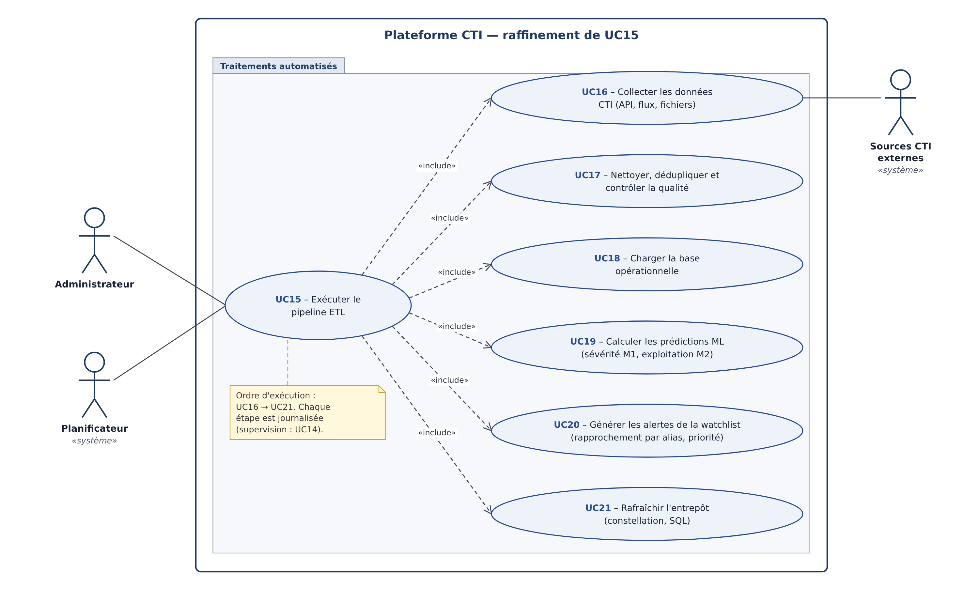
Figure 2 – Refinement of UC15 (Run the ETL pipeline)

9.3 Class diagram — domain view
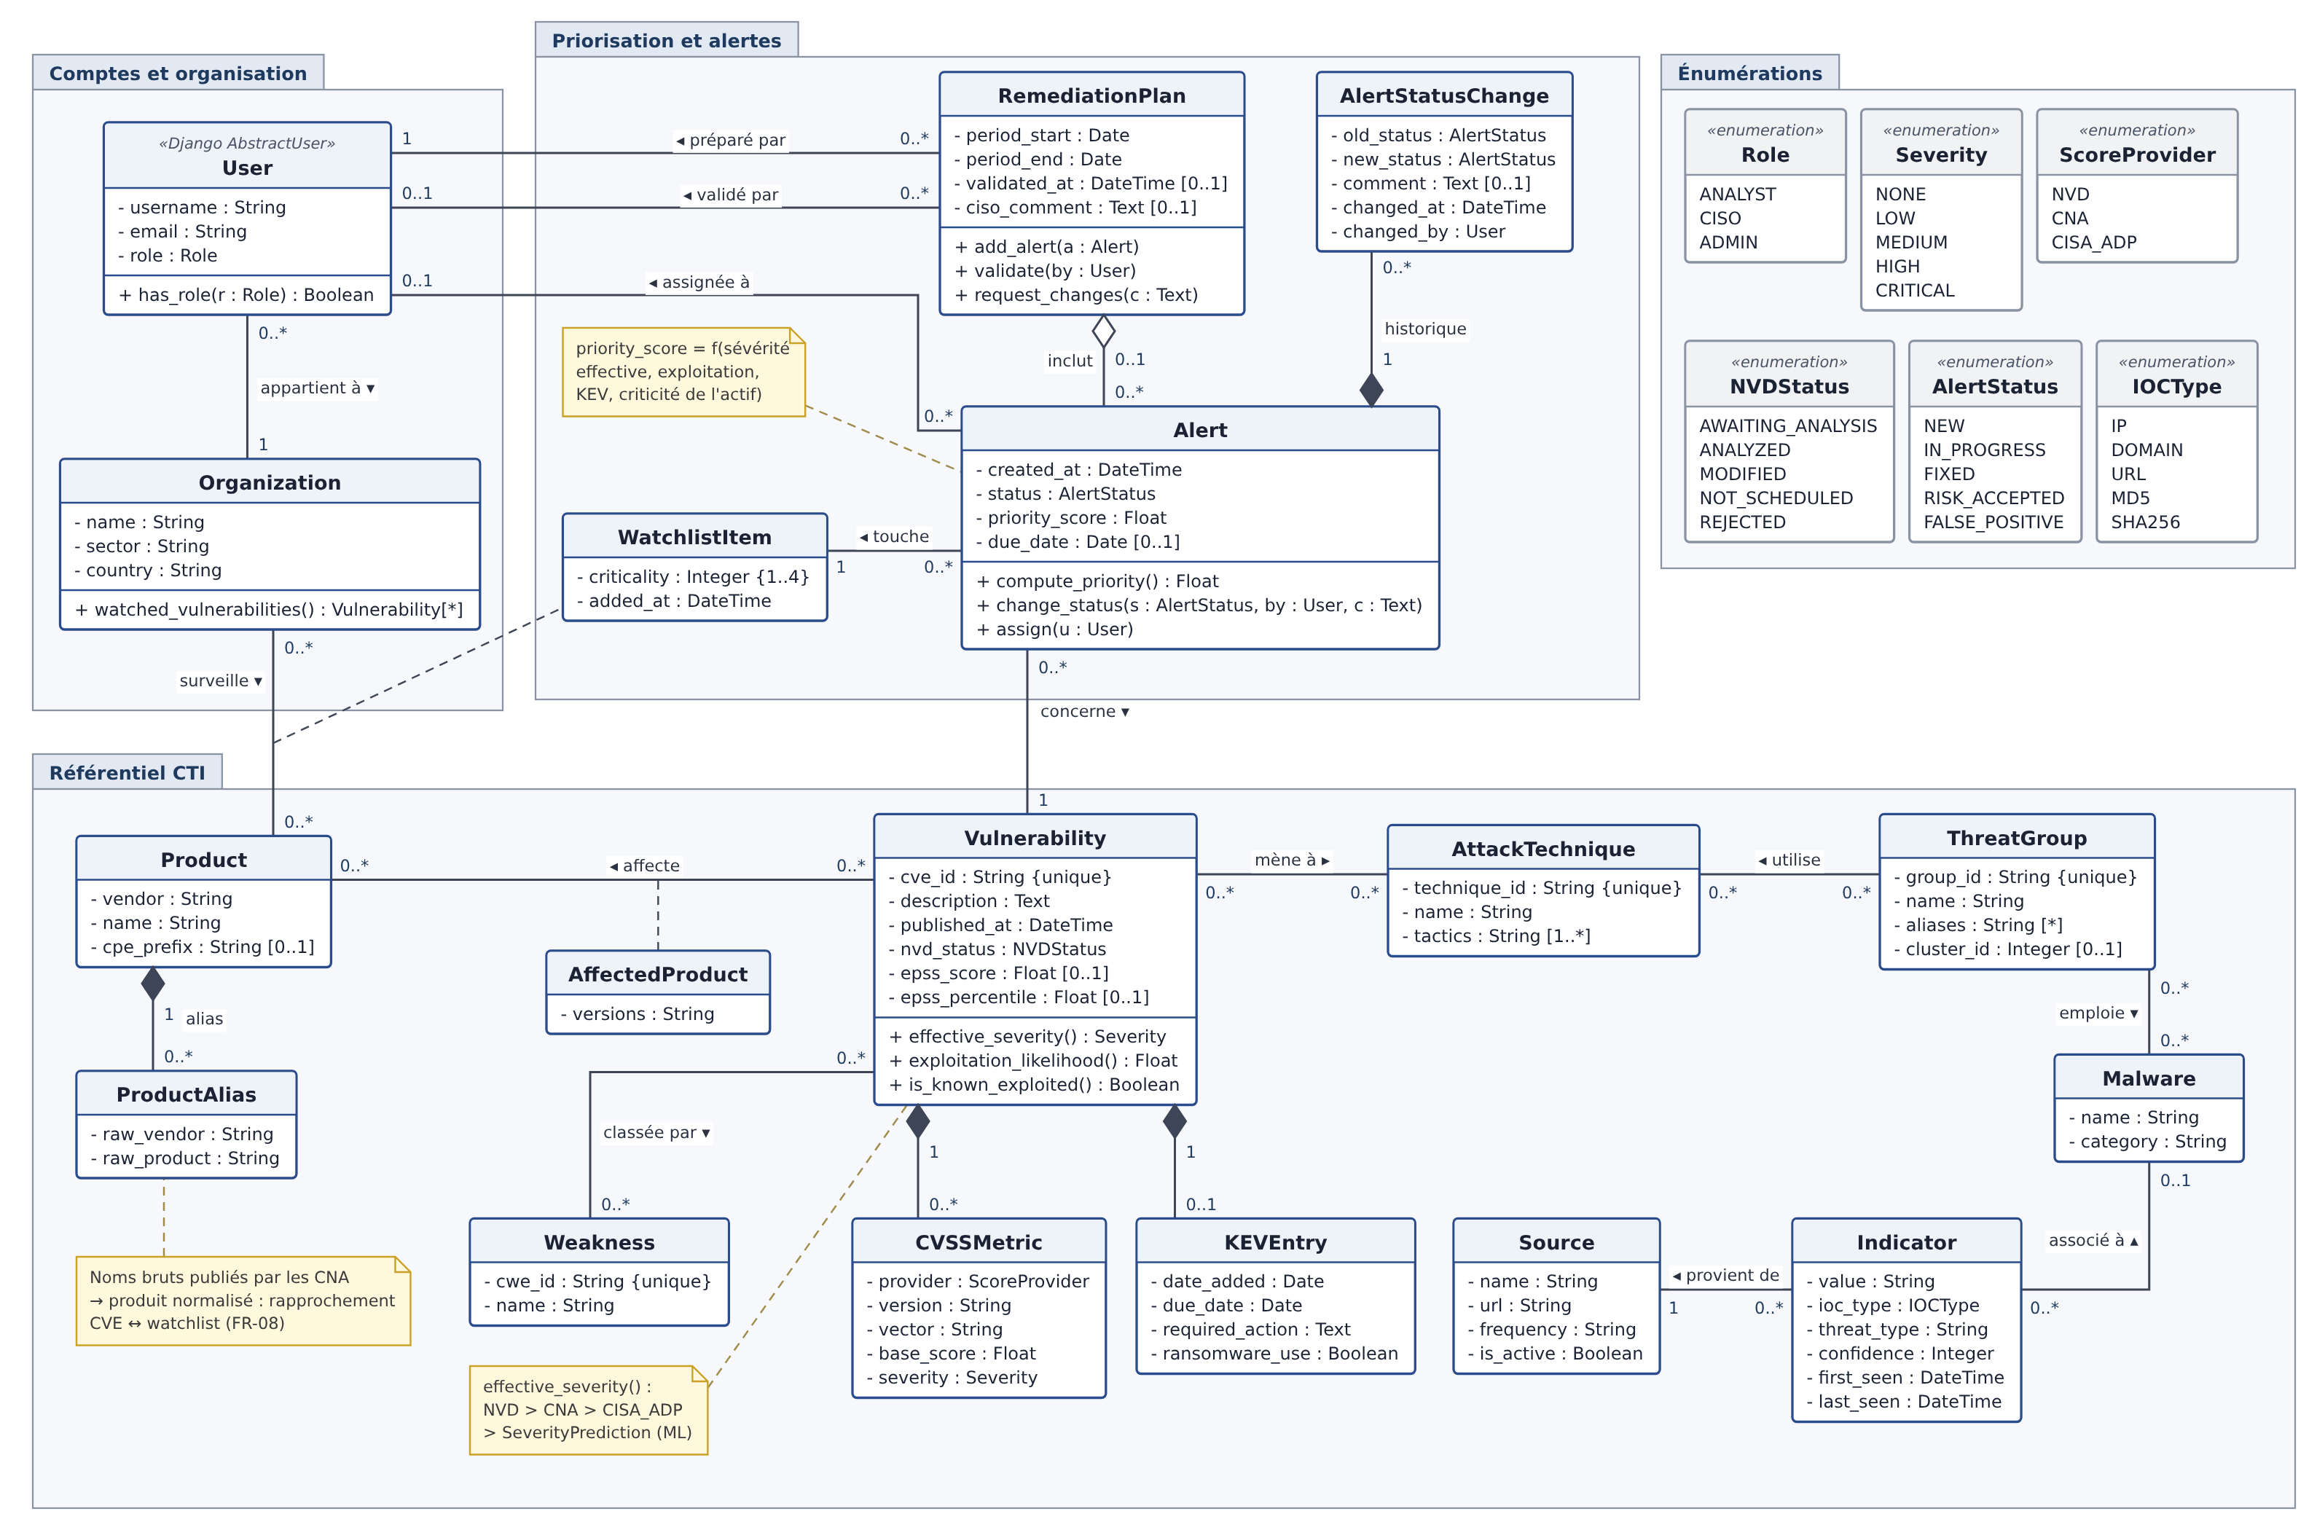
Figure 3 – Class diagram — accounts, prioritization and CTI reference data
Key design choices: WatchlistItem is an association class that carries the asset criticality; ProductAlias maps the raw vendor and product names published by the CNAs to a normalized product, which makes the CVE–watchlist matching reliable; a Vulnerability can hold several CVSS scores (NVD, CNA, CISA ADP) and falls back on the ML prediction when none exists; an Alert links a vulnerability to a watched product and keeps its status history (AlertStatusChange); a RemediationPlan is prepared by an analyst and validated by the CISO.

9.4 Class diagram — machine learning and ETL view
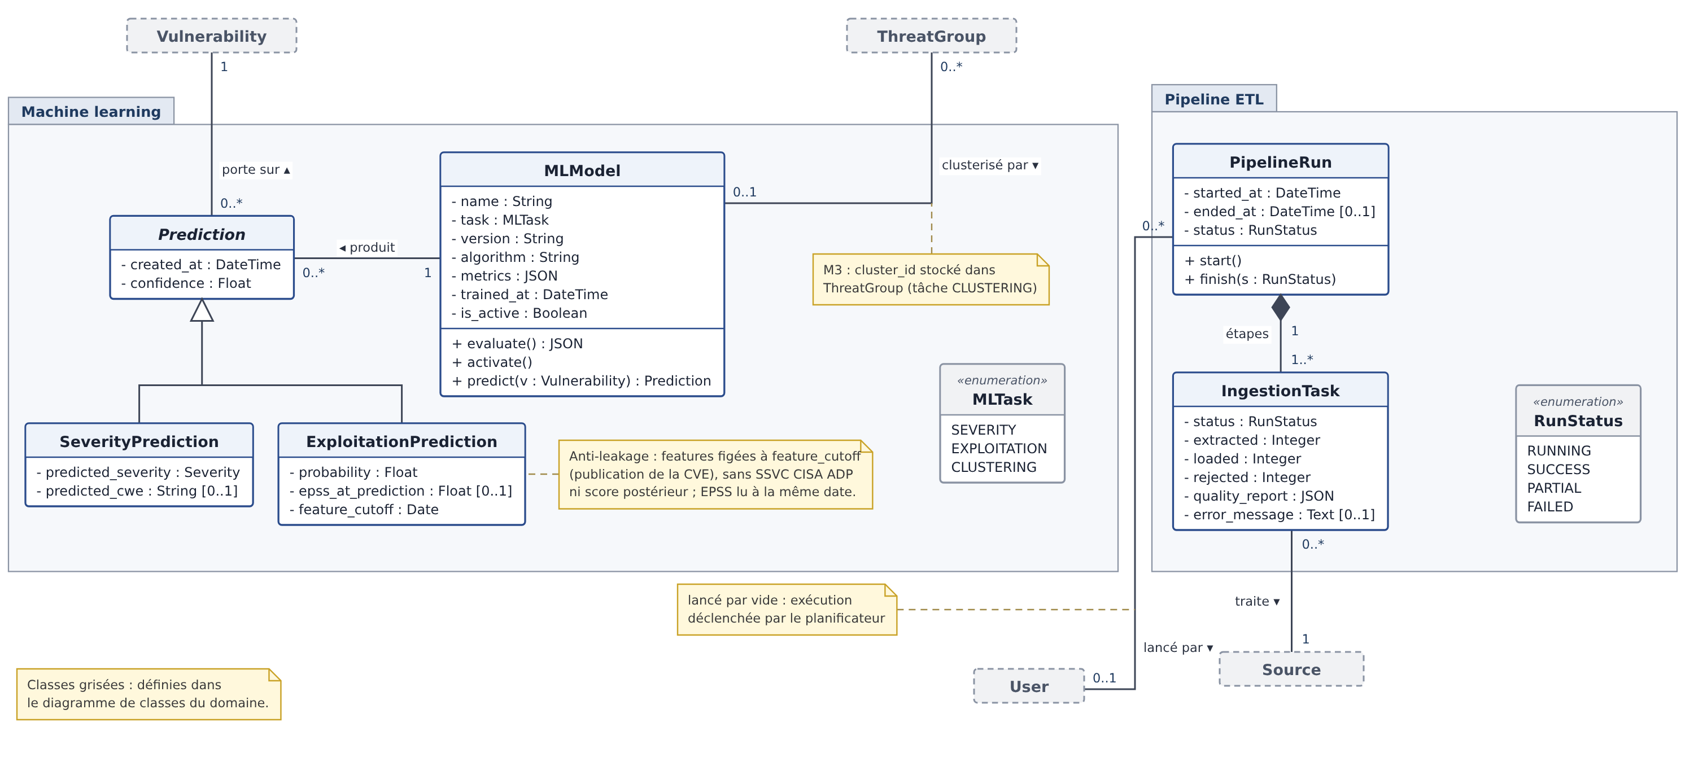
Figure 4 – Class diagram — machine learning and ETL pipeline
Grey classes are defined in the domain view. Predictions specialize into severity and exploitation predictions; ExploitationPrediction stores the feature cut-off date and the EPSS value of the same date for a fair benchmark; the clustering model (M3) writes cluster_id into ThreatGroup; each pipeline run is composed of one ingestion task per source.

10. Technical Architecture
The platform is organized in layers. Each layer has a precise role and communicates with the next one:
Layer | Role | Technology
Data sources | Public CTI providers: APIs, bulk files, STIX bundles. | CVE List V5, NVD, CISA KEV, FIRST EPSS, MITRE CWE, MITRE ATT&CK, CTID, abuse.ch ThreatFox
Ingestion and ETL | One connector per source: extraction, raw snapshot (staging), transformation, deduplication, quality checks and loading into the operational schema. | Python, Pandas, Django management commands
Storage | Operational schema for the application; analytical schema (constellation) refreshed from it by SQL at the end of each run (ELT). | PostgreSQL
Analytics and ML | Model training in notebooks, batch scoring after each run on the operational schema, results stored with the model version. | scikit-learn
Application | Business logic: prioritization, alerts, remediation plan, roles and REST API. | Django, Django REST Framework
Presentation | Triage console for analysts; Power BI Desktop reports for the CISO, opened outside the console. | Django templates, Bootstrap 5, Chart.js; Power BI Desktop
The architecture can be summarized as follows:
CTI sources → Connectors → Staging → Transformation and quality checks → PostgreSQL operational schema → ML scoring and alert generation → SQL refresh of the constellation warehouse → Django console and Power BI
Deployment uses Docker Compose with three services: the database (PostgreSQL), the web application (Django) and the scheduled ETL job. Power BI Desktop connects to the warehouse from the CISO's workstation.

11. Data Model

11.1 Operational database (Django)
The operational schema implements the class diagrams of sections 9.3 and 9.4. Main tables:
Table | Role | Main columns
users, organizations | Accounts, roles and organizations. | username, email, password (hashed), role (ANALYST / CISO / ADMIN), organization; name, sector, country
products, product_aliases, watchlist_items | Products, CNA name aliases and the organization's watchlist. | vendor, name, cpe_prefix; product, raw_vendor, raw_product; organization, product, criticality (1–4), added_at
vulnerabilities | CVE reference data. | cve_id, description, published_at, nvd_status, epss_score, epss_percentile
cvss_metrics, kev_entries | Scores and exploitation evidence. | provider (NVD / CNA / CISA_ADP), version, vector, base_score, severity; date_added, due_date, required_action, ransomware_use
affected_products | Link between vulnerabilities and products. | vulnerability, product, versions
weaknesses, attack_techniques | CWE and ATT&CK catalogs, with their link tables. | cwe_id, name; technique_id, name, tactics
threat_groups, malware, indicators | Threat intelligence. | group_id, name, aliases, cluster_id; name, category; value, ioc_type, threat_type, confidence, first_seen, last_seen
sources, pipeline_runs, ingestion_tasks | Sources and ETL monitoring. | name, url, frequency, is_active; started_at, ended_at, status, triggered_by; extracted, loaded, rejected, quality_report, error_message
alerts, alert_status_changes, remediation_plans | Triage, status history and remediation. | vulnerability, watchlist_item, status, priority_score, due_date, assignee, plan; alert, old_status, new_status, comment, changed_at, changed_by; period_start, period_end, prepared_by, validated_at, validated_by, ciso_comment
ml_models, predictions | Models and their outputs. | name, task, version, algorithm, metrics, trained_at, is_active; model, vulnerability, confidence, predicted_severity or probability, epss_at_prediction, feature_cutoff

11.2 Data warehouse — constellation schema
The warehouse is designed with the Kimball method (business process → grain → dimensions → facts). Three business processes (vulnerability exposure, alert remediation, threat activity) give three fact tables that share conformed dimensions. The warehouse is refreshed by SQL from the operational schema at the end of each pipeline run (ELT), so no second ingestion path is needed.
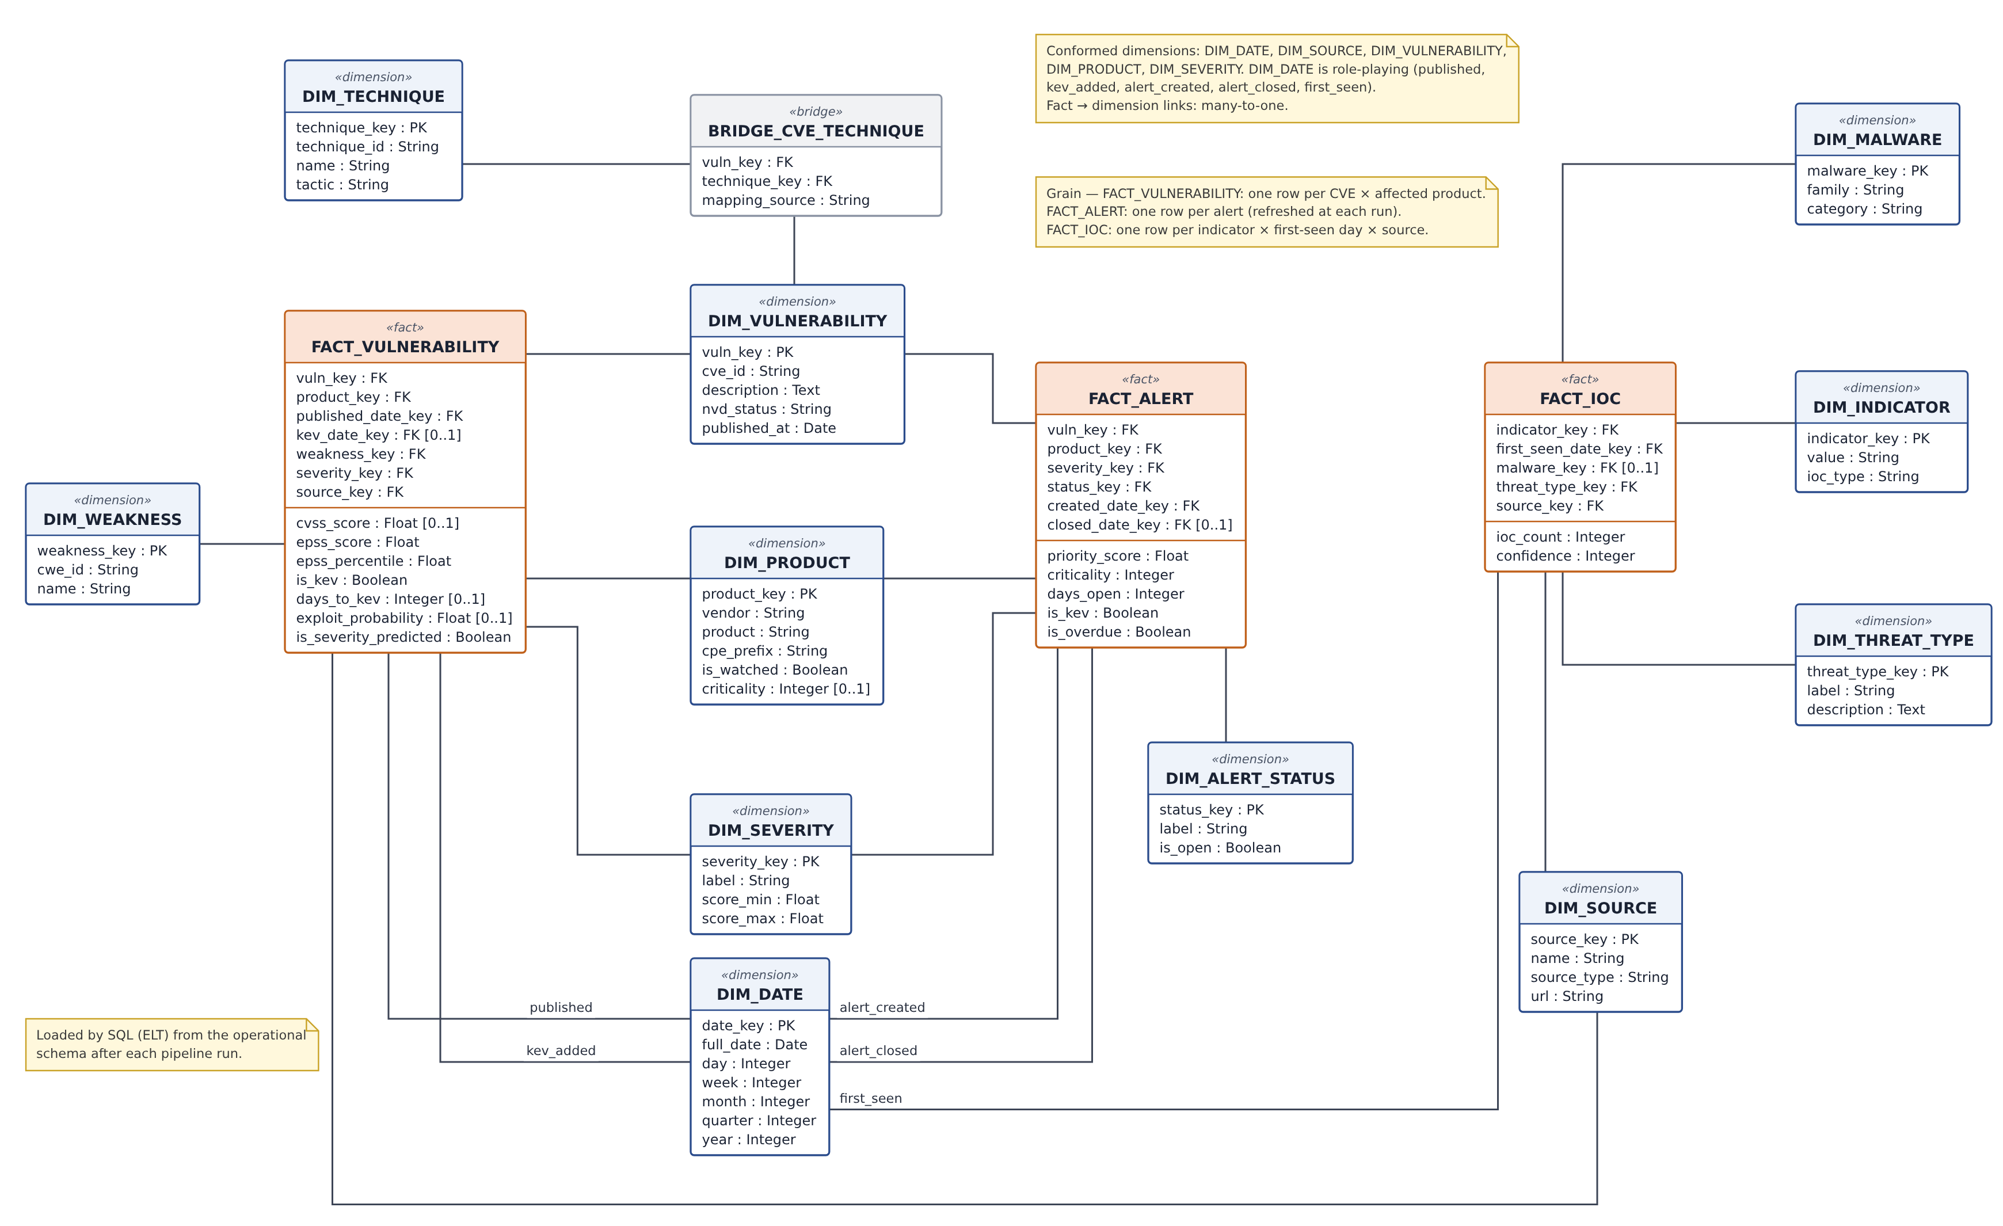
Figure 5 – Data warehouse — constellation schema
Table | Type | Grain or role | Main columns
FACT_VULNERABILITY | Fact | One row per CVE × affected product | 7 foreign keys; measures: cvss_score (empty when no score), epss_score, epss_percentile, is_kev, days_to_kev, exploit_probability, is_severity_predicted
FACT_ALERT | Fact | One row per alert, rebuilt at each run | 6 foreign keys; measures: priority_score, criticality, days_open, is_kev, is_overdue
FACT_IOC | Fact | One row per indicator × first-seen day × source | 5 foreign keys; measures: ioc_count, confidence
BRIDGE_CVE_TECHNIQUE | Bridge | Many-to-many link between CVEs and ATT&CK techniques | vuln_key, technique_key, mapping_source
DIM_DATE | Conformed, role-playing dimension | Calendar used as published, kev_added, alert_created, alert_closed and first_seen dates | full_date, day, week, month, quarter, year
DIM_SOURCE | Conformed dimension | Origin of each record | name, source_type, url
DIM_VULNERABILITY, DIM_PRODUCT, DIM_WEAKNESS, DIM_SEVERITY, DIM_TECHNIQUE | Dimensions (vulnerability, product and severity are conformed) | Analysis axes of vulnerabilities and alerts | cve_id, nvd_status; vendor, product, is_watched, criticality; cwe_id; severity label and score range; technique_id, tactic
DIM_ALERT_STATUS | Dimension | Alert workflow status | label, is_open
DIM_INDICATOR, DIM_MALWARE, DIM_THREAT_TYPE | Dimensions | Analysis axes of threat activity | value, ioc_type; family, category; threat type label
Counting rules: a CVE appears once per affected product in FACT_VULNERABILITY, so CVE counts use DISTINCTCOUNT in DAX; FACT_VULNERABILITY keeps the primary CWE of each CVE (the full list stays in the operational schema); FACT_ALERT is rebuilt at each run, so remediation KPIs always reflect the current status; EPSS values are refreshed at each run, and a weekly snapshot table can be added if trend analysis is required.

12. Project Methodology

12.1 Approach
We combine three complementary methods: Scrum to manage the project, the Kimball dimensional modeling method to design the warehouse, and CRISP-DM to conduct the machine learning work inside the sprints.
Method | Applied to | How
Scrum | Whole project | Four sprints aligned with the four official validations; each sprint delivers a demonstrable increment of the platform.
Kimball (4 steps) | Data warehouse | 1. Select the business processes (vulnerability exposure, threat activity). 2. Declare the grain. 3. Identify the dimensions. 4. Identify the facts and measures.
CRISP-DM | Machine learning | Business understanding → data understanding → data preparation → modeling → evaluation → deployment, applied to M1 from sprint 1 (baseline) and to M2 and M3 in sprints 3 and 4.

12.2 Scrum roles
Role | Member | Responsibilities
Product Owner | Imen Hichri | Owns and prioritizes the product backlog, writes acceptance criteria and presents the increment at each validation.
Scrum Master | Oumaima Hafiane | Facilitates the events, tracks progress (burndown), removes impediments and enforces the Definition of Done.
Development Team | Oumaima Hafiane, Imen Hichri | Design, implementation, testing and documentation.
Stakeholders | Project supervisor and module teachers | Review the increment at each validation and give feedback.

12.3 Scrum artifacts
- Product backlog: epics broken into user stories ("As a <role>, I want <goal> so that <benefit>"), each with acceptance criteria, a MoSCoW priority and an estimate in story points (Fibonacci scale).
- Sprint backlog: the user stories selected for the sprint, split into tasks of half a day at most.
- Increment: a working, demonstrable version of the platform at the end of each sprint.
- Definition of Done: code merged through a reviewed pull request; tests and data-quality checks pass; documentation (README, data dictionary) updated; feature running in the Docker environment; demonstrated to the Product Owner.

12.4 Scrum events (adapted to about 6 hours per week per member)
- Sprint: 3 to 4 weeks, ending with an official validation.
- Sprint planning (1 h): sprint goal and sprint backlog.
- Sync meetings (2 × 15 min per week, online): replace the daily scrum, completed by asynchronous updates on the board.
- Backlog refinement (30 min, mid-sprint): clarify and estimate the next stories.
- Sprint review: held during the validation session; the increment is demonstrated to the supervisor and the feedback is added to the backlog.
- Sprint retrospective (30 min): what to keep, stop and start.

12.5 Sprint plan
Sprint | Weeks | Sprint goal | Main deliverables | Validation
Sprint 1 | W1–W4 | Foundations and first data slice | Requirements and design (this document, UML, warehouse model); Docker, GitHub and PostgreSQL setup; CVE List V5 and CISA KEV connectors; staging and first load of the operational schema; Django project with authentication and roles; M1 baseline from the CVE List V5 dump (go/no-go) | Validation 1
Sprint 2 | W5–W8 | Complete integration and first alerts | EPSS, NVD, CWE and ThreatFox connectors; data-quality checks and run logs; constellation warehouse refreshed by SQL; first Power BI pages; vulnerability search and enriched CVE record; watchlist with product aliases and alert generation | Validation 2
Sprint 3 | W9–W12 | Machine learning and prioritization | Final M1 and M2 (benchmark against EPSS); predicted severity and priority score in the console; prioritized list, alert statuses and history; remediation plan workflow; Power BI KPIs and drill-down | Validation 3
Sprint 4 | W13–W15 | Finalization | ATT&CK and CTID connectors and M3 clustering (Could); pipeline monitoring page; tests and performance tuning; frozen demonstration snapshot; documentation and user guide; demonstration rehearsal | Validation 4 (final)
Week numbers are indicative: each sprint ends on the date of the corresponding official validation.

12.6 Product backlog (excerpt)
ID | User story | Priority | Sprint | Use cases
US01 | As an administrator, I want to manage accounts and roles so that each user only accesses authorized functions. | Must | S1 | UC01, UC11
US02 | As the system, I want to ingest CVE records and KEV entries every day so that the data stays up to date. | Must | S1 | UC15, UC16
US03 | As an analyst, I want to search vulnerabilities by CVE, vendor or product so that I can quickly assess an exposure. | Must | S2 | UC07
US04 | As an analyst, I want an enriched CVE record (CVSS, EPSS, KEV, CWE) so that I understand the risk. | Must | S2 | UC08
US05 | As the system, I want to integrate EPSS, NVD, CWE and ThreatFox data so that analyses cover vulnerabilities and threats. | Must | S2 | UC16–UC18
US06 | As an administrator, I want every run logged with quality checks so that failures are traceable. | Must | S2 | UC14, UC17
US07 | As an analyst, I want to maintain a watchlist of our products with their aliases and criticality so that alerts match our assets. | Must | S2 | UC09
US08 | As an analyst, I want alerts created automatically when a vulnerability affects a watched product so that nothing is missed. | Must | S2 | UC20
US09 | As a CISO, I want a first Power BI report on vulnerability volume, severity and exposure so that I can follow trends. | Must | S2 | UC02, UC21
US10 | As an analyst, I want a predicted severity for CVEs without any CVSS score so that I can still prioritize them. | Must | S1–S3 | UC19, UC08
US11 | As an analyst, I want a prioritized alert list and to update alert statuses with a comment so that remediation is tracked. | Must | S3 | UC04, UC05
US12 | As a CISO, I want KPI dashboards with drill-down and remediation delays so that I can steer remediation. | Must | S3 | UC02
US13 | As an analyst, I want an exploitation probability compared with EPSS so that I can rank alerts by risk. | Should | S3 | UC19, UC04
US14 | As an analyst, I want to prepare a weekly remediation plan that the CISO approves so that the team fixes the right vulnerabilities first. | Should | S3 | UC06, UC03
US15 | As an administrator, I want to activate a model version after reviewing its metrics so that predictions stay under control. | Should | S3 | UC13
US16 | As an administrator, I want a monitoring page for pipeline runs so that I can check failures quickly. | Could | S4 | UC14
US17 | As an analyst, I want to see APT groups with similar techniques so that I can anticipate attacker behavior. | Could | S4 | UC10
US18 | Campaign alerts on IOC spikes (M4) and natural-language questions (AI analyst): moved to the perspectives. | Won't | — | —

12.7 Team organization
Member | Scrum role | Lead areas | Shared work
Oumaima Hafiane | Scrum Master | CVE List V5 connector and M1 features, machine learning models (M1–M3), Django console (alerts, prioritization, remediation plan) | Tests, documentation, demonstration
Imen Hichri | Product Owner | Other connectors (KEV, EPSS, NVD, CWE, ThreatFox, ATT&CK, CTID), data quality, warehouse and Power BI reports | Tests, documentation, demonstration
Each member reviews the other's pull requests, so both can explain the whole system during the validations. Oumaima takes the CVE List V5 connector because M1 depends on it, so the machine learning work does not wait for the other connectors.

12.8 Tools and engineering practices
- GitHub repository: protected main branch, one feature branch per user story, pull requests reviewed by the other member.
- GitHub Projects board: columns Product Backlog, Sprint Backlog, In Progress, Review and Done; sprint burndown updated weekly.
- Docker Compose: shared, reproducible environment; secrets in a non-versioned .env file.
- Notebooks and modules: exploration in Jupyter, final pipelines and models in versioned Python modules.

12.9 Quality assurance and testing
- Unit tests for connectors and transformations (Django test framework, pytest).
- Data-quality tests on every run: uniqueness, value ranges, referential integrity, row counts.
- ML evaluation protocol: time-based train/test split, simple baselines, leakage checks (features limited to the CVE publication date), metrics reported for each model, comparison of M2 with EPSS of the same date.
- Acceptance tests: each user story is checked against its acceptance criteria during the sprint review.

12.10 Risk management
Risk | Probability | Impact | Mitigation
R1. Incomplete NVD enrichment since April 2026 (missing CVSS, CWE) | High | High | Combine CNA and CISA ADP scores from CVE List V5; M1 predicts missing severities; KPI on the share of unscored CVEs.
R2. API rate limits or access changes (NVD, abuse.ch) | Medium | Medium | Free API keys; bulk downloads (CVE List V5 releases); local raw snapshots; retries with backoff.
R3. Data quality issues (duplicates, inconsistent dates before 2023) | High | Medium | Quality checks and rejection logs; trend analyses based on NVD dates or starting in 2023.
R4. ML models below expectations (M1 under the target, M2 below EPSS) | Medium | Medium | M1 baseline and go/no-go in sprint 1; M1 limited to severity if CWE prediction is weak; M2 presented as an honest benchmark, EPSS kept in the priority score.
R5. Scope creep (extensions, Could items) | Medium | High | MoSCoW priorities; M4 and the AI analyst moved to the perspectives; Could items started only once the Must items are done.
R6. Limited weekly time (about 6 hours per member) | High | Medium | Small vertical slices, strict sprint goals, two short sync meetings per week.
R7. Learning curve (Django, Power BI) | Medium | Medium | Follow the course progress; simple interface; reuse patterns seen in class.
R8. BI course tooling (SSIS used in class, Python ETL in the project) | Low | Medium | Validate the choice with the supervisor in sprint 1; implement one flow in SSIS if required.
R9. Misuse of IOC data | Low | High | Metadata only; IOCs never visited or executed; terms of use respected.
R10. Product names differ between CVE records and the watchlist (one vendor, several spellings across CNAs) | High | High | ProductAlias table; watchlist limited to about fifteen products; list of unmatched vendor names reviewed each sprint.
R11. Label leakage in M2 (CISA ADP SSVC fields, scores added after the KEV entry) | Medium | High | Features frozen at the publication date; leakage check in the evaluation protocol; comparison with EPSS of the same date.
R12. Embedding Power BI in the console requires a paid licence | High | Low | Reports opened in Power BI Desktop outside the console; licence availability checked with the school in sprint 1.
R13. The live demonstration depends on the CVEs published that week | Medium | High | Frozen database snapshot and a rehearsed scenario.

13. Conclusion and Perspectives
- Project summary: the CTI Data Warehouse integrates heterogeneous public threat intelligence into a constellation-schema warehouse, exposes decision dashboards to the CISO and a triage console to analysts, and uses machine learning to estimate the severity and exploitation likelihood of vulnerabilities, including those left without an official score since April 2026.
- Risk assessment: the main risks are data completeness after the NVD policy change, product name matching and the limited weekly time (about 180 hours in total). They are addressed by the multi-source design, the alias table, the ML fallback for missing scores and a reduced scope with strict MoSCoW priorities (section 12.10).
- Planned final demonstration (10 minutes): on a frozen data snapshot, (1) the analyst of the fictitious bank logs in: a recent CVE without any CVSS score affects a watched product; the model predicts a critical severity and a high exploitation probability, the alert appears at the top of the list and the analyst updates its status; (2) the CISO explores the Power BI reports (vendor → CWE → technique drill-down, KEV trend, remediation delays) and approves the remediation plan; (3) one slide compares M2 with EPSS (precision-recall curve).
- Perspectives: IOC anomaly detection and campaign alerts (former M4); AI analyst answering natural-language questions through read-only query templates; knowledge graph (Neo4j); streaming ingestion; additional sources (vendor advisories, GitHub Security Advisories, OSV, URLhaus, Feodo Tracker); Power BI Service embedding; multi-organization deployment; integration with ticketing tools.
- Next steps: after validation of this specification, create the product backlog in GitHub Projects, set up the Docker environment and start sprint 1.

Appendix A — Glossary
Term | Meaning
APT | Advanced Persistent Threat: organized attacker group conducting long, targeted intrusions.
ATT&CK | MITRE knowledge base of adversary tactics and techniques observed in real attacks.
CISA | Cybersecurity and Infrastructure Security Agency (United States); publishes the KEV catalog.
CISO | Chief Information Security Officer (RSSI in French).
CNA | CVE Numbering Authority: organization allowed to assign CVE identifiers and write CVE records.
CPE | Common Platform Enumeration: standard naming of products and versions.
CRISP-DM | Cross-Industry Standard Process for Data Mining: reference process for data science projects.
CTI | Cyber Threat Intelligence: knowledge about threats, attackers, techniques and indicators.
CTID | Center for Threat-Informed Defense: publishes mappings between CVEs and ATT&CK techniques.
CVE | Common Vulnerabilities and Exposures: unique identifier of a publicly known vulnerability.
CVSS | Common Vulnerability Scoring System: severity score from 0 to 10.
CWE | Common Weakness Enumeration: catalog of software weakness types.
DoD | Definition of Done: shared checklist a backlog item must satisfy to be considered done.
ELT | Extract, Load, Transform: data is loaded first, then transformed inside the database with SQL (used to refresh the warehouse).
EPSS | Exploit Prediction Scoring System: daily probability that a CVE is exploited within 30 days (FIRST).
ETL | Extract, Transform, Load: process that feeds the data warehouse.
IOC | Indicator of Compromise: technical trace of an attack (IP address, domain, URL, file hash).
KEV | Known Exploited Vulnerabilities: CISA catalog of vulnerabilities exploited in the wild.
KPI | Key Performance Indicator.
MoSCoW | Prioritization method: Must, Should, Could, Won't.
NIST / NVD | National Institute of Standards and Technology / National Vulnerability Database.
OLAP | Online Analytical Processing: multidimensional analysis (roll-up, drill-down, slice and dice).
SSVC | Stakeholder-Specific Vulnerability Categorization: decision points (exploitation, automatable, technical impact) added by CISA ADP to CVE records.
STIX | Structured Threat Information Expression: standard JSON format for exchanging CTI.
TTP | Tactics, Techniques and Procedures of an attacker.

Appendix B — References
- Help Net Security, "NIST admits defeat on NVD backlog, will enrich only highest-risk CVEs going forward", 16 April 2026. https://www.helpnetsecurity.com/2026/04/16/nist-national-vulnerability-database-nvd-enrichment/
- The Hacker News, "NIST Limits CVE Enrichment After 263% Surge in Vulnerability Submissions", 17 April 2026. https://thehackernews.com/2026/04/nist-limits-cve-enrichment-after-263.html
- CVE Program, CVE List V5. https://github.com/CVEProject/cvelistV5
- NIST, NVD API — request an API key. https://nvd.nist.gov/developers/request-an-api-key
- CISA, Known Exploited Vulnerabilities Catalog. https://www.cisa.gov/known-exploited-vulnerabilities-catalog
- FIRST, EPSS — Get the Data. https://www.first.org/epss/data
- MITRE, ATT&CK STIX data. https://github.com/mitre-attack/attack-stix-data
- Center for Threat-Informed Defense, Mappings Explorer (CVE and KEV mappings). https://center-for-threat-informed-defense.github.io/mappings-explorer/external/cve/
- Center for Threat-Informed Defense, "Put Your Money Where Your Adversaries Are: Exploited Vulnerabilities", 13 February 2025. https://ctid.mitre.org/blog/2025/02/13/pkev-blog/
- abuse.ch, ThreatFox API. https://threatfox.abuse.ch/api/
- Django Software Foundation, "Django 6.1 released", 5 August 2026. https://www.djangoproject.com/weblog/2026/aug/05/django-61-released/

