|  |  |  |
| --- | --- | --- |
| ****Sound Absorption Test Report Type E-Mounting**** | **Report number** | {{report_number}} |
| **Acoustic - Measurements of sound absorption in a reverberation room according to AS ISO 354 - 2006** | | |

|  |  |  |  |
| --- | --- | --- | --- |
| **Client:** | {{client}} | | |
| **Address:** | {{address}} | | |
| **Test Date:** | {{test_date}} | | |
| **Issue Date:** | {{issue_date}} | | |
| **Test specimen trade name:** | **{{specimen_name}}** | | |
| **Description of specimen:** | {{specimen_desc}} | | |
| **Sample size:** | {{A}} | | |
| **Sample mass:** | {{B}} | | |
| **Test facility:** | Canterbury Acoustic Testing Services Ltd, 180 Hazeldean Road, Addington, Christchurch 8024, New Zealand | | |
| **Test room description:** | Described in Appendix: 1, Figures 1 and 2 | | |
| **Measurement process:** | Described in Appendix: 1 | | |
| **Area of test specimen:** | {{C}} | | |
|  |  | | |
| **Sample mounting:** | Type E-400 mounting (400 mm air cavity behind sample), the perimeter edging is constructed from 3 mm steel plate, when installed the edging is sealed to the reverberation room floor with duct tape.  The ceiling tiles were mounted in a two-way suspended ceiling grid in a 1200 mm x 600 mm grid configuration.  The grid sat on top of a 30 mm lip of the steel perimeter edging. The grid was sealed and taped to the perimeter edging using duct tape, As shown in Appendix: 2, Figures 3 and 4 | | |
|  |  | | |
| **Average test conditions over test duration:** | Air Temperature (deg 0C) | {{temperature}} | |
|  | Relative Humidity (R/H) % | {{humidity}} | |
|  | Barometric pressure (atm) kPa | {{pressure}} | |
|  |  | | |
| **Comments:** | The test results presented refer only to the test specimens and prevailing conditions on the day of the measurements and may or may not be representative of a different batch of material. | | |
|  | The Noise Reduction Coefficient (NRC) has been calculated in accordance with ASTM C423 – 99. Although this single number rating is not mentioned in AS ISO 354 – 2006, it has been included due to its wide use when comparing the acoustic properties of sound absorbent materials. | | |
|  |  | | |
| **Verification Report:** | Report Number: {{report_number}} | | Issue Date: {{issue_date}} |
|  |  | | |
| **Approval:** | Prepared by: | | |
|  | Mike Latimer    Acoustic Lab Lead  Canterbury Acoustic Testing Services Ltd | | |

|  |  |  |
| --- | --- | --- |
| ****Measurement Results:**** | **Report number** | {{report_number}} |

|  |  |  |  |  |
| --- | --- | --- | --- | --- |
| **Test results for C Max Tech 20 mm** | | | | **{{ chart }}** |
| **Frequency** *f* **(Hz)** | **T1 - Empty Chamber (seconds)** | **T2 - With Sample (seconds)** | **αS One-third octave** |
| 100 | {{hz[100].t1}} | {{hz[100].t2}} | {{hz[100].oto}} |
| 125 | {{hz[125].t1}} | {{hz[125].t2}} | {{hz[125].oto}} |
| 160 | {{hz[160].t1}} | {{hz[160].t2}} | {{hz[160].oto}} |
| 200 | {{hz[200].t1}} | {{hz[200].t2}} | {{hz[200].oto}} |
| 250 | {{hz[250].t1}} | {{hz[250].t2}} | {{hz[250].oto}} |
| 315 | {{hz[315].t1}} | {{hz[315].t2}} | {{hz[315].oto}} |
| 400 | {{hz[400].t1}} | {{hz[400].t2}} | {{hz[400].oto}} |
| 500 | {{hz[500].t1}} | {{hz[500].t2}} | {{hz[500].oto}} |
| 630 | {{hz[630].t1}} | {{hz[630].t2}} | {{hz[630].oto}} |
| 800 | {{hz[800].t1}} | {{hz[800].t2}} | {{hz[800].oto}} |
| 1000 | {{hz[1000].t1}} | {{hz[1000].t2}} | {{hz[1000].oto}} |
| 1250 | {{hz[1250].t1}} | {{hz[1250].t2}} | {{hz[1250].oto}} |
| 1600 | {{hz[1600].t1}} | {{hz[1600].t2}} | {{hz[1600].oto}} |
| 2000 | {{hz[2000].t1}} | {{hz[2000].t2}} | {{hz[2000].oto}} |
| 2500 | {{hz[2500].t1}} | {{hz[2500].t2}} | {{hz[2500].oto}} |
| 3150 | {{hz[3150].t1}} | {{hz[3150].t2}} | {{hz[3150].oto}} |
| 4000 | {{hz[4000].t1}} | {{hz[4000].t2}} | {{hz[4000].oto}} |
| 5000 | {{hz[5000].t1}} | {{hz[5000].t2}} | {{hz[5000].oto}} |

|  |  |  |  |  |  |  |
| --- | --- | --- | --- | --- | --- | --- |
| **Ratings according to ISO 11654: 1997** | | | | | | |
| **Practical sound absorption coefficient** | | | | | | |
| **Frequency (Hz)** | 125 | 250 | 500 | 1000 | 2000 | 4000 |
| **αp** | {{psac[0]}} | {{psac[1]}} | {{psac[2]}} | {{psac[3]}} | {{psac[4]}} | {{psac[5]}} |

|  |  |
| --- | --- |
| **Weighted sound absorption coefficient** | |
| Weighted sound absorption coefficient αw | {{wsac[0]}} |
| Shape indication | {{wsac[1]}} |
| Absorber classification | {{wsac[2]}} |
| It is strongly recommended to use this single-number rating in combination with the complete sound absorption coefficient curve that can be obtained on request | | |

|  |  |
| --- | --- |
| **Rating according to ASTM C423** | |
| **Single number ratings to ASTM - 99, ASTM C423 - 17** | |
| Noise Reduction Coefficient (NRC) | {{snr[0]}} |
| Sound Absorption Average (SAA) | {{snr[1]}} |

|  |  |  |
| --- | --- | --- |
| ****Appendix: 1**** | **Report number** | {{report_number}} |

|  |  |
| --- | --- |
| **Facility:** | The reverberation room at the Canterbury Acoustic Testing Services Lab facility, 180 Hazeldean Road, Christchurch, New Zealand, is a cuboid shape chamber. Constructed in accordance with AS ISO 354 - 2006. Subsections *6.1.1 Volume of reverberation room*, and *6.1.2 Shape of reverberation room*, of the following dimensions, 7.7 m x 6.1 m x 4.7 m high. The room has a cubic volume of 219 m3 and internal surface area of 223.66 m2. |
|  |  |
| **Diffuser treatment:** | The chamber has six stationary hanging diffusers, made from 12 mm painted plywood and MDF, in the following sizes, 3 at 1.2 x 1.4 m, 3 at 1.2 x 1 m, 3 at 1.2 x 1.2 m.  The diffusers are suspended in a random orientation to create a diffuse sound field in accordance with AS ISO 354 - 2006.  A polyhedron volume diffuser constructed from 2 mm dampened aluminium sheet, fixed centrally, and offset to the ceiling of the chamber. The diffuser is 2.080 m at the base and 0.6 m high.  Two adjacent corners of the chamber have melamine covered MDF volume diffuser in the form of an acute Isosceles triangle 0.75 m at the base and 1.1 m high. |
|  |  |
| **Procedure:** | The tests were carried out following the interrupted noise technique outlined in AS ISO 354: 2006 Acoustics -- Measurement of sound absorption in a reverberation room. |
|  |  |
| **Generation of sound field:** | The test signal used was random pink noise, generated by a National Instruments Multi Analyser System, using PC based acquisition software. The signal was fed through an amplifier to two omnidirectional speakers placed in opposite corners of the reverberation room, to excite the sound field in the reverberation room. |
|  |  |
| **Receipt of signal:** | The sound field was measured using six microphone positions connected to a National Instruments Multi Analyser System, using PC based acquisition software. The reverberation times were determined for the empty room and for the room containing the test specimen. This was achieved by analysis of nine decays of the sound field, in six microphone/loudspeaker configurations, giving 54 decays for each 1/3 octave frequency band.  The 1/3 octave frequency band decay data was exported from the acquisition program, the data was analysed to determine the absorption coefficient of the test specimen. |

|  |  |  |
| --- | --- | --- |
| ****Appendix: 1 Figures**** | **Report number** | {{report_number}} |

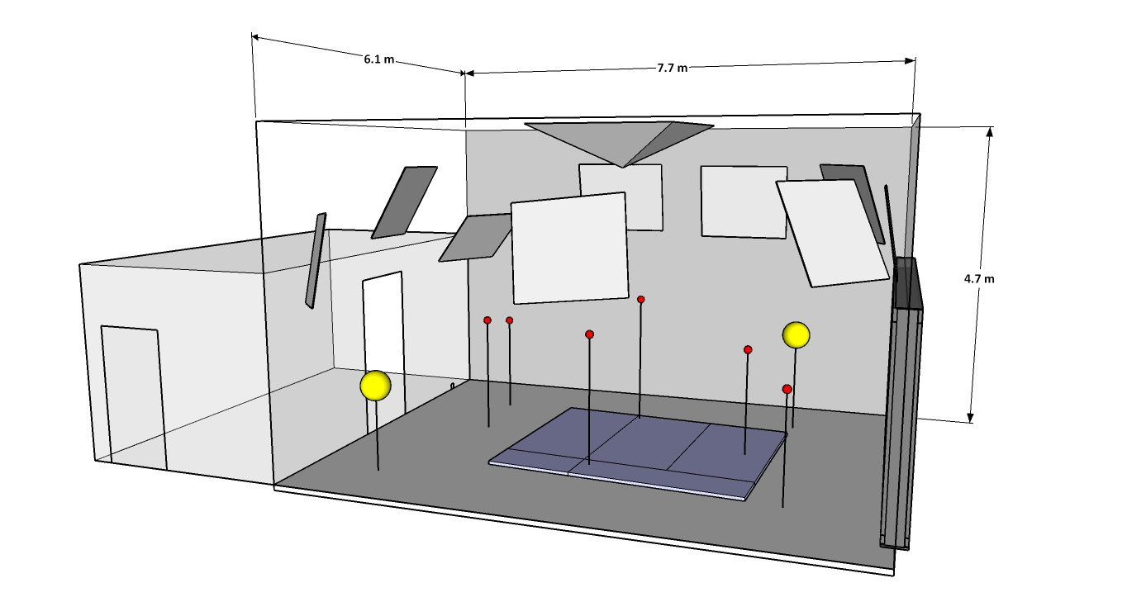

Figure 1 - General layout of the reverberation room

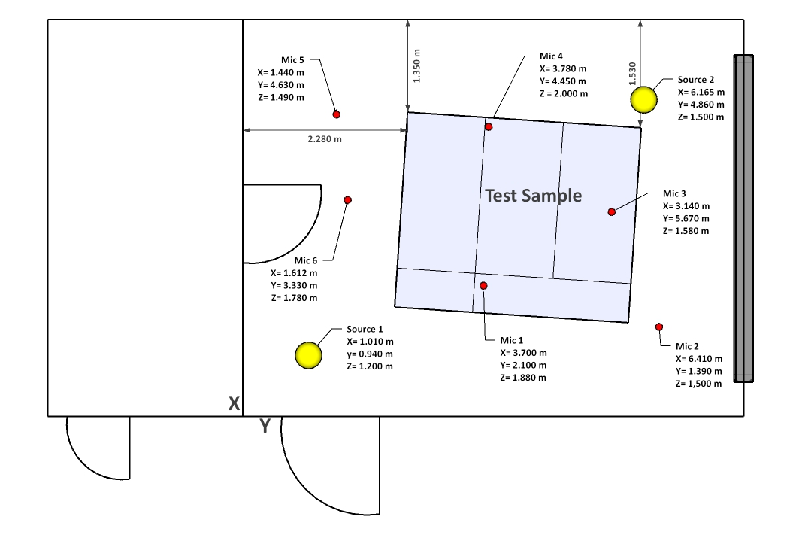

Figure 2 - Plan view showing, microphone, speaker, sample placement

|  |  |  |
| --- | --- | --- |
| Appendix: 2 | **Report number** | {{report_number}} |

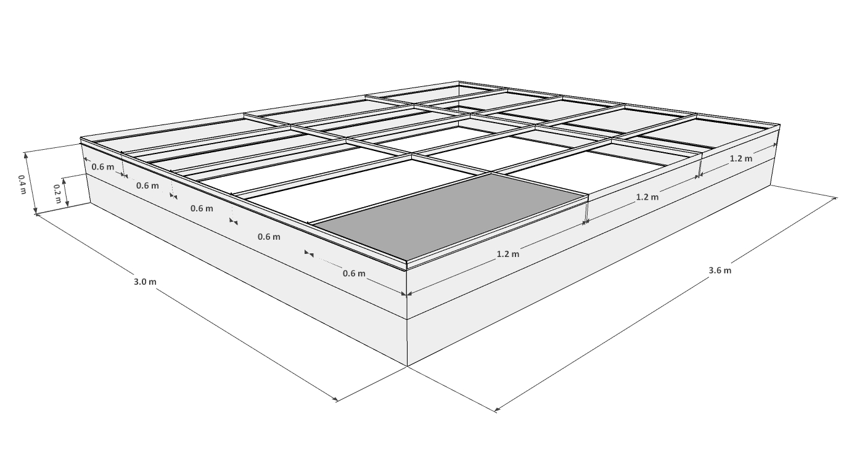

Figure 3 - E-200/400 Suspended Ceiling Rig

Figure 4 - Click or tap here to enter text. ready for testing