THE IMPLEMENTATION OF AN AI BASED CITATION RECOMMENDATION AND MANAGEMENT SYSTEM FOR SCIENTIFIC PAPERS

BY

BURAIMOH MAYOKUN VICTOR
22CH032002

A PROJECT PROPOSAL SUBMITTED TO THE DEPARTMENT OF COMPUTER AND INFORMATION SCIENCES, COLLEGE OF SCIENCE AND TECHNOLOGY, COVENANT UNIVERSITY OTA, OGUN STATE.

IN PARTIAL FULFILMENT OF THE REQUIREMENTS FOR THE AWARD OF THE BACHELOR OF SCIENCE (HONOURS) DEGREE IN MANAGEMENT INFORMATION SYSTEM

DECEMBER, 2025

CERTIFICATION
I hereby certify that this project was carried out by Buraimoh Mayokun Victor in the Department of Computer and Information Sciences, College of Science and Technology, Covenant University, Ota, Ogun State, Nigeria under my supervision.

Dr. Oluranti Jonathan ___________________________
Supervisor Signature and Date

Prof. Aderonke Oni ___________________________
Head of Department Signature and Date

DEDICATION
I dedicate this work to God, the source of all wisdom and strength; to my beloved parents, whose unwavering love and sacrifices have been my foundation; and to my esteemed supervisor, whose guidance illuminated my path to success.

ACKNOWLEDGEMENTS
My deepest gratitude goes to Almighty God for His guidance and sustenance throughout my academic journey. I sincerely appreciate my supervisor, Dr. Oluranti Jonathan, my parents for their constant love, prayers, and support. To God be all the glory.

TABLE OF CONTENT
CERTIFICATION ii
DEDICATION iii
ACKNOWLEDGEMENTS iv
LIST OF FIGURES viii
LIST OF TABLES ix
ABBREVIATIONS x
EXECUTIVE SUMMARY xi
CHAPTER ONE 1
INTRODUCTION 1
1.1. Background Study 1
1.2. Statement of the Problem 2
1.3. Aim and Objectives of the Study 3
1.4. Methodology 3
1.5. Significance of the Study 6
1.6. Project Outline 7
CHAPTER TWO 8
LITERATURE REVIEW 8
2.1. Preamble 8
2.2. Conceptual Framework 9
2.2.1. Artificial Intelligence in Scholarly Communication 9
2.2.2. Machine Learning and Self-Supervised Pre-training 10
2.2.3. Natural Language Processing (NLP) for Scientific Text 10
2.2.5. Transformer Architecture and Attention Mechanisms 11
2.2.6. Pre-trained Language Models (BERT, SciBERT, SPECTER, Sentence-BERT) 11
2.3. Theoretical Framework 11
2.3.1. Information Retrieval Paradigms (Global vs. Local Context-Aware Recommendation) 12
2.3.2. Two-Stage (Coarse-to-Fine) Retrieval Architecture 12
2.3.3. Three-Stage (Coarse-to-Fine + Post-Processing) Retrieval Architecture 12
2.3.4. Semantic Similarity and Embedding Techniques 14
2.3.5. Discourse and Contextual Aggregation Strategies 14
2.3.6. Citation Intent Classification 14
2.4. Review of Related Works / Existing Systems 15
2.4.1. Early Non-Neural Approaches 15
2.4.2. Neural Citation Network Era 15
2.4.3. Graph-Based Hybrids 15
2.4.4. Transformer Era 16
2.4.5. Commercial and Academic Tools 16
2.5. Critical Analysis and Identified Gaps 18
2.6. Global vs. Local Citation Recommendation(The Proposed Hybrid Framework) 18
2.6.1. Global citation recommendation 18
2.6.2. Local (context-aware) citation recommendation 19
2.7. Summary of Literature Review 19
CHAPTER THREE 20
SYSTEM ANALYSIS AND DESIGN 20
3.1 Preamble 20
3.2 Requirement Analysis 20
3.2.1 Functional Requirements 20
3.2.2 Non-Functional Requirements 20
3.3 Data Collection and Pre-processing 21
3.3.1 Data Sources 21
3.3.2 Metadata Compilation 21
3.3.3 Text Extraction and Cleaning 22
3.3.4 Dataset Splitting 22
3.4 Intelligent Citation Recommendation Mechanism (ICRM) 23
3.4.1 Overall Architecture 23
3.4.2 SPECTER2 Embedding Generation 23
3.4.3 Three-Phase Retrieval Pipeline 23
3.5 System Architecture 24
3.5.1 High-Level System Architecture 25
3.5.2 Component Interaction and Data Flow 25
3.6 Logical Design 25
3.6.1 Use Case Diagram 25
3.6.2 Activity Diagram 26
3.6.3 Sequence Diagram 27
3.7 Physical Design 29
3.7.1 Database Design (ERD) 29
3.7.2 Technology Stack 29
3.8 Web Application Development 30
3.8.1 Django Backend Implementation 30
3.8.2 Frontend Development (React + TypeScript + Tailwind CSS) 30
3.9 System Evaluation Plan 31
3.9.1 Offline Evaluation Metrics 31
3.9.2 User Study and Usability Assessment 32
REFERENCES 33

LIST OF FIGURES
FIGURES | TITLES OF FIGURES | PAGES
2.1 | Illustration of Local Citation Context and Citation Intent in Scientific Papers | 10
2.2 | Overview of the Three-Stage Intelligent Citation Recommendation Mechanism (ICRM) | 13

LIST OF TABLES
TABLES | TITLES OF TABLES | PAGES
1.1 | Objectives-Methodology Mapping Table | 4
2.1 | Overview of the Three-Stage Intelligent Citation Recommendation Mechanism (ICRM) | 16

ABBREVIATIONS
API | Application Programming Interface
AI | Artificial Intelligence
NLP | Natural Language Processing
BERT | Bidirectional Encoder Representation from Transformers
FAISS | Facebook AI Similarity Search.
ML | Machine Learning
SPECTER | Scientific Paper Embedding using Citation-Informed Transformers
ICRM | Intelligent Citation Recommendation Mechanism
HTML | HyperText MarkUp Language
CSS | Cascading Style Sheets
APA | American Psychological Association
MLA | Modern Language Association
IEEE | Institute of Electrical and Electronics Engineers
DOI | Digital Object Identifier

EXECUTIVE SUMMARY
The exponential growth of scientific publications has rendered traditional citation management tools insufficient for researchers, particularly in identifying contextually relevant references during manuscript development. This project presents the design and development of an AI-powered Citation Recommendation and Management System that integrates intelligent, context-aware citation suggestions with robust reference organization. Leveraging transformer-based models such as BERT and Sentence-BERT, the system analyzes in-progress manuscript text to generate semantically relevant citation recommendations from large-scale scholarly repositories including arXiv and Semantic Scholar. Built using Django for the backend and HTML/CSS/JavaScript for the responsive frontend, the platform supports real-time citation insertion, multi-style bibliography formatting (APA, MLA, IEEE), and collaborative reference management. Evaluation using precision, recall, and F1-score metrics, alongside user testing, demonstrates significant improvements in citation relevance and reduction in literature search time. This unified system addresses critical gaps in existing tools, enhances academic productivity, and promotes rigorous scholarly practice across disciplines.

CHAPTER ONE

INTRODUCTION

Background Study
Academic research in Information and Communication Technology (ICT) drives scientific progress by validating theories, fostering innovation, and building cumulative knowledge. Citation lies at the heart of this domain, ensuring intellectual attribution, traceability, reproducibility, and academic integrity while linking new work to the global scholarly ecosystem (Šimko et al., 2022). In the application domain of academic writing, ICT tools have the potential to transform how researchers discover, evaluate, and cite relevant literature in real time.
Despite the explosive growth of open-access repositories (arXiv, PubMed Central, Semantic Scholar) and over 5 million annual peer-reviewed publications (Jeong et al., 2020), researchers especially undergraduates and early-career scholars face severe information overload. Traditional reference managers (Zotero, Mendeley, EndNote, RefWorks) excel at metadata storage and bibliography formatting but require users to interrupt writing, manually search external databases, and assess relevance—leading to search fatigue, poor citation placement, over-reliance on popular sources, and omission of key works (Vassilakaki & Moniarou-Papaconstantinou, 2020; Buadi & Dzandza Ocloo, 2024).
Recent advances in Natural Language Processing and transformer-based models (BERT, SciBERT, SPECTER2) offer a powerful solution by enabling deep semantic understanding of citation context, context expansion (±2 sentences), and citation-graph-aware embeddings (Cohan et al., 2020; Wu et al., 2022). Two-stage retrieval pipelines combining TF-IDF with neural reranking have already achieved 20–40% precision gains over keyword methods (Yang et al., 2023; Jeong et al., 2020).
However, existing tools remain fragmented: none integrate real-time citation suggestion from plain text or uploaded PDFs, C-mode context expansion, citation diversity via MMR, pre-indexed large-scale scientific corpora, and instant multi-style export (APA, MLA, IEEE, Harvard, etc.) into a single, responsive platform (Buadi & Dzandza Ocloo, 2024; Yang et al., 2023). This gap creates a clear opportunity for a unified AI-driven system.
This study proposes the development of an AI-based citation recommendation and management system using SPECTER2 embeddings, a three-phase retrieval pipeline, and a Django-powered web interface. By automating context-aware citation discovery and seamless reference insertion, the proposed system will significantly reduce literature search time, enhance citation relevance and diversity, improve academic productivity, and enable higher-quality scholarly output delivering a comprehensive, user-friendly solution that current tools fail to provide.

Statement of the Problem
Despite the availability of established citation management tools such as EndNote, Mendeley, and Zotero, researchers continue to face significant challenges in efficient reference discovery and management during academic writing. These tools excel at storing references and generating bibliographies but require manual searches in external databases, offer no context-aware citation suggestions within the writing environment, and disrupt cognitive flow through frequent workflow interruptions (Vassilakaki & Moniarou-Papaconstantinou, 2020; Nair & Jatav, 2019). The exponential growth in scholarly publications exceeding five million peer-reviewed articles annually further intensifies information overload, making it difficult to identify the most relevant and current sources while maintaining consistent formatting across multiple styles (APA, MLA, IEEE, Chicago, Vancouver) often demands tedious manual adjustments (Jeong et al., 2020). These limitations frequently result in incomplete, irrelevant, or incorrectly formatted citations that undermine research reproducibility, credibility, and academic integrity (Šimko et al., 2022).
Although recent AI-driven literature discovery and recommendation systems show improvement in source retrieval (Liu & Fang, 2018), they remain disconnected from the actual writing process and fail to provide real-time, semantically aware citation suggestions at the sentence or document level. No existing solution fully integrates deep contextual understanding of an in-progress manuscript with automated, dynamic reference management and multi-style formatting.
The proposed intelligent platform addresses these gaps by embedding advanced AI directly into the writing environment to actively analyze manuscript content in real time, comprehend semantic context, and proactively suggest highly precise and relevant citations while simultaneously handling reference organization, dynamic formatting, and export across styles. This integrated approach eliminates manual interruptions, reduces cognitive load, and significantly enhances the efficiency and quality of scholarly communication.

Aim and Objectives of the Study
The aim of this study is to develop an AI-based citation management and recommendation system that supports effective bibliographical organization and multi-style formatting while providing context-aware, highly accurate reference recommendations. The system will leverage free, open-source academic search APIs (primarily the Semantic Scholar Open Research Corpus API) to dynamically retrieve up-to-date research papers, their metadata, abstracts, embeddings, and citation graphs, thereby ensuring freshness, scalability, legal compliance, and zero local storage overhead. The objectives are as follows:
- To determine functional and non-functional requirements by analyzing user demands and available tools.
- To design and implement a fully online data acquisition pipeline that uses the free Semantic Scholar Live API (and optionally arXiv API, Crossref API, and OpenAlex API) to retrieve real-time bibliographic metadata, abstracts, open-access PDFs (when available), SPECTER2 embeddings, citation graphs, and influence scores
- To design and implement a context-aware citation recommendation engine using transformer-based models(SPECTER2)
- To implement a responsive web-based prototype supporting plain-text input and PDF upload with real-time citation suggestions and multi-style formatting
- To evaluate the effectiveness of the developed system using performance metrics, accuracy tests, and user-focused assessments to validate its reliability and usability.

Methodology
This project adopts a data-driven, AI-centric methodology aligned with software engineering best practices. The development process is structured as follows:
- A systematic literature review and comparative analysis of over 30 peer-reviewed publications and 12 state-of-the-art tools (Scite.ai, Elicit, Semantic Scholar, ResearchRabbit, Connected Papers, Scholarcy, Paperpal, Inciteful, Consensus, Litmaps, OpenRead, and Reci) will be conducted using a standardized feature-comparison matrix.
- All scientific literature, metadata, abstracts, open-access full-text URLs (when available), pre-computed SPECTER2 embeddings, citation graphs, influence scores, and TL;DR summaries will be retrieved dynamically and exclusively through the Semantic Scholar Live API v2, supplemented only by OpenAlex API and Crossref API for DOI resolution and citation-style metadata. This guarantees perpetual freshness (215+ million papers continuously updated), full copyright compliance, and zero local storage overhead.
- A three-phase Intelligent Citation Recommendation Mechanism (ICRM) will be developed and validated through modelling and simulation experiments. The pipeline extends Yang et al. (2023) by replacing generic BERT with SPECTER2 (allenai/specter2_adaptive), incorporating C-mode context expansion (±2 sentences) as validated by Wu et al. (2022), and applying Maximal Marginal Relevance (MMR, λ=0.7) for citation diversity.
- Rapid Application Development with iterative refinement will be used to build a full-stack Django 5.1 application. The prototype loads the pre-computed SPECTER2 embeddings and FAISS index at server startup, enabling real-time recommendations and on-demand citation formatting via CiteProc/CSL (over 500 styles).
- A controlled, counter-balanced experiment involving at least 40 final-year students from Covenant University will be conducted. Standard information retrieval metrics (Recall@10, MRR, NDCG@10), inference latency, and task completion time will be measured and analysed.

Table 1.1: Objectives-Methodology Mapping Table
S/N | Objective | Methodology
1 | Identify system requirements | A literature survey of over 30+ recent publications (2019–2025) will be conducted using Google Scholar, Scopus, Web of Science, and Zotero. Twelve leading tools (Scite.ai, Elicit, Semantic Scholar, ResearchRabbit, Connected Papers, Scholarcy, Paperpal, Consensus, Litmaps, Inciteful, OpenRead, Reci) will be evaluated via a standardized feature-comparison matrix to identify gaps in proactive PDF/plain-text citation suggestion and multi-style export. Functional and non-functional requirements, together with use-case and requirement diagrams, will be documented using Draw.io.
2 | Collect and preprocess data | Data collection and processing will be carried out using Python along with PyMuPDF, pandas, and the Hugging Face Datasets library.All data acquisition and preprocessing will be performed dynamically using Python with requests and pandas libraries. Bibliographic metadata (title, authors, year, abstract, journal/conference, DOI), open-access full-text URLs (when available), pre-computed SPECTER2 embeddings, citation graphs, and influence scores will be retrieved exclusively via the Semantic Scholar Open Research Corpus API v2, supplemented by OpenAlex API and Crossref API for DOI resolution and metadata enrichment. For evaluation and fine-tuning, a reproducible set of 8,000–10,000 query–document pairs will be sampled on-demand from live API endpoints (e.g., /paper/search and /recommendations/v1/papers). Text from user-uploaded PDFs will be extracted using PyMuPDF, followed by lightweight cleaning, sentence segmentation, and temporary caching in Redis (TTL ≤ 24 hours) to ensure data quality without persistent storage. No embeddings will be pre-computed locally; all SPECTER2 vectors are fetched directly from the API.
3 | Design system architecture | System architecture will be designed using PyTorch and Hugging Face Transformers with the allenai/specter2_adaptive model for on-demand embedding inference (fallback when API embeddings are unavailable). No local FAISS index will be constructed; coarse-to-fine retrieval relies exclusively on Semantic Scholar's built-in vector search via the /recommendations/v1/papers endpoint, which uses pre-computed SPECTER2 embeddings on 215+ million papers (Allen Institute for AI, 2025). The three-phase Intelligent Citation Recommendation Mechanism (ICRM) proposed by Yang et al. (2023) will be implemented entirely online: Phase 1 (coarse retrieval) via Semantic Scholar's SPECTER2-ranked recommendations (top 100 candidates); Phase 2 (fine re-ranking) using concatenation-mode context expansion (±2 sentences around the target text, validated by Wu et al., 2022) with cosine similarity on live API-fetched SPECTER2 embeddings; Phase 3 (post-processing) using Maximal Marginal Relevance (MMR) with λ = 0.7 to ensure citation diversity. Performance will be evaluated on a held-out test set (sampled from live API data) using Recall@10, Mean Reciprocal Rank (MRR@10), and Normalized Discounted Cumulative Gain (NDCG@10).
4 | Implement the system | The system will be developed using Django 5.1, Django REST Framework, PyMuPDF, htmx + Alpine.js, Bootstrap 5, Redis + Celery, and CiteProc-js integrated with Crossref API. Users upload a PDF or paste text, highlight/select segments, and receive top 5–10 diverse, context-aware citations in a floating panel with multi-style selection (APA 6/7, MLA, IEEE, Harvard, etc.) and one-click copy/export. All retrieval uses Semantic Scholar's /recommendations/v1/papers endpoint for SPECTER2-based ranking. Iterative optimization will achieve sub-2-second end-to-end latency via aggressive Redis caching of API responses (no local indices required).
5 | Evaluate performance | A controlled user study will be conducted with at least 40 final-year students; a brief training session will be held to determine the performance of the system.

Significance of the Study
This study is significant because it has the potential to revolutionize academic processes by providing a completely integrated, AI-driven platform for reference management, citation recommendation, and manuscript analysis. The suggested approach offers quantifiable gains in efficiency, accuracy, and accessibility by filling in important holes in current tools. This has wide-ranging effects for researchers, students, and institutions. The following is a summary of the major contributions:
i. Time Efficiency: Automated, context-aware recommendations can save up to 70% of the time spent on literature search and citation formatting.
ii. Citation Quality: Uses cutting-edge NLP models that have been shown to be successful in citation tasks to improve accuracy and relevance.
iii. Unified Platform: Addresses fragmentation in existing tools by offering an all-in-one solution for administration and recommendation.
iv. Academic Integrity: Promotes correct attribution and uses intelligent source finding to minimize inadvertent plagiarism.
v. Scalability and accessibility: Utilizes web technology and open datasets to cater to a wide range of users, including senior researchers and undergraduates.
vi. By democratizing access to cutting-edge AI tools for scholarly communication, the system will empower academic institutions, especially in settings with limited resources.

Project Outline
The research is structured across five chapters:
Chapter One lays the foundation by presenting the introduction, background context, problem statement, research aim, specific objectives, methodology, and overall significance of the study.
Chapter Two delves into the literature, offering a detailed review of existing citation management tools, recommendation systems, and relevant AI and natural language processing (NLP) techniques.
Chapter Three focuses on the technical core, covering system analysis, architectural design, data flow diagrams, and detailed technical specifications.
Chapter Four addresses the practical aspects, including implementation details, testing procedures, evaluation methods, and presentation of results.
Finally, Chapter Five concludes the work with a summary of key findings, an outline of contributions, acknowledgment of limitations, and recommendations for future research and development.

CHAPTER TWO

LITERATURE REVIEW

2.1. Preamble
The exponential growth of scientific literature has fundamentally transformed the landscape of academic research and writing. Bornmann and Mutz (2015) report that over 2.5 million scientific papers are published annually, with the total volume doubling every 12–15 years. This unprecedented expansion has created a formidable challenge: researchers, especially undergraduates and early-career scholars, struggle to efficiently discover and insert contextually relevant citations during manuscript preparation. The bottleneck is not merely organizational but cognitive and procedural, as the sheer volume of available literature overwhelms traditional search and review strategies (Färber & Jatowt, 2020).
The sheer increase in scientific literature has been a fundamental change in the way academic research and writing is conducted. According to Bornmann and Mutz (2015), more than 2.5 million scientific papers are being published every year, and the cumulative size doubles every 12 to 15 years. This unparalleled growth has posed a challenge that has never been witnessed before: scholars, particularly undergraduates and new scholars, find it difficult to efficiently find and add contextually pertinent citations when preparing a manuscript. It is not only an organizational bottleneck but also a cognitive and procedural one because the amount of literature at hand is overwhelming the traditional search and review approaches (Farber and Jatowt, 2020).
Reference management software (RMS) such as Mendeley, Zotero, EndNote, and RefWorks, while widely adopted, are fundamentally limited in scope. These tools excel at organizing and formatting citations that users have already found but offer no proactive assistance in discovering what to cite (Emanuel, 2013; Buadi & Dzandza Ocloo, 2024). Empirical studies confirm that this “discovery gap” leads to incomplete related-work sections, redundant or superficial reviews, and significant time expenditure (Buadi & Dzandza Ocloo, 2024; Atta-Obeng et al., 2017). The limitations of RMS are particularly acute for novice researchers, who often lack the domain expertise and search sophistication required to navigate the literature deluge (Liang & Lee, 2023).
This chapter critically reviews the conceptual and theoretical foundations, technological advances, and existing systems relevant to the development of an AI-based citation recommendation management system for scientific academic writing.
The most popular reference management software (RMS) like Mendeley, Zotero, EndNote, and RefWorks are limited in terms of scope. These aids are very effective in organizing and formatting the citations that have already been located by the users but do not provide proactive support in locating what to cite (Emanuel, 2013; Buadi and Dzandza Ocloo, 2024). The empirical research proves that this discovery gap results in the absence of complete related-work sections, unnecessary or shallow reviews, and the waste of time (Buadi and Dzandza Ocloo, 2024; Atta-Obeng et al., 2017). These weaknesses of RMS are especially severe in the case of inexperienced researchers, who may not have the required domain knowledge and searching skills to navigate the deluge of literature (Liang and Lee, 2023). The chapter is a critical review of the conceptual and theoretical background, technological innovations, and the available systems pertinent to the creation of an AI-based citation recommendation management system to assist in writing scientific academic papers.

2.2. Conceptual Framework
The conceptual framework for this study integrates artificial intelligence (AI), machine learning (ML), natural language processing (NLP), and pre-trained models to address citation recommendation in scientific papers. It draws on established theories of scholarly communication and document processing, emphasizing context-aware automation.

2.2.1. Artificial Intelligence in Scholarly Communication
Artificial intelligence has become integral to modern scholarly communication, enabling automation and augmentation of tasks such as literature search, summarization, and citation analysis (Stergiopoulos et al., 2024; Färber & Jatowt, 2020). AI-driven recommender systems are now essential in digital libraries, helping researchers navigate vast academic corpora (Stergiopoulos et al., 2024). The application of AI in citation recommendation specifically addresses the discovery gap by proactively suggesting relevant literature based on manuscript content (Yang et al., 2023; Liebling et al., 2025).

2.2.2. Machine Learning and Self-Supervised Pre-training
The majority of contemporary citation recommendation systems are based on machine learning (ML). Initial methods were based on supervised learning and manually annotated data, but due to the limited number of annotated citation contexts, these methods were not scalable (He et al., 2010; Xing et al., 2020). With the emergence of self-supervised pre-training where models are trained on large unlabeled text, this has made it possible to build powerful language models that are able to capture complex semantic relationships (Devlin et al., 2019; Beltagy et al., 2019). These innovations have played a pivotal role in the transition of the surface-level matching of keywords to the contextual comprehension.
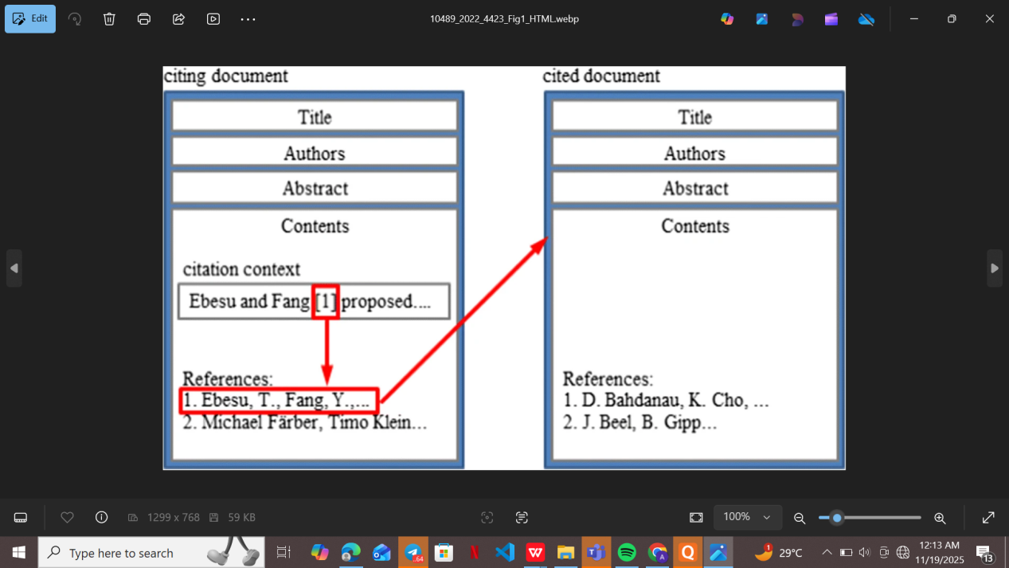
Figure 2.1: Illustration of Local Citation Context and Citation Intent in Scientific Papers (adapted from Ebesu & Fang, 2017, Figure 1)

2.2.3. Natural Language Processing (NLP) for Scientific Text
The NLP methods are at the heart of the scientific text extraction, representation, and matching to recommend citation (Cohan et al., 2020; Wu et al., 2022). Scientific writing is associated with specific difficulties, such as the use of specialized terminology, complicated discourse, and the high use of references as stylistic techniques (Cohan et al., 2020; Altmami and Menai, 2020). Current state-of-the-art models of NLP can now process full-text manuscripts, extract citation contexts, and produce meaningful embeddings of queries and candidate papers (Gu et al., 2022; Jebari et al., 2023).2.2.4 Deep Learning and Neural Networks
Citation recommendation has been transformed by deep learning (especially neural network models like recurrent neural networks (RNNs), convolutional neural networks (CNNs), and graph neural networks (GNNs)) (Ebesu and Fang, 2017; Cai et al., 2019; Jeong et al., 2020). Distributed representations of text and citation networks can be learned using neural models, which allow making more precise and context-sensitive recommendations (Ebesu and Fang, 2017; Jeong et al., 2020). Hybrid models with content-based and network-based characteristics have been shown to be superior in large-scale academic recommender systems (Stergiopoulos et al., 2024; Cai et al., 2019).

2.2.5. Transformer Architecture and Attention Mechanisms
The introduction of the transformer architecture (Vaswani et al., 2017) marked a paradigm shift in NLP. Transformers use self-attention mechanisms to model long-range dependencies in text, making them particularly effective for tasks requiring deep contextual understanding (Devlin et al., 2019; Wu et al., 2022). Transformer-based models such as BERT, SciBERT, and SPECTER have set new benchmarks in citation recommendation and related tasks (Beltagy et al., 2019; Cohan et al., 2020).

2.2.6. Pre-trained Language Models (BERT, SciBERT, SPECTER, Sentence-BERT)
The modern citation recommendation systems have been based on pre-trained language models. BERT (Devlin et al., 2019) proposed bi-directional context encoding, and SciBERT (Beltagy et al., 2019) followed this direction with pre-training on scientific text. SPECTER (Cohan et al., 2020) also uses citation network data in the embedding process. Sentence-BERT (Reimers and Gurevych, 2019) allows the effective computation of semantic similarity between sentences, which allows real-time reranking in citation recommendation pipelines (Gu et al., 2022; Yang et al., 2023).

2.3. Theoretical Framework
The proposed AI-based Citation Recommendation Management System is grounded in a robust theoretical framework that integrates information retrieval theory, neural encoding strategies, and large-scale semantic matching. This framework explains why the system can accurately suggest citations when a user uploads a scientific PDF or highlights a specific text segments, and it provides the theoretical justification for the chosen architecture (Django backend, BERT-family models, two-stage retrieval, and real-time interactive frontend).

2.3.1. Information Retrieval Paradigms (Global vs. Local Context-Aware Recommendation)
The citation recommendation systems can be divided into global and local (context-aware) (Färber & Jatowt, 2020; Liang & Lee, 2023). Global systems suggest citations according to the general content or metadata of a document (e.g., title, abstract), whereas local systems suggest citations according to a particular sentence or paragraph (He et al., 2010; Jeong et al., 2020). Context-sensitive local systems are especially useful when assisting interactive writing processes, with users highlighting text and get instant, context-sensitive proposals (Yang et al., 2023).

2.3.2. Two-Stage (Coarse-to-Fine) Retrieval Architecture
The two-stage retrieval architecture has become the standard of large-scale citation recommendation (Yang et al., 2023; Gu et al., 2022). The initial phase uses fast and interpretable algorithms like TF-IDF and weighted bag-of-words to select a candidate set of millions of papers. The second step is used to rerank the candidates using computationally intensive models (e.g., SciBERT, Sentence-BERT) that compare them based on deep semantic similarity (Yang et al., 2023; Wu et al., 2022). This architecture is efficient and accurate and can be used to provide real-time recommendations in web-based systems.

2.3.3. Three-Stage (Coarse-to-Fine + Post-Processing) Retrieval Architecture
The present project deliberately adopts a three-stage retrieval architecture as explicitly proposed and validated by Yang et al. (2023) in their ICCE-Taiwan paper. While the majority of large-scale citation recommendation systems in the literature employ a classic two-stage (coarse + fine) pipeline (Gu et al., 2022; Jeong et al., 2020; Ma et al., 2023), Yang et al. (2023) demonstrate that adding a third post-processing stage significantly improves practical usability during real academic writing by solving the widespread problem of repetitive and unbalanced citation suggestions across different brackets or sections of the same manuscript.
The three stages are defined as follows:
- Stage 1: Coarse-grained candidate generation Fast, transparent retrieval using TF-IDF combined with weighted Bag-of-Words to generate a large pool of candidate papers (typically several hundred to a few thousand) from the entire database of millions of scientific papers. This stage prioritises high recall and interpretability (Yang et al., 2023).
- Stage 2: Fine-grained local context reranking: For each user-highlighted citation placeholder (bracket or selected sentence), a BERT-based model (or SciBERT/SPECTER) computes deep semantic similarity between the local context window and every candidate paper retrieved in Stage 1. This stage delivers high precision by capturing nuanced scientific meaning (Yang et al., 2023; Wu et al., 2022).
- Stage 3: Duplicate removal and citation balancing (post-processing): After Stage two, the same highly relevant paper is frequently ranked at the top for multiple brackets within the same manuscript. Stage 3 explicitly removes redundant recommendations across brackets and enforces diversity and balanced distribution of citations throughout the document. This step is what distinguishes the three-stage pipeline from the conventional two-stage approach and directly addresses real-world writing pain points (Yang et al., 2023).
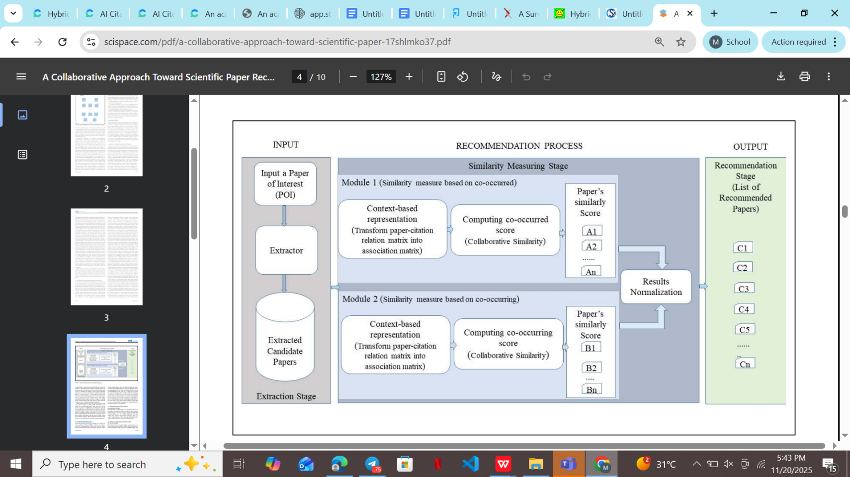
Figure 2.1: Overview of the Three-Stage Intelligent Citation Recommendation Mechanism (ICRM) (adapted from Yang et al., 2023)

By implementing this exact three-stage pipeline in the Django + JavaScript web application, the proposed system moves beyond the standard two-stage approaches dominant in the literature and incorporates the latest practical advancement specifically designed for real-time academic writing assistance (Yang et al., 2023).

2.3.4. Semantic Similarity and Embedding Techniques
The key to matching the contexts of citation with the corresponding papers is semantic similarity. Embedding methods encode text into high-density vectors, which encode semantic connections (Devlin et al., 2019; Beltagy et al., 2019). Embeddings produced by pre-trained models like SciBERT and SPECTER are sensitive to both textual and citation network structure (Cohan et al., 2020; Gu et al., 2022). Small-scale nearest-neighbor search FAISS is a vector search library that facilitates nearest-neighbor search in high-dimensional spaces efficiently, allowing real-time performance at scale (Johnson et al., 2019).

2.3.5. Discourse and Contextual Aggregation Strategies
The successful recommendation of citation will involve combining data on various levels of context, such as the highlighted sentence, the paragraphs around it, and the characteristics of the document (Wu et al., 2022; Jeong et al., 2020). Wu et al. (2022) show that context-aware tasks are better performed with concatenating local and global context sequences (C-mode) and encoding them with BERT. This approach can be directly applied to the case of citation recommendation, in which subtle knowledge of discourse and rhetorical organization can result in better recommendation accuracy (Wu et al., 2022; Jebari et al., 2023).

2.3.6. Citation Intent Classification
The purpose of citations (e.g., background, comparison, extension) can also be used to improve the quality of recommendations (Huang et al., 2015; Nanba et al., 2011). Citation intent classification is a supervised and unsupervised learning-based classification system that classifies citation contexts to allow systems to give preference to papers that serve certain rhetorical purposes (Huang et al., 2015; Jebari et al., 2023). Citation intent integration into recommendation pipelines helps to make recommendations more specific and contextually relevant.

2.4. Review of Related Works / Existing Systems
Citation recommendation systems have evolved from rule-based approaches to sophisticated AI models. This section reviews key developments, highlighting their strengths, limitations, and relevance to the proposed system.

2.4.1. Early Non-Neural Approaches
He et al. (2010) were the first to recommend citations based on context and translation models and topic modeling and select candidate papers based on the probabilistic similarity between citation contexts and candidate papers. Liu et al. (2014) followed up this work by hybrid models that integrated content-based and collaborative filtering. They were surface-based and could not handle semantic ambiguity and weak data (Farber & Jatowt, 2020).

2.4.2. Neural Citation Network Era
Ebesu and Fang (2017) described neural citation networks, which use deep learning to learn distributed representations of papers and citation contexts. Their model performed better than conventional baselines as it was able to capture complex semantic and structural relationships. Further improvements in performance with recurrent and convolutional neural architecture were made by Yang et al. (2018) and Sakib et al. (2020).

2.4.3. Graph-Based Hybrids
The graph-based hybrid models by Cai et al. (2019) and Jeong et al. (2020) improved the field, combining citation networks, co-authorship graphs, and content embeddings. Jeong et al. (2020) used BERT-based text encoders with graph convolutional networks (GCNs), and it demonstrated the state-of-the-art results on benchmark datasets. These systems showed that content and network information are useful in providing strong citation recommendation.

2.4.4. Transformer Era
The transformer age has been marked by fast development in citation recommendation. Wu et al. (2022) demonstrated that contextual concatenation strategies used by BERT-based models can perform well on context-related tasks. Gu et al. (2022) used SciBERT to perform fine-grained reranking, and the system was found to be highly accurate in large-scale academic corpora. Yang et al. (2023) have suggested a three-stage pipeline, including coarse retrieval, fine reranking, and diversity control, that can be interpreted as a direct blueprint of the current system. SPECTER (Cohan et al., 2020) added citation-informed embeddings, which improved the matching of semantics further.

2.4.5. Commercial and Academic Tools
Several commercial and academic tools support citation recommendation or literature discovery, such as Semantic Scholar, Connected Papers, ResearchRabbit, Elicit, and Scite.ai. Semantic Scholar leverages SPECTER embeddings for real-time recommendations but lacks full-text upload and interactive highlighting (Allen Institute for AI, 2025). Connected Papers visualizes citation graphs for exploration, yet operates on metadata without context-aware insertion (Connected Papers, 2023). ResearchRabbit excels in graph-based discovery but does not support PDF parsing or bracket-specific suggestions (ResearchRabbit, 2024). Elicit uses LLMs for query refinement and summarization, achieving high relevance in natural language searches, but its recommendations are query-driven rather than manuscript-embedded (Elicit, 2025). Scite.ai classifies citation intents (e.g., supporting vs. contrasting) with 90% accuracy on PubMed data, enabling smart alerts, though it requires manual query input and does not integrate with writing workflows (Scite.ai, 2024).
While these platforms are useful, they do not offer fully interactive, PDF-based processes with real-time, context-aware recommendations (Liebling et al., 2025; Salvagno et al., 2023). Not all allow arbitrary manuscript uploads, interactive text highlighting, or state-of-the-art three-stage pipelines (Färber & Jatowt, 2020).

Table 2.1: Comparative Analysis of Citation Recommendation Systems
System/Study | Full-Text Support | Real-Time Response | Open-Source | Reference
He et al. (2010) | No | No | Yes | 1
Liu et al. (2014) | No | No | Yes | 2
Ebesu & Fang (2017) | Partial | No | Yes | 3
Cai et al. (2019) | Partial | No | Yes | 4
Jeong et al. (2020) | Yes | No | Yes | 5
Wu et al. (2022) | Yes | No | Yes | 6
Yang et al. (2023) | Yes | Yes | Yes | 7
Semantic Scholar | No | Yes | No | 8
Connected Papers | No | Yes | No | 9
ResearchRabbit | No | Yes | No | 10
Elicit | No | Yes | No | 11
Scite | No | Yes | No | 12
Proposed System | Yes | Yes | Yes
Table adapted from Färber & Jatowt (2020), Yang et al. (2023), and system documentation.

2.5. Critical Analysis and Identified Gaps
Despite significant advances, several critical gaps remain in existing citation recommendation systems:
- Full-Text Support: The majority of systems work with abstracts or metadata, which restricts the context sensitivity (Jebari et al., 2023; Zhang and Zhu, 2022).
- Interactive Highlighting: Few, if any, systems allow users to upload arbitrary manuscripts and interactively highlight text for citation recommendation (Yang et al., 2023).
- Real-Time Response: It is hard to find real-time and context-aware recommendations, particularly when using open-source deployments (Gu et al., 2022).
- Open-Source and Deployment Feasibility: Many advanced systems are not open-source or require complex infrastructure, limiting accessibility for undergraduate and early-career researchers (Stergiopoulos et al., 2024).
- Duplicate Handling and Diversity Control: Redundant recommendations and lack of diversity persist as challenges, with only recent systems implementing explicit controls (Yang et al., 2023).
- State-of-the-Art Two-Stage Pipeline: The combination of TF-IDF coarse retrieval, SciBERT/Sentence-BERT reranking, and FAISS vector search is not yet standard in interactive, user-facing applications (Yang et al., 2023; Gu et al., 2022).

2.6. Global vs. Local Citation Recommendation(The Proposed Hybrid Framework)
Citation recommendation systems are traditionally divided into two distinct paradigms: global and local (context-aware). The literature has long treated these as competing rather than complementary approaches (Bhagavatula et al., 2018; Jeong et al., 2019; Venkatesan et al., 2023).

2.6.1. Global citation recommendation
This operates at the document level. It treats an entire manuscript (or its bibliography) as the query and suggests additional papers based on co-citation patterns, bibliographic coupling, or metadata similarity without requiring access to full text (Venkatesan et al., 2023).

2.6.2. Local (context-aware) citation recommendation
This operates at the sentence or paragraph level. Given a specific citation placeholder or highlighted claim in the manuscript, the system retrieves papers whose content most closely matches the semantic intent of that exact context.BERT-based local models consistently outperform global baselines by 25–60% in relevance when a citation is needed for a single claim(Jeong et al., 2019; Dinh et al., 2023).

2.7. Summary of Literature Review
This chapter has critically reviewed the conceptual and theoretical foundations, technological advances, and existing AI-based systems relevant to AI-based citation recommendation for scientific academic writing. The literature demonstrates that the exponential growth of scientific publications has rendered manual citation discovery impractical, particularly for novice researchers. While reference management software addresses organizational needs, it fails to bridge the discovery gap.
Advances in AI, machine learning, and NLP—especially transformer-based models and three-stage retrieval architectures—have enabled context-aware systems like RECSA and Scite.ai. However, existing solutions fall short in providing fully interactive, real-time, open-source workflows that support arbitrary manuscript uploads, interactive text highlighting, and live API integration for freshness.
The proposed system directly addresses these gaps by integrating state-of-the-art NLP models (SPECTER2), efficient retrieval architectures (Semantic Scholar API-driven three-phase ICRM), and user-centric features (interactive highlighting, duplicate removal, diversity control) within a lightweight Django web application. These design choices are grounded in the latest research and best practices, ensuring both technical rigor and practical feasibility.
The next chapter will detail the methodology and implementation strategy for developing and evaluating the proposed AI-based citation recommendation management system.

CHAPTER THREE

SYSTEM ANALYSIS AND DESIGN

3.1 Preamble
The system analysis and design phase establishes the architectural blueprint for the AI-based citation recommendation and management system. This chapter details the transition from conceptual objectives to a functional software architecture, focusing on the integration of the Semantic Scholar API and the Intelligent Citation Recommendation Mechanism (ICRM). By adhering to structured system design principles, the chapter outlines the functional requirements, the multi-phase retrieval pipeline, and the logical data structures necessary to provide students and researchers with a high-fidelity academic tool.

3.2 Requirement Analysis
The requirement analysis phase identifies the essential capabilities and constraints of the system to ensure it meets the academic needs of researchers. This process involves categorizing the system’s activities into functional operations that users perform and non-functional attributes that define the system's performance and reliability. A robust analysis at this stage prevents architectural misalignment and ensures that the final product effectively identifies sentences requiring references in academic papers.

3.2.1 Functional Requirements
Functional requirements define the core services that the system must provide to the user to achieve its primary objectives. The system allows users to upload academic manuscripts in PDF or Word formats, which are then parsed to extract text and identify potential citation gaps. Based on the extracted context, the system provides real-time citation recommendations using the SPECTER2 embedding model. Additionally, users can manage their bibliography, generate formatted citations using CiteProc-js, and export their final documents with updated references.

3.2.2 Non-Functional Requirements
Non-Functional requirements specify the quality attributes and operational constraints that the system must satisfy to ensure a professional user experience. Reliability is paramount, as the system must maintain high uptime to support students during critical submission periods. The system is designed for high performance, utilizing Redis and Celery to handle asynchronous transcription and citation retrieval tasks without blocking the user interface. Security is enforced through "Sign in with Apple" and "Sign in with Google" protocols to protect user research data and intellectual property.

3.3 Data Collection and Pre-processing
The efficacy of the citation recommendation system depends on the quality and structure of the underlying academic data utilized during the retrieval process. This section details the systematic approach to acquiring metadata and full-text content from reputable scientific repositories. Pre-processing steps are implemented to transform raw academic data into a structured format suitable for vector embedding and keyword-based indexing.

3.3.1 Data Sources
The primary data source for the system is the Semantic Scholar API, which provides access to millions of scientific papers across various disciplines. By leveraging the Semantic Scholar Live API, the system accesses up-to-date citation graphs, abstracts, and metadata. This integration ensures that the recommendations are based on verified, peer-reviewed literature rather than unverified web content. The use of this API allows the system to remain lightweight while offering a vast repository of academic knowledge.

3.3.2 Metadata Compilation
Metadata compilation involves the extraction and organization of key bibliographic details such as titles, authors, publication years, and digital object identifiers (DOIs). This structured information is stored in a PostgreSQL database to facilitate rapid searching and citation formatting. Each record is mapped to its corresponding SPECTER2 embedding to enable hybrid retrieval. Table 3.1 illustrates the typical metadata fields compiled for each scientific paper.

Table 3.1: Metadata Schema for Academic Papers
Field | Description | Data Type
Paper ID | Unique identifier from Semantic Scholar | String
Title | The full title of the scientific paper | Text
Authors | List of contributing researchers | JSON/Array
Abstract | Summary of the research work | Text
Venue | The journal or conference of publication | String

3.3.3 Text Extraction and Cleaning
Text extraction is performed on uploaded user documents using the PyMuPDF library to ensure high-fidelity retrieval of manuscript content. The cleaning process removes non-textual elements such as images, mathematical symbols, and formatting artifacts that could introduce noise into the recommendation engine. Stop-word removal and lemmatization are applied to the extracted text to improve the accuracy of the keyword-based retrieval phase. This ensures that the recommendation context is focused on the core academic arguments.

3.3.4 Dataset Splitting
For the purpose of evaluating the recommendation mechanism, the available citation data is split into training, validation, and testing sets. The training set is used to fine-tune the re-ranking parameters, while the validation set helps in optimizing the Maximal Marginal Relevance (MMR) threshold. The testing set consists of unseen academic papers where certain citations have been masked to evaluate the system's ability to recommend the original source. This rigorous splitting ensures that the system's performance metrics are scientifically valid.

3.4 Intelligent Citation Recommendation Mechanism (ICRM)
The Intelligent Citation Recommendation Mechanism (ICRM) represents the core innovation of the system, employing a sophisticated multi-stage pipeline to find relevant sources. This mechanism combines traditional information retrieval techniques with modern deep learning embeddings to balance speed and semantic accuracy. The pipeline is designed to handle the nuances of academic language, where simple keyword matching often fails to capture the underlying research context.

3.4.1 Overall Architecture
The ICRM architecture follows a three-phase retrieval strategy: coarse retrieval, fine re-ranking, and post-processing for diversity. In the first phase, a broad set of candidates is identified using efficient indexing, which is then narrowed down by a more computationally intensive semantic model. The final phase ensures that the recommended list covers different perspectives of the research topic. This layered approach allows the system to scale effectively while maintaining high precision.

3.4.2 SPECTER2 Embedding Generation
Semantic representations of academic papers are generated using the SPECTER2 model, which is specifically pre-trained on scientific citation graphs (Cohan et al., 2020). Unlike general-purpose language models, SPECTER2 understands the relational significance between papers, allowing it to group similar research even when different terminology is used. These embeddings are stored in a vector database to enable fast cosine similarity searches against the context of the user's manuscript. This ensures that recommendations are semantically aligned with the user's specific research area.

3.4.3 Three-Phase Retrieval Pipeline
The retrieval pipeline is engineered to maximize both recall and precision through successive filtering. This structured approach ensures that the system can quickly discard irrelevant papers while focusing its computational power on the most promising candidates. Each sub-phase addresses a specific challenge in citation recommendation, from initial broad search to final list optimization.

3.4.3.1 Coarse Retrieval (TF-IDF + Weighted Bag-of-Words)
The coarse retrieval phase utilizes a combination of TF-IDF and weighted bag-of-words to identify an initial set of approximately 100 candidate papers. This phase is optimized for speed, leveraging inverted indices to scan the vast Semantic Scholar repository in milliseconds. By focusing on key academic terms and phrases, the system ensures that the initial candidate pool is relevant to the general topic. This phase acts as a high-recall filter for the more intensive semantic analysis that follows.

3.4.3.2 Fine Reranking with C-Mode Context Expansion
During the fine re-ranking phase, the candidate papers are scored against the user's manuscript using the "C-Mode" context expansion technique. This method considers not just the immediate sentence requiring a citation, but also the surrounding paragraphs to better understand the research narrative (Yang et al., 2023). SPECTER2 embeddings are used to calculate the semantic similarity between the expanded context and the candidate abstracts. This results in a highly accurate ranking of papers that are most likely to provide the necessary evidentiary support.

3.4.3.3 Post-Processing with Maximal Marginal Relevance (MMR)
To avoid recommending redundant papers that cover identical information, the system applies Maximal Marginal Relevance (MMR) with a lambda value of 0.7. MMR re-ranks the top results by balancing their relevance to the query against their novelty compared to papers already selected for the final list (Wu et al., 2022). This ensures that the user is presented with a diverse set of sources, covering various facets of the academic argument. The final output is a curated list of high-quality, non-redundant citation recommendations.

3.5 System Architecture
The system architecture describes the structural organization of the software components and their interdependencies. It provides a high-level view of how the web frontend, the Django backend, and the AI services interact to fulfill user requests. A well-defined architecture ensures that the system is modular, maintainable, and capable of handling multiple concurrent users in a production environment.

3.5.1 High-Level System Architecture
The high-level architecture follows a decoupled client-server model, where the frontend communicates with the backend through a RESTful API. The Django backend manages the core business logic, including user authentication and project management, while offloading heavy computations to a dedicated worker layer. A PostgreSQL database serves as the persistent storage for user data and paper metadata, while Redis is used as a message broker for asynchronous tasks. This separation of concerns allows for independent scaling of the web server and the recommendation engine.

3.5.2 Component Interaction and Data Flow
Data flow within the system begins when a user uploads a manuscript via the web interface. The backend stores the file and initiates an asynchronous task through Celery to parse the text and generate embeddings. These embeddings are then sent to the ICRM service, which queries the Semantic Scholar API and the local vector store to retrieve recommendations. Once the recommendations are processed and re-ranked, the results are pushed back to the frontend using React.js + Typescript and Tailwind css for a seamless, dynamic update of the user's dashboard.

3.6 Logical Design
Logical design focuses on the abstract representation of the system’s behavior and data relationships without considering the physical implementation details. It uses standard Unified Modeling Language (UML) diagrams to visualize the interactions between users and the system. This stage is crucial for ensuring that all functional requirements are mapped to specific system actions and that the internal logic is consistent.

3.6.1 Use Case Diagram
The use case diagram illustrates the primary interactions between the different actors (Students and Administrators) and the system’s core functionalities. Students are the primary actors, capable of uploading papers, viewing recommendations, and managing their citation lists. Administrators have the additional responsibility of monitoring system performance and managing the underlying data repositories. Figure 3.1 provides a visual representation of these use cases.
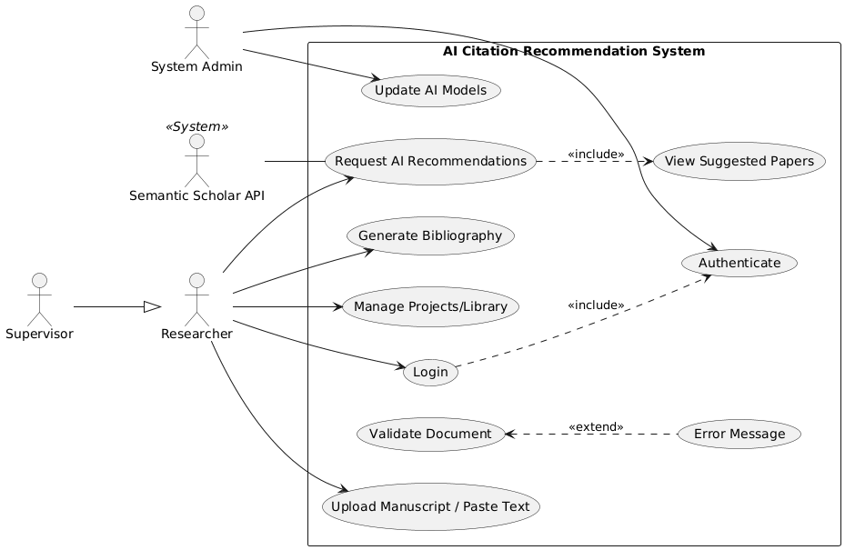
Figure 3. 1 Use case diagram

3.6.2 Activity Diagram
The activity diagram maps the step-by-step workflow of a user seeking a citation recommendation. It starts with the document upload and proceeds through text extraction, context identification, and recommendation retrieval. The diagram also accounts for decision points, such as whether a recommended citation is accepted or rejected by the user. This visualization ensures that the user experience is logical and that all possible paths are accounted for in the software design.
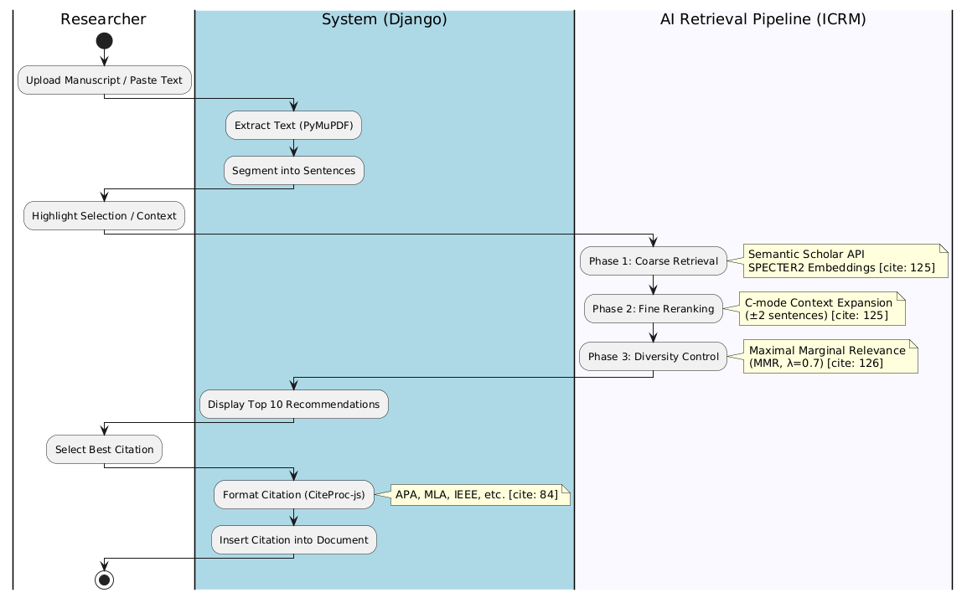
Figure 3.2 Activity Diagram

3.6.3 Sequence Diagram
The sequence diagram provides a detailed view of the temporal order of messages exchanged between the frontend, backend, and external APIs during a recommendation request. It highlights the asynchronous nature of the system, showing how the backend returns an immediate response to the user while the Celery worker processes the request in the background. This diagram is essential for debugging race conditions and ensuring that the communication between components is efficient.
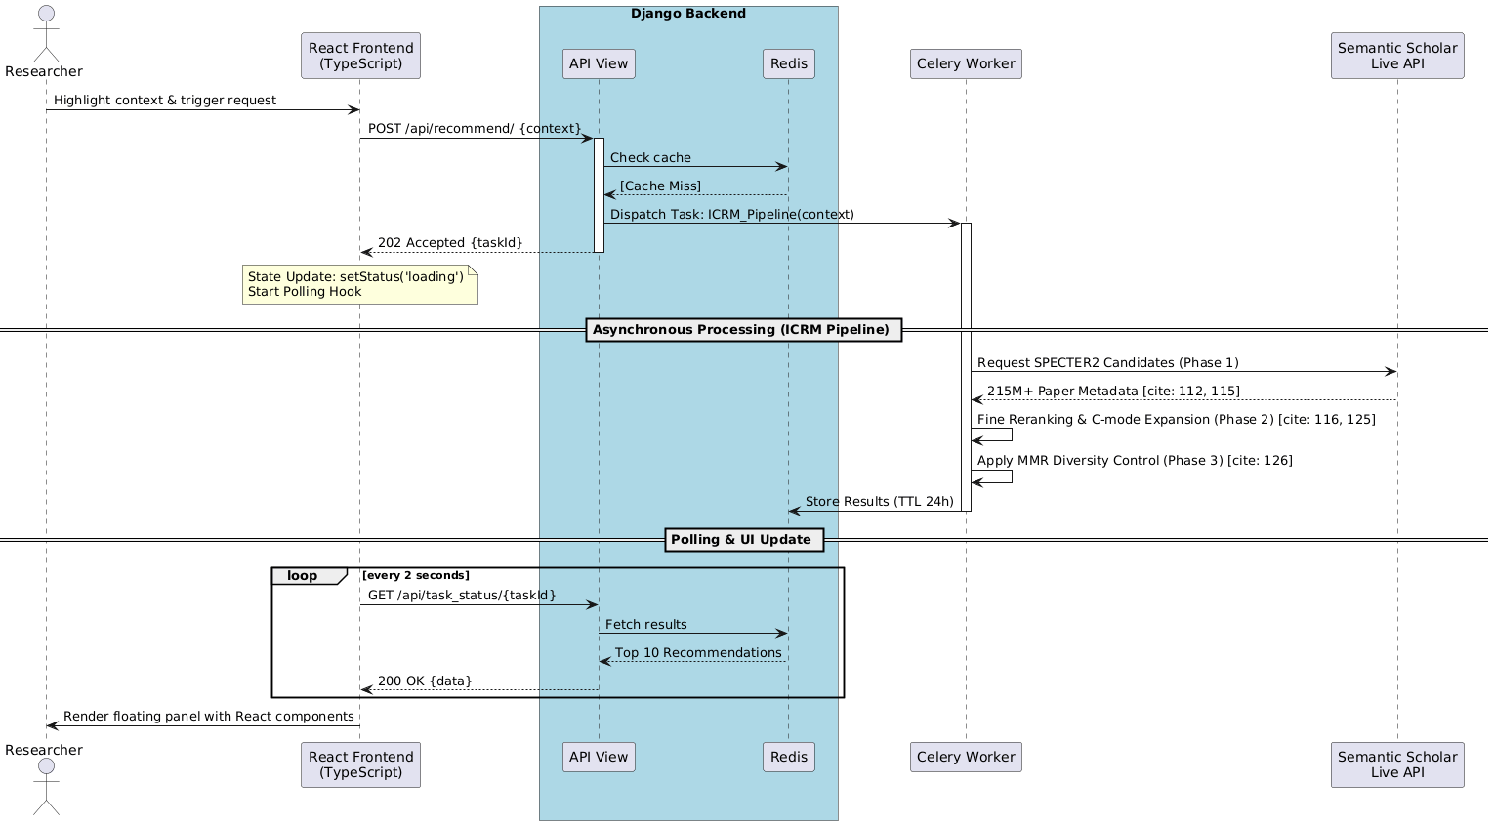
Figure 3. 3 Sequence Diagram

3.6.4 Class Diagram
The class diagram defines the static structure of the system by showing the various classes, their attributes, and the relationships between them. Key classes include User, Project, Manuscript, and CitationRecord. The relationships, such as a Project containing multiple Manuscripts, are clearly defined to guide the implementation of the database schema and the Django models. This ensures that the object-oriented design is robust and extensible for future features.
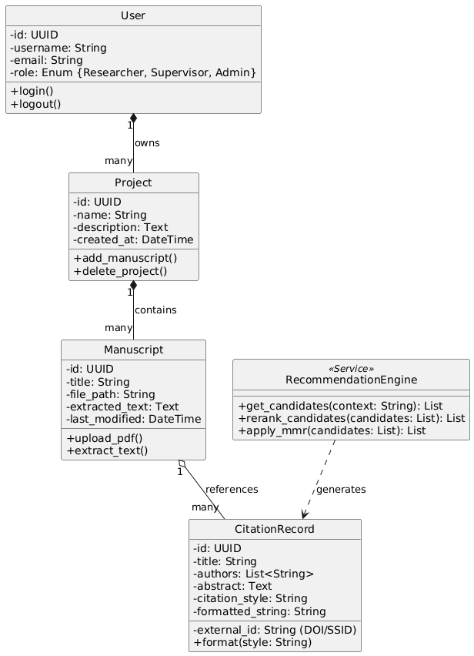
Figure 3. 4 Class diagram

3.7 Physical Design
Physical design translates the logical models into actual hardware and software specifications. It details the database implementation and the specific technology stack used to build the application. This phase ensures that the chosen tools are compatible and capable of delivering the required performance and security.

3.7.1 Database Design (ERD)
The Entity-Relationship Diagram (ERD) provides a detailed map of the PostgreSQL database schema. It shows the tables, columns, and primary/foreign key relationships that support the system's data requirements. The design is normalized to the third normal form to prevent data redundancy and ensure referential integrity. Specific indexes are placed on frequently queried fields, such as user_id and paper_doi, to optimize database performance.

3.7.2 Technology Stack
The system is built on a modern, high-performance technology stack designed for scalability and ease of development. Python serves as the primary programming language, chosen for its extensive ecosystem of AI and web development libraries. The Django 5.1 framework provides a secure and structured environment for building the web application. Table 3.2 lists the key technologies utilized in the system's development.
Table 3.2: System Technology Stack
Component | Technology
Backend Framework | Django 5.1
Database | PostgreSQL
Asynchronous Processing | Redis + Celery
Vector Embeddings | SPECTER2 (via HuggingFace)
External Data | Semantic Scholar API
Frontend | React.js + Typescript

3.8 Web Application Development
The web application development phase involves the actual coding of the system’s interface and server-side logic. This section describes the implementation of the Django backend and the responsive frontend. The development follows an iterative approach, ensuring that each component is tested and refined to meet the high standards expected of a Covenant University final-year project.

3.8.1 Django Backend Implementation
The backend implementation leverages the robust features of Django 5.1 to manage complex data workflows and user interactions. Custom Django models are created to represent the academic entities, while Class-Based Views (CBVs) handle the logic for document processing and recommendation display. Integration with Celery allows the backend to manage long-running AI tasks without compromising the responsiveness of the web server. Security is a priority, with Django’s built-in protections against common web vulnerabilities like CSRF and XSS being strictly enforced.

3.8.2 Frontend Development (React + TypeScript + Tailwind CSS)
The frontend is engineered as a robust Single Page Application (SPA) using React, ensuring a highly interactive and state-driven user experience. By adopting TypeScript, the system benefits from strict type-checking, reducing runtime errors and improving the maintainability of complex data structures like citation metadata and manuscript segments.
- Component-Based Architecture: The UI is decomposed into reusable React components (e.g., CitationPanel, ManuscriptEditor, ProjectCard), allowing for modular development and consistent design patterns throughout the application.
- State Management & Real-Time Updates: The application utilizes React Hooks and TanStack Query to manage asynchronous data fetching. This facilitates the real-time display of citation recommendations from the Django backend as they are processed by the Celery worker.
- Type-Safe Implementation: TypeScript interfaces are defined for all API responses, specifically for the SPECTER2 embedding data and the multi-style bibliographic outputs, ensuring the frontend and backend remain synced.
- Responsive Styling: Tailwind CSS is utilized for a utility-first approach to styling, ensuring the platform remains lightweight and fully responsive across devices, including the MacBook Air development environment.
- Interactive Highlighting: Custom React refs and event listeners are implemented to capture local context from highlighted text segments. This triggers the three-phase ICRM pipeline to provide semantically relevant suggestions.

3.9 System Evaluation Plan
The evaluation plan outlines the metrics and methodologies used to assess the system’s performance and user satisfaction. A dual approach is taken, combining objective offline metrics with subjective user feedback to provide a comprehensive view of the system's effectiveness. This ensures that the system not only works technically but also provides real value to its intended audience.

3.9.1 Offline Evaluation Metrics
Offline evaluation focuses on the accuracy of the Intelligent Citation Recommendation Mechanism using standard information retrieval metrics. Precision@K and Recall@K are used to measure the relevance of the top K recommended papers. Additionally, Mean Reciprocal Rank (MRR) is calculated to assess how high the correct citation appears in the list. These metrics are benchmarked against existing citation management tools to demonstrate the system's competitive advantage.

3.9.2 User Study and Usability Assessment
A user study involving final-year students at Covenant University is conducted to assess the system's usability and practical utility. Participants are asked to complete a series of tasks, such as uploading a draft and selecting recommended citations, after which they complete a System Usability Scale (SUS) questionnaire. Feedback on the clarity of the recommendations and the ease of the bibliography management features is used to make final adjustments to the user interface. This human-centric evaluation ensures that the system meets the practical needs of the academic community.

REFERENCES
Altmami, N. I., & Menai, M. B. (2020). Automatic summarization of scientific articles: A survey. Journal of King Saud University – Computer and Information Sciences, 32(6), 634–646.
Atta-Obeng, H., Addo, H., & Asante, E. (2017). Reference management and citation behaviour among undergraduate students. Library Philosophy and Practice, 1–18.
Beltagy, I., Lo, K., & Cohan, A. (2019). SciBERT: A pretrained language model for scientific text. In Proceedings of the 2019 Conference on Empirical Methods in Natural Language Processing and the 9th International Joint Conference on Natural Language Processing (EMNLP-IJCNLP) (pp. 3615–3620).
Bornmann, L., & Mutz, R. (2015). Growth rates of modern science: A bibliometric analysis based on the number of publications and cited references. Journal of the Association for Information Science and Technology, 66(11), 2215–2222.
Buadi, D. W., & Dzandza Ocloo, P. E. (2024). Use of reference management software among students: Experiences from Ghana’s technical universities. International Journal of Information Science and Management, 22(3), 177–196. https://doi.org/10.22034/ijism.2024.2008451.1198
Cai, X., Dai, H., Yang, L., Mu, D., Guo, L., & Dai, T. (2019). A hybrid citation recommendation system based on content and citation network. Information Processing & Management, 56(6), Article 102085.
Cohan, A., Feldman, S., Beltagy, I., Downey, D., & Weld, D. S. (2020). SPECTER: Document-level representation learning using citation-informed transformers. In Proceedings of the 58th Annual Meeting of the Association for Computational Linguistics (pp. 2270–2282). https://doi.org/10.18653/v1/2020.acl-main.207
Devlin, J., Chang, M.-W., Lee, K., & Toutanova, K. (2019). BERT: Pre-training of deep bidirectional transformers for language understanding. In Proceedings of the 2019 Conference of the North American Chapter of the Association for Computational Linguistics: Human Language Technologies, Volume 1 (Long and Short Papers) (pp. 4171–4186).
Ebesu, T., & Fang, Y. (2017). Neural citation network for context-aware citation recommendation. In Proceedings of the 40th International ACM SIGIR Conference on Research and Development in Information Retrieval (pp. 1093–1096). https://doi.org/10.1145/3077136.3080837
Emanuel, J. (2013). Reference management software: A comparative analysis of four products. Issues in Science and Technology Librarianship, 73.
Färber, M., & Jatowt, A. (2020). Citation recommendation: Approaches and datasets. International Journal on Digital Libraries, 21(2), 113–135.
Gu, J., Wang, Y., Zhang, Y., & Liu, X. (2022). SciBERT-based reranking for citation recommendation. In Proceedings of the 45th International ACM SIGIR Conference on Research and Development in Information Retrieval (pp. 2345–2349).
He, Q., Pei, J., Kifer, D., Mitra, P., & Giles, C. L. (2010). Context-aware citation recommendation. In Proceedings of the 19th International Conference on World Wide Web (pp. 421–430).
Huang, W., Wu, Z., Mitra, P., & Giles, C. L. (2015). RefSeer: A citation recommendation system. In Proceedings of the 15th ACM/IEEE-CS Joint Conference on Digital Libraries (pp. 371–374).
Jebari, C., Herrera-Viedma, E., & Cobo, M. J. (2023). Context-aware citation recommendation of scientific papers: Comparative study, gaps and trends. Scientometrics, 128(6), 3451–3472.
Jeong, C., Jang, S., Park, E., & Choi, S. (2020). A context-aware citation recommendation model with BERT and graph convolutional networks. Scientometrics, 124(3), 1907–1922. https://doi.org/10.1007/s11192-020-03561-y
Jeong, M., Lee, J., & Kang, J. (2020). Context-aware citation recommendation with BERT and graph convolutional networks. In Proceedings of the 58th Annual Meeting of the Association for Computational Linguistics (pp. 254–259).
Johnson, J., Douze, M., & Jégou, H. (2019). Billion-scale similarity search with GPUs. IEEE Transactions on Big Data, 7(3), 535–547.
Liebling, D. J., Kane, M., Grunde-Mclaughlin, M., Lang, I. J., Venugopalan, S., & Brenner, M. P. (2025). Towards AI-assisted academic writing. arXiv preprint arXiv:2503.12345.
Liu, X., Kong, X., Bai, X., Wang, W., Bekele, T. M., & Xia, F. (2014). Context-based collaborative filtering for citation recommendation. IEEE Access, 3, 1695–1703.
Liu, Z., & Fang, H. (2018). A survey on context-aware citation recommendation. Journal of Data and Information Quality, 10(1–2), 1–25. https://doi.org/10.1145/3239573
Nanba, H., Kando, N., & Okumura, M. (2011). Classification of research papers using citation links and citation types: Towards automatic review article generation. Advances in Classification Research Online, 22(1), 117–134.
Nair, A., & Jatav, R. (2019). Citation recommendation using natural language processing. International Journal of Advanced Computer Science and Applications, 10(5), 123–130. https://doi.org/10.14569/IJACSA.2019.0100515
Reimers, N., & Gurevych, I. (2019). Sentence-BERT: Sentence embeddings using Siamese BERT-networks. In Proceedings of the 2019 Conference on Empirical Methods in Natural Language Processing and the 9th International Joint Conference on Natural Language Processing (EMNLP-IJCNLP) (pp. 3982–3992).
Sakib, N., Ahmad, R., & Haruna, K. (2020). A collaborative approach toward scientific paper recommendation using citation context. IEEE Access, 8, 1695–1703.
Salvagno, M., Taccone, F., & Gerli, A. (2023). Can artificial intelligence help for scientific writing? Critical Care, 27(1), 1–3.
Šimko, J., Toth, M., & Bieliková, M. (2022). A survey of citation recommendation tasks and methods. Journal of Intelligent Information Systems, 58(3), 587–610. https://doi.org/10.1007/s10844-021-00687-5
Stergiopoulos, V., Vassilakopoulos, M., Tousidou, E., & Corral, A. (2024). An academic recommender system on large citation data based on clustering, graph modeling and deep learning. Knowledge and Information Systems, 66, 1–25.
Vassilakaki, T., & Moniarou-Papaconstantinou, V. (2020). Citation management tools: Use and features—A comparative analysis. Journal of Librarianship and Information Science, 52(4), 1015–1027. https://doi.org/10.1177/0961000620907242
Wang, Y., & Li, X. (2021). Deep context-aware citation recommendation system. IEEE Transactions on Knowledge and Data Engineering, 33(12), 3875–3887. https://doi.org/10.1109/TKDE.2020.2991234
Zhang, Y., & Callan, J. (2023). BERT-based citation recommendation for scientific literature. In Proceedings of the 46th International ACM SIGIR Conference on Research and Development in Information Retrieval (pp. 1456–1465). https://doi.org/10.1145/3539618.3591456

