Programming in Python CST 362
Assignment 3

Mayon Francis
CS6A
44

1. List Manipulation
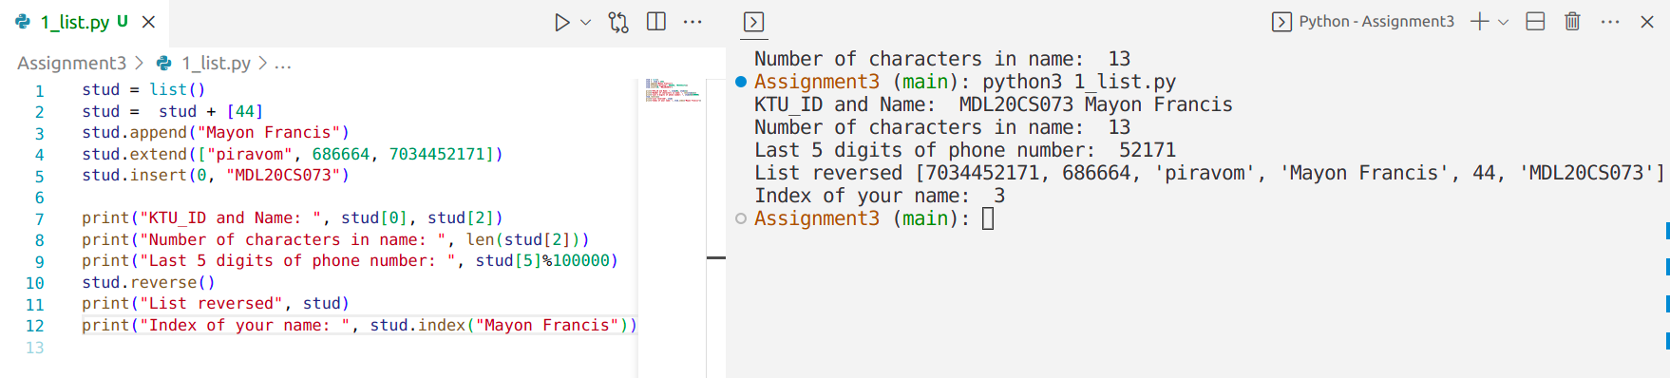
2. Read list of numbers and store it in a list. Create two new lists from the list created which contains prime and composite numbers.
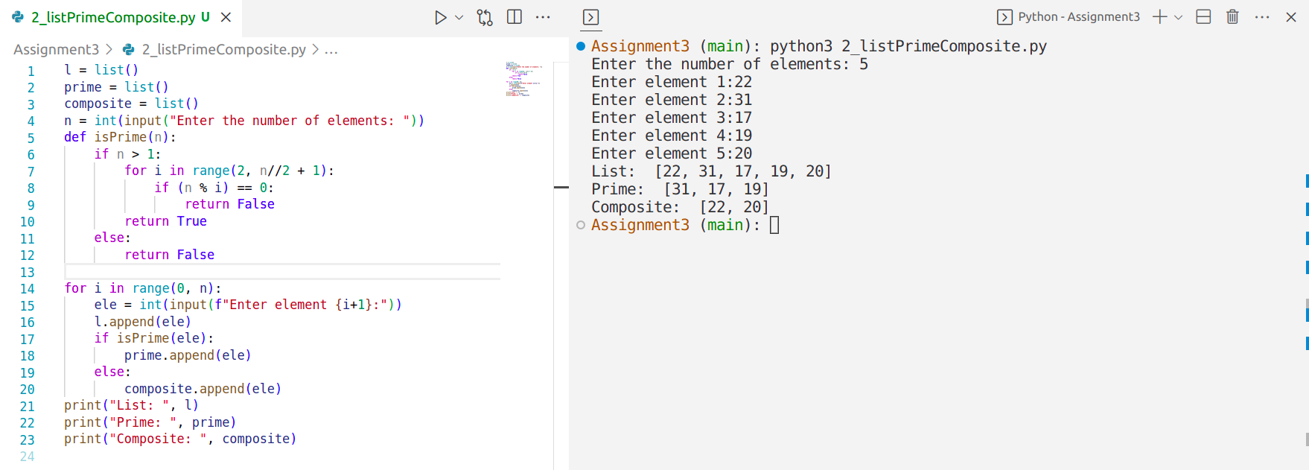
3. Read list of students names and do the following
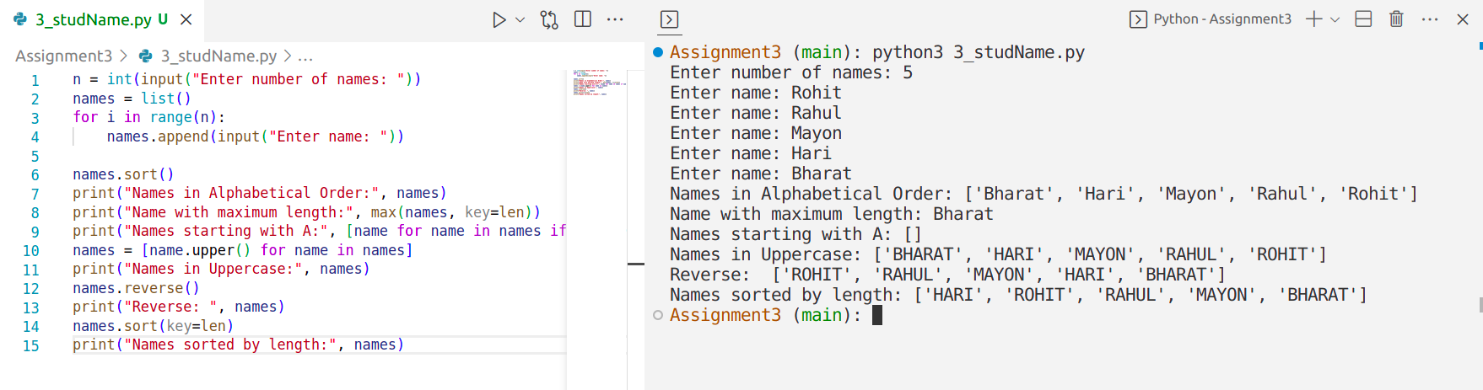
4. Use list comprehension to create lists
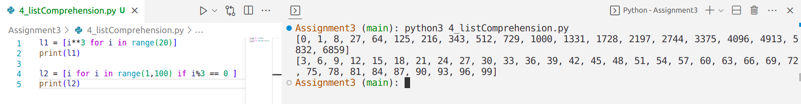

5. Read 10 numbers and stores it in a tuple. Find the sum, average of these elements also find the
largest and smallest.
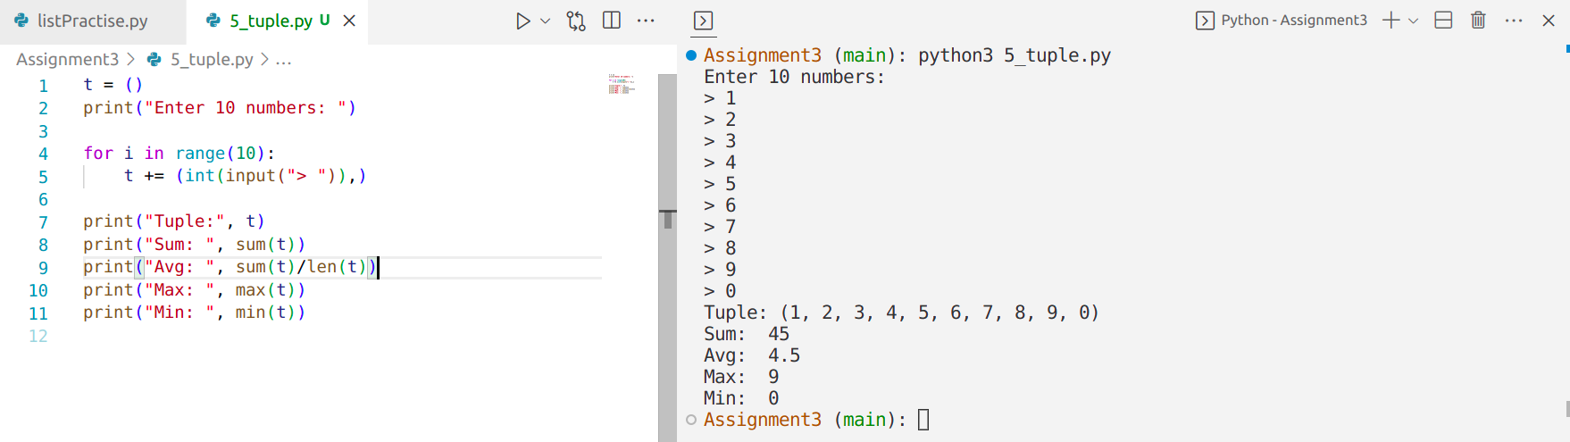

6. Find the union, intersection and symmetric difference of two sets A and B. Read the sets.
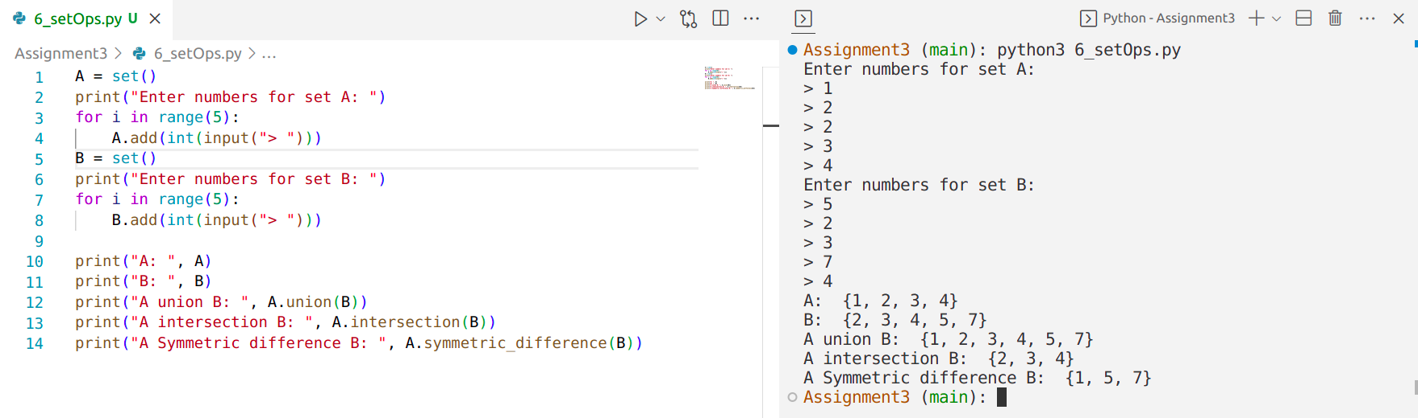
7.Read a string and print the words in alphabetical order

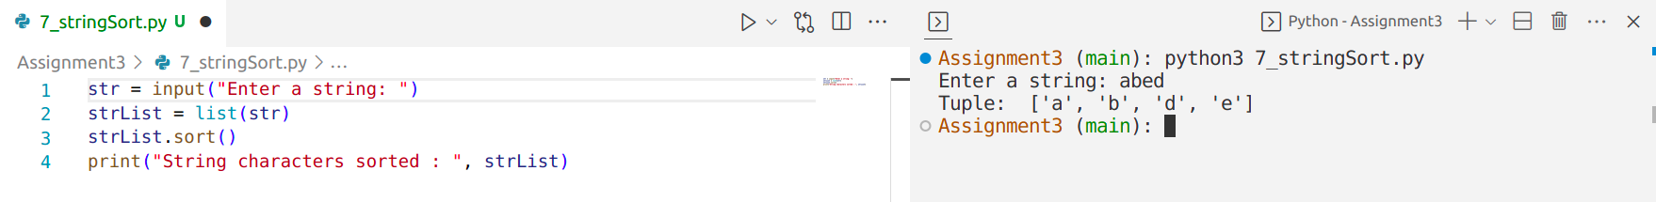

8.Read a string and print the words and its legth.Also find the average word length.
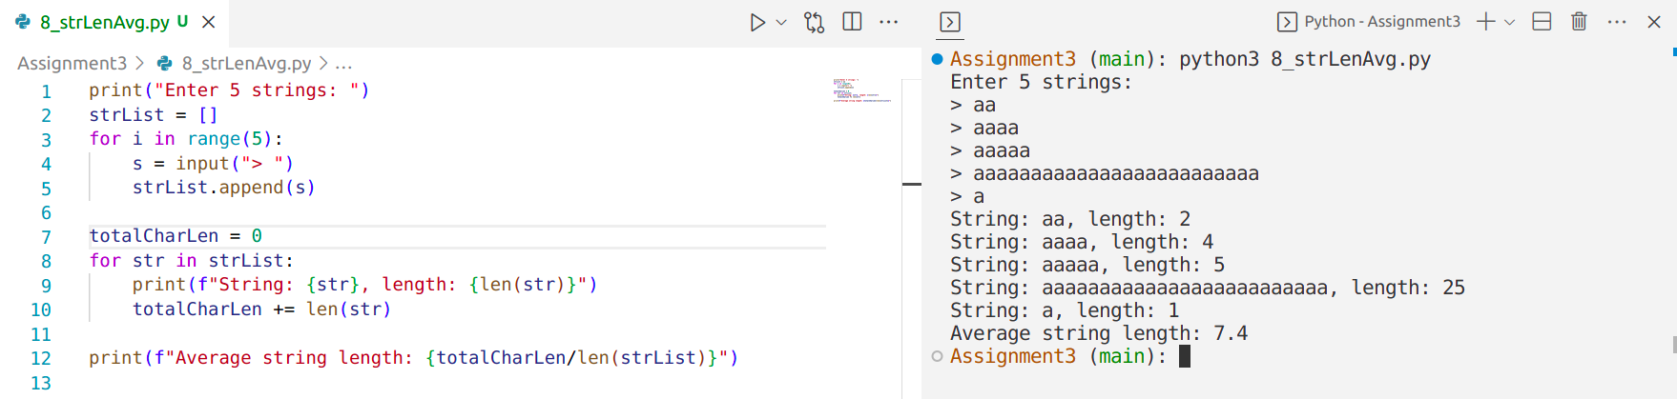

9.Read list of numbers and find the mean, median and standard deviation.
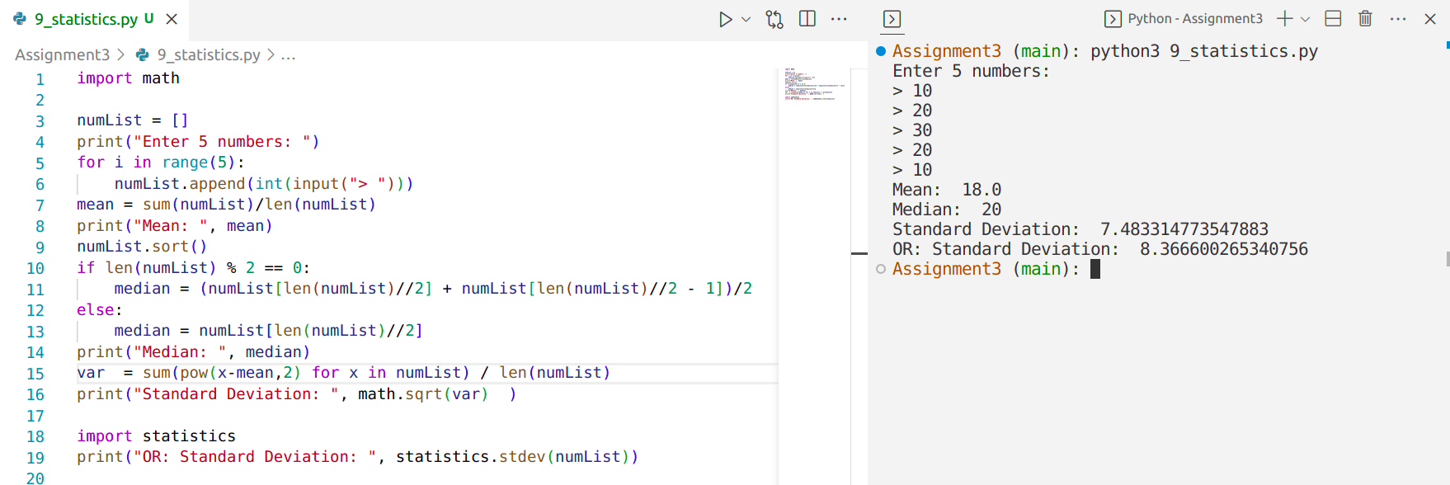

10. Consider a list consisting of integers, floating point numbers and strings. Separate them into different lists depending on the data types.
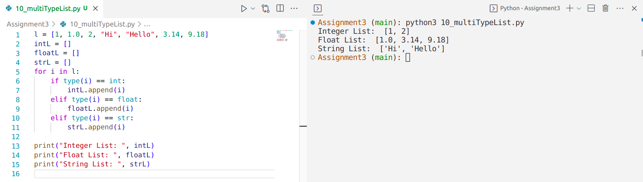

11. Check if the items in the list are sorted in ascending or descending order and print suitable messages accordingly. Otherwise, print “Items in list are not sorted”

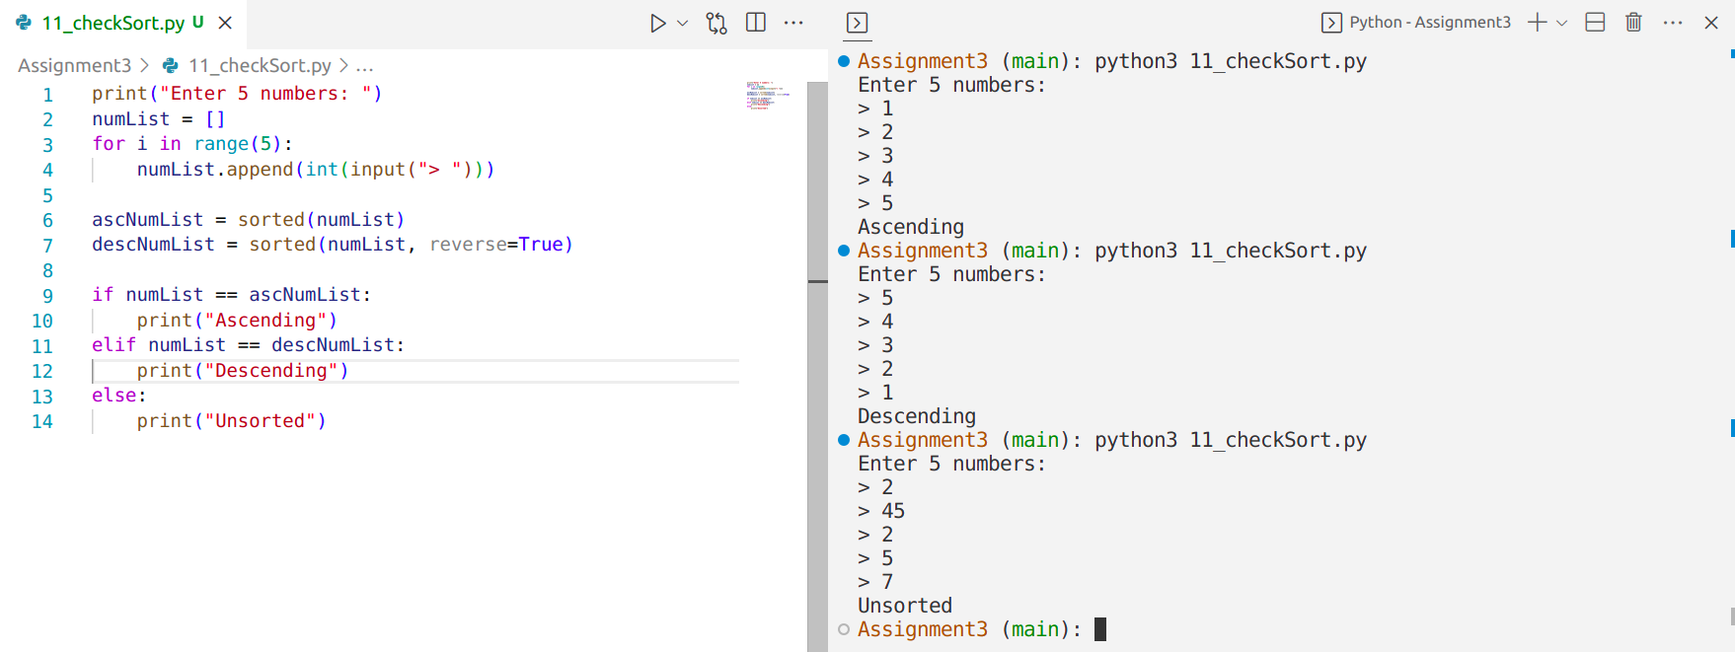

12.Remove all duplicate elements from a list i/p:10 20 20 30 40 o/p:10 30 40

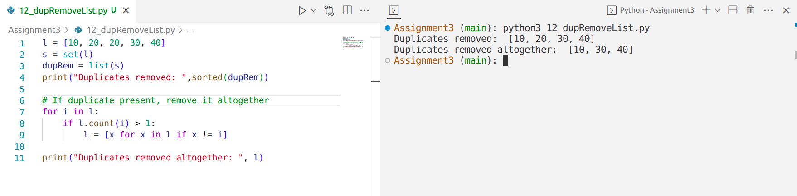

13.Find the number with largest frequency of occurrence. i/p:10 20 30 40 40 40 50 50 o/p:40

