Programming in Python CST 362
Assignment 7

Mayon Francis
CS6A
44

1.Draw the first letter of your name using turtle graphics. (M)
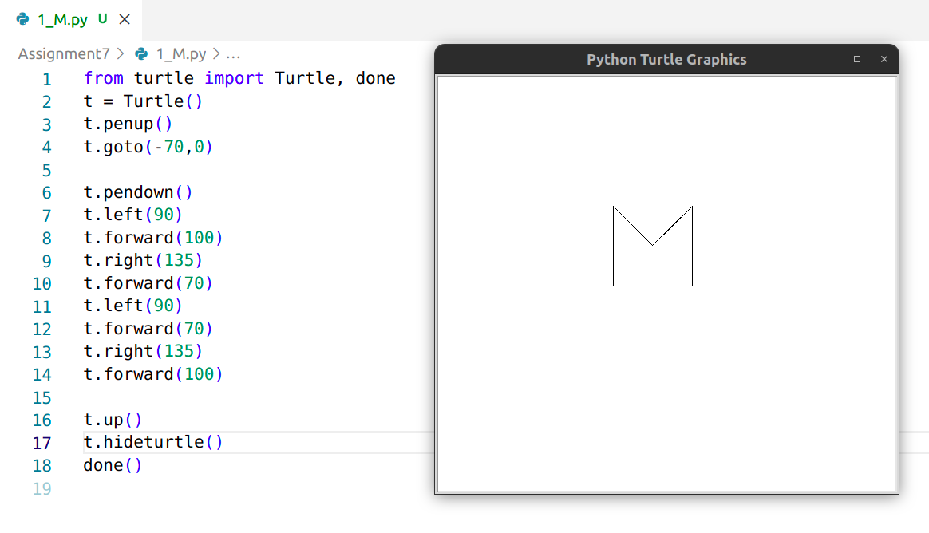
2. Draw the following figure (Face)
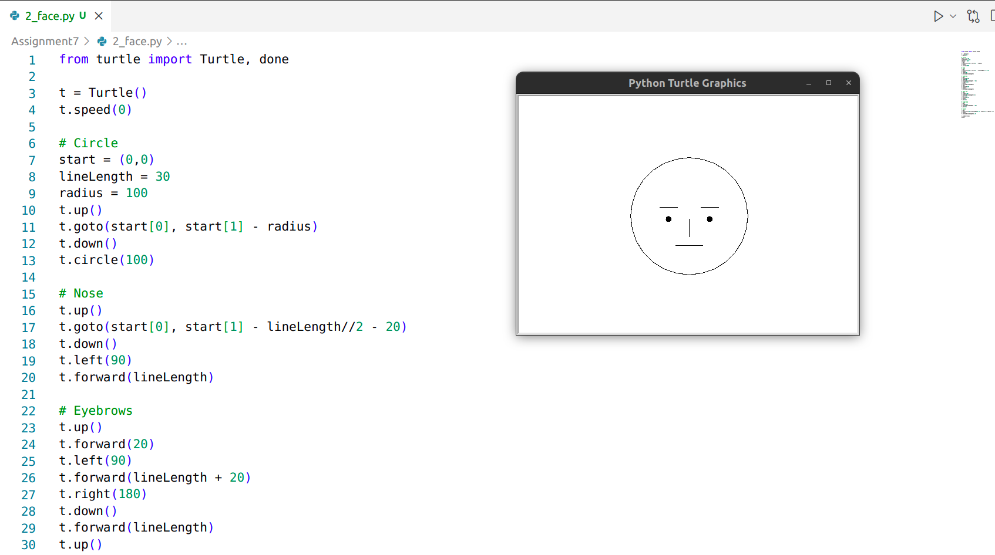

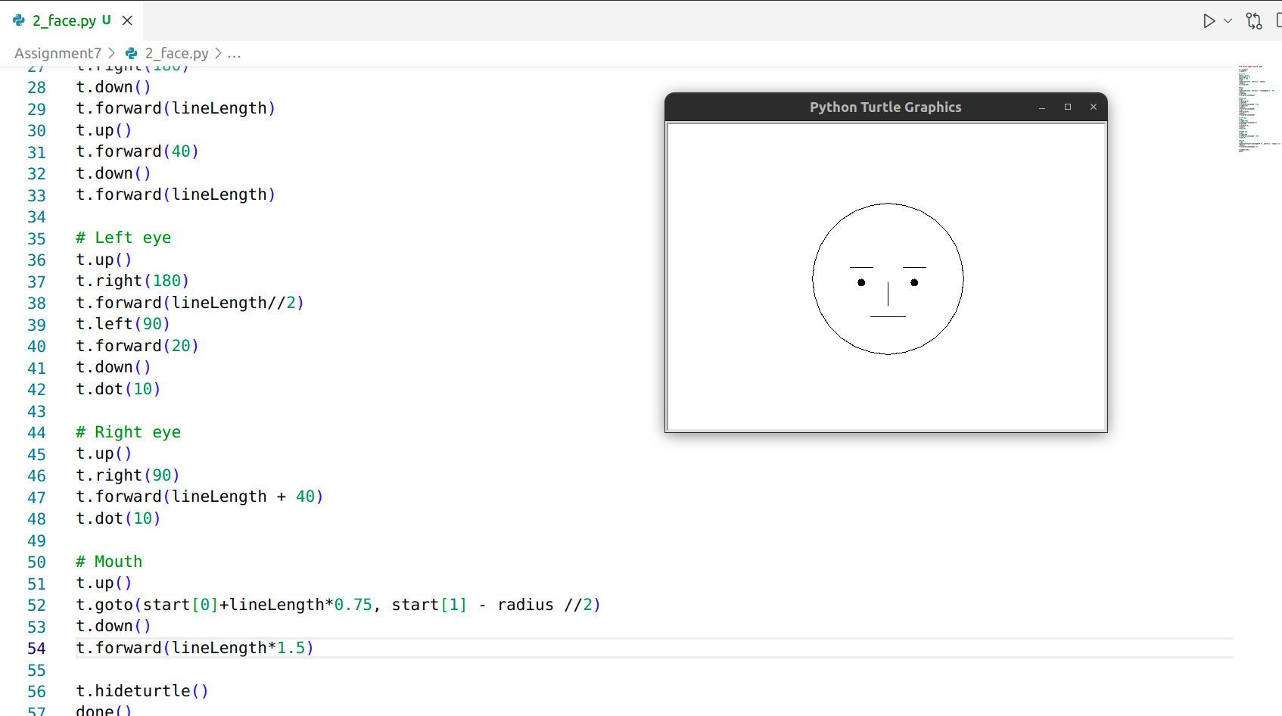

3.Draw a filled hexagon.( red color hexagon filled with yellow color)
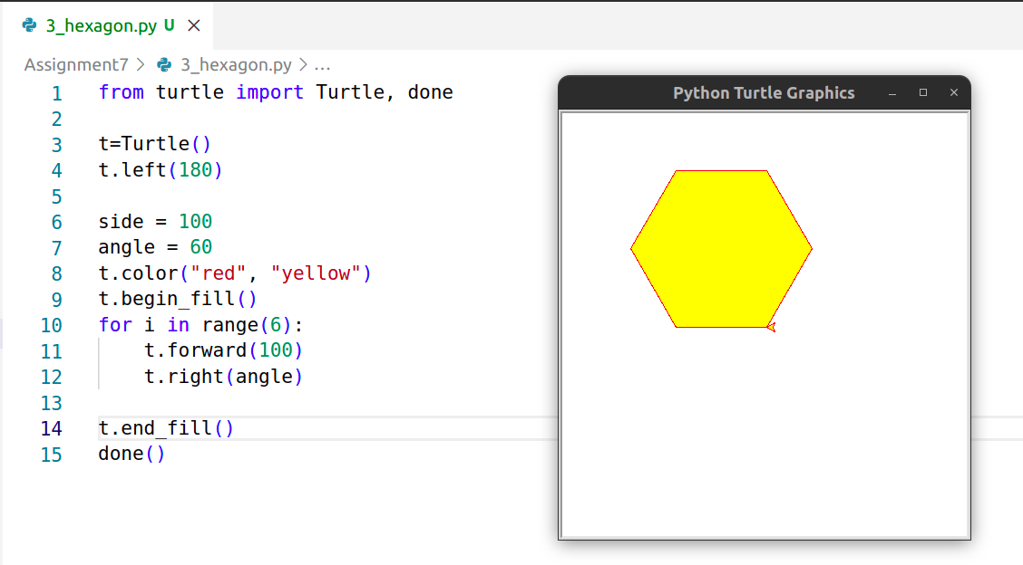

4.Draw a polygon. Coordinates of the polygon are stores in a list as tuples.
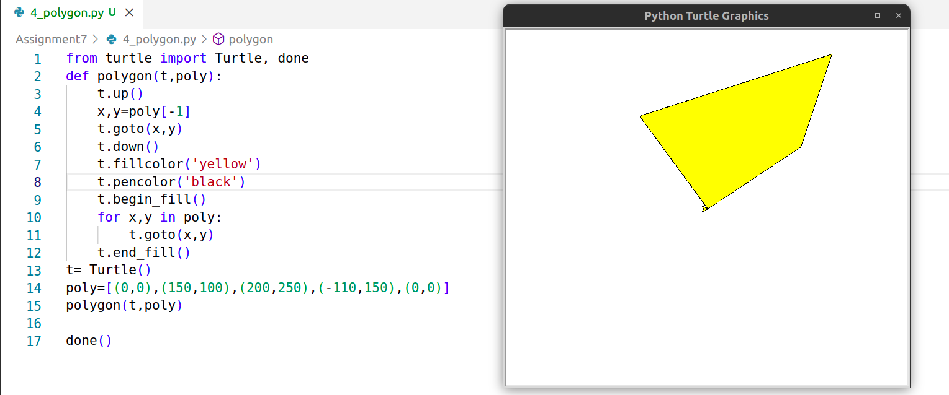

5. Draw a star
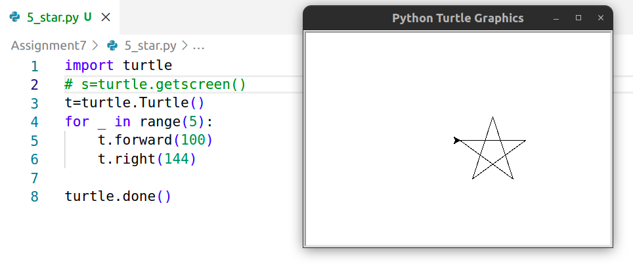

6.Take a selfy and create a gif file(use paint) and save it in your working directory as myimage.gif
7.Use image package shared earlier do the following Read and Display the image and image details
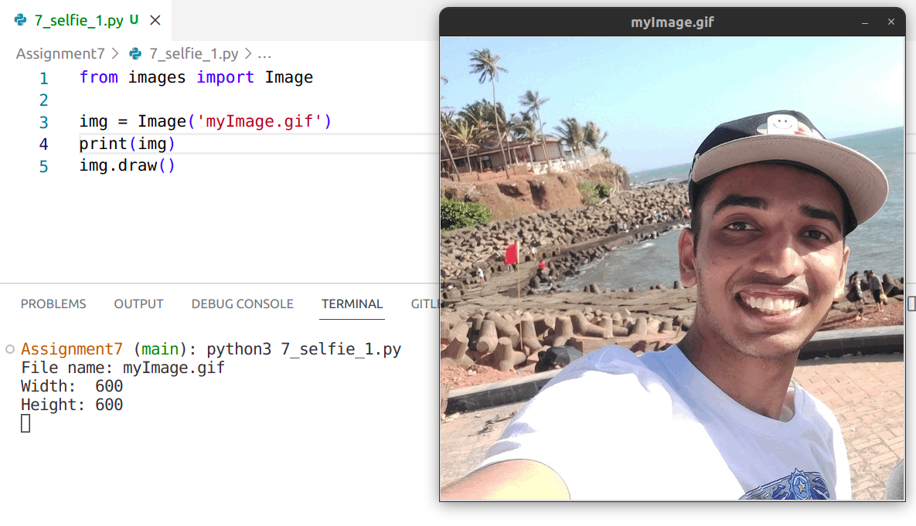

Convert the image into black and white
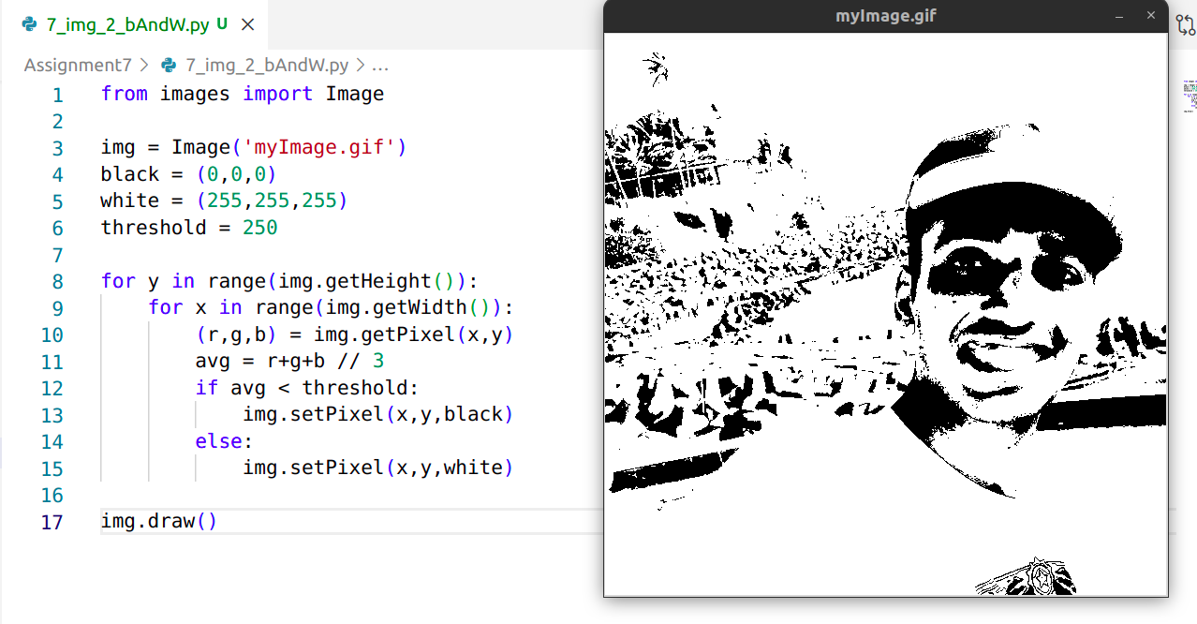

Convert the image into gray scale
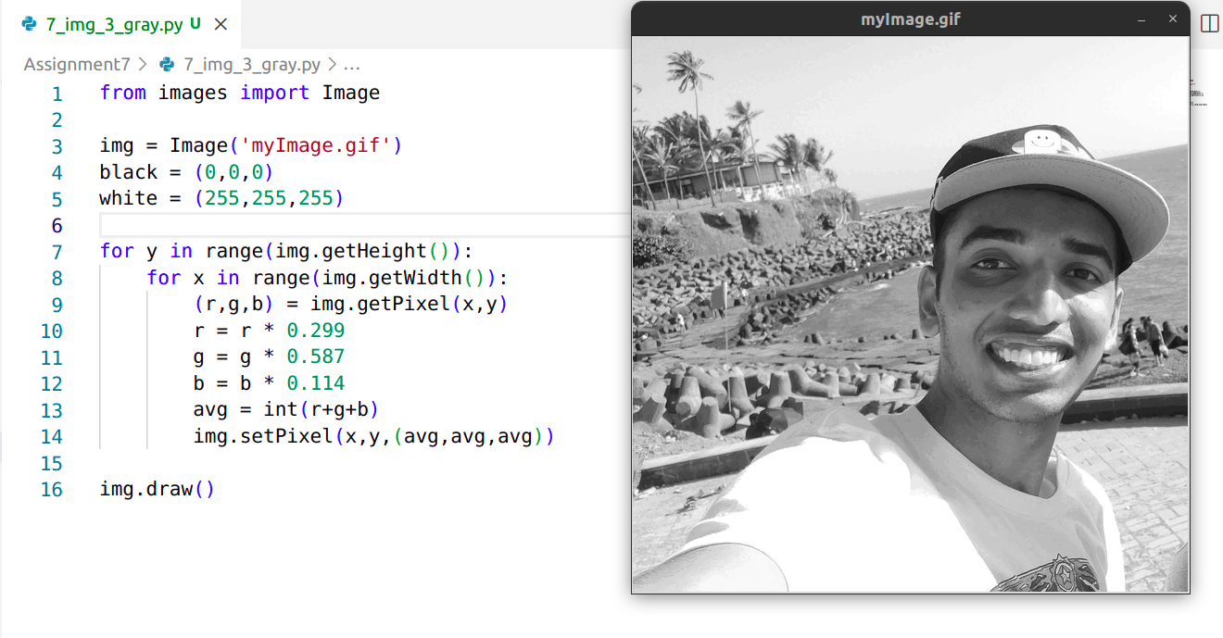
Scale the image into one half
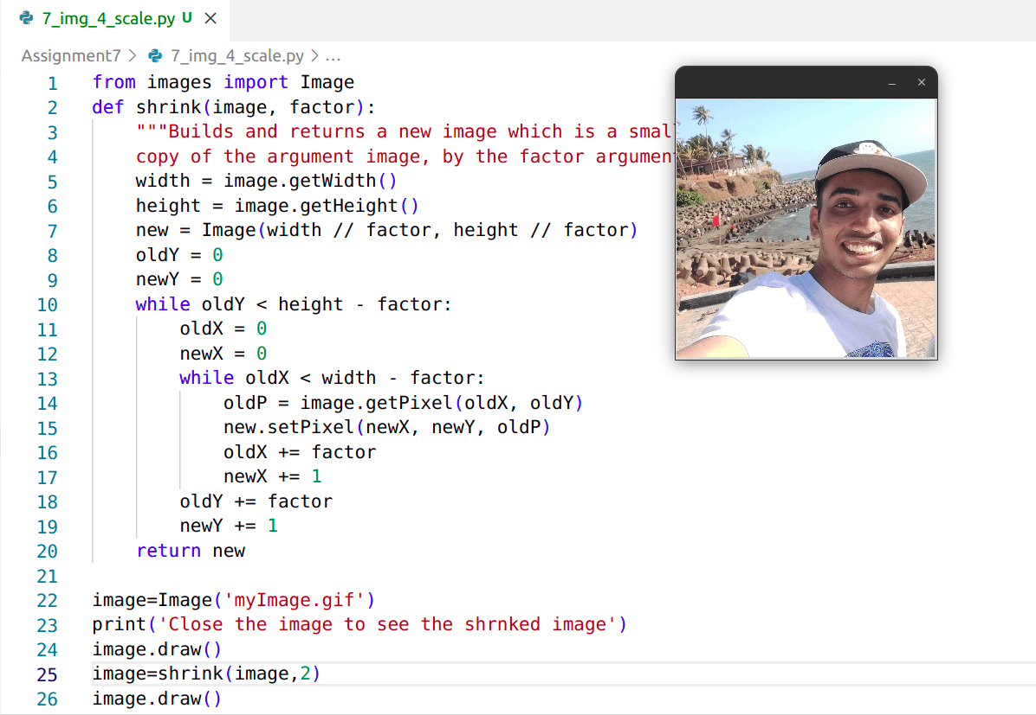

Blur the image
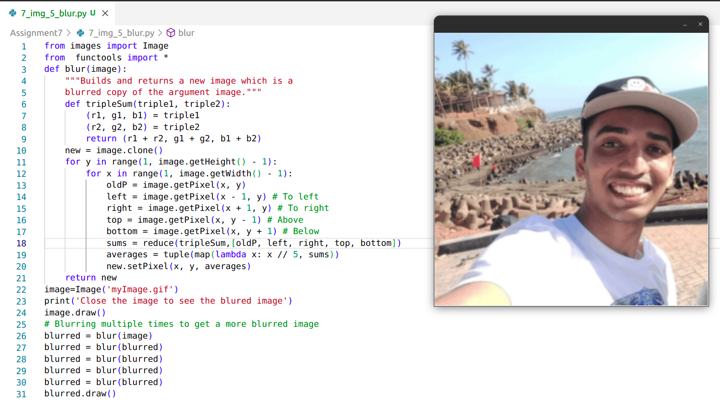

Place a block rectangle strip on the face
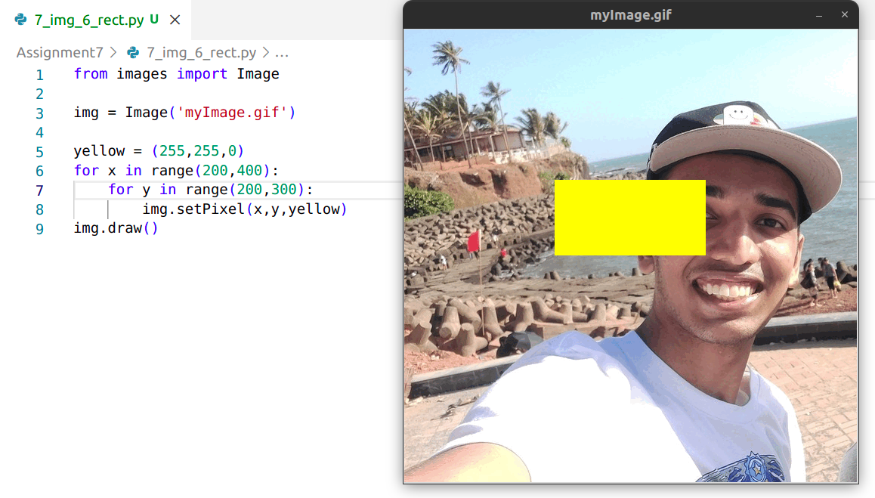

8. Create the GUI Applications using tkinter Read radius of a circle ( use entry box to read) and find the area and circumference( use two separate command button and associated functions)
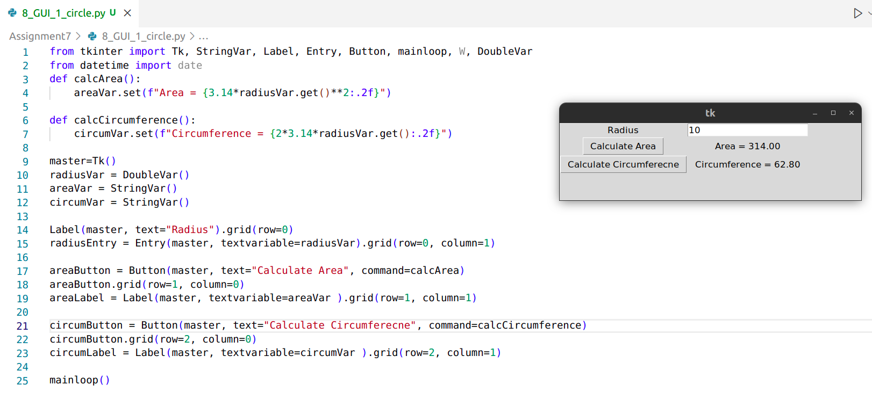
8. b) Write a GUI-based program that allows the user to convert temperature values between degrees Fahrenheit and degrees Celsius. The interface should have labeled entry fields for these two values. These components should be arranged in a grid where the labels occupy the first row and the corresponding fields occupy the second row. At start-up, the Fahrenheit field should contain 32.0, and the Celsius field should contain 0.0. The third row in the window contains two command buttons, labeled >>>> and <<<<. When the user presses the first button, the program should use the data in the Fahrenheit field to compute the Celsius value, which should then be output to the Celsius field. The second button should perform the inverse function.
