Programming in Python CST 362
Assignment 2

Mayon Francis
CS6A
44

1. Print the sin series x-x^3/3!+x^5/5!....x^n/n! ( read n)
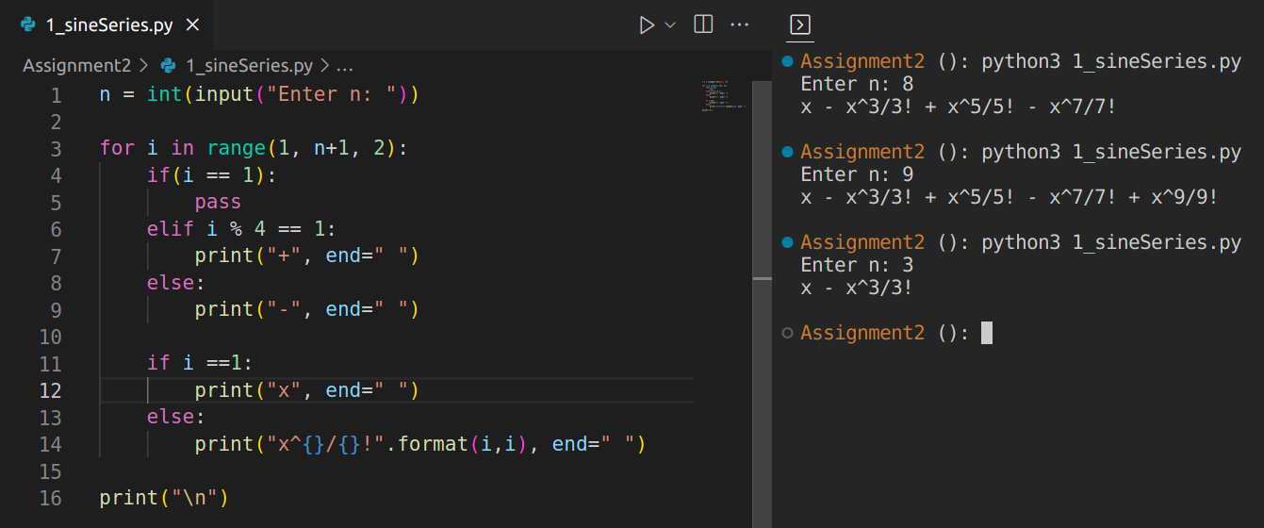

2. In the above program read the value x and find the sum of the series
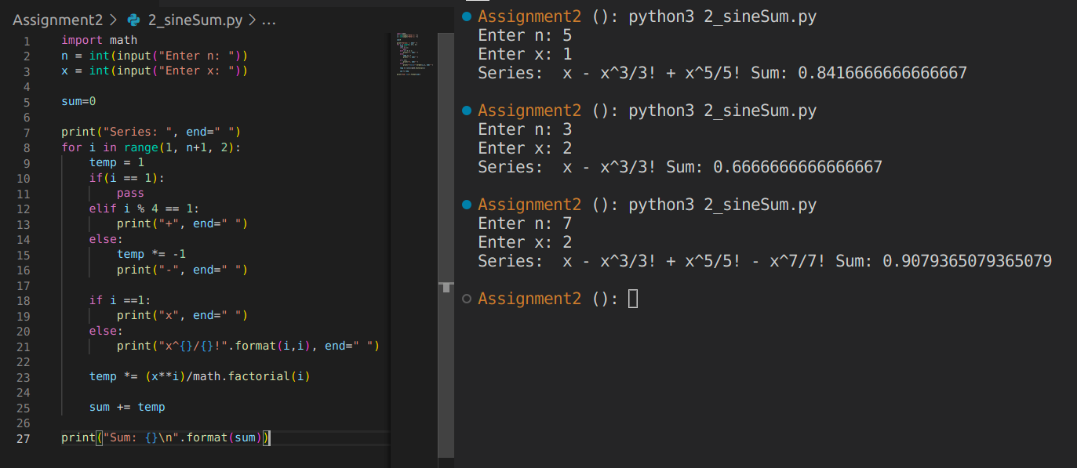

3. Print pyramid for n
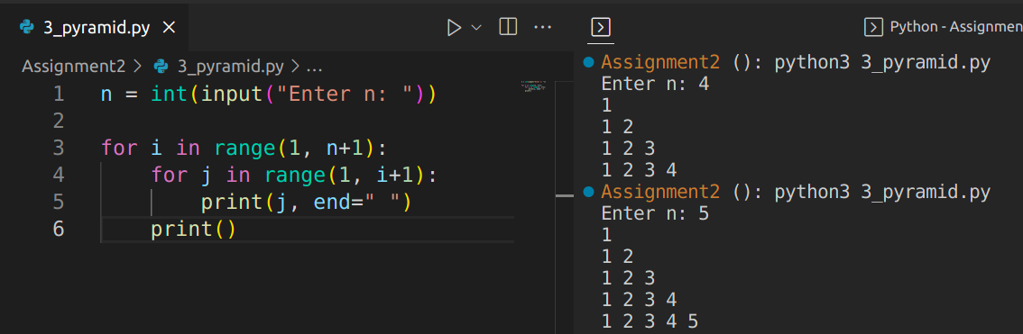

4. Reverse a number and also find the sum of the digits
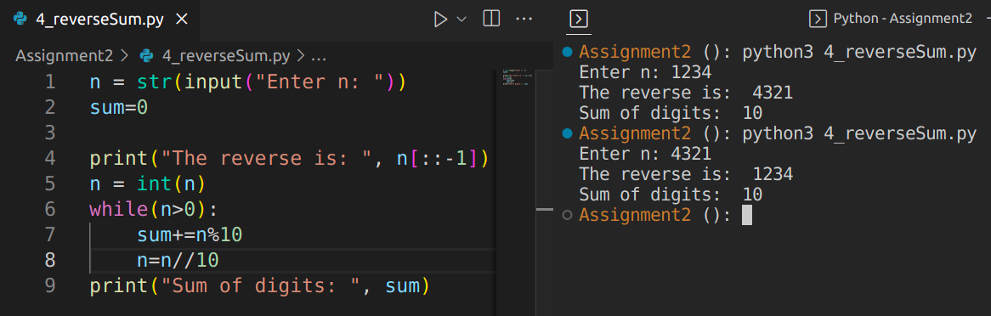

5. Check if armstrong
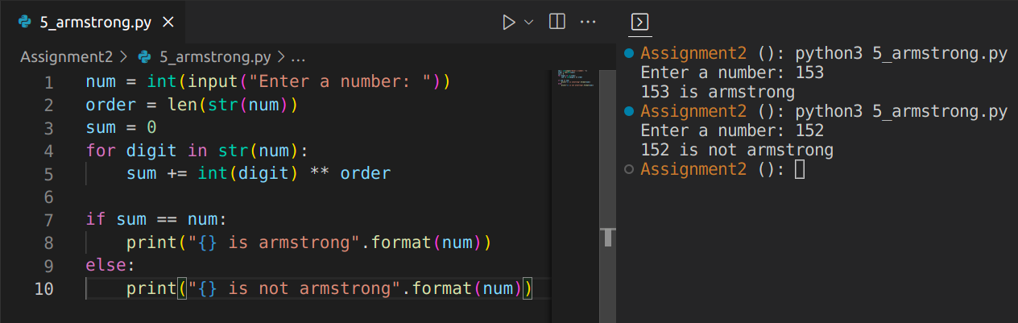
6. Calculate Root using newton’s method

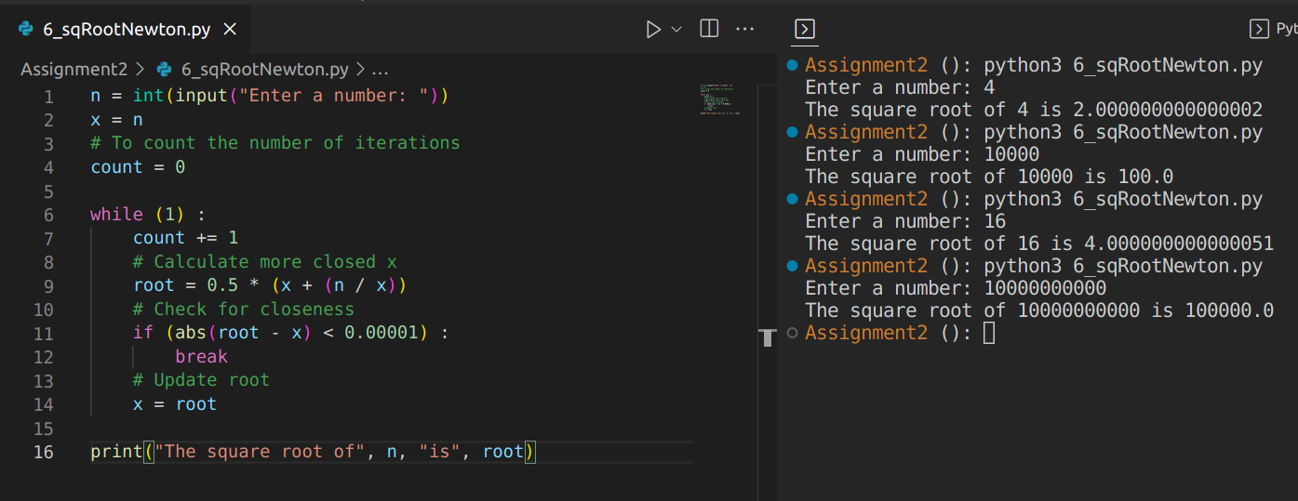
7. Investment Report
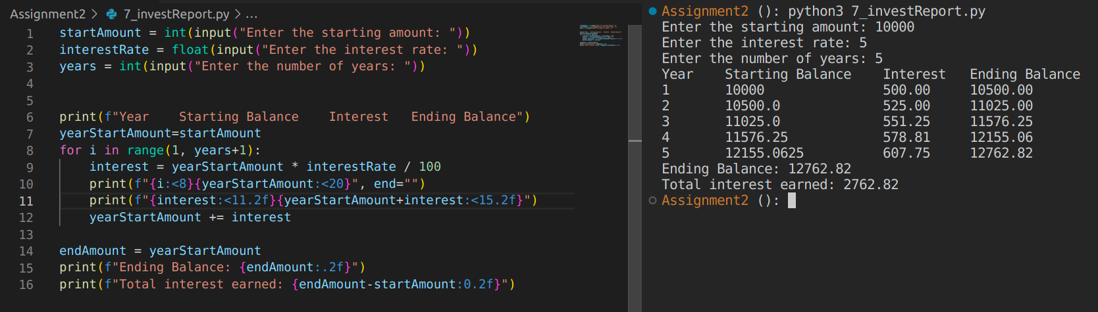
8. Check if krishnamurthy number
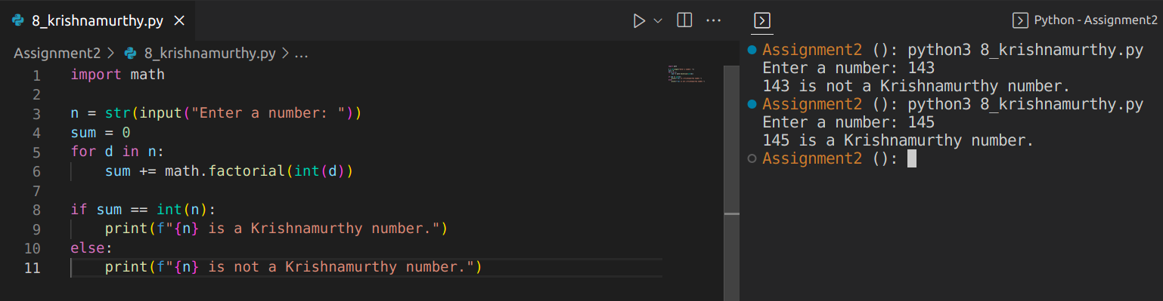

9. Sum of First and Last digit
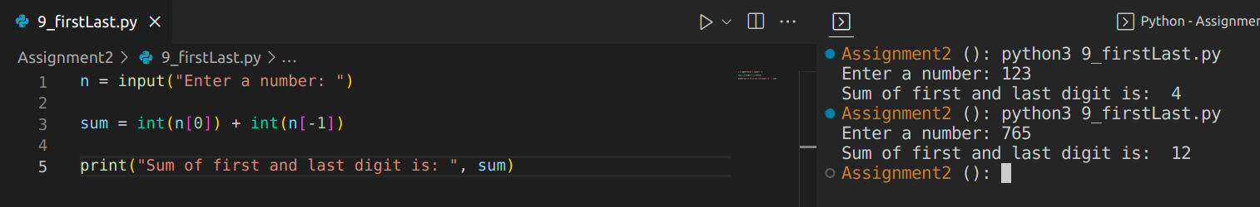
10. Print number in words (Digit wise)

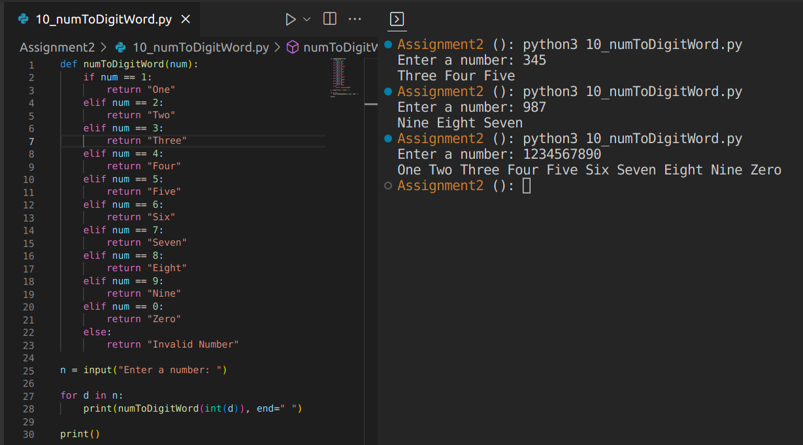

Strings

1. String Manipulation
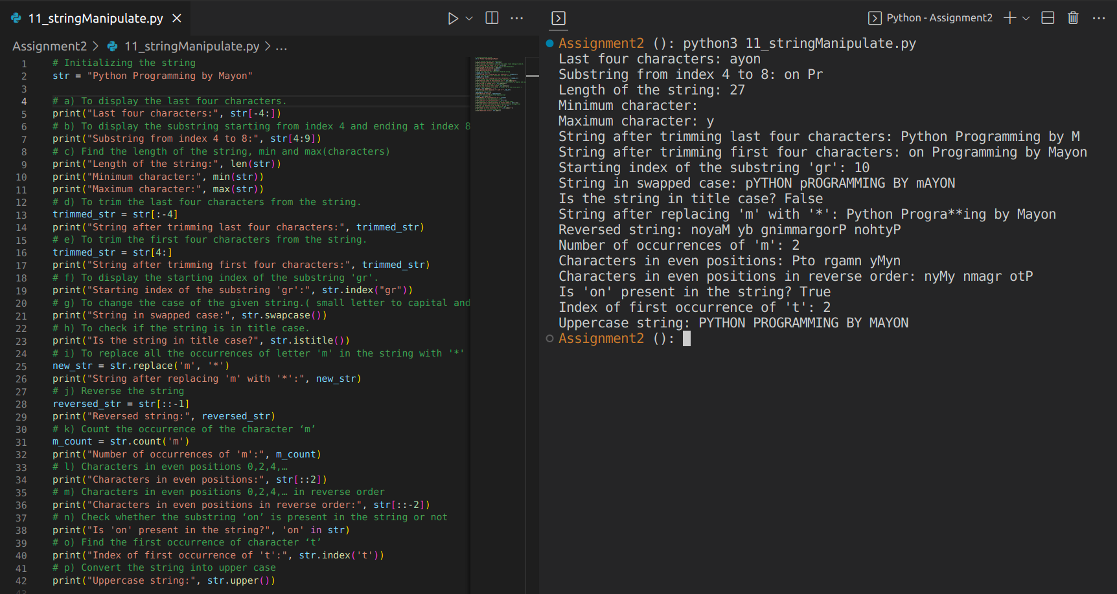

2. Check if palindrome
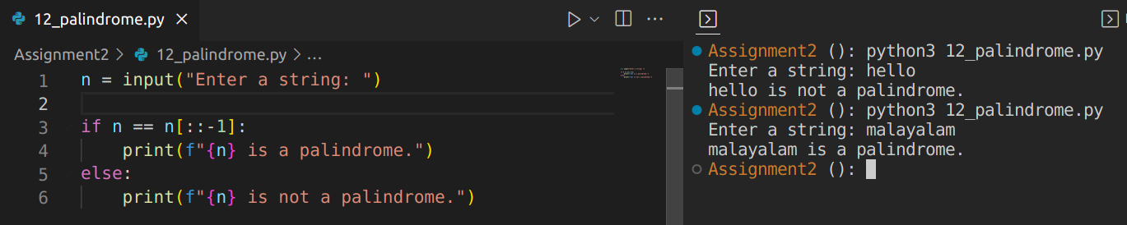

3. Count
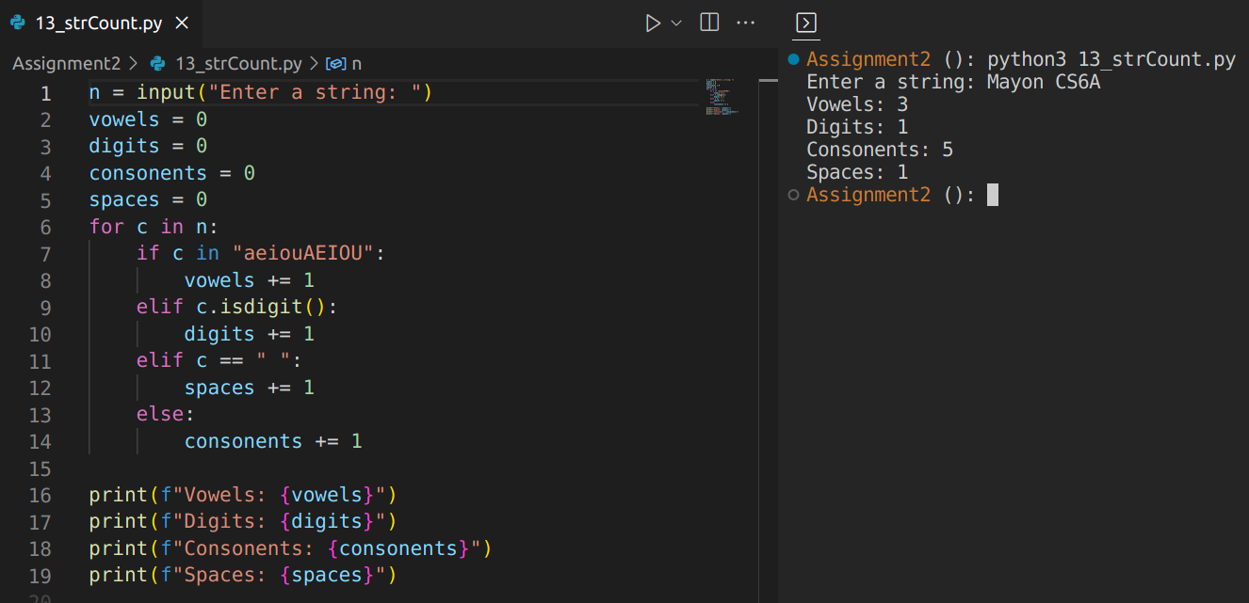

4. Binary To Decimal
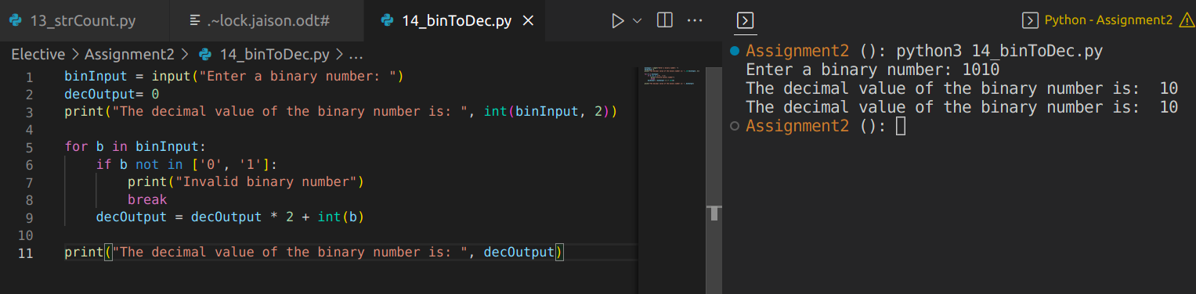
5. Read a decimal number and find its binary.( Hint: divide by 2 and append the reminder to a string)
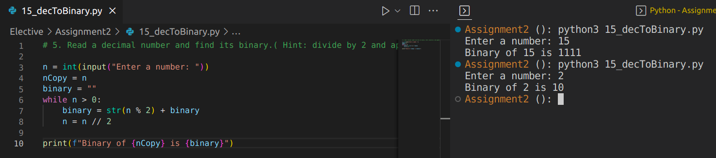
6. Binary to Hex

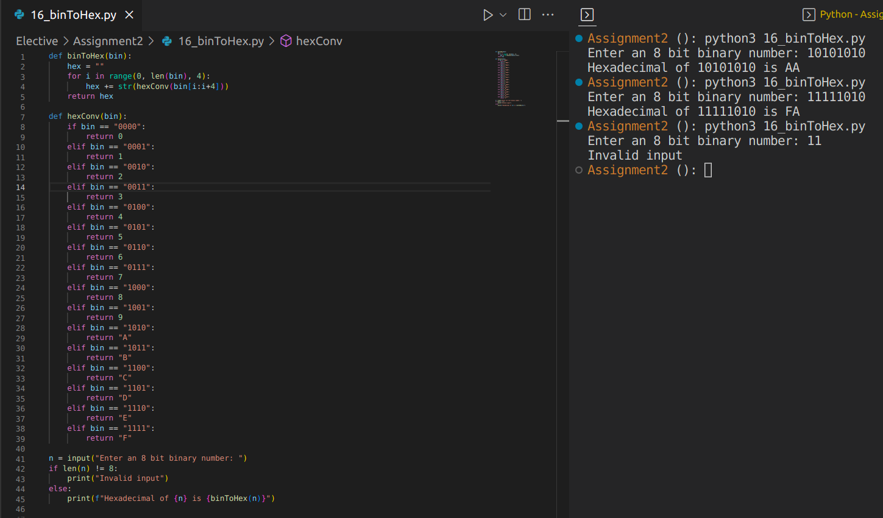
7. Hex to Decimal and Binary

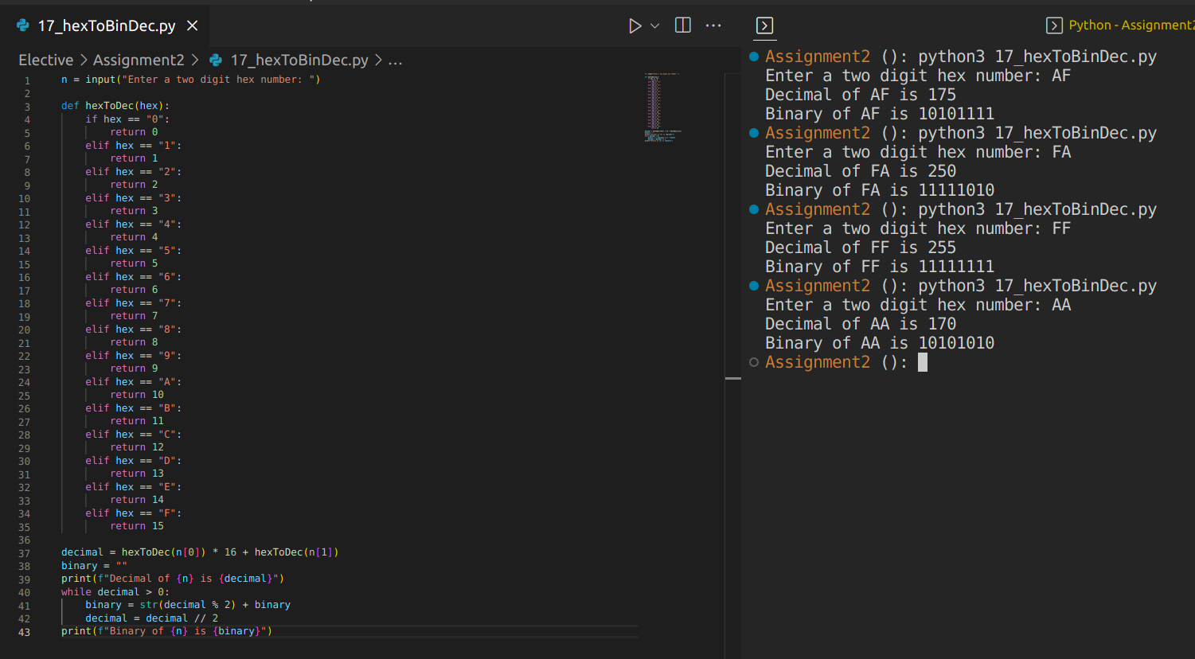

8. Swap Case
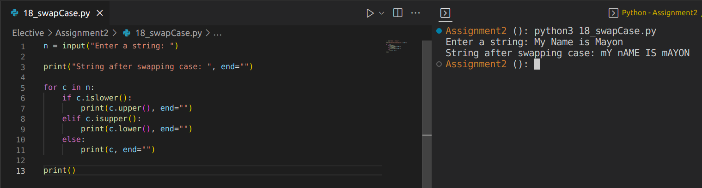

9. Encrypt a string using the shift cipher( key=3 Ceaser cipher)
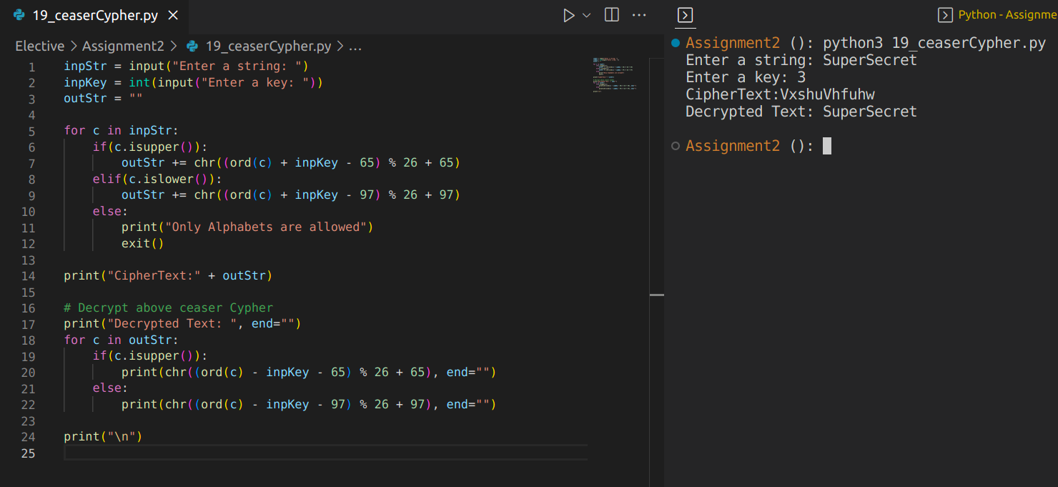

10. Check password strength
