  
   
   
DBHIDS Support for the Commonwealths Response to ACLU Litigation

MONTHLY SNAPSHOT OF

September 2020

Table of Contents

# Section 1: NSH Movement

## Philadelphia Waitlist

Effective 3/13/20, Governor Wolf placed a hold on all NSH admissions and discharges due to the spread of COVID-19. On May 19, 2020, NSH distributed an email which provided its plan to to resume admissions during the week of June 1, 2020. The plan included the COVID 19 DHS Protocol for State Facilities Admissions. As of 09/29/20 Philadelphia’s Forensic Waitlist for NSH stands at 2. The waitlist is composed of 0 Females and 2 Males.

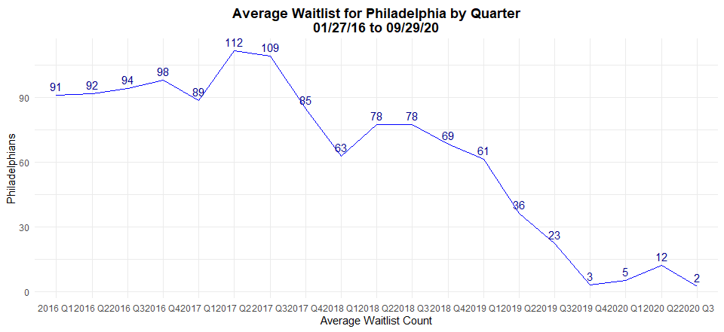

### Figure 1. Average number of Philadelphians on the NSH waitlist by quarter from 01/27/16 to 09/29/20.

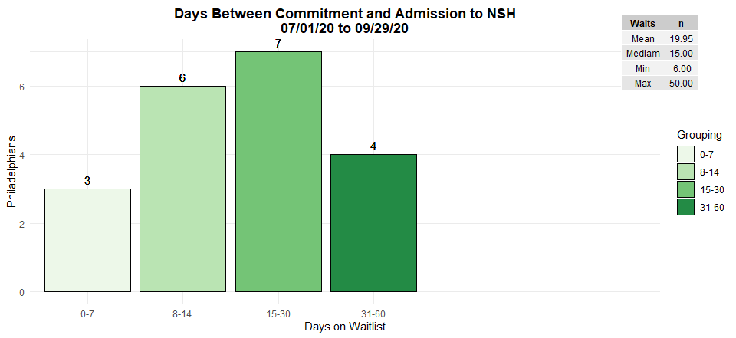

### Figure 2. Commitment to admission times from 07/01/20 to 09/29/20 (last 3 months). [1]

## Philadelphians Admitted to and Discharged from NSH

As of 09/29/20 533 Philadelphians have been discharged from NSH while 543 were admitted to NSH from the waitlist at PDP with 3 additional Philadelphians admitted from other sources.On 3/12/20, Governor Wolf placed a hold on all NSH Admissions and discharges due to COVID-19. On 4/14/20, community discharges resumed for individuals to a home or residential progam.

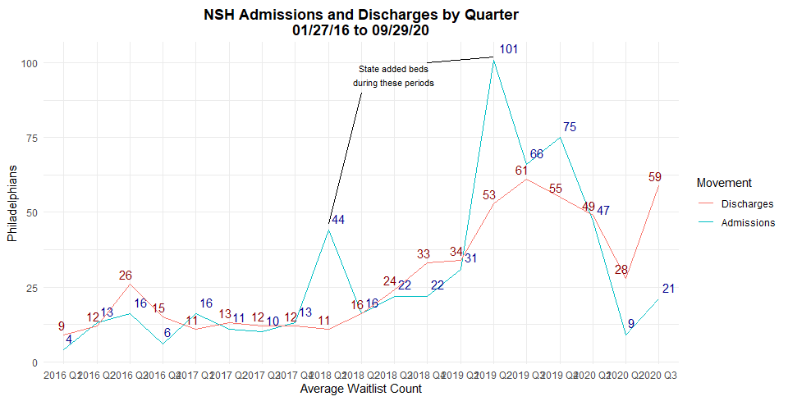

### Figure 3. Total NSH discharges and NSH admissions from 01/27/16 to 09/29/20.

## NSH Discharge Summary

The graph below shows a breakdown of where Philadelphians were placed after discharge from Norristown State Hospital as of 09/29/20. 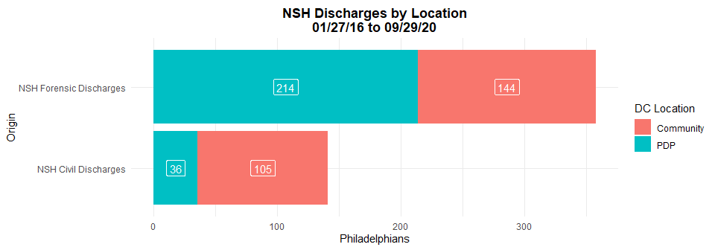

### Figure 4. Breakdown of NSH discharges by location for individuals returning to Philadelphia from 01/27/16 to 09/29/20.

* Since the 1/27/16 Settlement Agreement, NSH has restored 249 individuals to competency who were then returned to county jail (averaging 4.45 persons per month). 1 individual from the NSH Step Down Unit returned to county jail due to significant destruction of NSH property, for a total of 250 individuals returned to jail from NSH.

# Section 2: Forensic Support Team

## FST Summary

Formed in November 2016, the FST has taken on a wide range of efforts to improve the treatment and systemic management of Philadelphia citizens who have been adjudicated Incompetent to Stand Trial (IST) and are in jail waiting to be admitted to NSH. Due to progress on the Forensic Waitlist, low numbers of people waiting, dramatically decreased wait times, and systemic changes, FST has reorganized and joined with the NSH team to flexibly respond to the needs of the population. FST focuses its efforts on conducting docket reviews, advocating for people in mental health court, completing clinical as well as legal reviews, educating people (including lawyers and clinicians) about being on the waitlist and at NSH, and supporting individuals prior to and after re-entry to the community.  
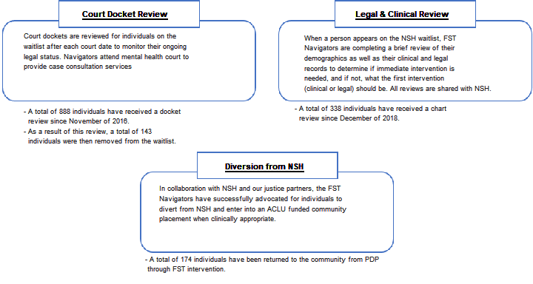

The graph below shows a breakdown of all Philadelphians returned to the community from their hosting location as of 09/29/20. Since 1/27/19, 423 individuals have been discharged from NSH and PDP to the community.

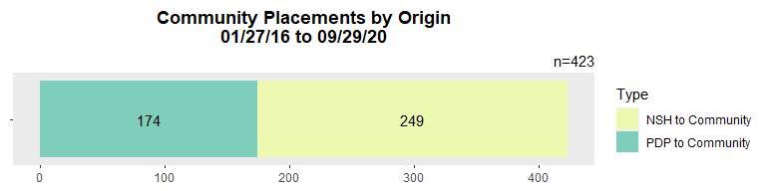

### Figure 5. All Philadelphians returned to the community from their hosting location from 01/27/16 to 09/29/20.

# Section 3: Community Placements

## ACLU Funded Placements

### Table 1. A breakdown of ACLU funded placement types including capacity, current census, individuals stepped down, and individuals identified for admission.

| **LOC** | **Placement** | **Total Beds** | **Beds Filled** | **Individuals Stepped Down** | **Individuals Identified\*** |
| --- | --- | --- | --- | --- | --- |
| EAC | Girard Recovery Center | 24 | 24 | 37 | 0 |
| RTFA | Horizon House - Old York DBT | 6 | 3 | 1 | 0 |
| Gaudenzia RTFA | 14 | 9 | 36 | 0 |
| New Vitae - South | 14 | 11 | 11 |
| New Vitae - West I | 12 | 7 | 13 |
| New Vitae - West II | 12 | 6 | 7 |
| VOA - Roosevelt TBI | 3 | 3 | 0 | 0 |
| VOA - Upsal TBI | 3 | 2 | 0 |
| CRR | HH - Farmhouse | 3 | 0 | 0 | 0 |
| Merakey - Fisher's Lane | 4 | 0 | 0 | 0 |
| RHD - Heart | 4 | 0 | 0 | 0 |
| RHD - Kailo | 4 | 0 | 0 | 0 |
| Carelink - STAR | 4 | 0 | 0 | 0 |
| Carelink - STAR Stepdown | 4 | 0 | 0 |
| Recovery House | SouthWest Recovery House | 6 | 0 | 0 | 0 |

### *Clinically assessed and identified as appropriate for this placement at this level of care.

#### ACLU Funded Placement Summary

DBHIDS established the programs listed above for Philadelphians committed to NSH or on the Forensic Waitlist at PDP. In March 2020, all these programs took immediate action to respond to the COVID-19 pandemic. Program responses included educating residents about COVID-19, temporarily suspending all community outings, having each resident’s support system communicate by phone and not visit in person, establishing plans to quarantine residents who were exposed to COVID-19, setting aside beds to quarantine people, having non-direct care staff work from home, having staff isolate themselves at home if exposed to the virus, and providing appropriate personal protective equipment. In addition, some of the providers listed above had to pause admissions because a resident or staff person tested positive for COVID-19.

DBHIDS provided guidance and support to the providers during this difficult time. For example, DBHIDS worked with providers to support residents who did not follow quarantine rules. In addition, DBHIDS continued to engage Philadelphians at NSH and on the Forensic Waitlist at PDP to identify those appropriate for these levels of care and prepare them for a successful transition back to the community. To enhance DBHIDS’s capability to engage Philadelphians at NSH given the restrictions imposed by COVID-19, DBHIDS and NSH drafted a protocol for DBHIDS to conduct telehealth assessments with Philadelphians at NSH. Implementation of this protocol was delayed due to technological barriers. Discharges from NSH were faciliated by the fact that NSH had tested all Philadelphians for COVID-19 and were retesting Philadelphians who had been approved for discharge.

1. 1 In November of 2019, Figure 2 shortened each grouping to account for the substantial decrease in admission wait times. The date range was also adjusted down from 6 months to 3, to better identify more recent trends in waitlist movement.