  
   
   
DBHIDS Support for the Commonwealth’s Response to ACLU Litigation

MONTHLY SNAPSHOT OF

February 2020

Table of Contents

Section 1: NSH Movement 2

Philadelphia Waitlist 2

Philadelphians Admitted to and Discharged from NSH 3

NSH Discharge Summary 3

Section 2: Forensic Support Team 4

FST Summary 4

Section 3: Community Placements 5

ACLU Funded Placements 5

# Section 1: NSH Movement

## Philadelphia Waitlist

As of 02/25/20 Philadelphia’s Forensic waitlist for NSH stands at 5. The waitlist is composed of 2 Females and 3 Males. This progress can be attributed to the State adding beds at NSH, an increase in the number of people who are found competent and returned to PDP, DBHIDS facilitating the return of people to the community, and ongoing community-based reform.

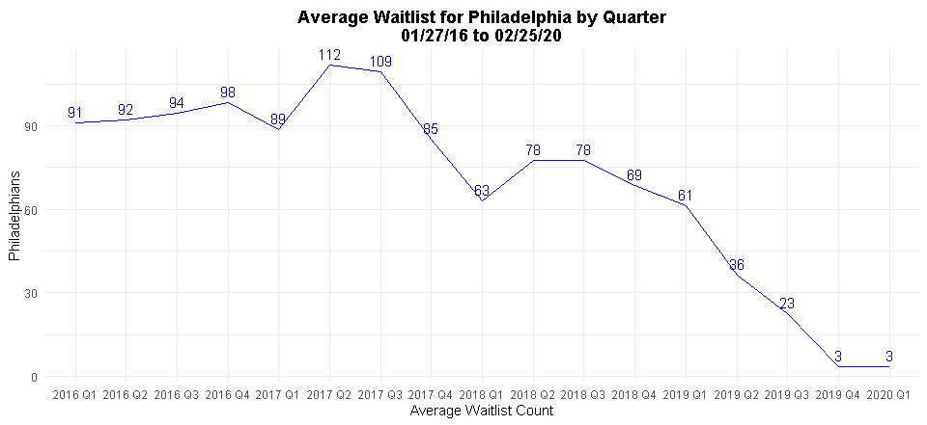

### Figure 1. Average number of Philadelphians on the NSH waitlist by quarter from 01/27/2016 to 02/25/20.

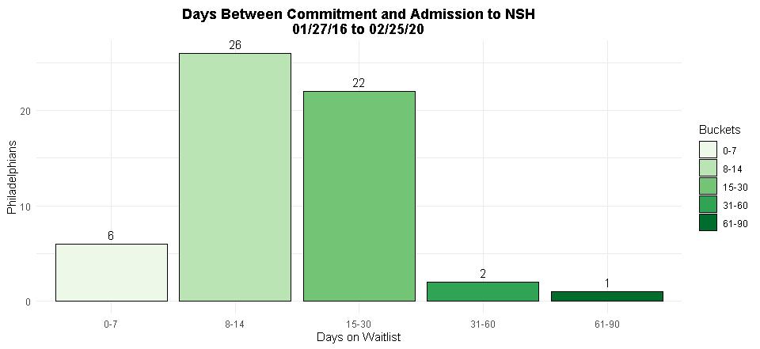

### Figure 2. Commitment to admission times from 11/27/19 to 02/25/20 (last 3 months). [1]

## Philadelphians Admitted to and Discharged from NSH

As of 02/25/20 425 Philadelphians have been discharged from NSH while 513 were admitted to NSH from the waitlist at PDP with 3 additional Philadelphians admitted from other sources.

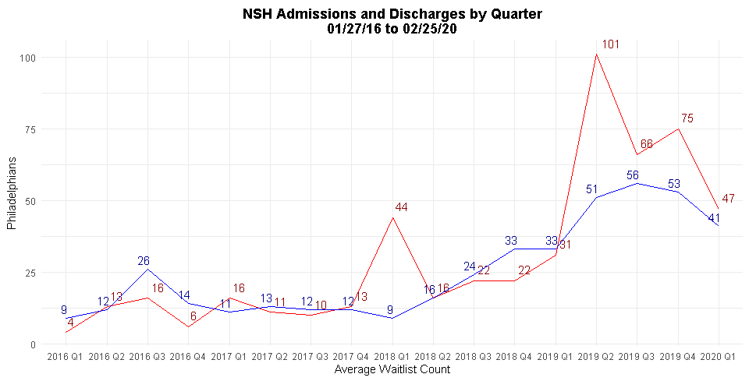

### Figure 3. Total NSH discharges and NSH admissions from 01/27/16 to 02/25/20.

## NSH Discharge Summary

The graph below shows a breakdown of where Philadelphians were placed after discharge from Norristown State Hospital as of 02/25/20. 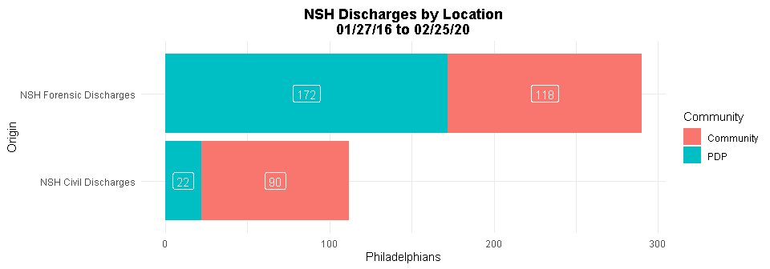

### Figure 4. Breakdown of NSH discharges by location for individuals returning to Philadelphia from 01/27/16 to 02/25/20.

* Since the 1/27/16 Settlement Agreement, NSH has restored 208 individuals to competency who were then returned to county jail (averaging 4.24 persons per month). 1 individual from the NSH Step Down Unit returned to county jail due to significant destruction of NSH property, for a total of 209 individuals returned to jail from NSH.

# Section 2: Forensic Support Team

## FST Summary

Formed in November 2016, the FST has taken on a wide range of efforts to improve the treatment and systemic management of Philadelphia citizens who have been adjudicated Incompetent to Stand Trial (IST) and are in jail waiting to be admitted to NSH. Due to progress on the Forensic Waitlist, low numbers of people waiting, dramatically decreased wait times, and systemic changes, FST has reorganized and joined with the NSH team to flexibly respond to the needs of the population. FST focuses its efforts on conducting docket reviews, advocating for people in mental health court, completing clinical as well as legal reviews, educating people (including lawyers and clinicians) about being on the waitlist and at NSH, and supporting individuals prior to and after re-entry to the community. 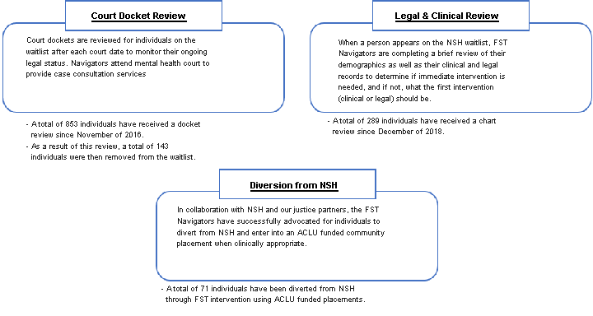

The graph below shows a breakdown of all Philadelphians returned to the community from their hosting location as of 02/25/20. 52% of the ACLU NSH discharges were to a community placement.

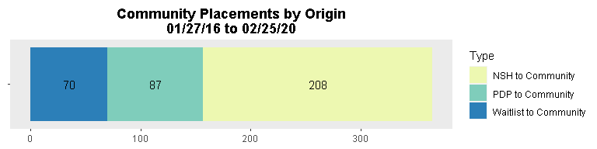

### Figure 5. All Philadelphians returned to the community from their hosting location from 01/27/16 to 02/25/20.

# Section 3: Community Placements

## ACLU Funded Placements

### Table 1. A breakdown of ACLU funded placement types including capacity, current census, individuals stepped down, and individuals identified for admission.

| **LOC** | **Placement** | **Total Beds** | **Beds Filled** | **Individuals Stepped Down** | **Individuals Identified\*** |
| --- | --- | --- | --- | --- | --- |
| EAC | Girard Recovery Center | 24 | 23 | 39 | NA |
| RTFA | Horizon House - Old York DBT | 6 | 4 | 1 | NA |
| Gaudenzia RTFA | 14 | 10 | 30 | NA |
| New Vitae - South | 11 | 10 | 10 |
| New Vitae - West I | 12 | 11 | 12 |
| New Vitae - West II | 12 | 8 | 6 |
| VOA - Roosevelt TBI | 3 | 3 | 2 | NA |
| VOA - Upsal TBI | 3 | 2 | NA |
| CRR | HH - Farmhouse | 3 | NA | NA | NA |
| Merakey - Fisher's Lane | 4 | NA | NA | NA |
| RHD - Heart | 4 | NA | NA | NA |
| RHD - Kailo | 4 | NA | NA | NA |
| Carelink - STAR | 4 | NA | NA | NA |
| Carelink - STAR Stepdown | 4 | NA | NA |
| Recovery House | SouthWest Recovery House | 6 | NA | NA | NA |

### *Clinically assessed and identified as appropriate for this placement at this level of care.

#### ACLU Funded Placement Summary

DBHIDS established these programs for Philadelphians committed to NSH or on the Forensic Waitlist at PDP. BHJRS Clinical Teams continue to engage individuals on the Forensic Waitlist at PDP and at NSH to identify those appropriate for these levels of care and prepare them for a successful transition.

* The Extended Acute Care (EAC) program at the Girard Recovery Center is the highest level of care in the community based forensic services network. It provides inpatient psychiatric care that focuses on psychiatric stabilization and preparation for step down to lower levels of care. To date, DBHIDS has established 24 forensic EAC beds.
* The Residential Treatment Facilities for Adults (RTFAs) provide housing and on-site psychiatric services to individuals who have severe mental illness but do not require a hospital level of care and would benefit from treatment in the community. To date, DBHIDS has established 56 forensic RTFA beds for Philadelphians.
* Community Residential Rehabilitation (CRR) Programs work in collaboration with outpatient and day program providers, provide rehabilitation, social and personal development services to persons in a community based residential program. The focus on CRRs is to assist individuals in improving his or her activities of daily living with support and care, while outpatient and day program providers provide mental health treatment. To date, DBHIDS has established 25 new forensic CRR beds. In addition, DBHIDS has placed numerous people in multiple CRRs that were not specifically established for people who were committed to NSH or on the waitlist at PDP.
* The Recovery House program provides an option for individuals who may benefit from co-occurring mental health and substance use treatment in the community. To date, DBHIDS has established 6 forensic recovery house beds.

1. 1 In November of 2019, Figure 2 shortened each grouping to account for the substantial decrease in admission wait times. The date range was also adjusted down from 6 months to 3, to better identify more recent trends in waitlist movement.