MS WORD:-

**Question No 1:-** Insert and Format image using these instructions:

a) Insert an image related to a topic of your choice.

b) Resize the image to a width of 20 inches while maintaining the aspect ratio.

c) Apply a border around the image using a style of your choice.

d) Add a caption below the image describing what it represents.

e) Align the image to the center of the page.

**Task 1 Response:**



Fire Works

**Question No. 2:-** Make a table using these instructions:

a) Create a 3x4 table to display the names and ages of three people.

b) Enter the column headings: "Name" and "Age".

c) Fill in the table with sample data for three people.

d) Merge the top row cells to create a table title and type "Participants".

e) Center-align all the text within the table.

**Task 2 Response:**

|  |  |  |
| --- | --- | --- |
| Participants | ***Name*** | ***Age*** |
| Peter | 67 |
| John | 45 |
| Jim | 87 |

**Question No 3:-** Working with Headers and Footers:

a) Insert a header at the top of the page with the text "Document Title" aligned to the left.

b) Add the current date to the header, aligned to the right.

c) Insert a footer at the bottom of the page with a page number centered.

d) Change the size of the Header text to 12.

e) Save the document with the name "Header Footer Example".

**Task 3 Response: (Present in the Header and Footer).**

MS Excel:-

**Question No 1:-** Table Creation:

a) Create a table with columns for "Item," "Quantity," and "Price."

b) Enter sample data for three items, including their quantity and price.

c) Calculate the total cost for each item by multiplying "Quantity" by "Price." Place this calculation in a new column named "Total Cost."

**Task 1 Response:**

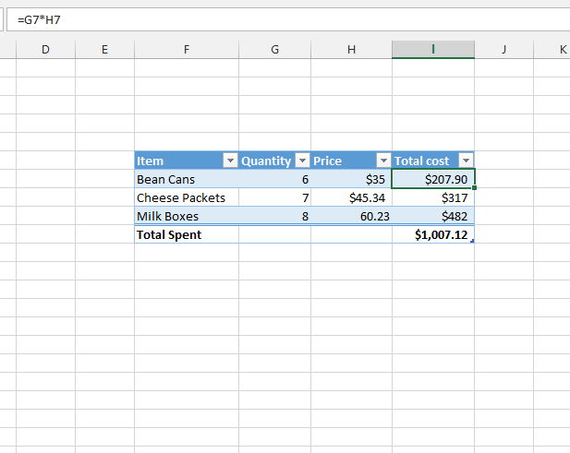

**Question No 2:-** If Function:

1. Create a table with columns for "Student Name," "Score," and "Pass/Fail."
2. Enter sample data for three students with their scores.
3. Use the IF function in the "Pass/Fail" column to determine if a student passes or fails based on the score:
4. If the score is 60 or above, the result should be "Pass."
5. If the score is below 60, the result should be "Fail."
6. Formula Example: =IF (B2 >= 60, "Pass", "Fail") (Assuming scores are in column).

**Task 2 Response:**

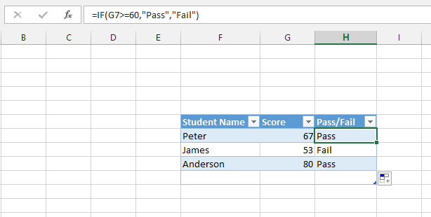

**Question No 3:-** Basic AND Function

a) Create a table with columns for "Student Name," "Score 1," and "Score 2."

b) Enter data for three students with their scores.

c) Use the AND function in a new column named "Pass Status" to determine:

d) If both "Score 1" and "Score 2" are greater than 50, display "Pass."

e) Otherwise, display "Fail."

f) Formula Example: =IF (AND (B2 > 50, C2 > 50), "Pass", "Fail") (Assuming scores are in columns B and C).

**Task 3 Response:**

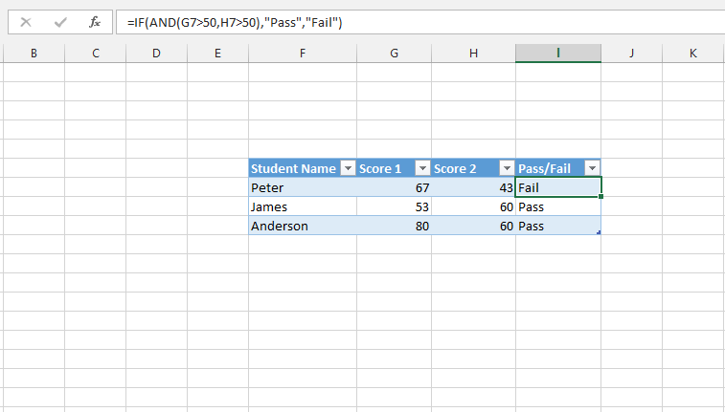

**Question No 4:-** Create a Cosine graph in MS Excel.

**Task 4 Response:**

