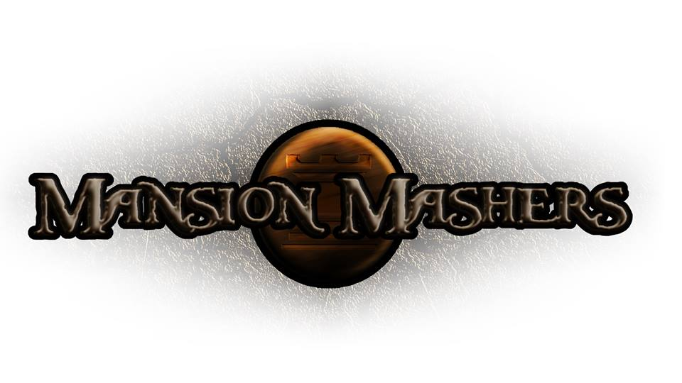**Game Design Document**

**GAM150S14-C**

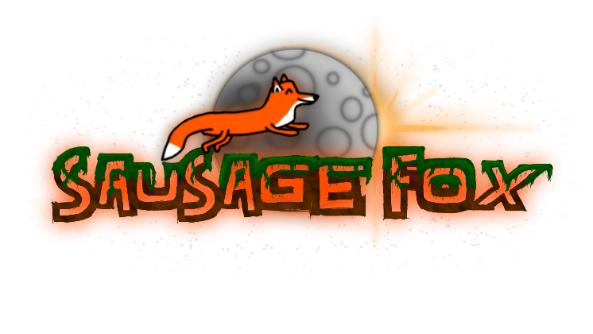**Spring 2014**

**Producer:**

Juli Gregg

**Tech Director**:

Dan Muller

**Game Designer**:

Luke Conlon

**Project Manager**:

Kaden Nugent

Table of Contents

High Concept: 2

Summary: 2

Story: 2

Game Flow: 2

Game Mechanics: 3

Game Characters: 3

Game Resources: 3

Game Environment: 4

Game Controls: 4

Visual Design: 4

Audio Design: 5

Behavior Design: 5

Physics Design: 5

Multiplayer Design: 5

Appendices 6

High Concept:

A 2-D dungeon crawler side-scroller hack and slash game.

Summary:

The mighty princesses of the Fox Clan are sent out to rescue the clan’s prince who has been captured during an attack by their enemy, Dog Clan. Due to the king being mortally wounded from the Dog Clan’s attack the heroines are on a deadline to bring back the sole heir to the Fox Clan. The player needs to successfully help the princesses hack and slash their way through enemy clan members to reach the end of each level. Each section of levels will feature a boss fight. Players will be able to customize the princesses’ stats, weapons, and pets as they gain abilities, money and stat points as the game progresses. Players also have the option to spend money they find along the way in the game to buy new items such as weapons and pets or buffs. In the end the player must wisely power up their character in order to save the prince for if there is no heir left when the king of the Fox Clan dies their clan will disband and be open to a takeover by the Dog Clan.

Story:

Under the dark cloak of night the Dog Clan silently works their way into the Fox Clan mansion. They sneak into Prince Oakley’s, the Fox Clan prince’s, room and take him prisoner. The Dog Clan sends some of their men to take their prisoner back to their own mansion while the remaining clan members begin their attack on the Fox Clan. A battle quickly breaks out in the mansion. While the Fox Clan was able to fight off the invading Dog Clan many have been wounded and the prince is still in the enemy’s clutches.

With the mansion and the clan members weak it is discovered that the king has been mortally wounded and is only expected to live for a few more days. The only ones left who can save Prince Oakley are the mighty princesses of the clan. The princesses are given the mission to rescue and return the prince from the Dog Clan. Their mission must succeed for the only heir if the king were to pass away is Prince Oakley. A clan with no king must disband. Therefore without Prince Oakley to take the king’s place the Fox Clan and their Mansion will be vulnerable to a takeover attempt by the Dog Clan.

Game Flow:

|  |  |
| --- | --- |
| **Phase 1:** | The player must fight off the Dog clan as they attack the mansion. |
| **StoryPart1:** | It is discovered Prince Oakley has been captured and the princesses are given mission to get him back. The princesses set out into the vast forest that separates the Fox and Dog mansions. |
| **Phase 2-4:** | Player plays 1-3 levels and faces off with a boss fight. |
| **Phase 5:** | Player has reached Dog Mansion and begin to fight their way in. Final boss is to defeat the Dog clan boss. Prince Oakley will be released when boss is beaten. |
| **StoryPart2:** | The heroines return with the prince just before the king passes away with a smile on his face upon seeing the rescued son. Prince Oakley is crowned king of the clan and the princesses are given high honors and medals. |

Game Mechanics:

|  |  |
| --- | --- |
| Movement | coordinate system, physics for slowing down/stopping |
| Damage | dealt by attacking using melee weapons, received by enemies fighting back |
| Killing Enemies | gain’s player experience, money, and/or weapons |
| Winning | Defeat bosses and destroy enemy mansion |
| Lose | Dying (health = hits player can take), defense/dodge stats effect hit points |

Game Characters:

|  |  |
| --- | --- |
| **Princesses**  **(Fox Clan)** | (main playable characters):  Names: Mayple, Ginko, Holly, Kaya  Creature: Fox |
| **Prince**  **(Fox Clan)** | (character player is rescuing)  Name: Oakley  Creature: Fox |
| **Bosses**  **(Dog Clan)** | (End of each level sets)  Four Bosses (Small: 3, Big: 1)  Creature: Dog |

Game Resources:

|  |  |  |  |  |  |  |  |  |  |  |  |  |  |  |  |
| --- | --- | --- | --- | --- | --- | --- | --- | --- | --- | --- | --- | --- | --- | --- | --- |
| **Stats:** | | Defense: | | | | | Health Points, Damage Reduction | | | | | | | | |
| Agility: | | | | | Attack Speed, Move Speed | | | | | | | | |
| Strength: | | | | | Damage | | | | | | | | |
|  | | | | | | | | | | | | | | | |
| **Weapons:** | | | | | Sword: | | | | | (+1)Strength, (+1)Agility | | | | | |
| Spear: | | | | | (+1)Strength, (+1)Defense | | | | | |
| Bow/Arrow: | | | | | (+4)Agility, (-2)Defense | | | | | |
| Axe: | | | | | (+2)Strength, (-1)Agility | | | | | |
|  | | | | | | | | | | | | | | | |
| **Specials:**  **\*Stretch\*** | | | | Bomb | | | | | | | | | | | |
| Throwables | | | | | | | | | | | |
| Flamethrower | | | | | | | | | | | |
|  | | | | | | | | | | | | | | | |
| **Buffs:**  **(Stack,**  **1 each)** | | | Defense: | | | | | Player | | | | | | | |
| Agility: | | | | | Player | | | | | | | |
| Strength: | | | | | Player | | | | | | | |
| Weapon: | | | | | Poison: | | | | Slow, Damage over time | | | |
| Fire: | | | | Damage over time | | | |
| Ice: | | | | Freeze/make extremely slow | | | |
| Haste: | | | | | Move Speed | | | | | | | |
| Mystery: | | | | | Random | | | | | | | |
|  | | | | | | | | | | | | | | | |
| **Money:** | | | | Buys weapons | | | | | | | | | | | |
| Buys buffs | | | | | | | | | | | |
| Lost on death | | | | | | | | | | | |
| Buy Pets | | | | | | | | | | | |
|  | | | | | | | | | | | | | | | |
| **Experience:** | | | | | | (Ex. Monster with 100xp) | | | | | | | | | |
| Ratio of damage on hit: | | | | | | | | | | | | | | | |
| Monster | | | | | | P1 | | | | | P2 | | | P3 | P4 |
| 100hp | | | | | | 10 | | | | | 50 | | | 30 | 10 |
| 100xp | | | | | | 10 | | | | | 50 | | | 30 | 10 |
|  | | | | | | | | | | | | | | | |
| **Gain Level:** | | | | | | Pick stat increase: | | | | | | | (3pts) Early, (1pt) Late | | |
| Flats Increase | | | | | | | | | |
| (3pts) Starting Level | | | | | | | | | |
|  | | | | | | | | | | | | | | | |
| **Hidden Inventory:** | | | | | | | | | Items go into inventory but are only accessible in-between levels | | | | | | |
|  | | | | | | | | | | | | | | | |
| **Pets:** | Adds to stats for different pets | | | | | | | | | | | | | | |
| Special Effects *stretch* | | | | | | | | | | | | | | |
| Pets that attack *stretch* | | | | | | | | | | | | | | |
| Example: Lobster | | | | | | | | | | | | | | |

Game Environment:

The main environments the player will be playing in are mansions and forests. The art style for the levels will give the appearance of perspective and depth however the player will have one line/axis they can move along. There are no plans to allow the player/character to be able to interact with background. There will be 1-3 levels in a set and each set will feature a boss. There will be 3-4 sets. A map will be used as a level select screen.

**\*See Appendix 1 for sample level background image.**

Game Controls:

|  |  |
| --- | --- |
| **A** | Move Left |
| **D** | Move Right |
| **S** | Crouch (S + Space drops down from platforms if able) |
| **Space** | Jump |
| **Left Mouse** | Attack |
| **Right Mouse** | Heavy Attack |
| **F** | Use Item |
| **Q** | Swap Item |
| **Game Controller** | Used for multiplayer *stretch*  (button controls currently undecided) |

Visual Design:

Mansion Mashers will have a 2-D cartoony style with perspective looking backgrounds. The camera will follow player and is changed based on if the player is within or beyond a certain range.

Audio Design:

Behavior Design:

Physics Design:

Multiplayer Design:

Appendices