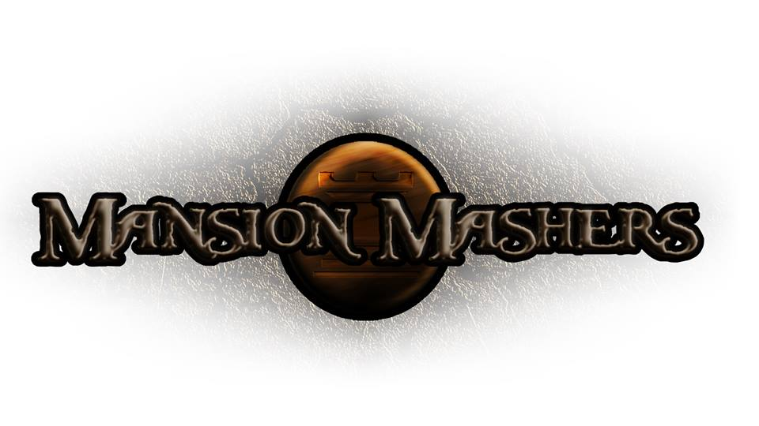**Weekly Production Report**

**Week 3**

**January 23, 2014**

**By Juli Gregg**

**High Concept**:

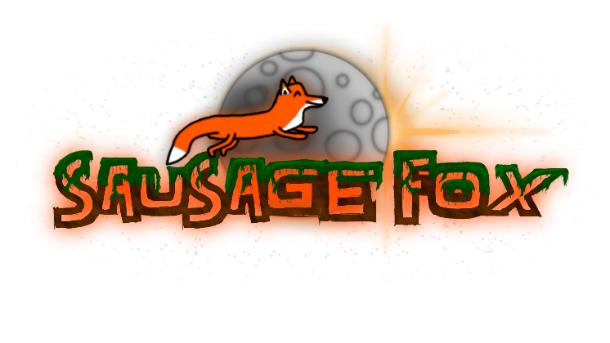A 2-D cartoon fantasy dungeon crawler side-scrolling hack and slash game.

**Producer:**

Juli Gregg

**Tech Director**:

Dan Muller

**Game Designer**:

Luke Conlon

**Project Manager**:

Kaden Nugent

Project Status:

Green

Current Milestone:

Concept/Engine Proof

Accomplishments:

**Juli Gregg**

Worked to implement Game State Manager. Completed work on Game Design Document and Game Concept Presentation.

**Dan Muller**

Worked on strengthening Player and Sprite code. Finishing up and testing Physics for Engine.

**Luke Conlon**

Created art assets including demo level background, HUD design,

**Kaden Nugent**

Objectives:

**Juli Gregg**

**Dan Muller**

**Luke Conlon**

**Kaden Nugent**

Highlights:

Currently ahead

Risks & Mitigations:

Being ahead means code might not be correct or most efficient

M- Attempting to create a format that allows for easy swapping of code in and out

**Signatures**

_____________________

Juli Gregg

_____________________

Dan Muller

_____________________

Luke Conlon

_____________________

Kaden Nugent