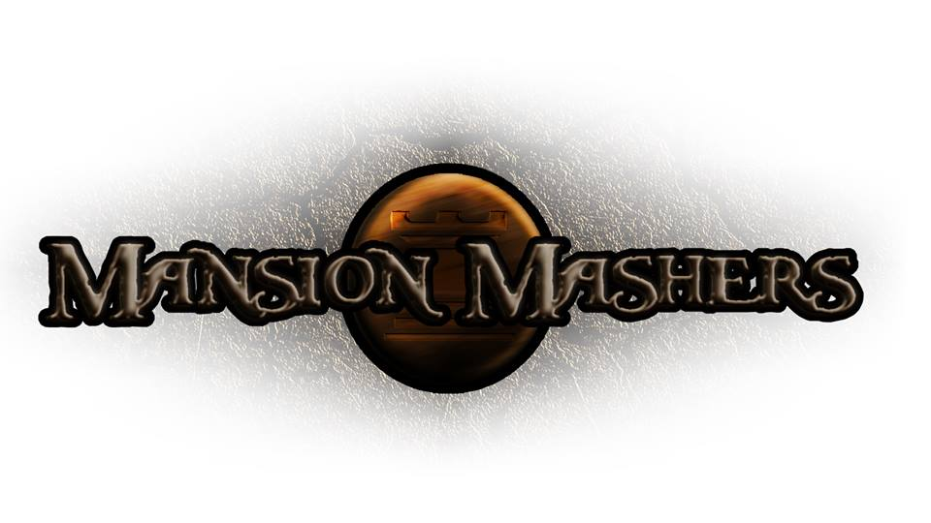**Weekly Production Report**

**Week 3**

**January 23, 2014**

**By Juli Gregg**

**High Concept**:

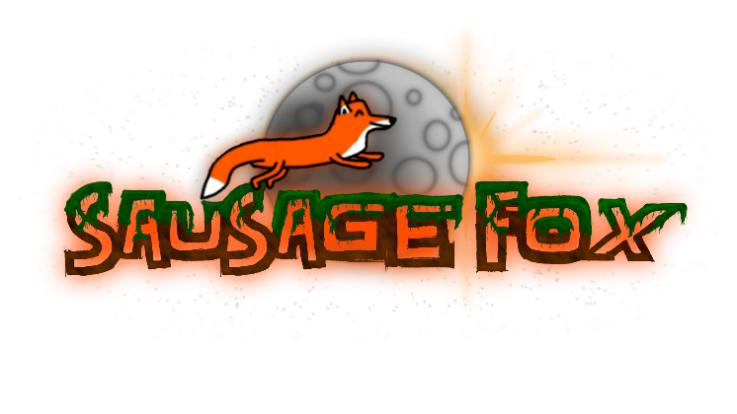A 2-D cartoon fantasy dungeon crawler side-scrolling hack and slash game.

**Producer:**

Juli Gregg

**Tech Director**:

Dan Muller

**Game Designer**:

Luke Conlon

**Project Manager**:

Kaden Nugent