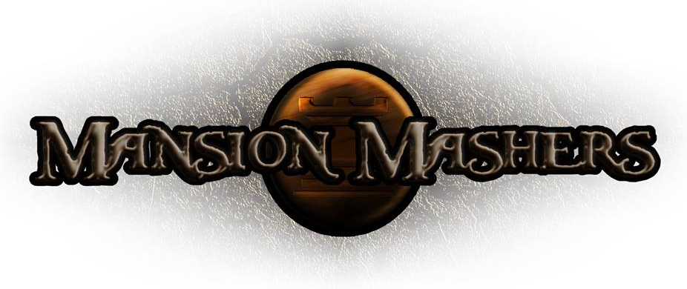
Game Design Document
GAM150S14-C
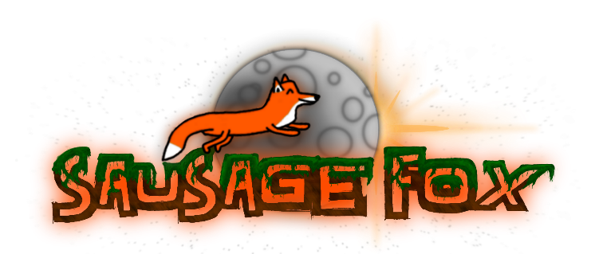
Spring 2014
Producer:
Juli Gregg
Tech Director:
Dan Muller
Game Designer:
Luke Conlon
Project Manager:
Kaden Nugent

Table of Contents

High Concept: 2
Summary: 2
Story: 2
Game Flow: 2
Game Mechanics: 2
Game Characters: 2
Game Resources: 2
Game Environment: 2
Game Controls: 2
Visual Design: 3
Audio Design: 3
Behavior Design: 3
Physics Design: 3
Multiplayer Design: 3
Appendices 4

High Concept:
A 2-D dungeon crawler side-scroller hack and slash game.

Summary:
- The main characters are princesses that go to save the captured princes
- Characters gain Abilities/Stats as the game progresses and as the character levels.
- Multiple weapons, increasing stats differently based on level
- Players will have the ability to create their character uniquely, Stats/Weapons/Pets
- Players can spend the money they find in game to buy items or buffs like: Weapons, Pets, or temporary buffs.
- The players need to hack and slash through many enemies to reach the end of each level. To then get to the boss fright after a section of levels.
Story:
- The princes gets taken by other clan.
- The king is on his death bed.
- Princess goes on a solo (or with other princesses) mission to get the princes
- The Enemies they are fighting are members of the other clan
- The final boss is the clan head.
- During the final boss fight the boss/clan shows their true selves
- Last boss fight you save the official heir.
- The Princess/es travel through the lands trying to find the Mansions of the clan who took the princes.
- The Princess/es rescue a prince per mansion
- The princes you save are youngest to oldest.

Game Flow:
- The player first starts out finding that the princes of the Mansion have been kidnapped from the other clan.
- The princesses then find the enemy clan invading and have to fight them out of your own mansion.

Game Mechanics:

Game Characters:
- Princesses (Main Playable Characters)
- Princes (The people to rescue)

Game Resources:
- Each character has their own stats of Agility, Strength, and Defence.

Game Environment:

Game Controls:
- A and D - moves left and right
- S - crouch (S + Space drops down from platforms if able)
- Space - jump
- E – interact
- Left Mouse – Attack
- Right Mouse – Heavy Attack
- F – Use Item
- Q – Swap Item
- Game Controller (for multiplayer)

Visual Design:

Audio Design:

Behavior Design:

Physics Design:

Multiplayer Design:

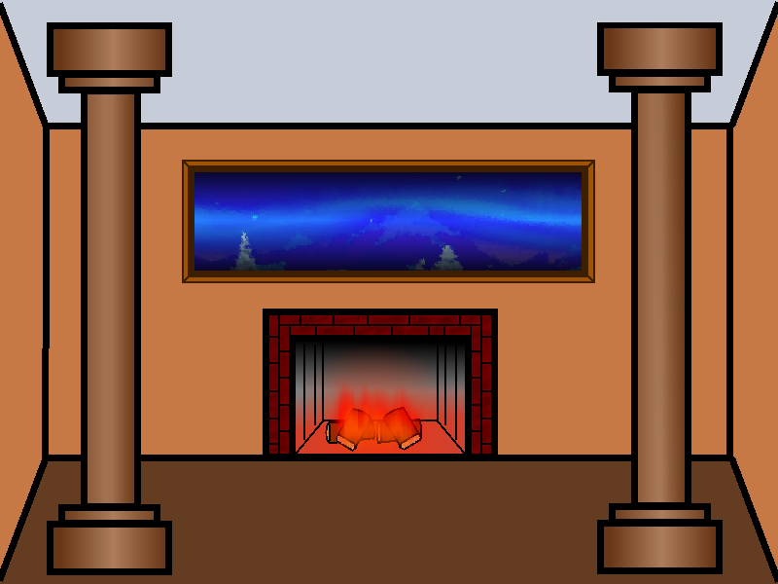
Appendices

