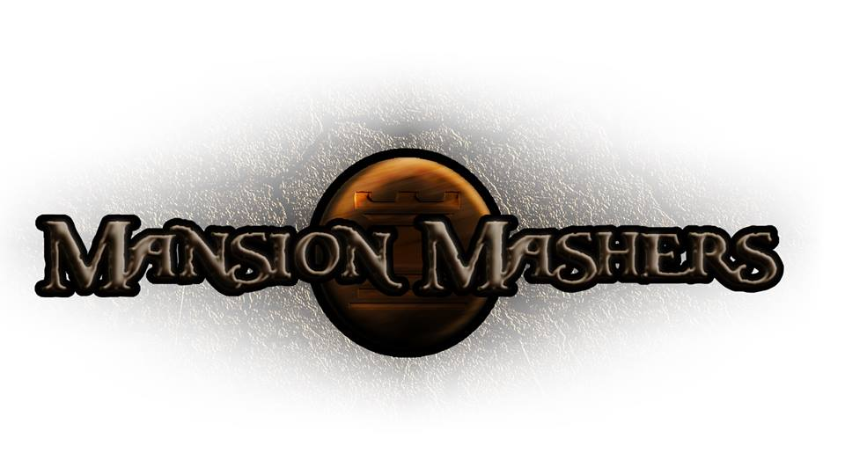

Technical Design Document
GAM150S14-C
Spring 2014
Producer:
Juli Gregg
Tech Director:
Dan Muller
Game Designer:
Luke Conlon
Project Manager:
Kaden Nugent

Table of Contents

Overview: 2
Graphics Implementation: 2
Multiplayer Implementation: 2
Coding Methods: 2
Debugging: 2
Tools: 2
Scripting Languages: 2
Technical Risks: 2
Appendices 3
Appendix A: Interface Flow 3
Flowchart 3
Mockups 3
Appendix B: Art Requirements 3
Appendix C: Audio Requirements 3

Overview:

Graphics Implementation:

Multiplayer Implementation:

Coding Methods:

Debugging:

Tools:

Scripting Languages:

Technical Risks:

Appendices

Appendix A: Interface Flow
Flowchart

Mockups

Appendix B: Art Requirements

Appendix C: Audio Requirements

