Name: Study about Immigration in the US.

Class: MW

Group Members: Fabio Savorgnan, Vivek Baghel, Yan Xu and Mayra Perez.

Brief Articulation: We intend to show different immigration trends by country(or regions), time and location in the US.

Dataset: We are going to extract data from FactFinder (Census.gov) but today the webpage is off for now so hopefully they will be back on Monday. For now, here is our MetaData:

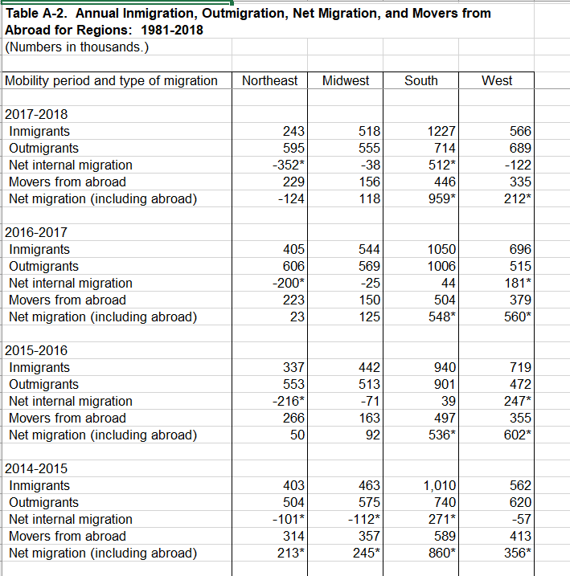

Screenshots:

Sketch Final Design:

