**System Admin II: Lab1**

* Using loop devices, create 4 PVs

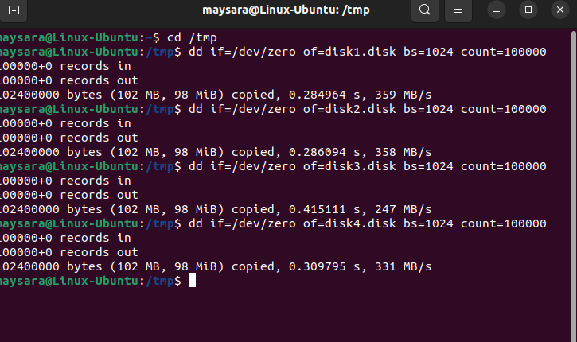

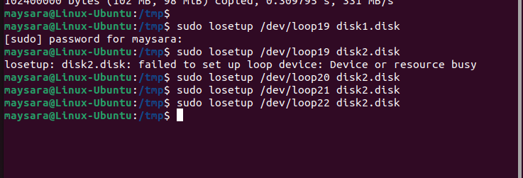

* Create VG and add PVs to it

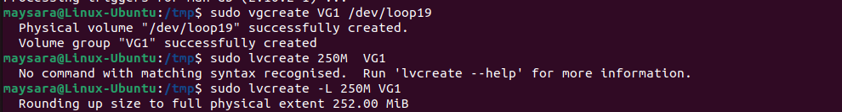

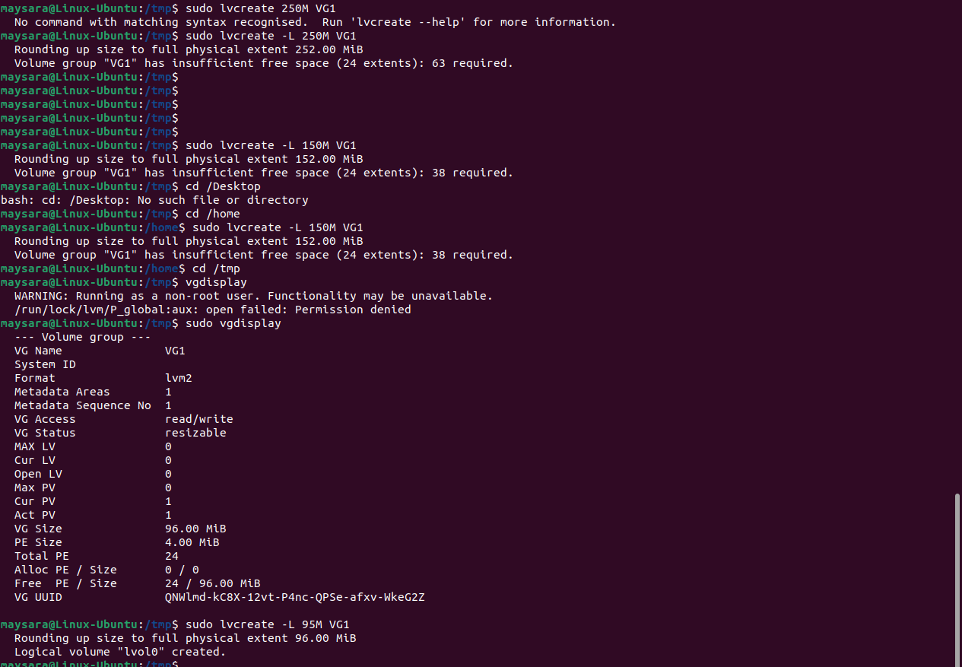

* Formate LV using ext4

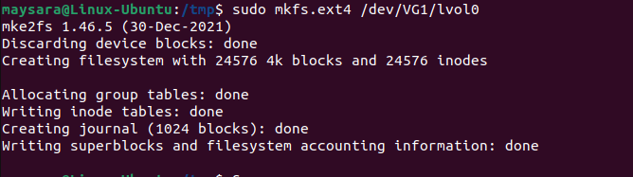

* Mount LV to /mnt directory
* Extend VG the remaining PV

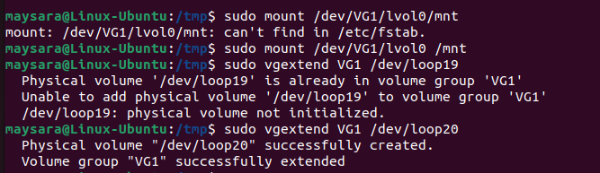

* Resize 2fs LV with 50M extra



**Network**

* Display Network interface info with ip command 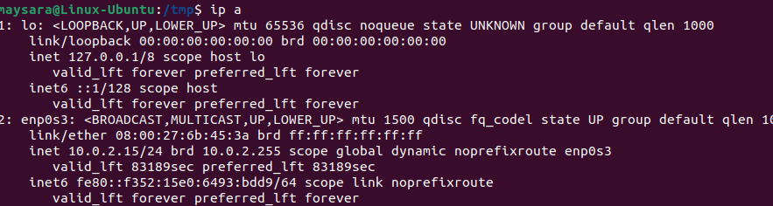
* Display currently active TCP connections on your Os using netstat command

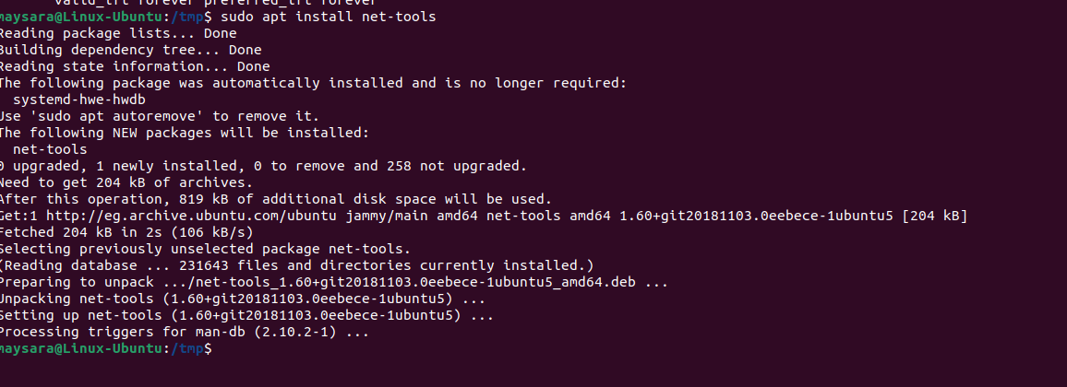

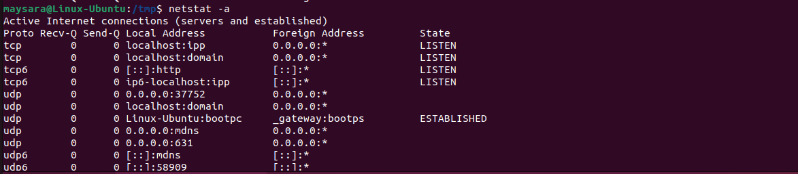

* Display currently open ports on your system using nmap

