**System Admin II :Lab 2**

* Identify the current USB devices

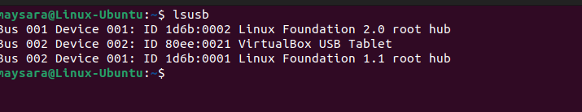

* Count how many CPUs (cores) on your device



* Take a snapshot of current disk statistics 5 times with 2s intervals

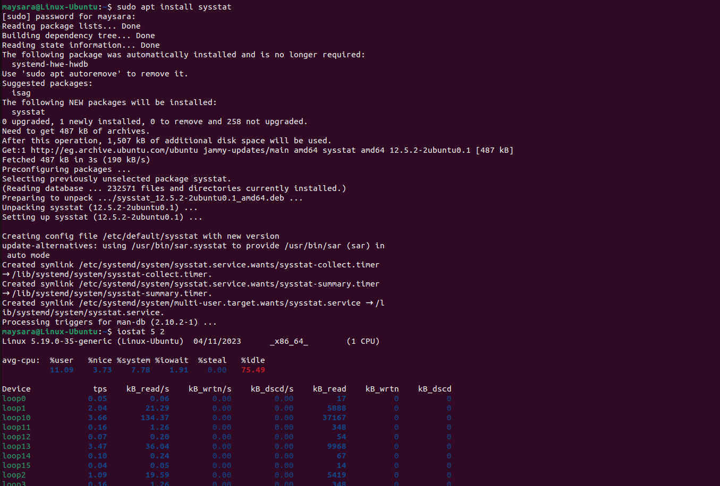

* Measure the network activities

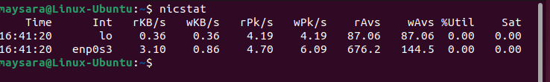

* List current PCI devices on your device

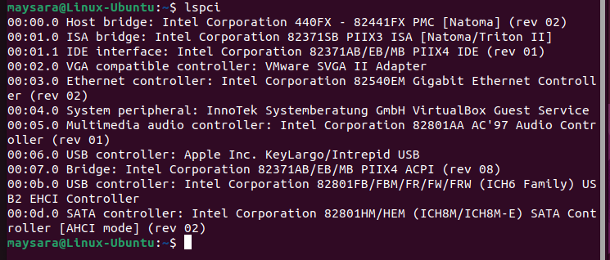

* List all files which are compressed by zip utilities



* Using grep and regex list all lines containing hex numbers on /var/log/syslog

