**System Admin II :Lab3**

* Install ftpd services on your device

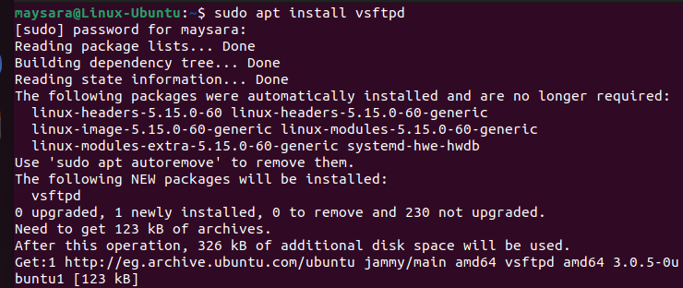

* Enable port 20 and 21 (tcp) using iptables command using input chain



* Connect to ftp server (e.g: localhost) and browse the current directory

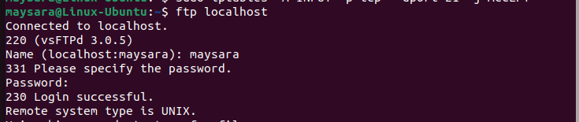

* Enable ufw service

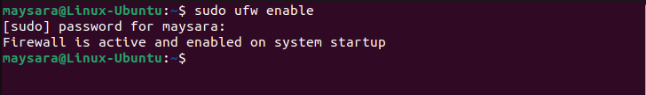

* Block port 20 and 21 (tcp) using ufw

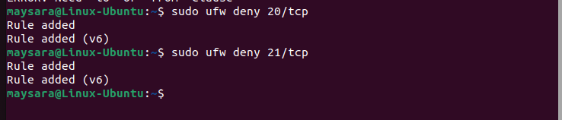

* Try to connect to ftp service

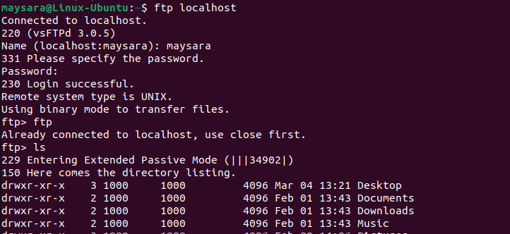

* Capture the ufw log to detect the blocked operations

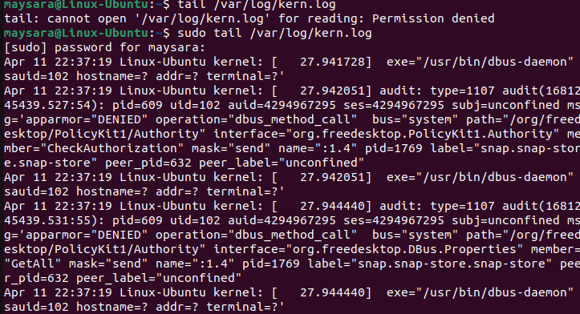

* Install nfs service on your system

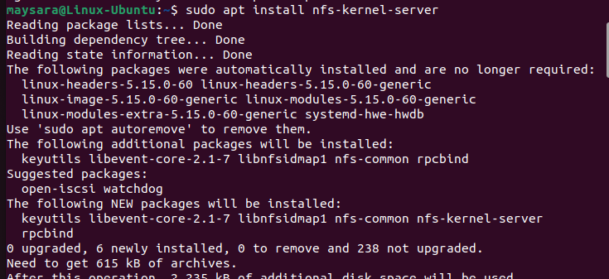

* Enable nfs service of the firewall

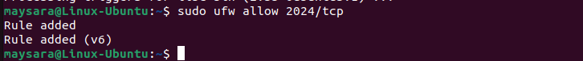

* Create and share /tmp/shares folder using exports command and etc/exports file

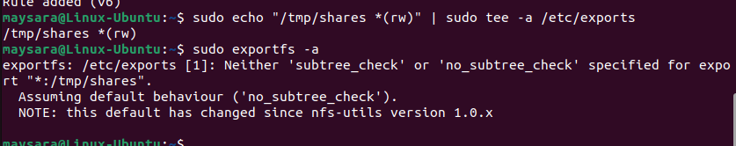

* Mount the remote share on /mnt folder



* Copy some files to remote share

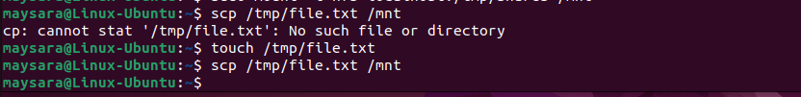

* Save iptables run to /tmp/iptables-backup file

