**System Admin II: Lab4**

* Using apt install apache2 server

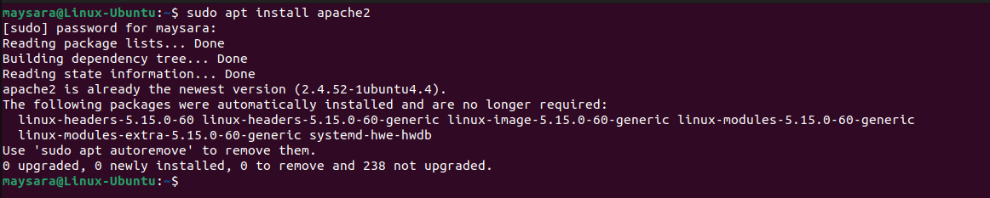

* Replace the default index.html content with your own content



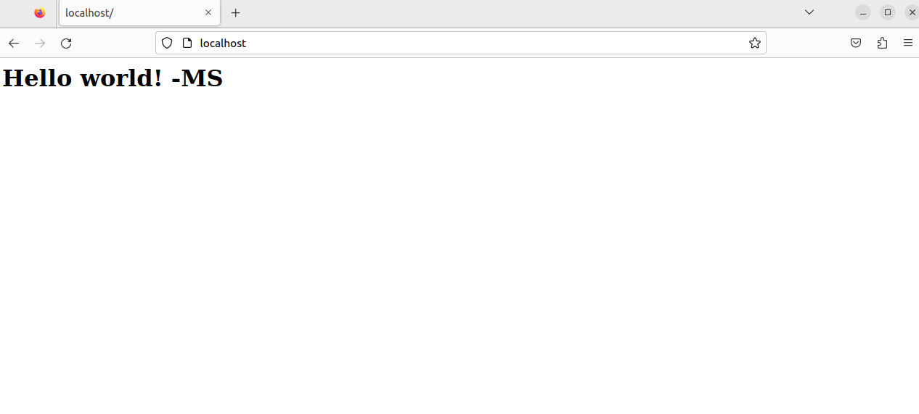

* Install php module for apache2

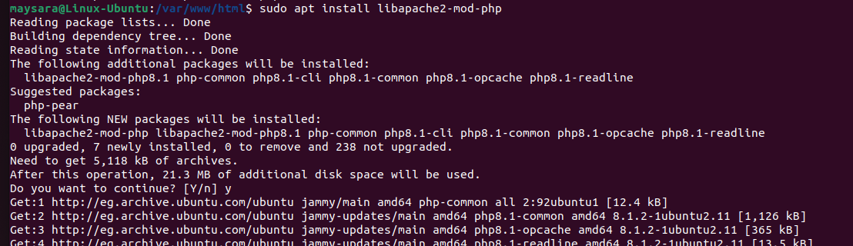

* Create new named VirtualHost to serve new php projct with special access log
* Create simple index.php file for the php site
* Configure /etc/hosts for php site



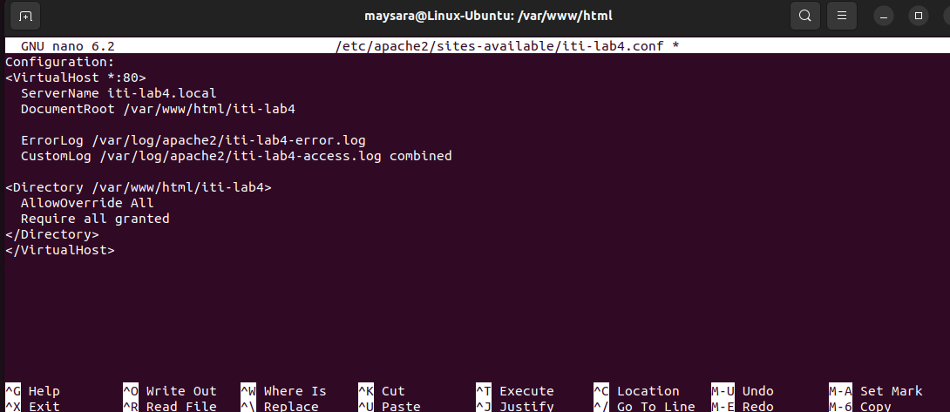

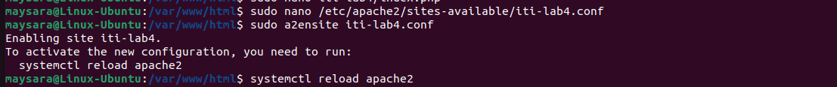



* Disable directory listing for the new VirtualHost



