**System Admin II: Lab5**

* Using apt install nginx

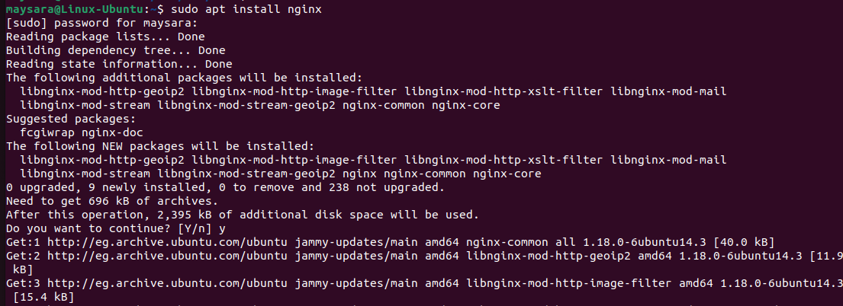

* Enable port 80 on the firewall



* Create index.html file on root directory of server section and test it

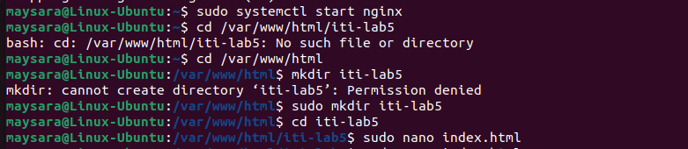

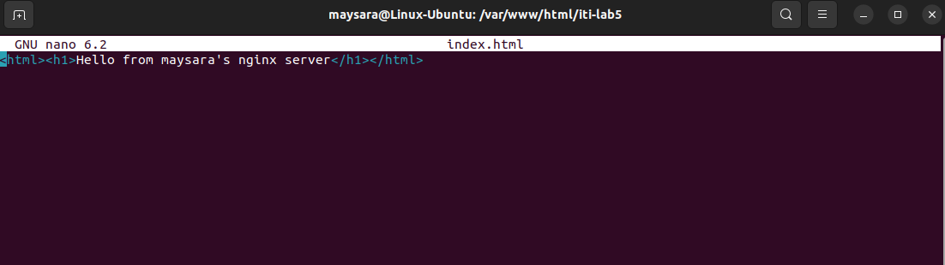

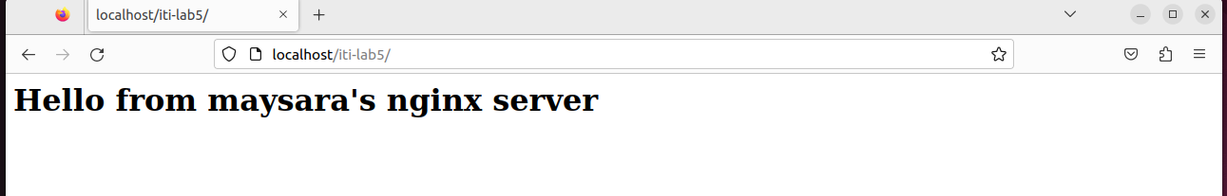

* Install php-pfm package

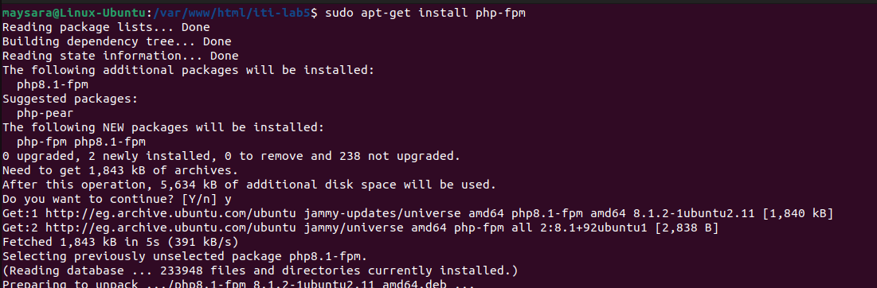

* Configure main site to enable php-pfm



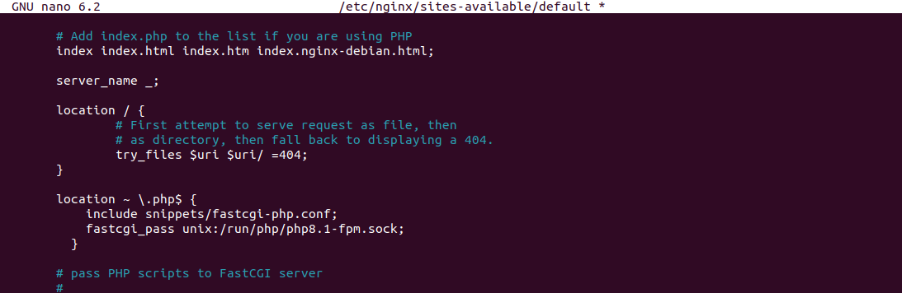

* Create index.php



