System Admin1-Lab3

• create users called itiuser1, itiuser2

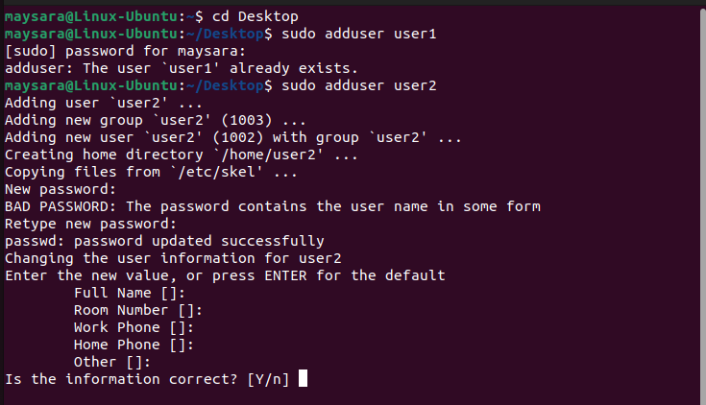

• create group called os_team

• create directory called os_team_workspace

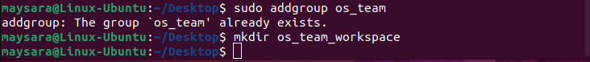

• assign os_team group to the directory os_team_workspaceand change mode to setgid (hint use sudo)

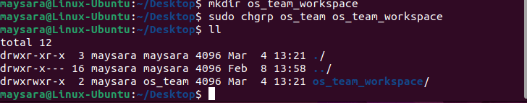

• list directory permissions and send screenshot.

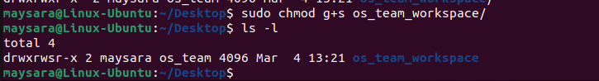

• add users itituser1 and itituser2 to os_teamgroup

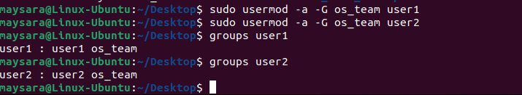

• send screenshot of all processes in tree mod

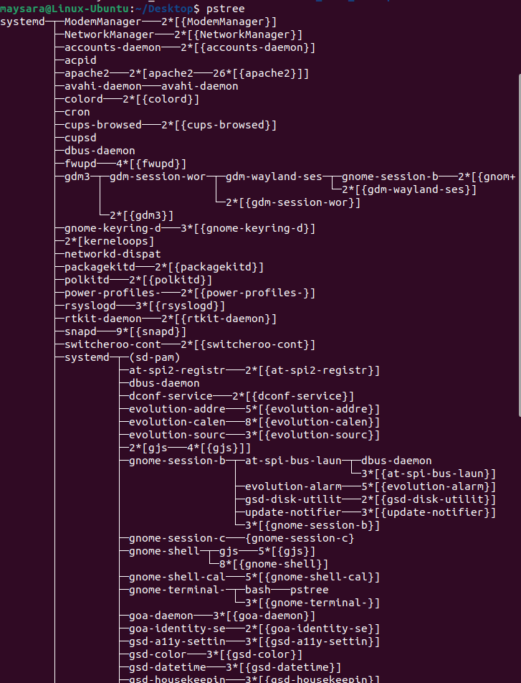

• execute command tail -f /var/log/syslog

