3 PRACTICAL
Use packet Tracer tool for configuration of 3 router networkusing one of the following protocol RIP/OSPF/BGP

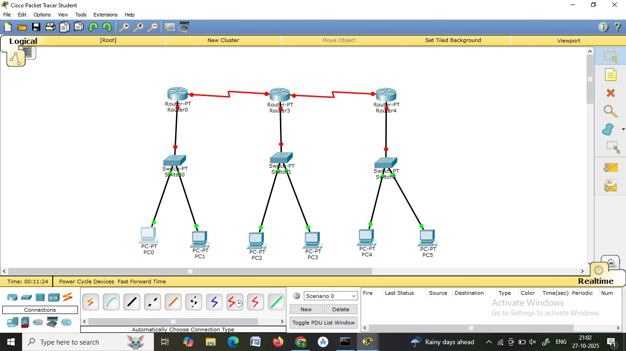
1.go to pc0 ->desktop->ip config address (type:10.10.10.1)->subnet automatically->default gateway(type:10.10.10.0)
2.go to pc1 ->desktop->ip config address (type:10.10.10.2)->subnet automatically->default gateway(type:10.10.10.0)
3.go to pc2 ->desktop->ip config address (type:20.20.20.1)->subnet automatically->default gateway(type:20.20.20.0)
4.go to pc3 ->desktop->ip config address (type:20.20.20.2)->subnet automatically->default gateway(type:20.20.20.0)
5.go to pc4 ->desktop->ip config address (type:30.30.30.1)->subnet automatically->default gateway(type:30.30.30.0)
6.go to pc5->desktop->ip config address (type:30.30.30.2)->subnet automatically->default gateway(type:30.30.30.0)

NOW GO ON “OPTION”-> preference->click on “always show port labels in logical workspace”

Now go on router0->config->fast ethernet0/0->click on “ON”->now type ip address ->
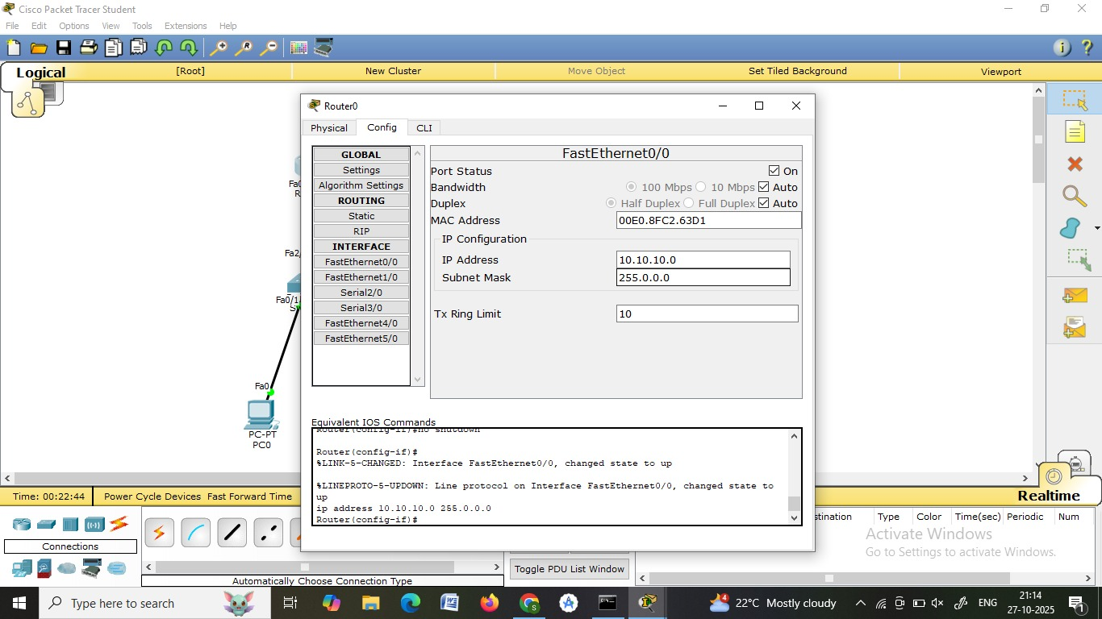

Now go to router1->config->fast ethernet0/0->click on “ON”->now type ip address (20.20.20.0)->subnet automatic
Now go to router2->config->fast ethernet0/0->click on “ON”->now type ip address (30.30.30.0)->subnet automatic

Now go to router0->config ->Serial2/0 ->click on “ON”->now type ip address (40.40.40.1)->subnet automatic
Now go to router1->Serial2/0 ->click on “ON”->now type ip address (40.40.40.2)->subnet automatic…….Stay on router1-> Serial3/0 ->click on “ON”->now type ip address (50.50.50.1)->subnet automatic
Now go to router2->config ->Serial2/0 ->click on “ON”->now type ip address (50.50.50.2)->subnet automatic

Now go to router0->config ->RIP ->Besides network add the netword(10.0.0.0) then click on add ->Besides network add the netword(40.0.0.0) then click on add
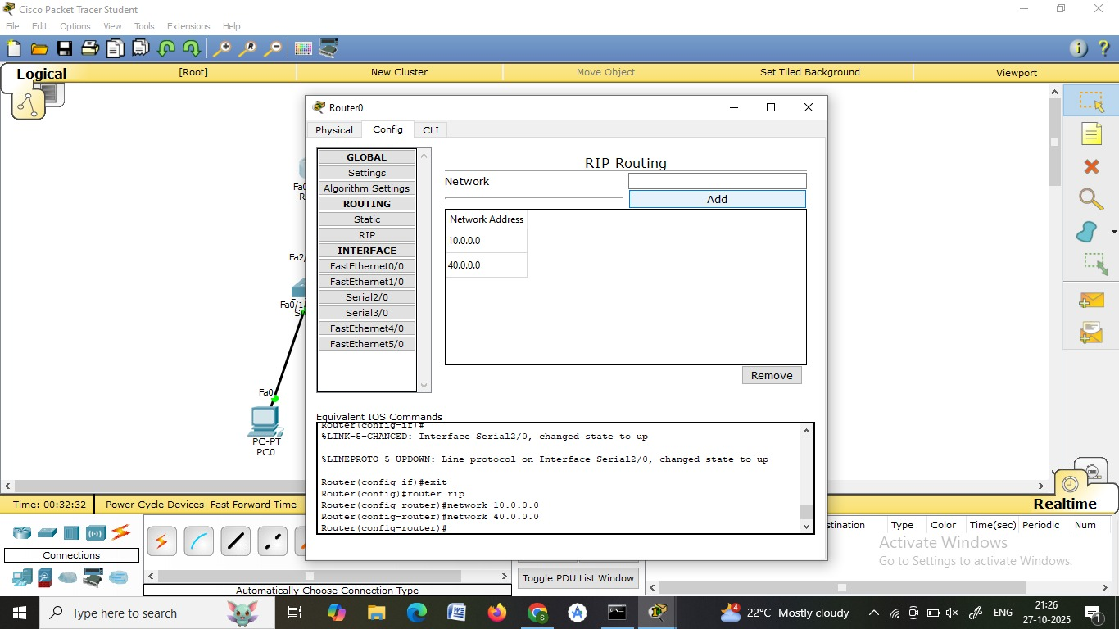
Now go to router1->config ->RIP ->Besides network add the netword(20.0.0.0) then click on add ->Besides network add the netword(40.0.0.0) then click on add->Besides network add the netword(50.0.0.0) then click on add
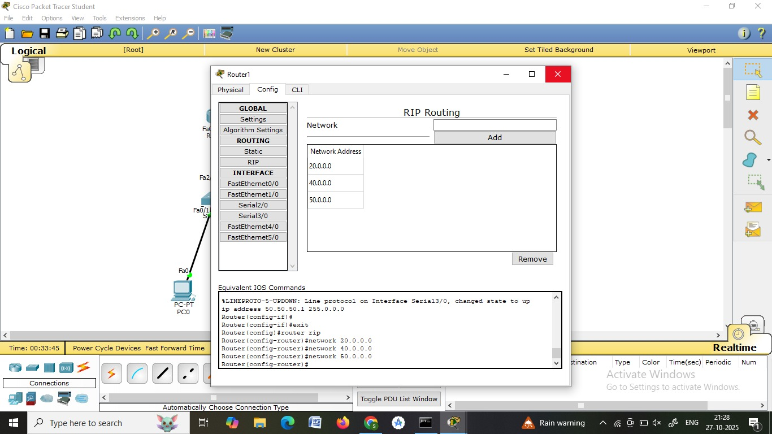

Now go to router2->config ->RIP ->Besides network add the netword(30.0.0.0) then click on add ->Besides network add the netword(50.0.0.0) then click on add
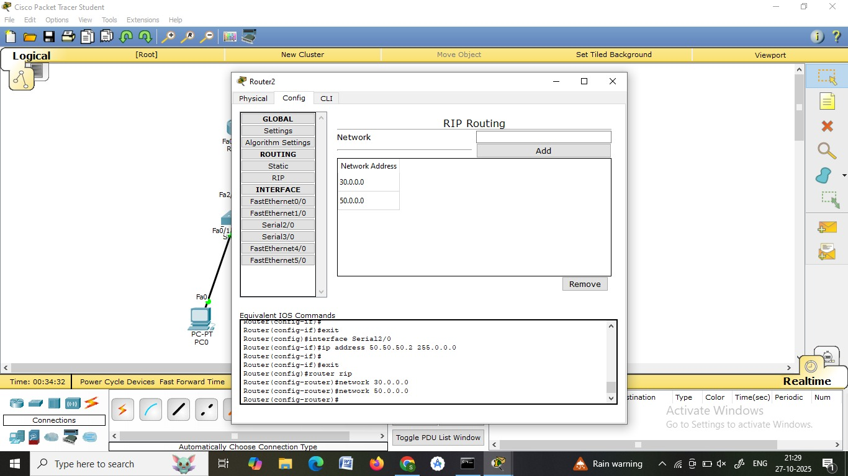

NOW CLICK ON MESSAGE ADD IT FROM PC0->PC1

