CN 7th practical

Aim: Study and Analyze the performance of HTTP, HTTPS and FTP protocol using Packet tracer tool.

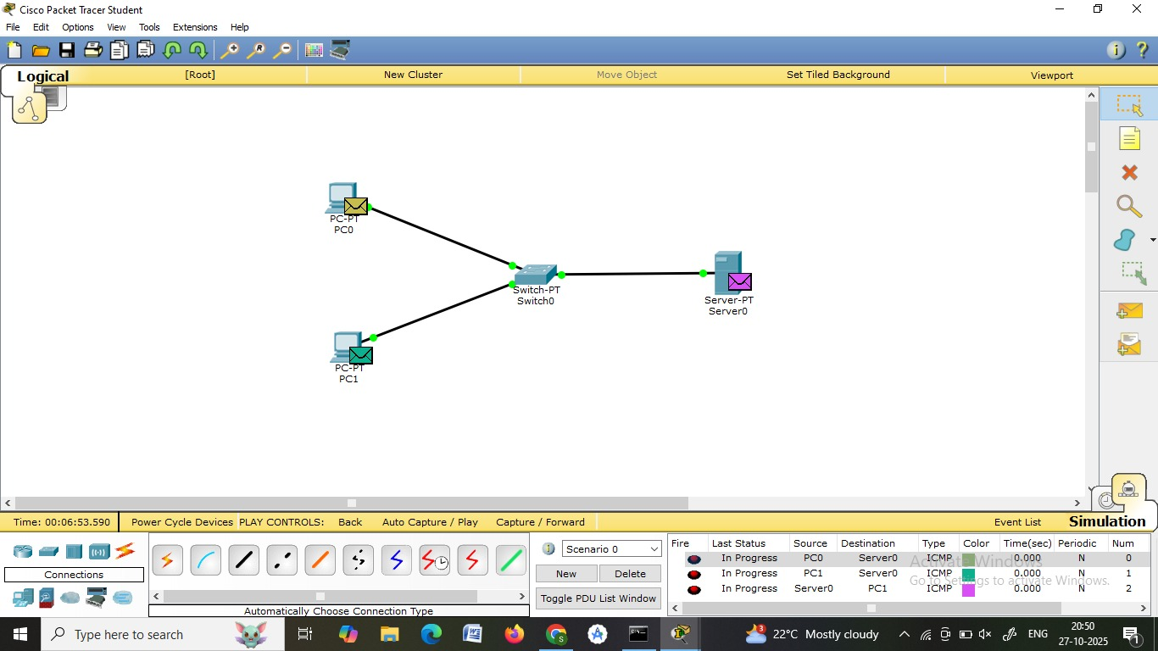

Steps :
1.Double click both pc -> desktop->Ip conffig ->Ip address (type: 192.168.1.1)-> click on subnet mask
Follow the same process for pc 2 and write ipaddress(type: 192.168.1.2)
2.Click on server-> desktop->Ip conffig ->Ip address (type: 192.168.1.3)
Now in server-> service->turn on http & https
3.Pass message from pc(source ) to server(destination)

