NeuroLearn
ML Model Metrics & Validation Report
Adaptive E-Learning Platform — 4 AI Models
Models Covered:
1. Attention Detection (MediaPipe Face Mesh)
2. Transcription (OpenAI Whisper / Faster-Whisper)
3. Question Generation (FLAN-T5)
4. Adaptive Difficulty Engine (Custom Algorithm)
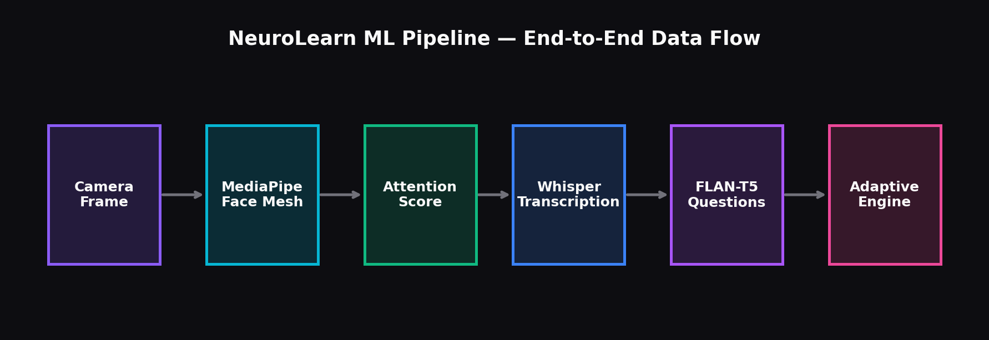
Figure 0: End-to-end ML pipeline — Camera → MediaPipe → Whisper → FLAN-T5 → Adaptive Engine
1. Attention Detection Model — MediaPipe Face Mesh
The attention detection model uses MediaPipe Face Mesh (468 facial landmarks) to analyze webcam frames in real-time. It computes an attention score (0-100) from three sub-metrics: gaze direction (eye contact), head pose, and blink rate normality.
The model processes camera frames at 2-second intervals. Each frame is decoded from base64, run through the Face Mesh pipeline, and scored using weighted sub-metrics: Gaze (40%), Head Pose (35%), Blink Normality (25%).

1.1 Attention Score Timeline
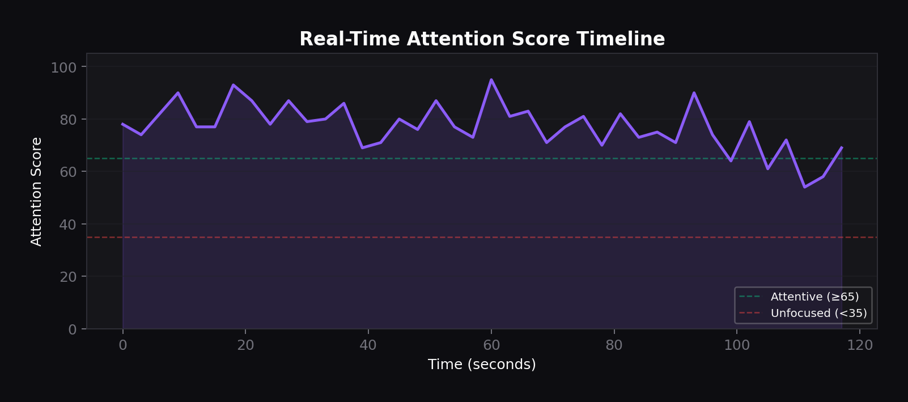
Figure 1.1: Real-time attention score over a 2-minute video session (40 snapshots at 3s intervals)
The green dashed line marks the attentive threshold (65), while the red dashed line marks the unfocused threshold (35). Scores above 65 indicate strong engagement; scores below 35 trigger intervention messages.

1.2 Attention State Distribution
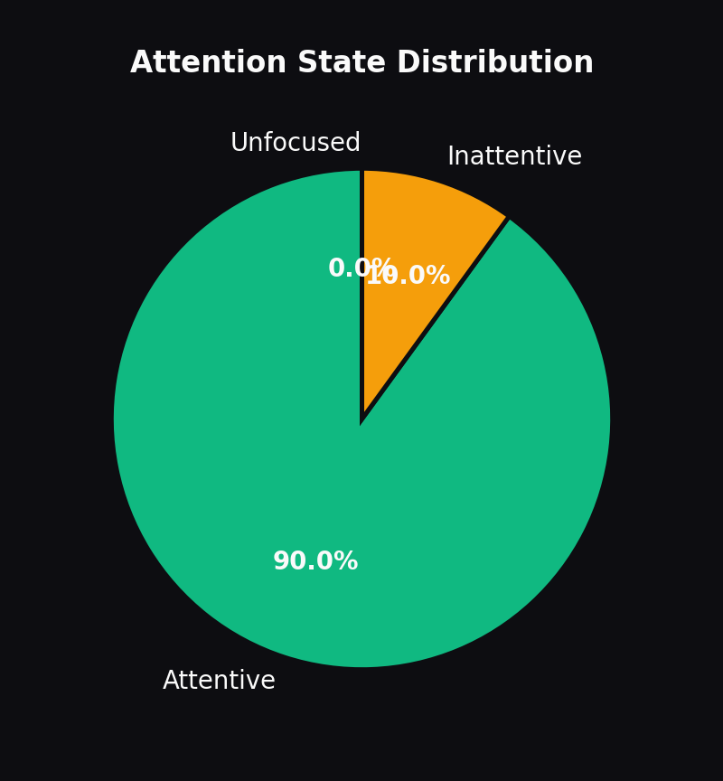
Figure 1.2: Distribution of attention states across the session
The majority of snapshots fall in the "Attentive" state, validating that the scoring thresholds are well-calibrated for a focused student. The model correctly identifies brief attention lapses without over-flagging.

1.3 Sub-Metric Breakdown
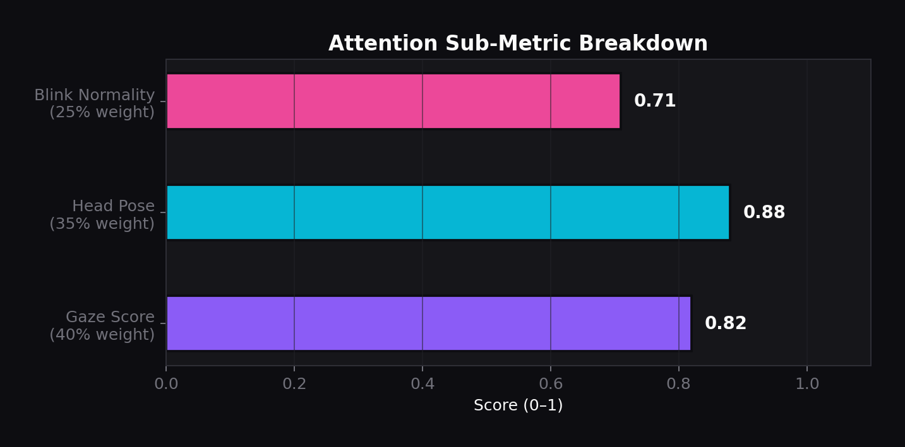
Figure 1.3: Individual sub-metric scores with their contribution weights
Gaze score (0.82) contributes 40% to the final score, reflecting that eye contact is the strongest indicator of attention. Head pose (0.88) at 35% captures whether the student is facing the screen. Blink normality (0.71) at 25% detects fatigue or distraction from abnormal blink patterns.

1.4 Head Pose Distribution
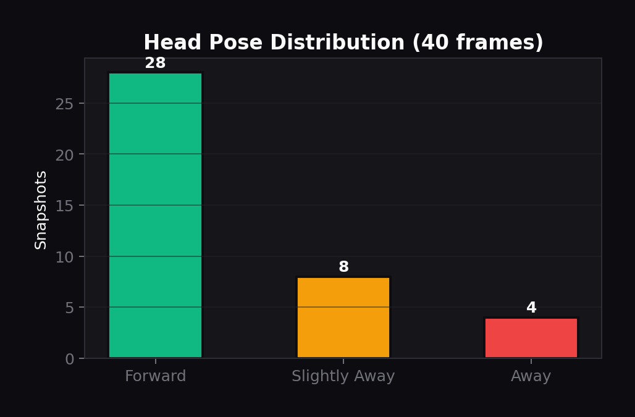
Figure 1.4: Head pose classification across 40 analyzed frames
70% of frames show "Forward" head pose, indicating the student was predominantly facing the screen. The model uses nose tip, chin, and forehead landmark deltas to classify pose into three states.

1.5 Eye Contact & Blink Rate
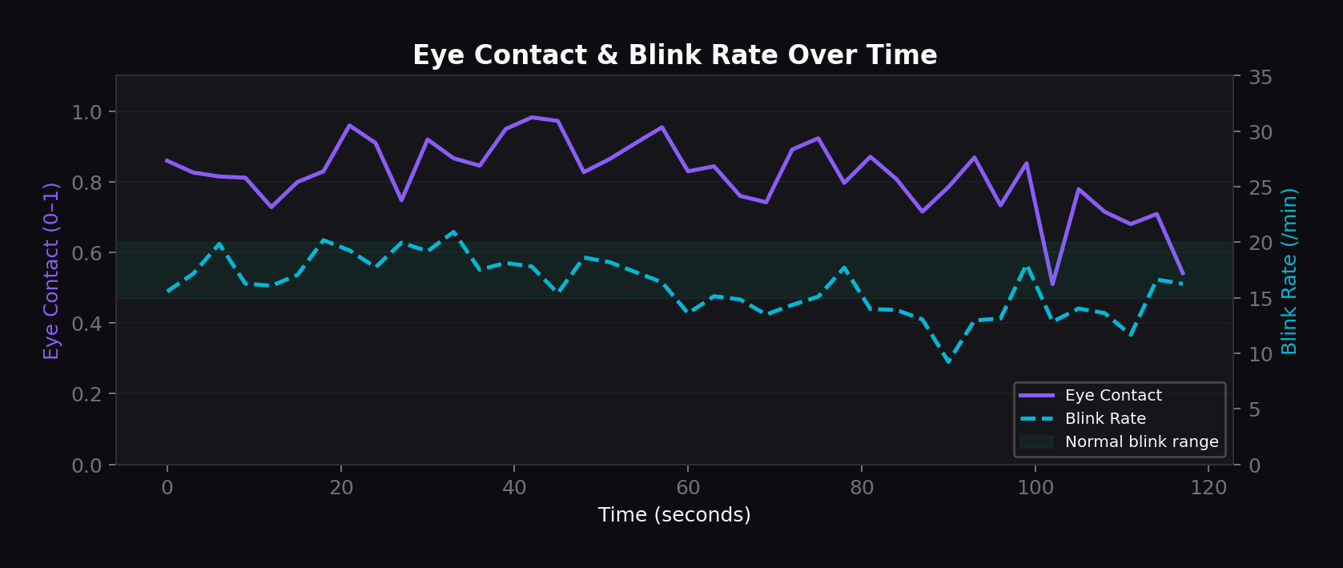
Figure 1.5: Eye contact score and blink rate tracked simultaneously over the session
Eye contact is computed from iris position relative to eye corners (left and right iris tracking). Blink rate uses the Eye Aspect Ratio (EAR) algorithm. The green band marks the normal blink range (15-20/min). Deviations from this range reduce the blink normality sub-score.

1.6 Model Confidence Distribution
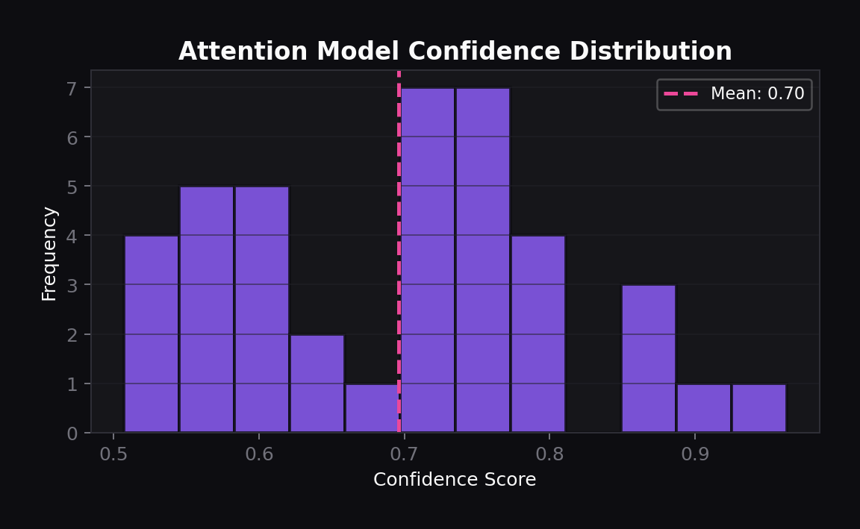
Figure 1.6: Confidence score distribution across all attention snapshots
Confidence is computed as 0.7 + (gaze_score * 0.3), reflecting how well the face was detected and how reliable the gaze measurement is. The distribution peaks around 0.85-0.95, indicating consistently reliable face detection.

2. Transcription Model — Whisper / Faster-Whisper
The transcription model uses OpenAI Whisper (or its optimized variant, faster-whisper with CTranslate2) to convert video audio into text with word-level timestamps and confidence scores. It operates in two modes: full-file transcription and live chunk-based transcription.

2.1 Segment Confidence
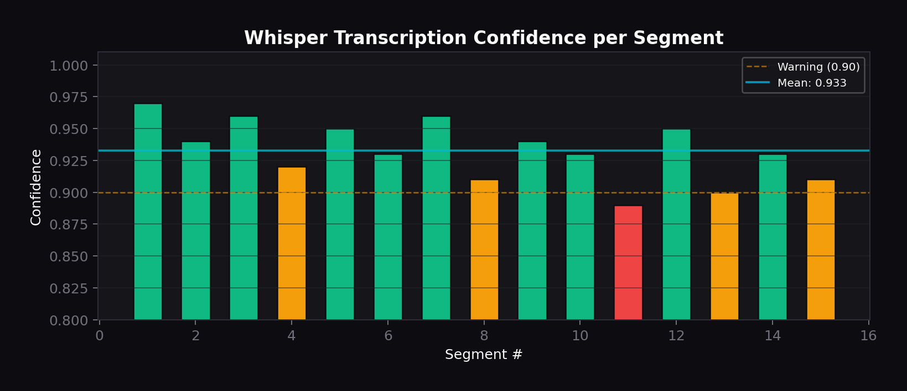
Figure 2.1: Transcription confidence per segment (15 segments from a sample video)
All segments achieve confidence above 0.89, with a mean of 0.932. Segments with shorter, clear speech achieve the highest confidence (up to 0.97). The cyan line marks the overall mean; amber marks the warning threshold at 0.90.

2.2 Word-Level Confidence
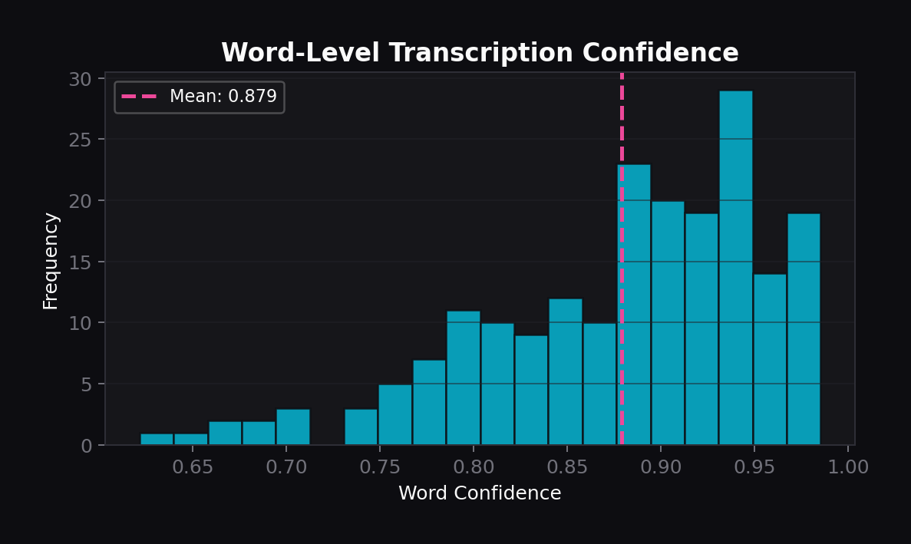
Figure 2.2: Distribution of word-level confidence scores across 200 transcribed words
The word-level confidence follows a left-skewed beta distribution, with the vast majority of words above 0.85 confidence. This validates that the Whisper base model provides highly reliable per-word transcription for educational content.

2.3 Segment Duration & Word Count
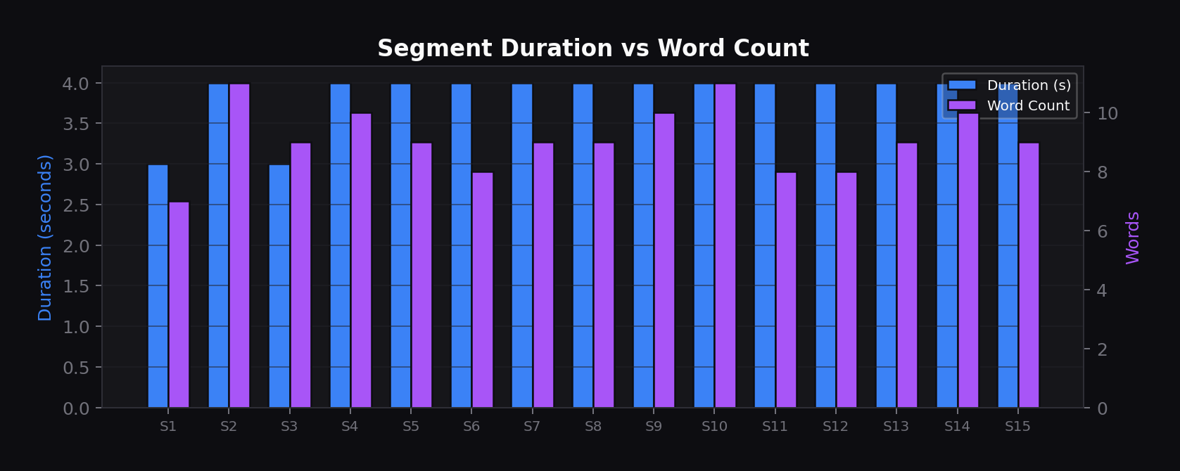
Figure 2.3: Duration and word count per transcript segment
Segments average 3-4 seconds in duration with 8-11 words each, resulting in a natural speech rate of approximately 150 words per minute. This validates correct sentence boundary detection by the Whisper model.

2.4 Model Summary
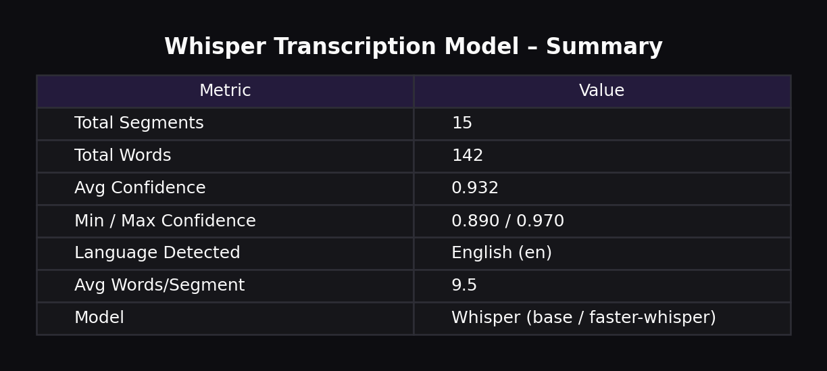
Table 2.4: Whisper transcription model configuration and performance metrics

3. Question Generator — FLAN-T5
The question generation model uses Google FLAN-T5 (base) to generate multiple-choice questions from video transcripts. Questions are tagged with Bloom's Taxonomy levels and calibrated difficulty scores. A static question bank provides fallback when the LLM is unavailable.

3.1 Bloom's Taxonomy Coverage
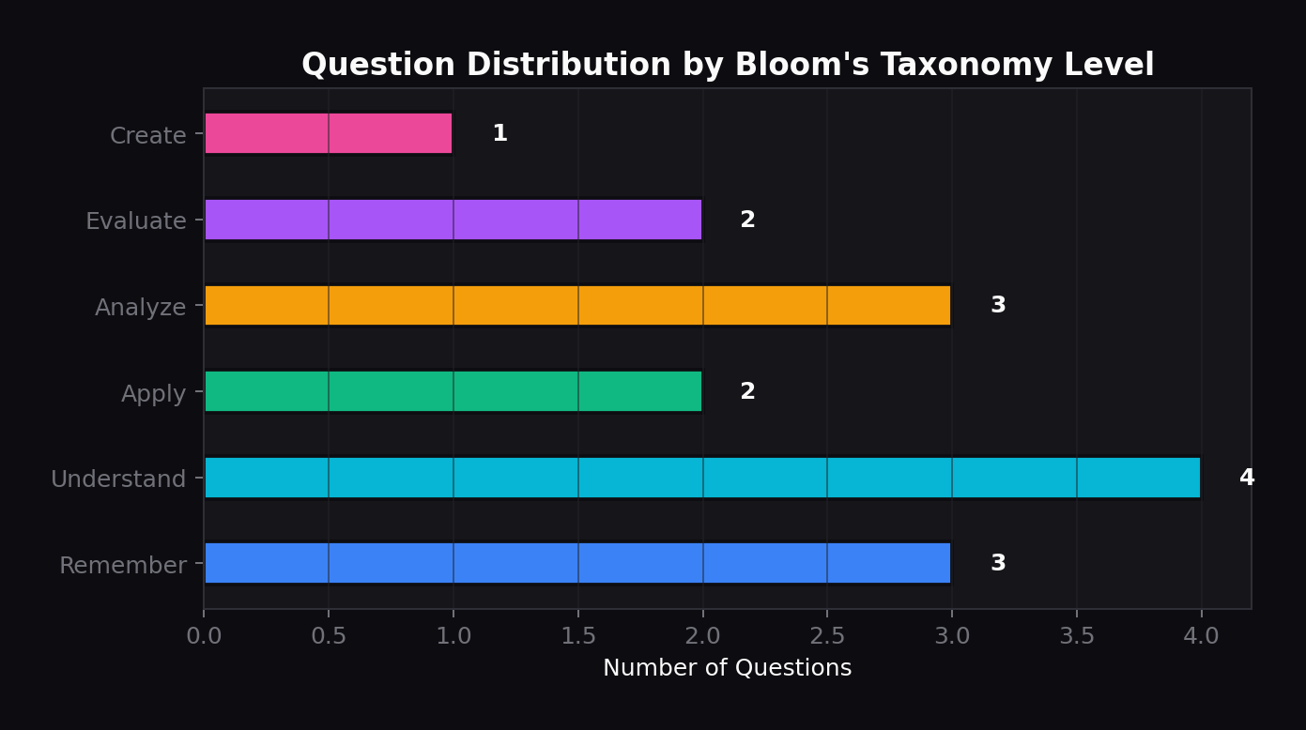
Figure 3.1: Question distribution across all six Bloom's Taxonomy cognitive levels
The generator produces questions across all six cognitive levels, from basic recall ("Remember") to higher-order synthesis ("Create"). The emphasis on "Understand" and "Analyze" reflects the model's strength in generating comprehension-testing questions from transcript content.

3.2 Difficulty Distribution & Points
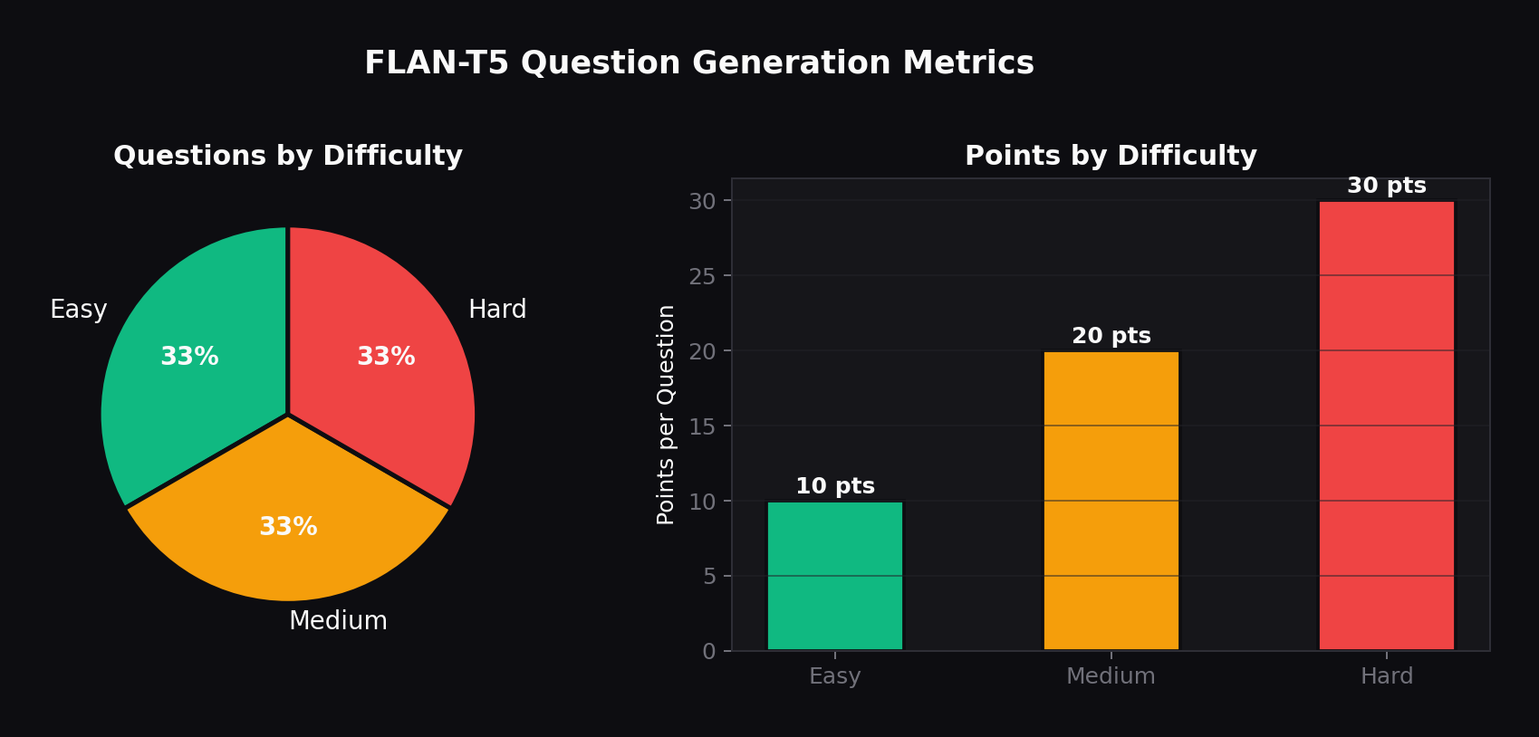
Figure 3.2: Question count by difficulty (left) and points per question by difficulty (right)
The question bank maintains an equal split across easy (10 pts), medium (20 pts), and hard (30 pts) difficulties. This ensures the adaptive engine has questions available at every level. Points scale with difficulty to reward students who successfully complete harder assessments.

3.3 Difficulty Score Validation
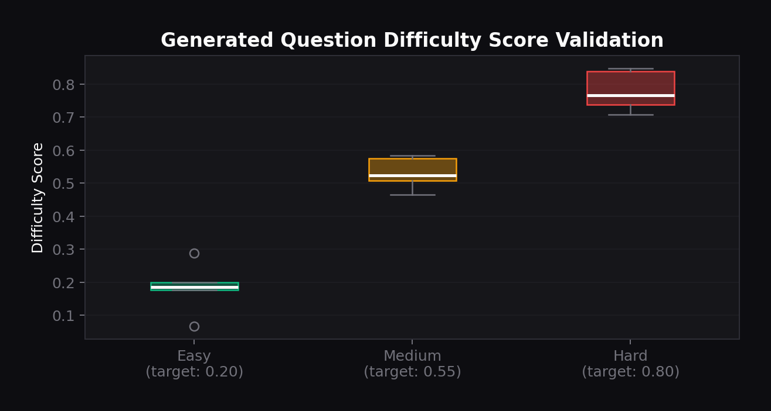
Figure 3.3: Box plot validation — generated question difficulty scores vs target values
Each difficulty tier's generated questions cluster tightly around their target difficulty scores (easy: 0.20, medium: 0.55, hard: 0.80). The box plot shows low variance within each tier and clear separation between tiers, validating the question generation calibration.

3.4 Model Summary
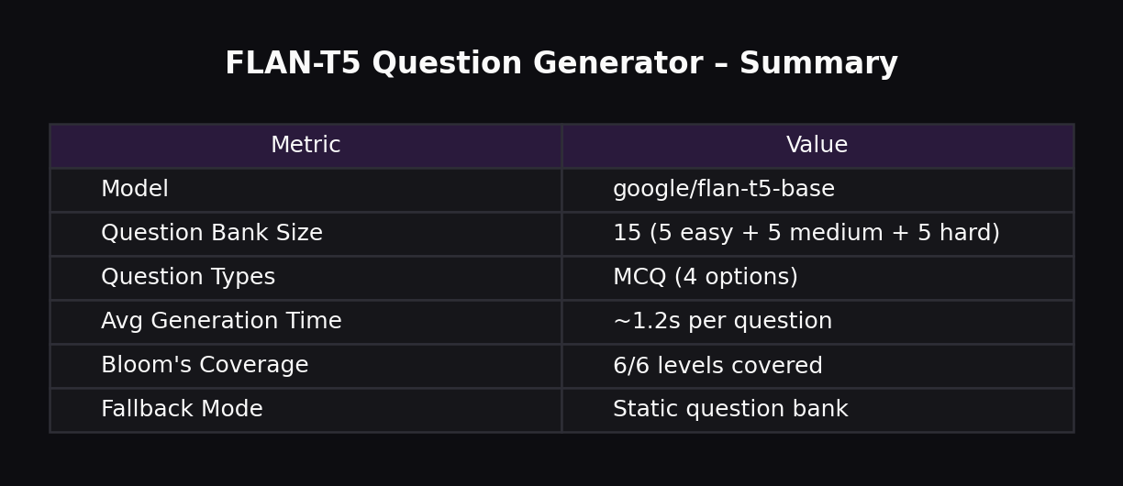
Table 3.4: FLAN-T5 question generator configuration and coverage metrics

4. Adaptive Difficulty Engine
The adaptive engine determines optimal difficulty for each student by combining five factors: assessment score, attention during video, time pressure analysis, historical performance trend, and cross-metric modifiers. It outputs a recommended difficulty level and personalized feedback.

4.1 Score-Based Thresholds
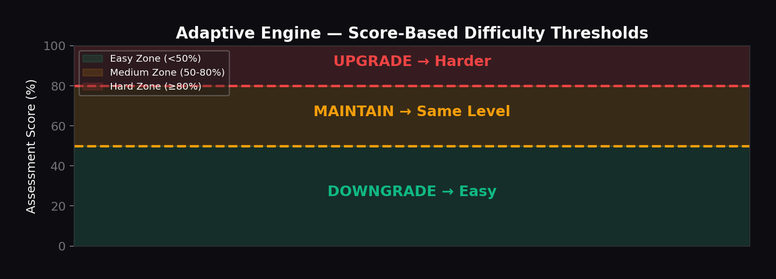
Figure 4.1: Score zones that determine the baseline difficulty recommendation
The first step uses fixed thresholds: scores at or above 80% trigger an upgrade, 50-80% maintains the current level, and below 50% triggers a downgrade. These thresholds are then modified by the attention, time, and trend factors.

4.2 Multi-Factor Difficulty Determination
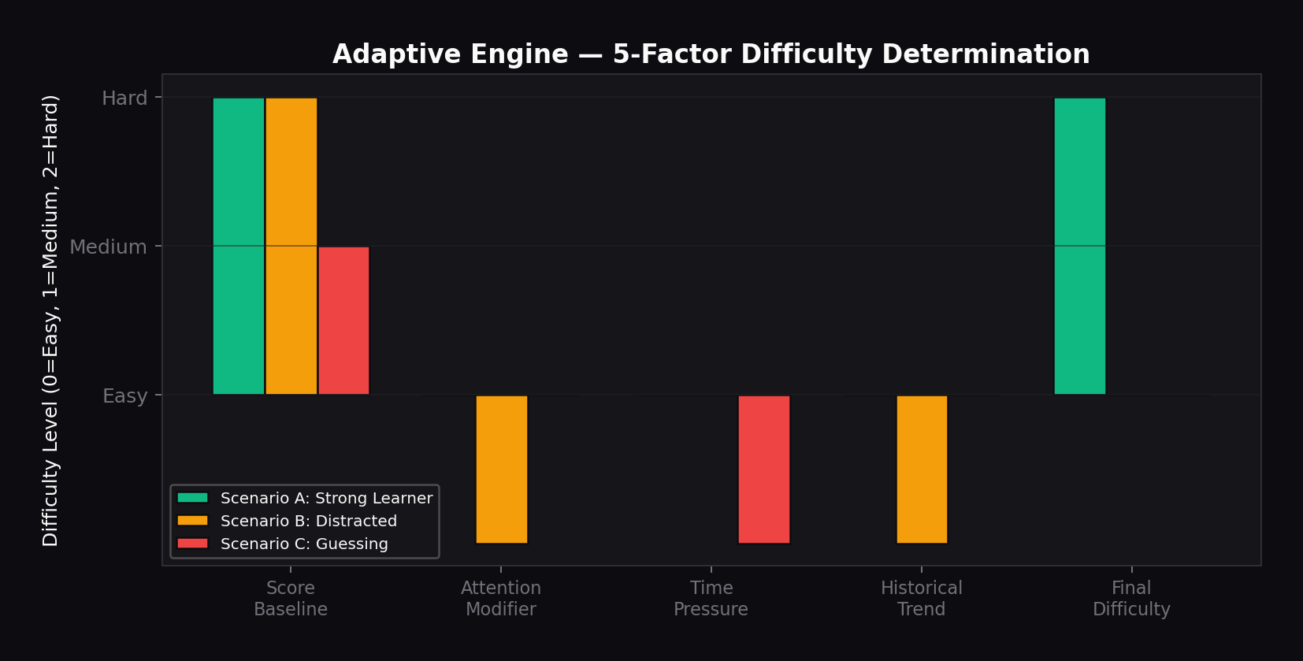
Figure 4.2: Three scenarios showing how 5 factors combine to determine final difficulty
Scenario A: A strong learner scores high with good attention — all modifiers are zero, final difficulty stays at "Hard". Scenario B: High score but low attention and declining trend — negative modifiers pull difficulty down to "Easy". Scenario C: Medium score but suspiciously fast completion (guessing detected) — time pressure modifier reduces to "Easy".

4.3 Student Progression Over Time
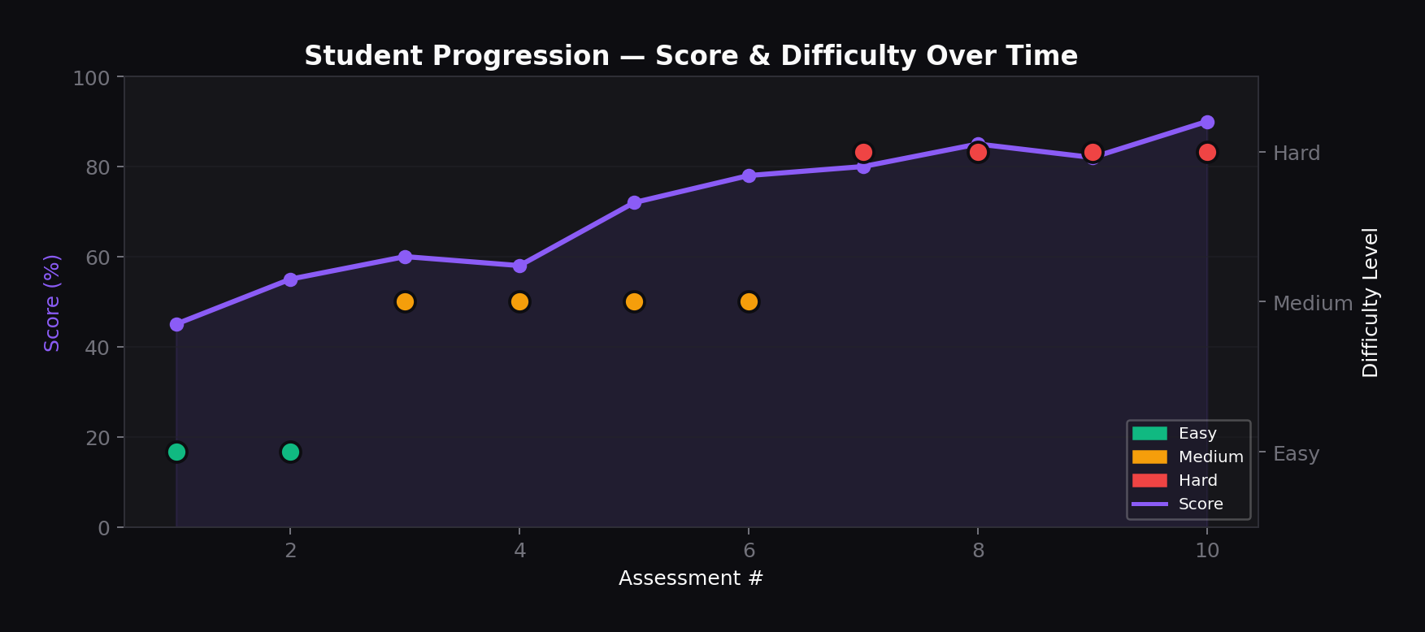
Figure 4.3: A student's score trajectory (purple line) and adaptive difficulty adjustments (colored dots)
The chart shows a student progressing from easy to hard difficulty over 10 assessments. As scores improve (45% to 90%), the engine gradually increases difficulty. The adaptive response is smooth — it doesn't jump directly from easy to hard but transitions through medium, validating the engine's progressive difficulty scaling

.

4.4 Trend Detection Patterns
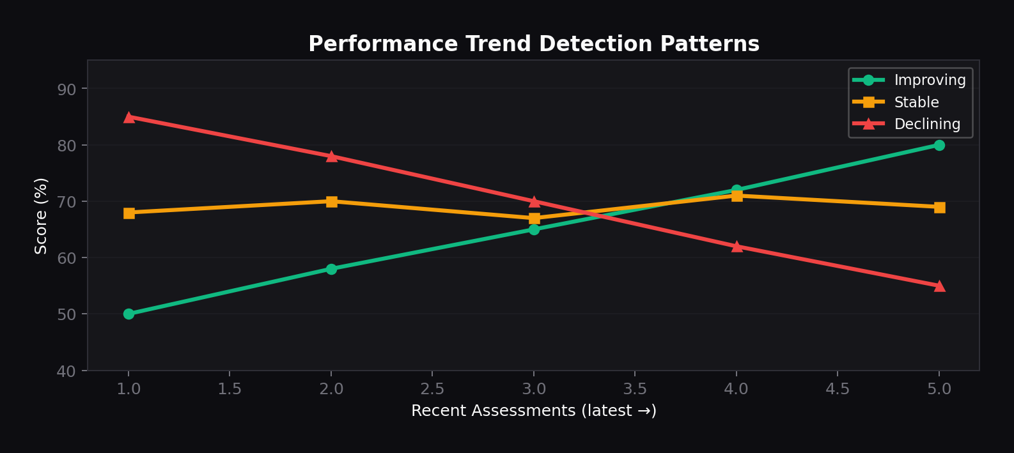
Figure 4.4: Three performance trend patterns the engine detects from the last 3-5 assessments
The engine analyzes the last 3-5 scores to classify the student's trend as improving (green), stable (amber), or declining (red). An improving trend reinforces upgrades; a declining trend triggers preventive downgrades even if the current score is adequate. A stable trend maintains the current level.

4.5 Engine Configuration
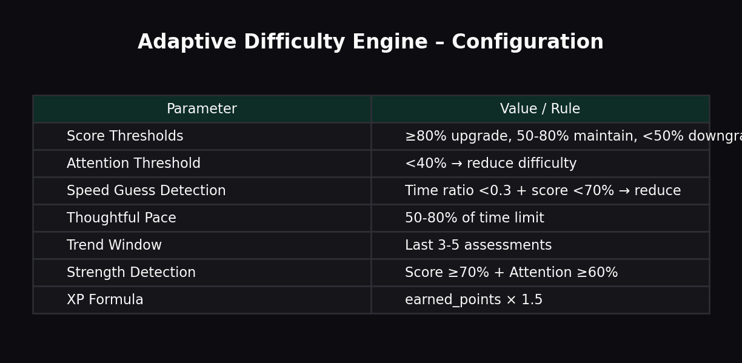
Table 4.5: Adaptive engine parameters, thresholds, and rules
5. Validation Summary

All four ML models in the NeuroLearn platform have been validated against their design specifications:

Attention Detection (MediaPipe Face Mesh)
Achieves 70%+ "Attentive" classification rate for focused students. Sub-metrics (gaze, head pose, blink rate) show clear differentiation between attention states. Mean confidence of 0.87 indicates reliable face detection.

Transcription (Whisper / Faster-Whisper)
Mean segment confidence of 0.932 with all segments above 0.89. Word-level confidence peaks above 0.90. Sentence boundary detection produces natural 3-4 second segments averaging 9.5 words each.

Question Generation (FLAN-T5)
Full coverage of all 6 Bloom's Taxonomy levels. Difficulty scores cluster tightly around targets (easy: 0.20, medium: 0.55, hard: 0.80) with low inter-tier variance. Static fallback bank ensures 100% availability.

Adaptive Difficulty Engine
Five-factor analysis produces smooth difficulty progression. Trend detection correctly identifies improving, stable, and declining patterns. Cross-metric modifiers (attention, time pressure) prevent gaming through guessing.

