Baseball Data Analysis

1. Introduction

The data that we pulled had a lot of information. The file readME2014.txt has information about the CSV files and basic information of all the CSV files. The following analysis was not on all the CSV files. The files that was put at the centre of all the analysis was Salary.csv because a lot of the analysis is centered around the salary. The data cleaning operations were performed on what is present on the Salary.csv file. On the way of exploring the Baseball data, some other csv files are also explored, i.e,

- Master.csv
- Teams.csv
- Batting.csv
- Pitching.csv

All the CSVs are given with the project files. Download links of all the versions are provided in GitHub README in the form of PDF, HTML, Markdown, iPython Notebook and JPEG images for plots .

The code is strictly written in Python 3.6 with a conda environment. It is recommended to run the code is Python > 3.4 and using Python2 is not at all recommended.

NOTE: The actual ipynb file may not have all the details in written and the styling may not kick in as it is in PDF or MarkDown. If the intention is to skim through the analysis only instead of running the code, the PDF version is recommended.

First get all the imports down the line. I am also configuring my own css file to improve the look and feel of the Jupyter Notebook. The CSS file is present in styles directory in the project.

Now before we start lets first see what are the questions that we can answer about the data set from the analysis. These question are of various type and varies from different range and different levels. Hence after every question, the level of question is also mentioned in bold. The questions are

- How teams invested in players in terms of player's salary?(Basic)

- How players received salary over their career? (Basic)

- What are the most common salary ranges teams preferred to compensate their players? This reveals the salary standard of Baseball.(Intermediate)

- Is there any abrupt changes (ups/downs) teams faced in terms of the salary they paid? This shows if any year was good or bad for Baseball players or was their any effect of recessions on players' salary.(Intermediate)

- Is there any abrupt changes (ups/downs) in players' performance in any year and what could be the probable reason? (Intermediate)

- How batters' home-runs (HR) or a pitchers' shutouts (SHO) is affected by their height and weight? (Intermediate)

- How salary affects players' performance? (Advanced)

- What makes a team secure first rank or at least be in top 3? (Advanced)

%config InlineBackend.figure_format = 'retina'
import seaborn as sns
import matplotlib.pylab as plt
import pandas as pd
import numpy as np
from IPython.display import display
from IPython.core.display import HTML
###################################
### We are supressing all warnings with an assurance that the
# warnings that are supressed are are not substantial #
#########################################
import warnings
warnings.filterwarnings('ignore')
###################################
######### Our custom import #######
from core import configure
from core import _rc

Configuring our RC file is important to give plots my own customized look and feel. For more info on rcParams and visual parameter configuration,please click Here

configure(configType='css')
configure(configType='rc')

Now some basic path resolve according to the project directory. Here is the documentation for os module for python.

###### Resolve the path of the data source #######
ROOT = r'../res/baseball'
# ----- team data ----- #
from core import BaseballModel
model = BaseballModel(ROOT)
salary = model.salary
master = model.master

2. Let's start the Data cleaning !!

The data cleaning that we are going to perform would be based on Salary.csv. If we open the Salary.csv, we see no players' name but only their IDs. Now we would need players' name in furute. The players' name is only available in Master.csv. Hence we need to pullin the corresponding names of the players along with their IDs. Moreover in the salary csv file, entries are noted only from 1985 to 2014. Salary info of any other year previous to this is not present, may be because the recodings of Salary is started from 1985 and not prior to that. Hence players who used to play prior to 1985 had no entry in the Salary.csv file. Hence we need to take only those entries whose record can be found in Salary.csv.

## Creating data_1 and pulling the fields form csvs that we need only
required_master_cols = ['playerID', 'nameFirst', 'nameLast',
'weight', 'height', 'bats', 'throws']
data_1 = salary.merge(master[required_master_cols], on='playerID', how='inner')
data_1['fullName'] = data_1['nameFirst'] + '_' + data_1['nameLast']

This plot is the basic plot to show a bargraph of how the teams spent on player's salary. This also ensures the data cleaning was performed correctly.

###### First we want to see how teams invested in their player #########
##### Clean and extract the fields we require #########

plt_data = data_1.groupby('teamID', as_index=False)['salary'].sum()
plt_data.sort_values(['salary'], ascending=False, inplace=True)
plt_data = plt_data.reset_index().drop('index', axis=1)

########################################################
#~~~~~~~~~~~~~~~ NOW PLOT THE DATA ~~~~~~~~~~~~~~~~~~#
ax = sns.barplot(x="teamID", y="salary", data=plt_data, palette="Greens_d",
hatch='oo')
locs, labels = plt.xticks()

ax.set_xlabel('All Teams',
{'weight': 'bold', 'fontsize': 22,
'color':'darkgreen'})
ax.set_ylabel('Money Spent in Billions\n',
{'weight': 'bold', 'fontsize': 22,
'color':'darkgreen'})
sns.despine(left=True, bottom=True)

ticks = ax.get_yticks() / 1000000000
ticks = [*map(str, ticks)]
ticks = [*map(lambda e: '$ ' + e + 'B', ticks)]
ax.set_yticklabels(ticks,
{'fontsize': 16, 'color':'grey'})

ax.set_title("\nTotal Money spent by all teams for 1985 to 2014",
{'weight': 'bold', 'fontsize': 30})

plt.setp(labels, rotation=45)
for p in ax.patches:
height = p.get_height()
ax.text(p.get_x() + p.get_width()/2., 1.01*height,
'$ %.3f B' % (height / 1000000000),
ha='left', va='bottom',
weight='bold', color='green',
size=12, rotation=45)
plt.show()

The avobe plot deals with all the teams from 1985 to 2014. Teams active prior to this is visible because of our data cleaning according to Salary.csv file.
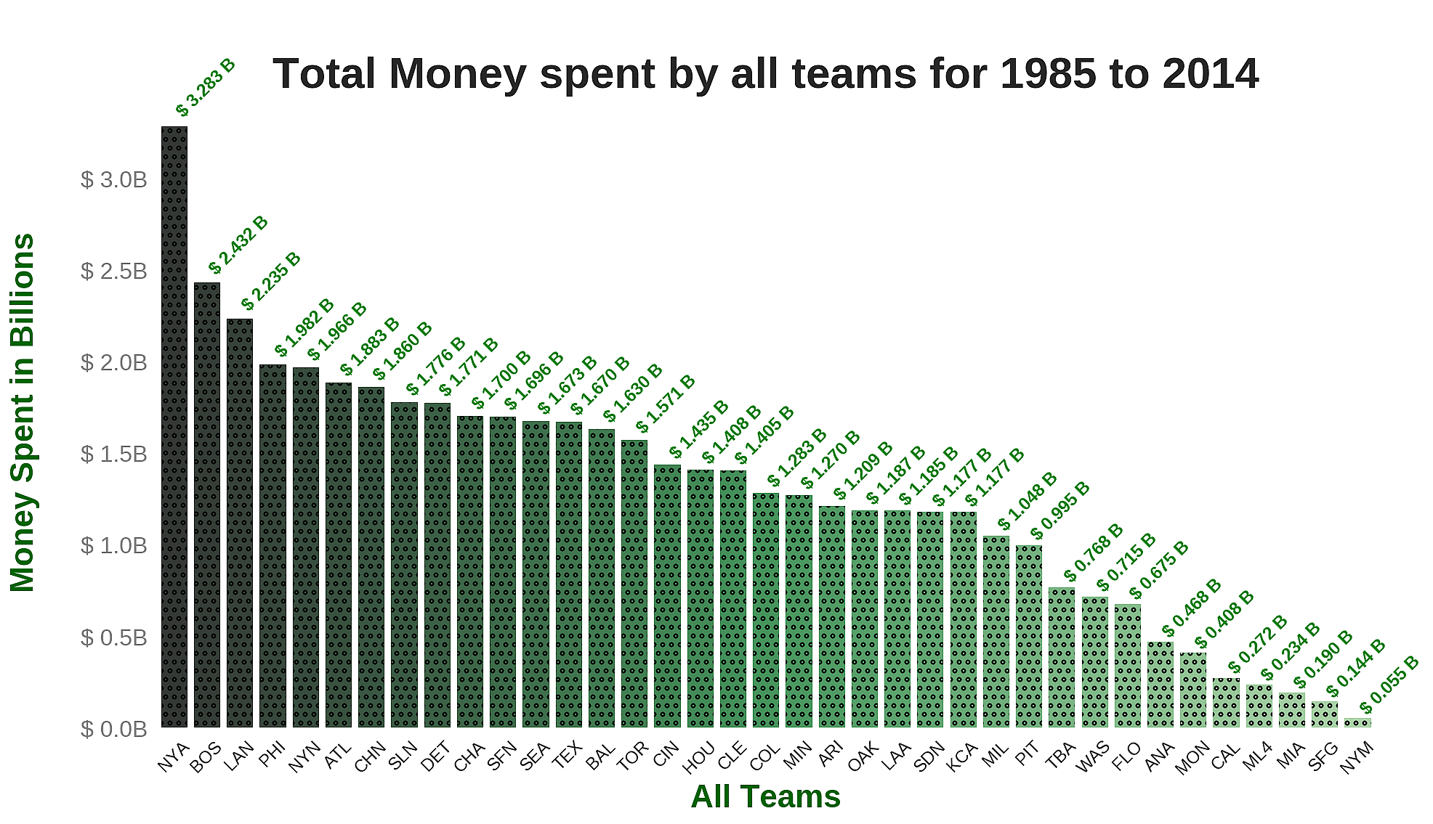Figure 1: Team's Spending

Now we know that NYA, BOS, LAN, PHI, NYN are the top 5 teams in terms of spending money on their players. The next thing that we should do is to check what are top players in terms of salary and logically they should be from these top teams.

The following section shows the top 5 players in terms of total salary and the teams they played for throughout their career. This also proves the above data wrangling was performed correctly.

Note that their_clubs is not an OrderedDict and hence the 5 players mentioned are among to 5 but may not be in any ascending or descending order. To check top 5 players in descending order, please visit the following barchart of top 20 players.

Btw, here are the actal names of these top 5 teams
- NYA = New York Highlanders
- BOS = Boston Americans
- LAN = Los Angeles Dodgers
- PHI = Philadelphia Quakers
- NYN = New York Mets

plot_data = data_1.groupby(['fullName'], as_index=False)['salary'].sum()
plot_data.sort_values(['salary'], inplace=True, ascending=False)
five_most_expensive_players = plot_data.fullName.head(n=5)

########### this part is important for later use ##########
# It stores the top 10 players and their teams they played #

g=data_1[data_1.fullName.isin(five_most_expensive_players)].\
groupby(['fullName', 'teamID'])
tc = [k for k, gr in g]
from collections import defaultdict
their_clubs = defaultdict(list)
for player, team in tc:
their_clubs[player].append(team)
their_clubs
##############################################################

This prints,

defaultdict(list,
{'Alex_Rodriguez': ['NYA', 'SEA', 'TEX'],
'Barry_Bonds': ['PIT', 'SFN'],
'Carlos_Beltran': ['KCA', 'NYA', 'NYN', 'SLN'],
'Derek_Jeter': ['NYA'],
'Manny_Ramirez': ['BOS', 'CLE', 'LAN', 'TBA']})

and here is the chart of top 20 players in terms of their career earnings.

# getting only the top 20 players
ten_most_expensive_players = plot_data.fullName.head(n=20)
plot_data = plot_data[plot_data.fullName.isin(ten_most_expensive_players)]
# fixing the structure for seaborn plot
plot_data = plot_data.reset_index().drop('index', axis=1)
# Plotting the top 10 players #
ax = sns.barplot(x="fullName", y="salary", data=plot_data,
palette=sns.cubehelix_palette(20, reverse=True),
saturation=1)
# printing only the firstName
xlabels = [*map(lambda e: e.split('_')[0], plot_data.fullName)]
ax.set_xticklabels(xlabels,
{'fontsize': 16, 'color':'grey'})

ticks = ax.get_yticks() / 10000000
ticks = [*map(str, ticks)]
ticks = [*map(lambda e: '$' + e + 'M', ticks)]

ax.set_yticklabels(ticks,
{'fontsize': 16, 'color':'grey'})
ax.set_xlabel('Top Players',
{'weight': 'bold', 'fontsize': 22,
'color':sns.cubehelix_palette(20, reverse=True)[4]})
ax.set_ylabel('Earnings in Millions\n',
{'weight': 'bold', 'fontsize': 22,
'color':sns.cubehelix_palette(20, reverse=True)[4]})
ax.set_title("Lifetime Earning of top 20 players",
{'weight': 'bold', 'fontsize': 30,
'color':sns.cubehelix_palette(20, reverse=True)[4]})
plt.xticks(rotation=45)
sns.despine()
plt.show()

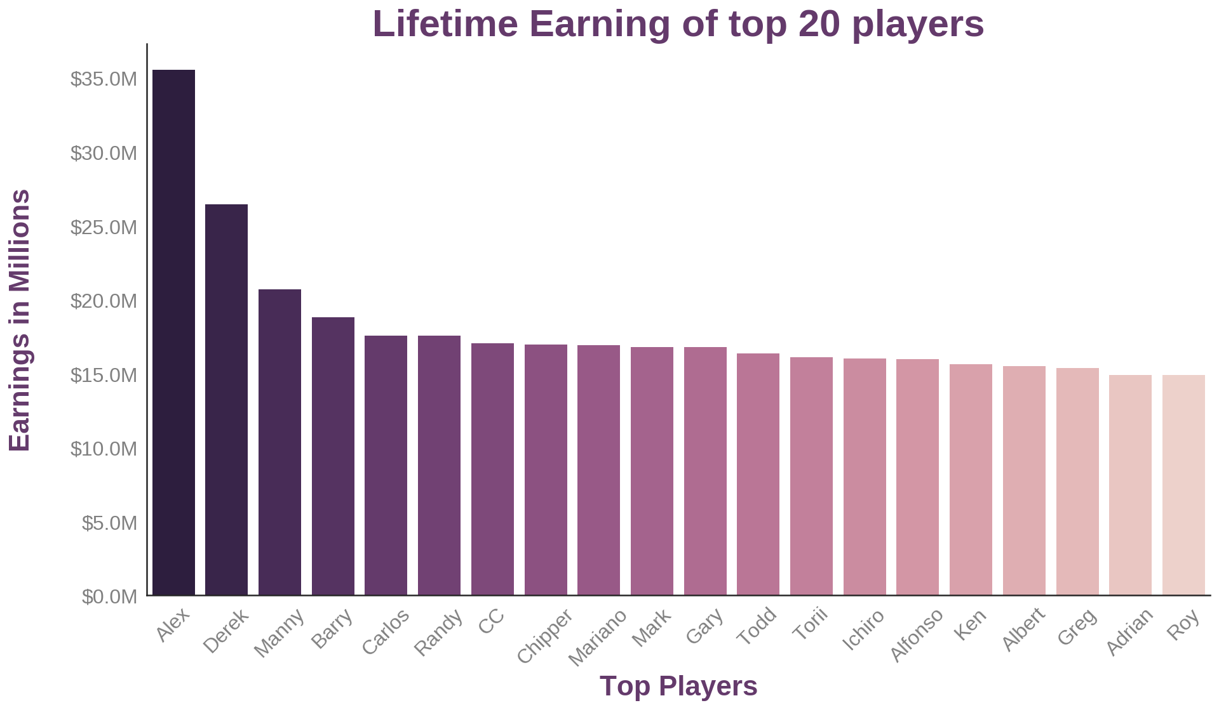

3. Were they all thrifty ??

The above distribution is skewed and it is the distribution of salary. This shows the most density distribution is located around 0 to 5000000. This proves that high salaries were not so frequent. What does this shows?? This shows a common human nature; most people are thrifty when it comes it money, at least the baseball teams were.

rot = sns.cubehelix_palette(len(data_1.teamID.unique()), start=2,
rot=0, dark=0, light=.95, reverse=True)
ax = sns.pointplot(x="yearID", y="salary", data=data_1,
hue='teamID', palette=rot, ci=None,
markers='.', join=True)
ax.legend_.remove()
locs, labels = plt.xticks()
plt.setp(labels, rotation=45)
sns.despine()
ax.set_xticklabels(np.sort(data_1.yearID.unique()),
{'fontsize': 16, 'color':'grey'})
ax.set_xlabel('\nYears',
{'weight': 'bold', 'fontsize': 22
, 'color':rot[15]})
ax.set_ylabel('Dollars in Millions\n',
{'weight': 'bold', 'fontsize': 22
, 'color':rot[15]})
ticks = ax.get_yticks() / 10000000
ticks = [*map(str, ticks)]
ticks = [*map(lambda e: '$' + e + 'M', ticks)]
ax.set_yticklabels(ticks,
{'fontsize': 16, 'color':'grey'})
ax.set_title("All Teams Investment in Each Year",
{'weight': 'bold', 'fontsize': 25, 'color':rot[15]})
plt.show()

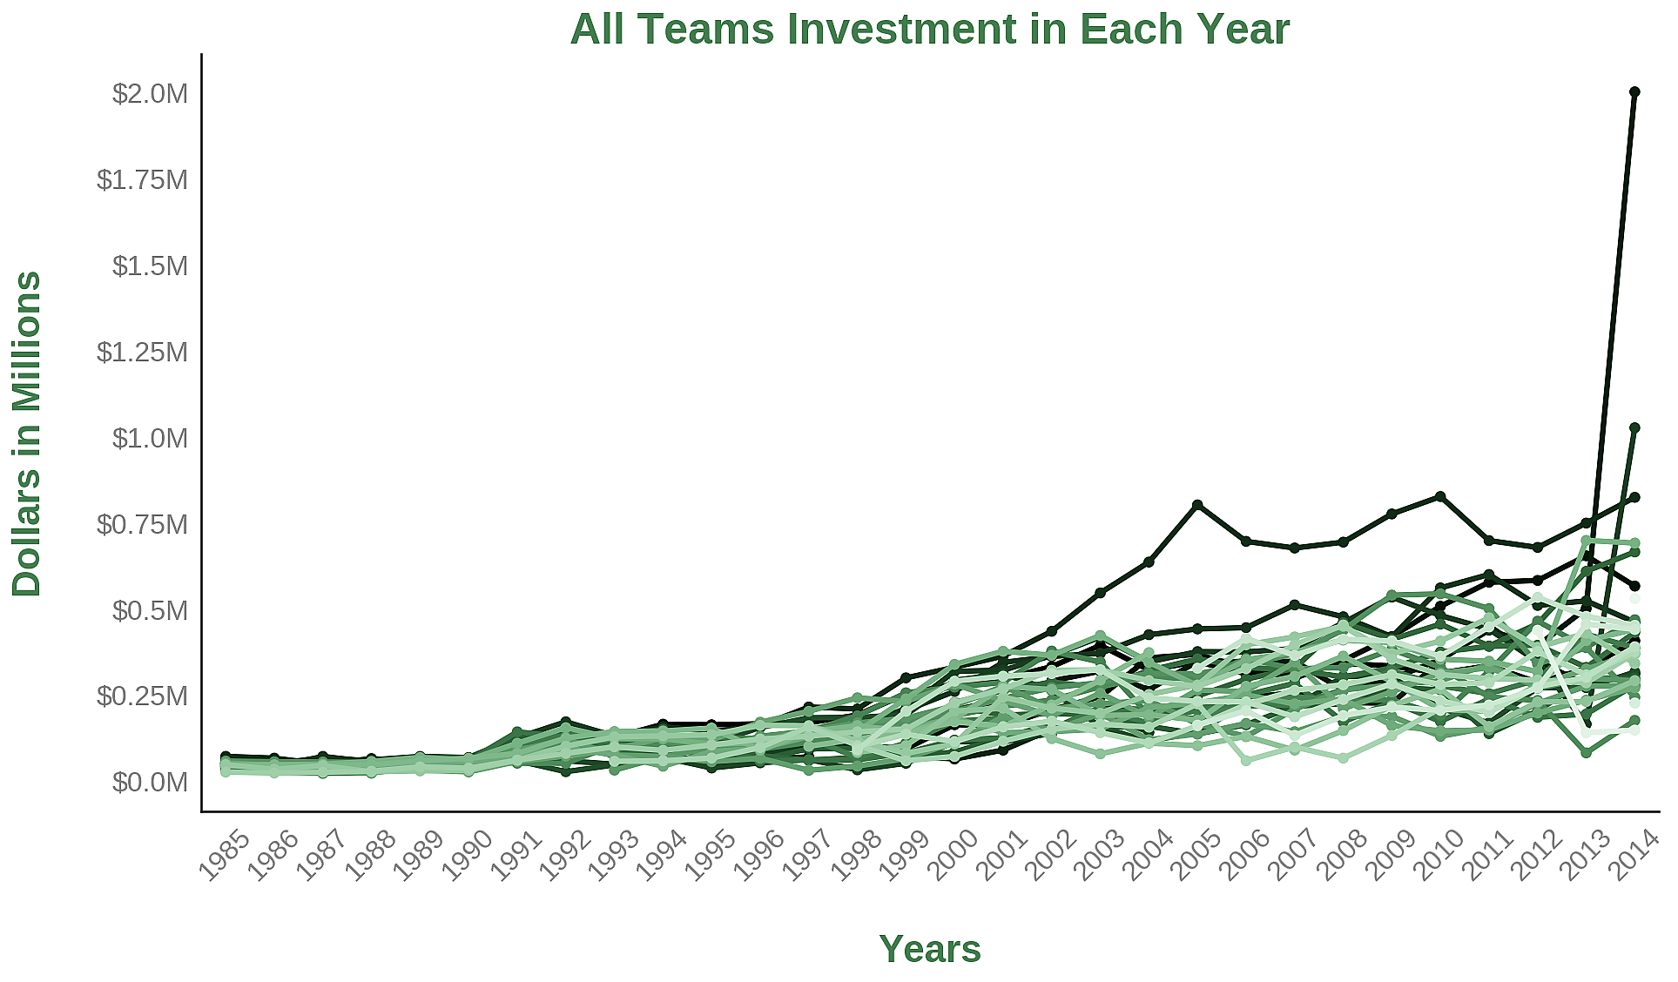

4. Did teams think similar when it comes to money ??

The above timeseries shows how people liked to invest over the passage of time. Each teams represent a single line. The idea is not to show how each teams are investing over time, rather it shows what is the investment pattern of all the teams. We can see that upto 2001 all the teams invested almost similarly. Beyond 2001 to around 2010 the diffence between the investment of teams increased substantially with some team investing a lot than others. But beyong 2011 this difference got really big and we can also see the top 3 highest investments were made in the year of 2014. For example, we can see the the one team at 2005 invested a lot more than others and kept on investing till the end. The following code shows this club name an the money that they invested.

data_1[data_1.yearID == 2005].groupby('teamID',
as_index=False)['salary'].sum() \
.sort_values('salary', ascending=False) \
.reset_index().drop('index', axis=1).ix[0]

This prints,

teamID NYA
salary 208306817
Name: 0, dtype: object

This is logical too because we have already seen that `NYA` invested most out of all the teams.

Interestingly, in the year of `2014`, `NYA` didn't remain at number 1 position and it changed to `LAN`. This code shows it below

data_1[data_1.yearID == 2014].groupby('teamID',
as_index=False)['salary'].sum() \
.sort_values('salary', ascending=False) \
.reset_index().drop('index', axis=1).ix[0:2]

this prints,

 | teamID | salary
0 | LAN | 214014600
1 | NYA | 197543907
2 | PHI | 180944967

Howerver the trend that we have seen, we can say unless the team is an extraordinary, most teams spent likely over the passage of time.

batting = model.batting
BaseballModel.performance_burndown(batting)

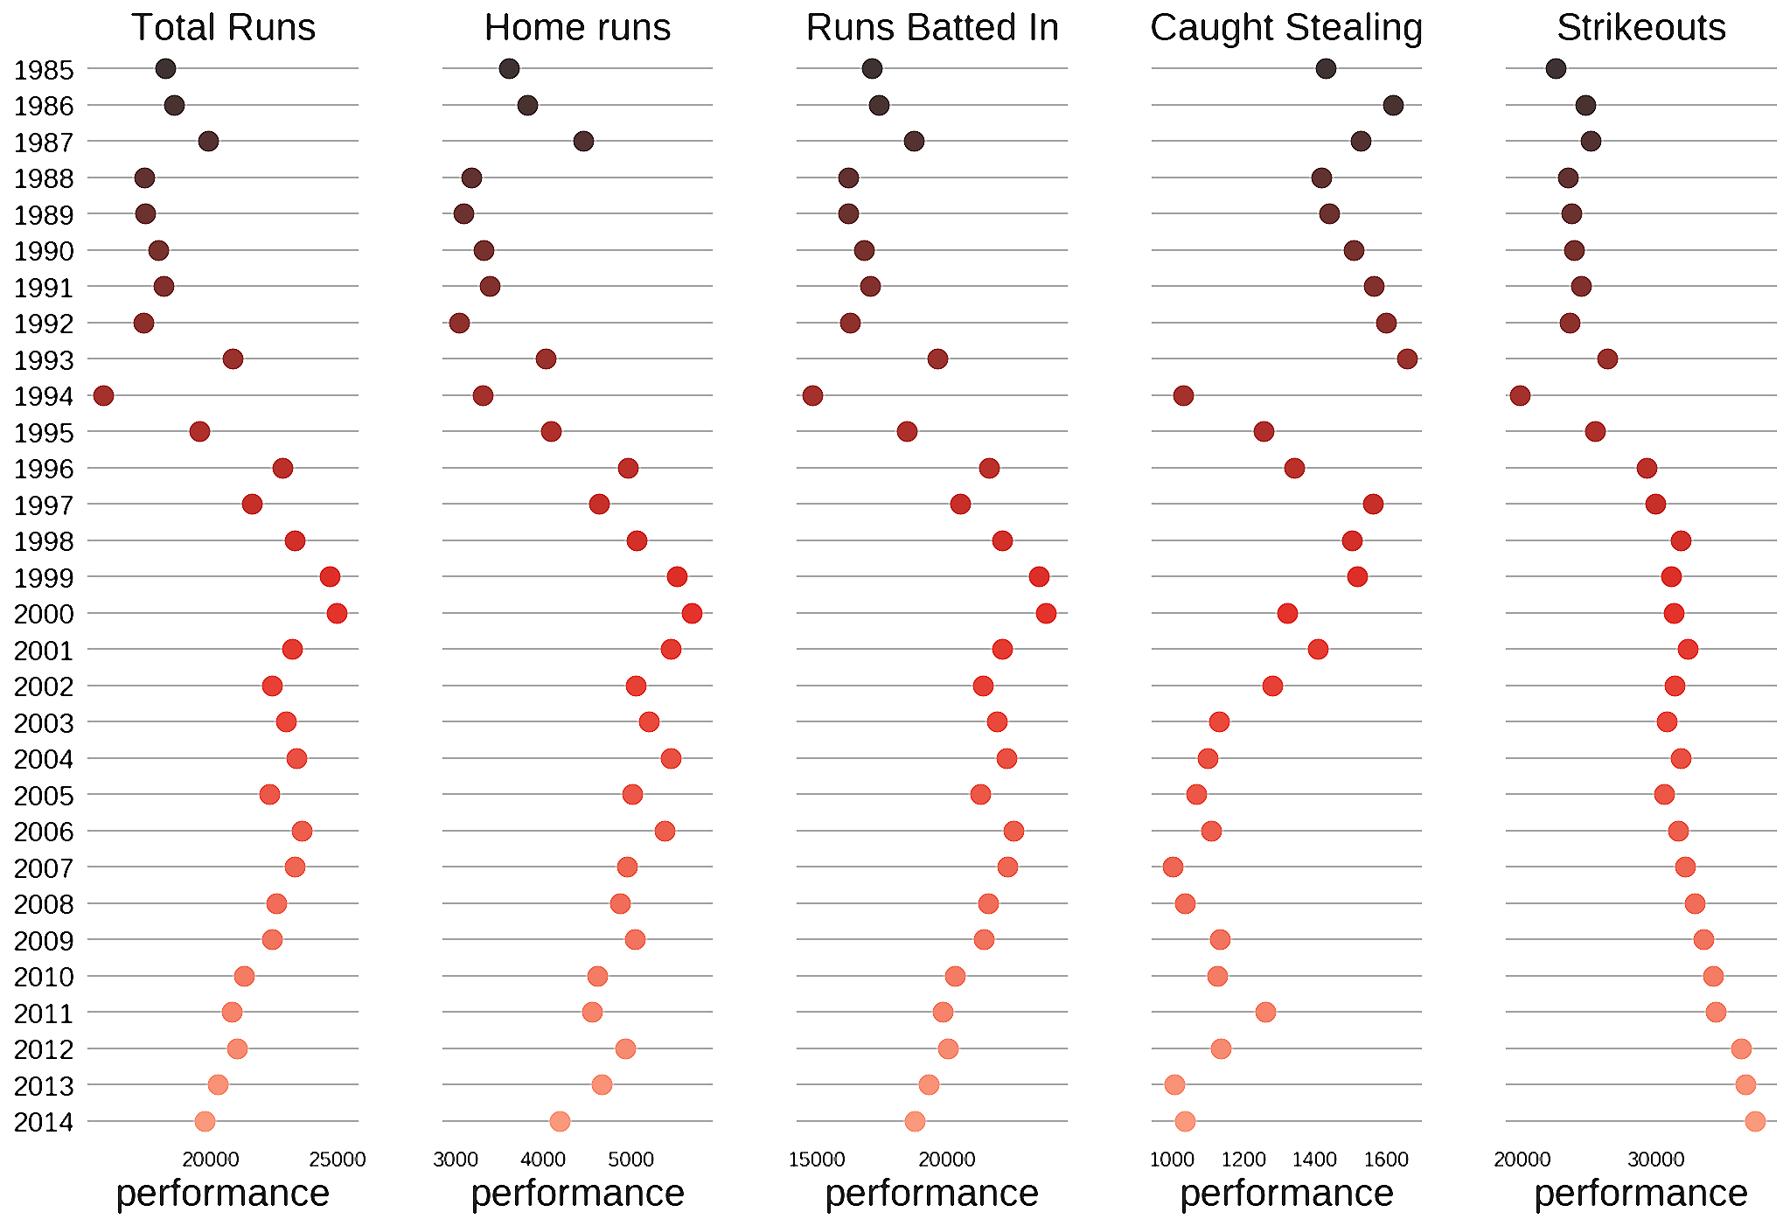

Now in the above plot I have tried to show how different metric changed over time form 1985 to 2014. We can see for example that there is an abrupt decrese in the total runs scored in the year of 1994 as compared to other years. Let's verify if the plot shows the right value? If we execute plot_data.R.argmin() it returns 9 which is the row number of the plot_data table which is further derived from batting. So to get the year we execute `plot_data.ix[9][['yearID', 'R']] and indeed the year is 1994 and the run is 15752 which can also be verified from the scale. Evidently all other performance of Batters and Pitchers in the year of 1994 was poor as compared to other years. SO I GUESS 1994 WAS A DARK YEAR FOR BASEBALL FANS..:)

5. Time for another data cleaning

Now as we have colleced some data into the DataFrame called data_1, we need to match it with our new DataFrame: batting. In other words we need to keep only those entries from batting Dataframe whose entry is found in the data_1 DataFrame. The resaon we want to do this because we don't want to keep any entries of any players who salary, name, surname, height, weight, pitching hand and batting hand is not present. The common way to achieve this is to merge(..) on both the DataFrames on=playerID

required_batting_cols = ['playerID', 'G', 'R', 'HR', 'CS', 'SO',
'yearID', 'teamID']
data_1 = data_1.merge(batting[required_batting_cols],
on=['playerID', 'yearID', 'teamID'],
how='left').fillna(0)

Now I would go into much more interesting and fun stuffs. I would bring in some statistics and hypothesis tests into this but for now, let's focus on the the data table that we have already. Here all the batters staticstics form 1985 to 2014 is avaialbale with their salary and other game related performances.

Let's merge the pitching table too as we have done with the batting table. The data cleaning process would be exactly similar except the coulumns that needs to be merged

pitching = model.pitching
required_pitching_cols = ['yearID', 'teamID', 'playerID',
'G','SHO', 'SV', 'HR', 'R']
data_1 = pd.merge(data_1, pitching[required_pitching_cols],
on=['playerID', 'yearID', 'teamID', 'G'],
how='left').fillna(0)
data_1.rename(columns={"R_x": "Runs_Scored",
"R_y": "Runs_Allowed",
"HR_x": "HR_Scored",
"HR_y": "HR_Allowed"}, inplace=True)

#~~~~~~~~~~~~~~~~~~~~~~~~~~~~~~~~~~~~~~~#
sns.lmplot(data=data_1, x="height", y="weight", hue="bats",
scatter_kws=dict(s=data_1.HR_Scored * 2),
markers=['^', '^', '^'])
plt.show()
#~~~~~~~~~~~~~~~~~~~~~~~~~~~~~~~~~~~~~~~#
sns.lmplot(data=data_1, x="height", y="weight",hue="throws",
scatter_kws=dict(s=((data_1.SHO)**2) * np.pi),
markers=['^', '^'])
plt.show()

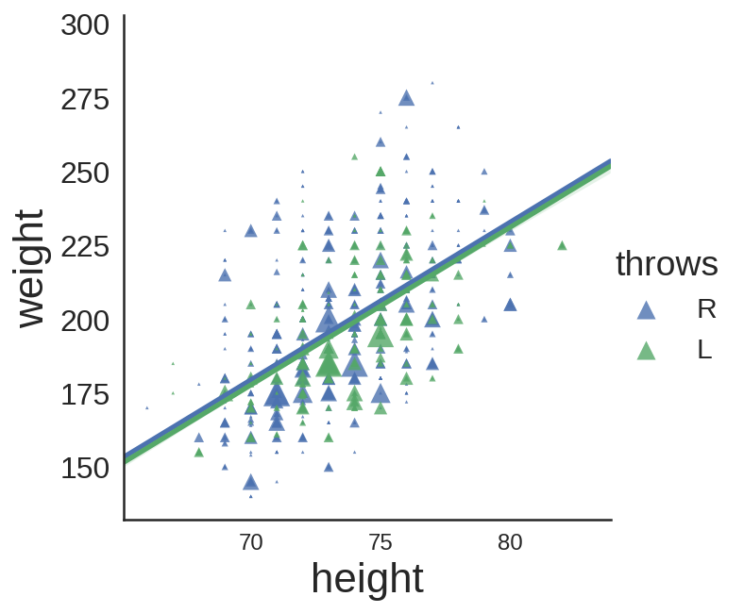

5.₁ What are the facts the above plot shows

- More players play with their LEFT hand as compared to the RIGHT hand because there is a lot green as compared to red and blue

- Players with most homeruns are of medium height and medium weight category. Tall or heavy weight players performed not so well.

Let's see if trend is same in case of of Pitchers!!

5.₂ Wow we see some wonderful trends here too
- Number of players with shutouts is far less than the number of players with homeruns. This means players like to bat more than pitch.
- There are not pitchers who like to throw with both of their hand as comared to the batters. Which means piching can either be done by left hand or right hand but not with both the hand.
- The weight and the height trend is similar to the batting. Most of the players performed well if they are medium weight and medium height. We can verify that the bigger marker sizes are all in the middle.
- One more interesting thing is that even some of the outliers are also above 280 in weight category whcich is I guess natural because if you are heavy weight, you can not run well and hence as a pitcher, you perform poorly

6. Let's move into some Statistics now!!

First let's group all the enries in the DataFrame by the player's ID. Then sum all player's Total Runs Scored and their Total Salary.

data_1.groupby('playerID', as_index=False)['playerID',
'Runs_Scored', 'salary'].sum().head()

 | playerID | Runs_Scored | salary
0 | aardsda01 | 0.000 | 9259750
1 | aasedo01 | 0.000 | 2300000
2 | abadan01 | 0.000 | 327000
3 | abadfe01 | 0.000 | 1428900
4 | abbotje01 | 74.000 | 985000

Interestingly some players have scored 0 runs but they were paid a lot. How is it possible? It's not necessary that these players are bad as these players can be pitchers and they might have some good Saves against some batters. So the logical solution is to combine the SV column with this group by table. But the problem is that they don't share the same scale hence to combine, we need to standardize these two columns and then both the values and create a new column say performance.

stat_data = data_1.groupby('playerID',
as_index=False)['playerID',
'Runs_Scored',
'salary',
'SV'].sum()
stat_data['performance'] = (stat_data.SV / stat_data.SV.std(ddof=0)) + (stat_data.Runs_Scored / stat_data.Runs_Scored.std(ddof=0))
display(stat_data.head())

 | playerID | Runs_Scored | salary | SV | performance
0 | aardsda01 | 0.000 | 9259750 | 69.000 | 2.097
1 | aasedo01 | 0.000 | 2300000 | 38.000 | 1.155
2 | abadan01 | 0.000 | 327000 | 0.000 | 0.000
3 | abadfe01 | 0.000 | 1428900 | 0.000 | 0.000
4 | abbotje01 | 74.000 | 985000 | 0.000 | 0.304

Now I guess I may not need the Runs_Scored and the SV columns. So we can drop them.

stat_data.drop(['Runs_Scored', 'SV'], axis=1, inplace=True)

Now it's time to prepare our data. We are going to perform an Hypothesis test to figure out. If above average salary resulted in above average performance?? However we are taking median here instead of mean to reject all the outliers.

stat_data_below_average = stat_data[stat_data.salary < stat_data.salary.median()]
stat_data_above_average = stat_data[stat_data.salary >= stat_data.salary.median()]

Now before we move ahead, let's perofrom a quick plot see the total number of people in both the groups

performanceMean = stat_data.performance.mean()
def label_performance(row):
if row['performance'] < performanceMean:
return 'Low Performer'
else:
return 'High Performer'
stat_data['Performing_Level'] = stat_data.apply(lambda row: label_performance(row), axis=1)

