**API DOC AdvancedSearch Project**

**GET: (Query In ElasticSearch)**

URL: http://127.0.0.1:5000/api/doQuery?keyword=west&index=cricket_stadiums

http://<host>:<port>/api/doQuery?keyword=<param1>&index=<param2>

Parameters:

1. keyword (required) and 2) index (required)

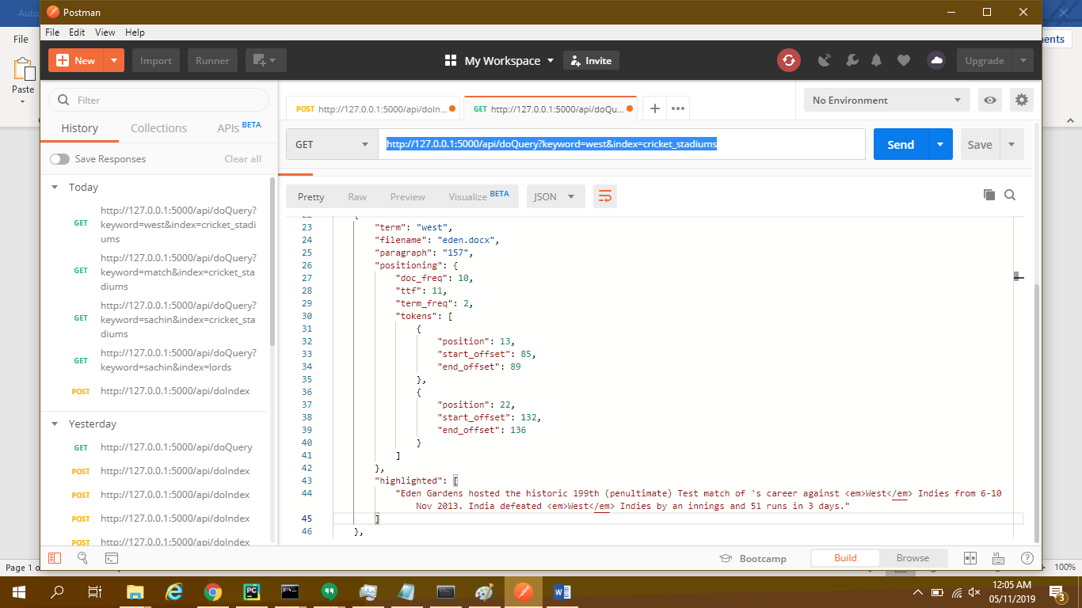

**POST (Indexing in ElasticSearch)**

URL: http://127.0.0.1:5000/api/doIndex

http://<host>:<port>/api/doIndex

BODY:

{

"filename":"<filename>",

"index":"<index_name>"

}

Sample Body:

{

"filename":"data\\MyBooks\\eden.docx",

"index":"stadium_eden"

}

