Overview

The purpose of this report is to identify business opportunities in the City of Chicago through data analysis. To find business opportunity, evaluation of two data sets were conducted; list of contracts awarded by the City of Chicago and list of contractors conducting business in the City of Chicago. These data sets were chosen because they both represented the City of Chicago contractual information. Also from a prima face, a Vendor ID was identified as primary key to join these datasets.

The initial assumption was to conceptualize a coherence between vendors and contracts. This in theory can help derive conclusions which contractor has been awarded contacts by the City of Chicago. This was an exciting point, when connection between two different tables representing two different identities could come together and provide valuable insights for entrepreneurs.

To achieve our goal, an understanding of the demand and supply of contacts was important. Step one, accumulate data sets to answer the following shown in Figure 1. Contacts Awarded. This graph shows us the different types of contacts issued which represents the demand for contracts.

**CONTRACTS**

Contract.Type

:34667

DELEGATE AGENCY :16957

COMPTROLLER-OTHER : 4644

CONSTRUCTION-AVIATION : 3977

CONSTRUCTION-LARGE $3MILLIONorABOVE: 3230

COMMODITIES : 2215

(Other) :21183

Vendor.ID

22085024V: 1704

15792481T: 1691

90506630P: 744

85246282A: 731

77755055X: 723

9088362A : 715

(Other) :80565

State

IL :80067

WI : 867

PA : 606

CA : 492

IN : 437

MO : 425

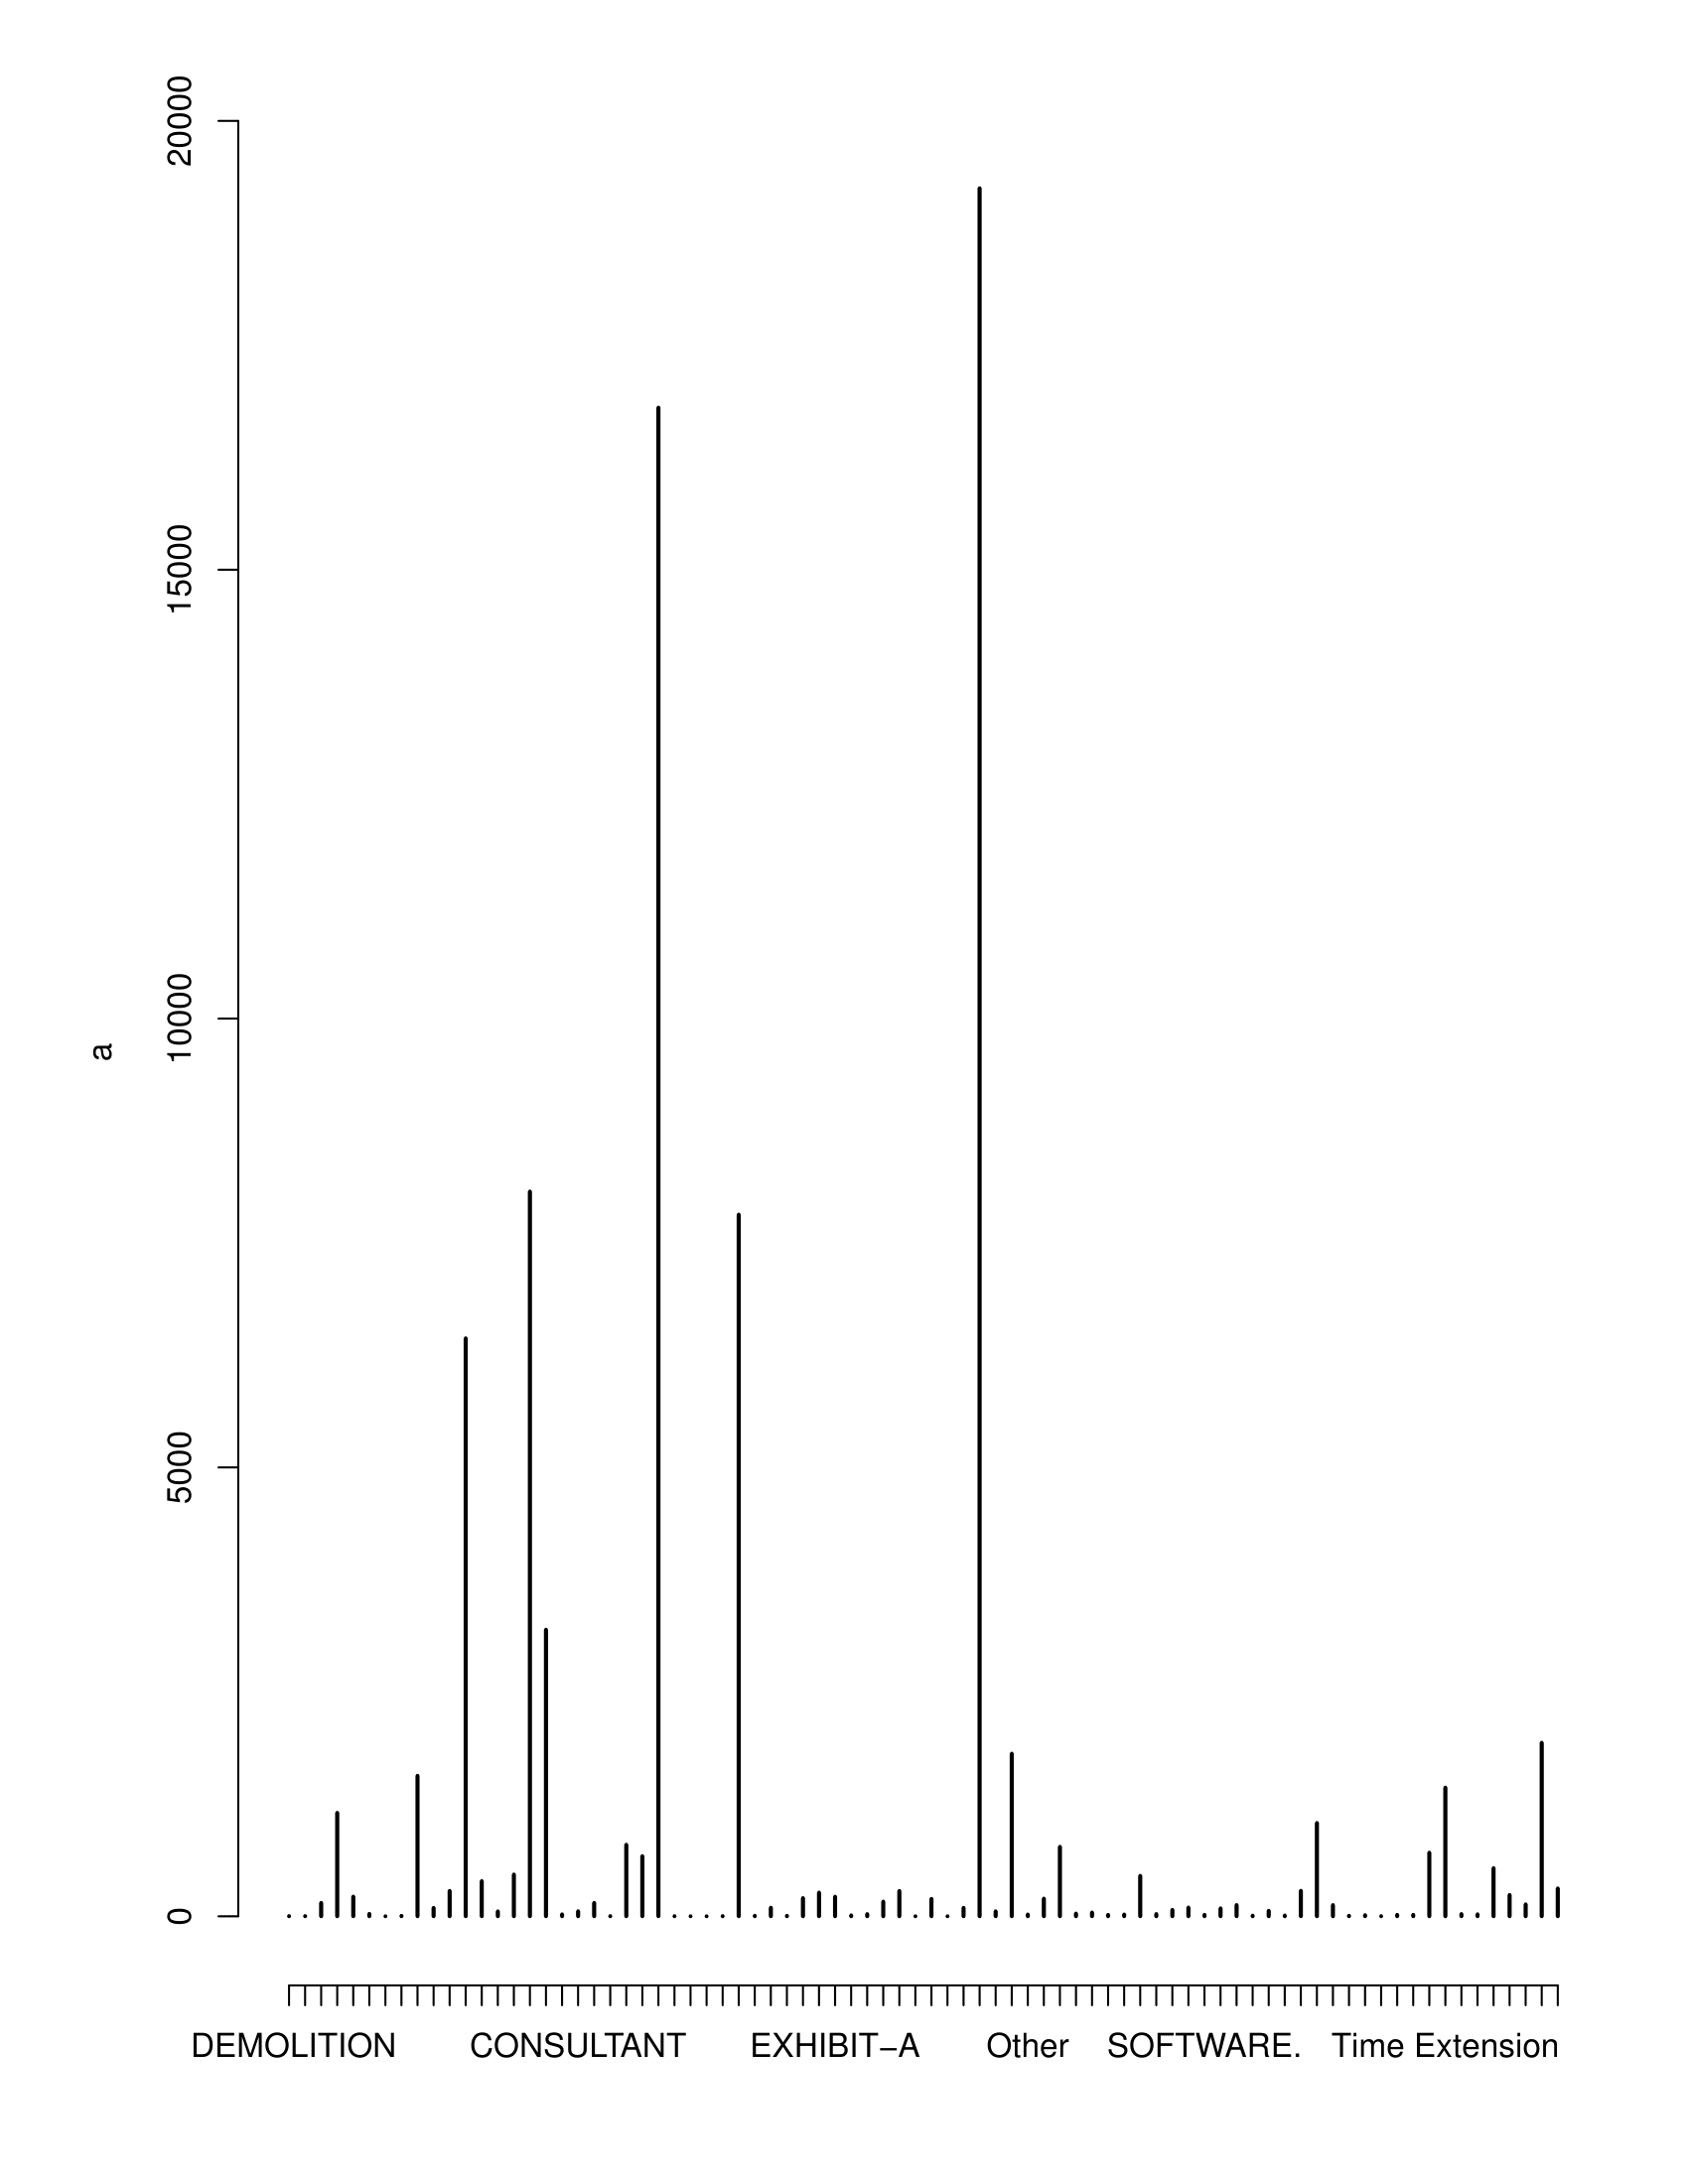(Other): 3979

**This diagram represents: Complete analysis on type of contracts.**

**List of contractors doing business**

VENDOR.ID

1001810 : 1

1002908 : 1

1003070 : 1

1003778 : 1

1004390 : 1

10054955X: 1

(Other) :4983

STATE

IL :4075

CA : 103

NY : 91

TX : 63

MA : 45

PA : 41

(Other): 571

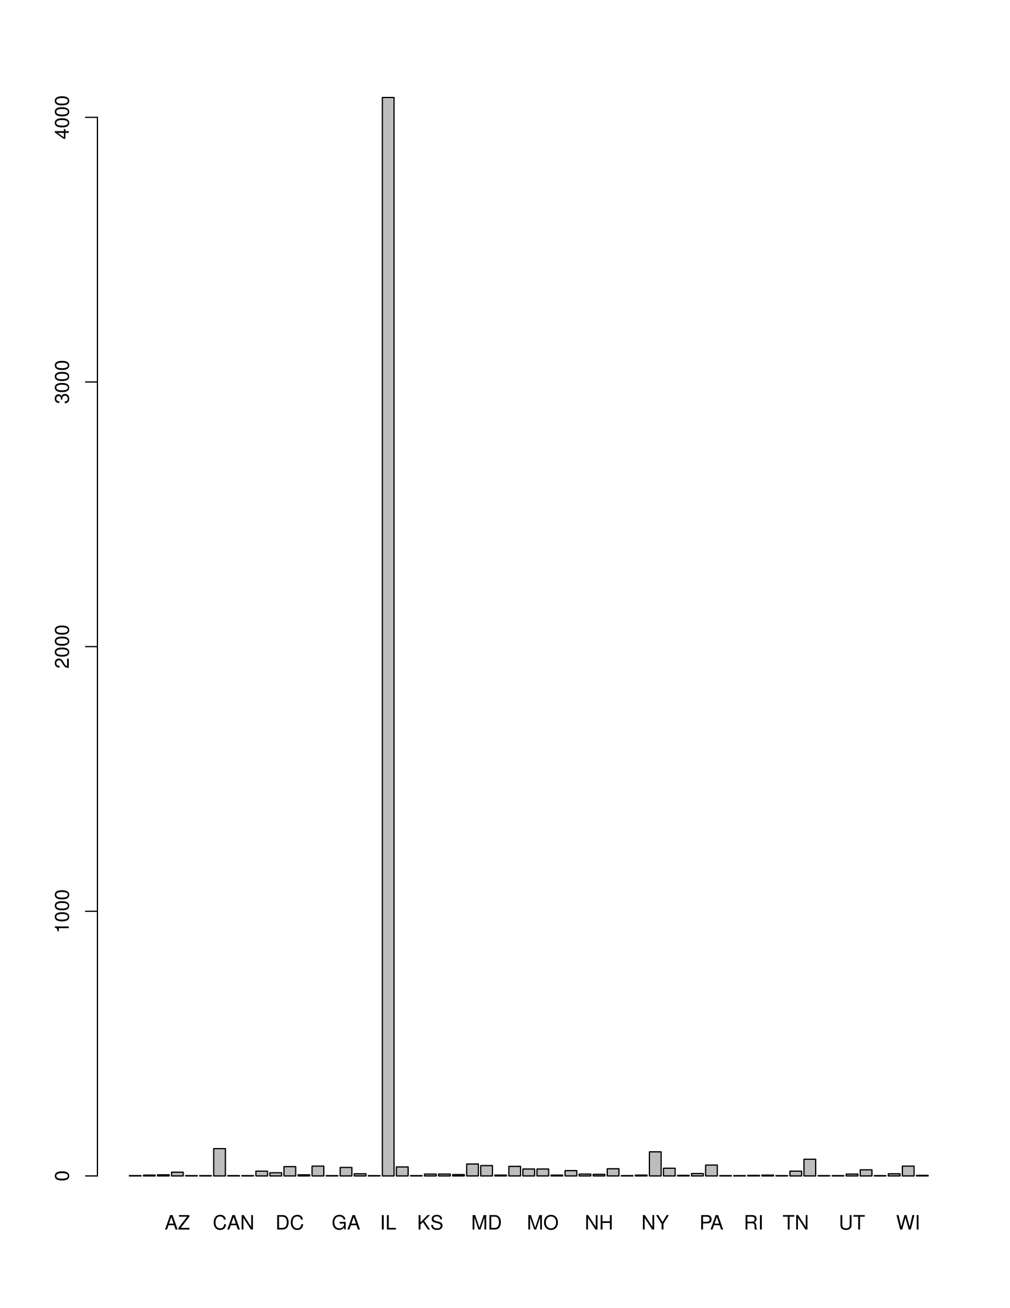

**This diagram represents: The No. of contractors on the basis of state.**

|  |
| --- |
| **AL AR AZ BC**  **3 4 14 1**  **BMU CA CAN CANADA CO**  **1 103 1 1 18**  **CT DC DE FL FRA**  **12 35 4 37 1**  **GA IA ID IL IN**  **32 8 1 4075 34**  **ITA KS KY LA MA**  **1 7 7 5 45**  **MD ME MI MN MO**  **39 3 36 26 26**  **MS NC NE NH NJ**  **3 20 7 6 27**  **NM NV NY OH OK**  **1 3 91 29 2**  **OR PA PAK QUEBEC RI**  **9 41 1 1 2**  **SC SD TN TX UAE**  **3 1 18 63 1**  **UKR UT VA VT WA**  **1 7 23 1 8**  **WI WV**  **37 2** |

**------------------------------------------------------------------------------------------------------------------------------------------**

Add Line Item 12

ARCH/ENGINEERING

1796

ARCH/ENGINEERING-AVIATION

106

COMMODITIES

2215

COMMODITIES-AVIATION

89

COMMODITIES-SMALL ORDERS

695

COMPTROLLER-OTHER

4644

Construction

493

CONSTRUCTION

1654

CONSTRUCTION-AVIATION 3977

CONSTRUCTION-GENERAL 1967

CONSTRUCTION-LARGE $3MILLION 3230

CONSTRUCTION-LARGE $5MILLION 4

CONSTRUCTION SERVICES 22

CONVERTED 948

Delegate Agency 697

DELEGATE AGENCY 16957

Demolition 4

DEMOLITION 171

DEMOLITION-SMALL ORDERS 317

Emergency 6

EXHIBIT-A 318

EXHIBIT-B 14

HARDWARE 31

HIRED TRUCK 164

JOC 283

miscellaneous 18

Modification 1955

One Shot 426

ONE SHOT 1

Other 24

PRO SERV 97

PRO SERV-AVIATION 160

PRO SERV-BUSINESS CONSULTING 9

PRO SERV-SMALL ORDERS 84

PRO SERV-SOFTWARE/HARDWARE 14

PRO SERV CONSULTING $250,000 1303

PRO SERV CONS. UNDER$250,000 179

Professional Services 249

PROPERTY LEASE 865

REVENUE 69

ROOFING 17

Service Contract 23

SOFTWARE 87

TELECOMMUNICATIONS 13

Term Agreement 820

Time Extension 1655

UTILITIES-ELECTRICITY 42

VEHICLES/HEAVY EQUIPMENT (CAPITAL)599

WORK SERV-AVIATION 309

WORK SERVICES-SMALL ORDERS 163

WORK SERVICES / FACILITIES MAINT. 2211

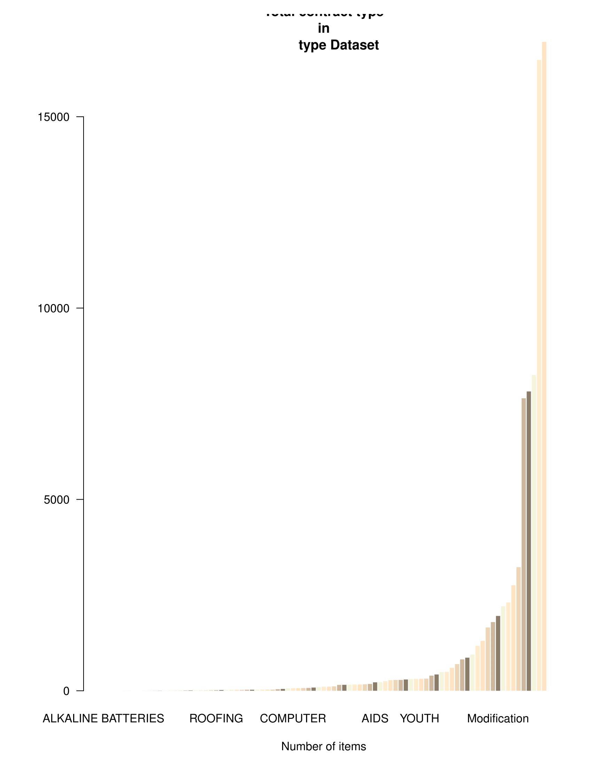**This diagram represents: Complete contracting options offered.**

**Construction stats**

**Image 2 construction data**

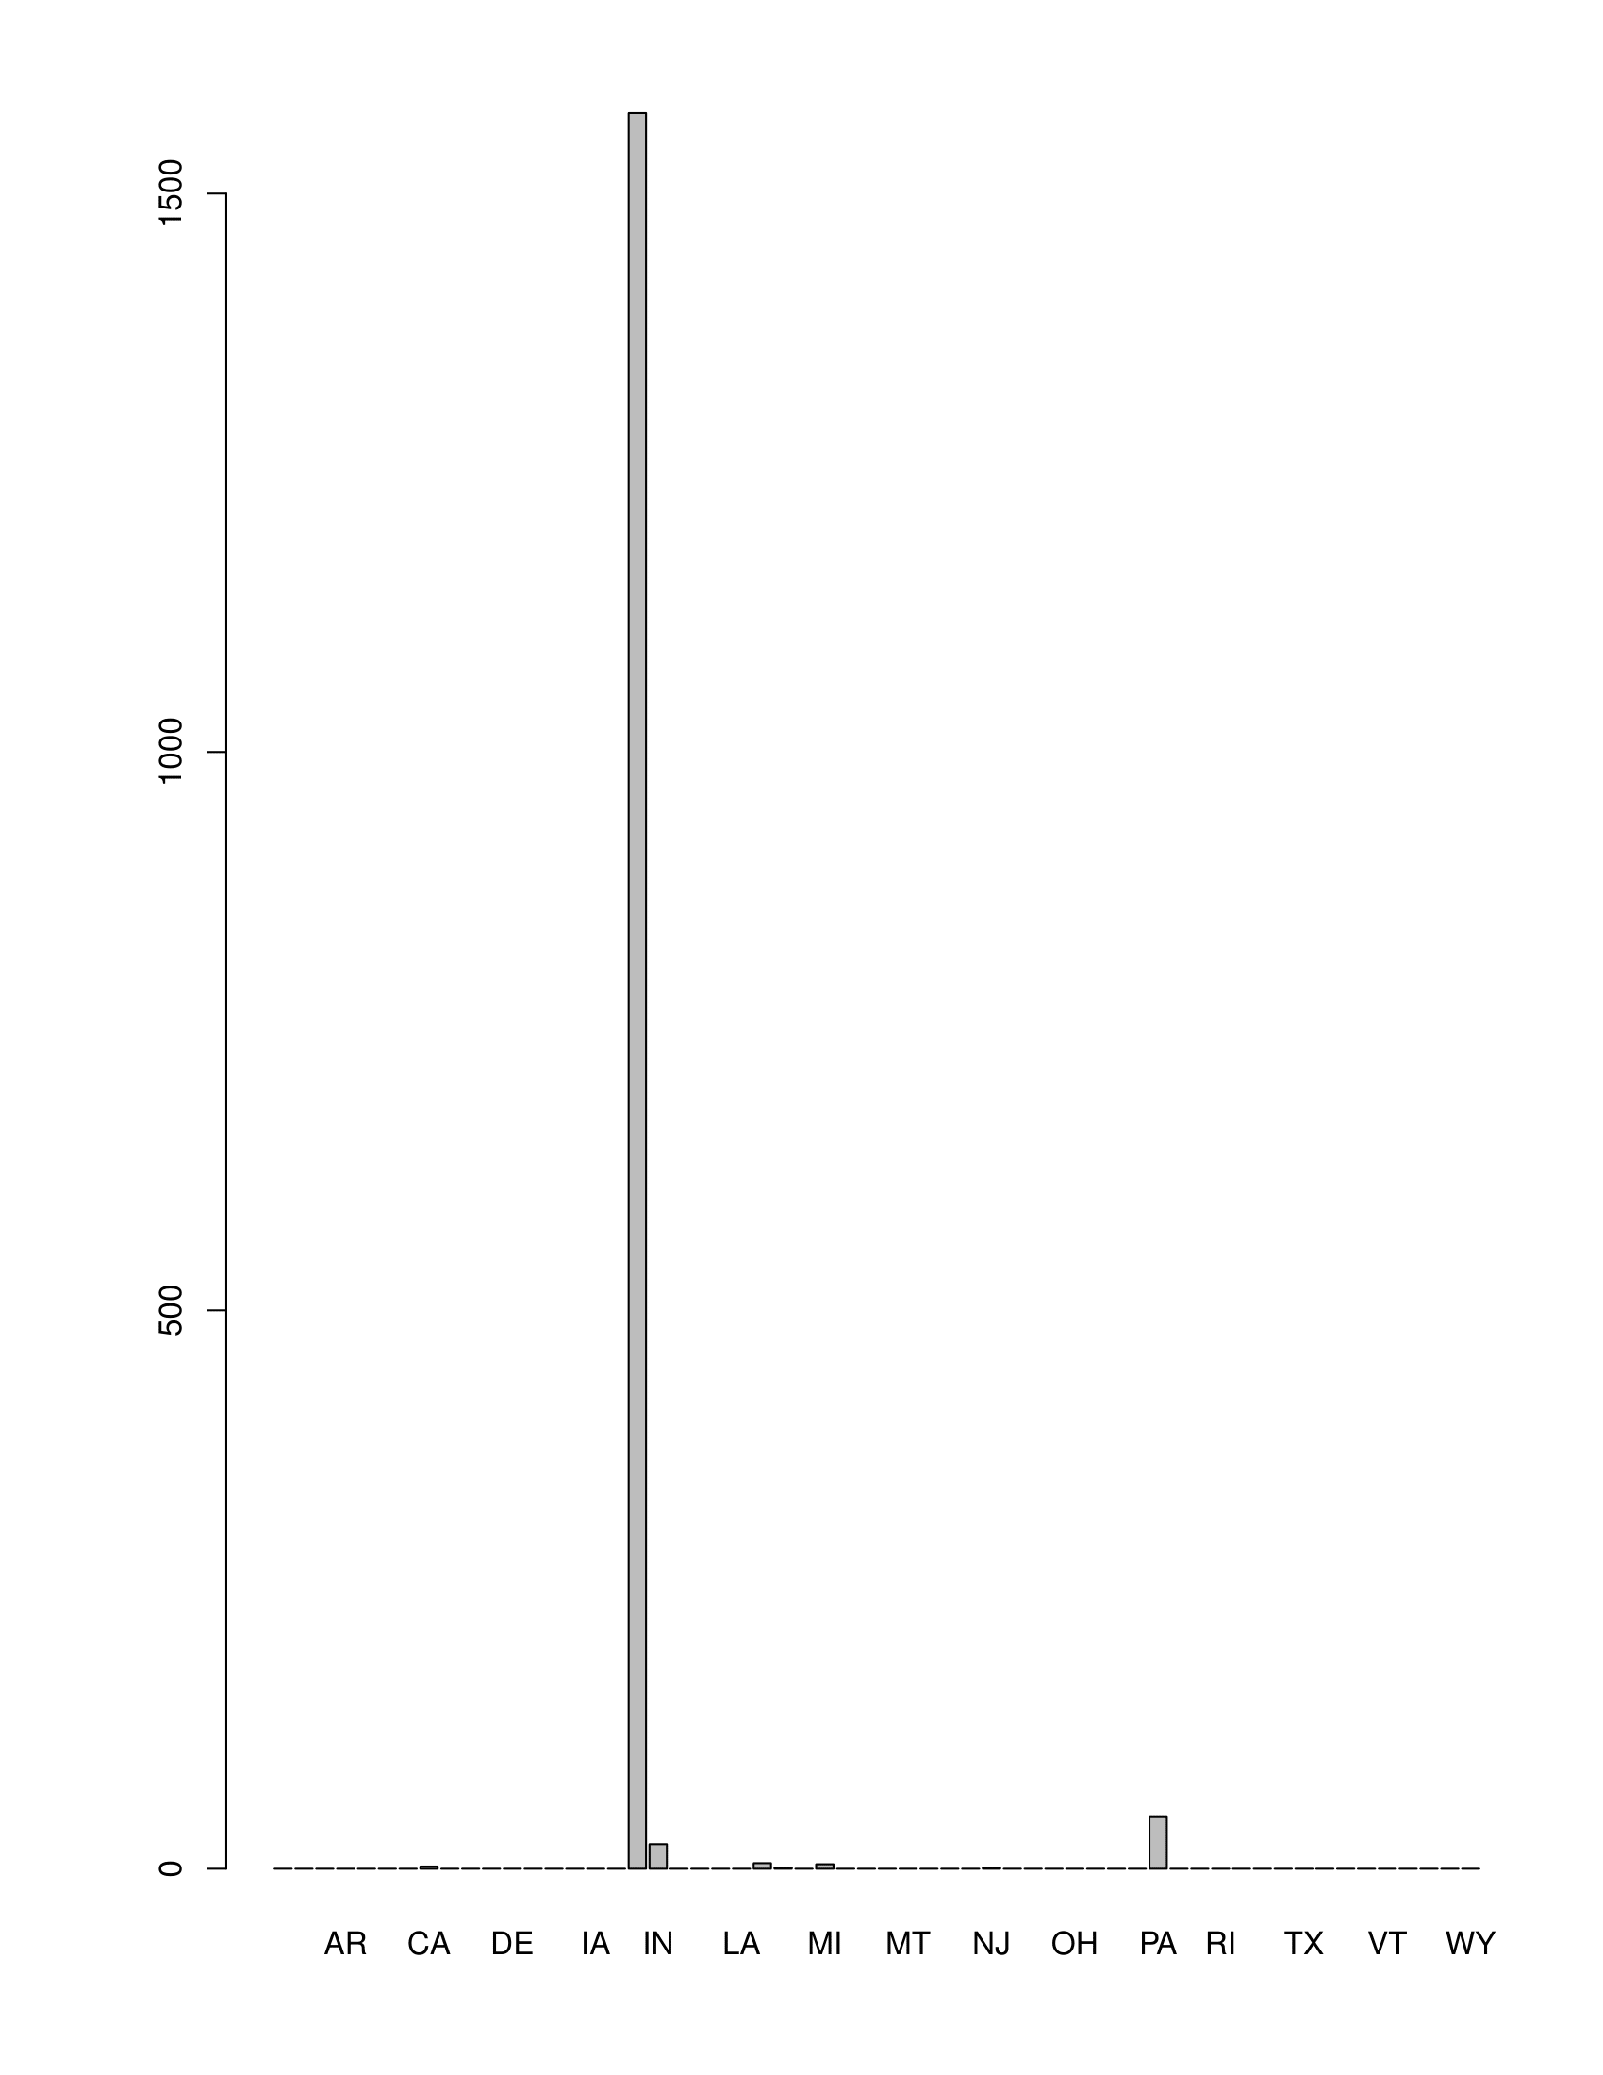

**This diagram represents: construction stats based on states.**

Vendor.Name

WALSH CONSTRUCTION COMPANY OF ILL:321

WALSH/II IN ONE/RITEWAY JV :249

F.H. PASCHEN/S.N. NIELSEN, INC :162

G & V CONSTRUCTION CO INC : 56

SEVEN-D CONSTRUCTION CO. : 51

RITEWAY CONSTRUCTION SERVICES : 50

(Other) :765

Vendor.ID City State

15792481T:321 CHICAGO :1099 IL :1572

33664895T:249 BENSENVILLE : 59 PA : 47

9123471X :162 SUMMIT : 50 IN : 22

90506630P: 56 : 40 MA : 5

93201616L: 51 BELLE VERNON: 38 MI : 4

15300606X: 50 ELGIN : 35 CA : 2

(Other) :765 (Other) : 333 (Other): 2

Contract.Type

CONSTRUCTION :1654

: 0

Add Line Item : 0

ARCH/ENGINEERING : 0

ARCH/ENGINEERING-AVIATION: 0

COMMODITIES : 0

(Other) : 0

State

IL :1572

PA : 47

IN : 22

MA : 5

MI : 4

CA : 2

(Other): 2

Contractors doing business construction data analysis narrow down:

**Construction in totality:**

|  |  |  |  |
| --- | --- | --- | --- |
| Vendor.ID  15792481T: 910    85246282A: 731  93472804Z: 308  77755055X: 296  21973746A: 287  9123471X : 276  (Other) :5442 | |  |  | | --- | --- | | Vendor.Name  WALSH CONSTRUCTION COMPANY OF ILL:  WALSH/T J LAMBRECHT JV :  TURNER-CONCRETE STRUCTURES-LINDAHL TRI VENTURE :  BIGANE PAVING COMPANY :  SUMIT CONSTRUCTION CO., INC. :  F.H. PASCHEN/S.N. NIELSEN, INC :  (Other) : | 910  731  308  296  287  276  5442 | |

|  |
| --- |
| State  IL :8074  IN : 48  PA : 48  MI : 31  OH : 10  NJ : 8  (Other): 31 |

**WORK SERVICE AND FACILITIES**

**PDF WORK SERVICE AND FACILITIES.**

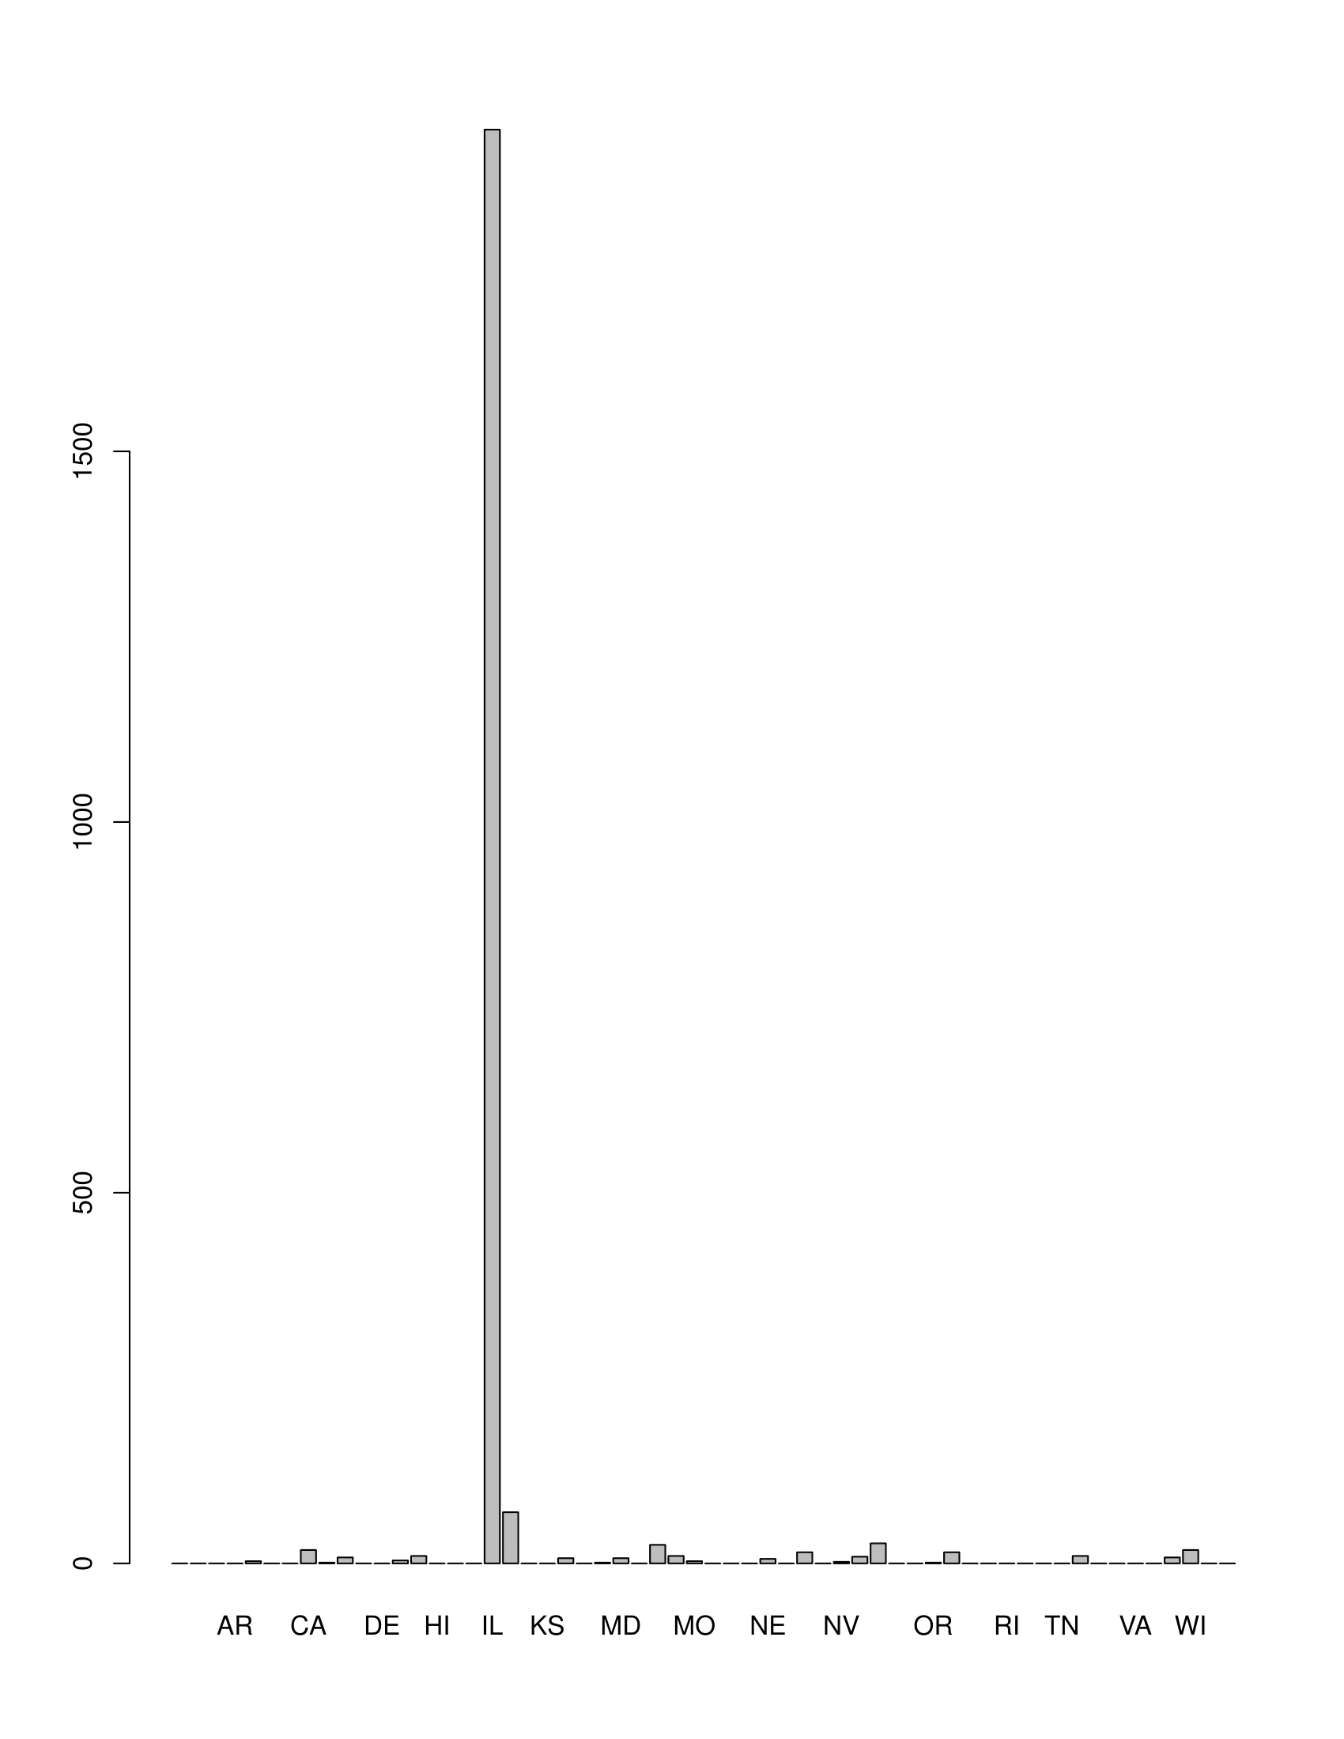

**This diagram represents: WORK SERVICE AND FACILITIES stats based on states.**

**WORK SERVICE AND FACILITIES**

Contract.Type

WORK SERVICES / FACILITIES MAINT.:2211

: 0

Add Line Item : 0

ARCH/ENGINEERING : 0

ARCH/ENGINEERING-AVIATION : 0

COMMODITIES : 0

(Other) : 0

|  |  |  |  |  |  |  |  |  |  |
| --- | --- | --- | --- | --- | --- | --- | --- | --- | --- |
| |  | | --- | | Vendor.Name Vendor.ID | | IRON MOUNTAIN RECORDS MANAGEMENT, INC.: 130 3659491E : 130 | | CHRISTY WEBBER LANDSCAPES : 54 31316936Z: 41 | | AIR ONE EQUIPMENT INC : 41 87834402H: 36 | | SKYTECH ENTERPRISES, LIMITED : 41 6265925M : 35 | | SECURITY PROFESSIONALS INC : 35 15551683L: 33 | | DIGBY'S DETECTIVE & SECURITY AGT INC : 33 3610706Z : 33 | | (Other) :1877 (Other) :1903 | |  |

State

IL :1934

IN : 69

OH : 27

MI : 25

CA : 18

WI : 18

(Other): 120

**ARCH/ENGINEERING**

**Image engineering**

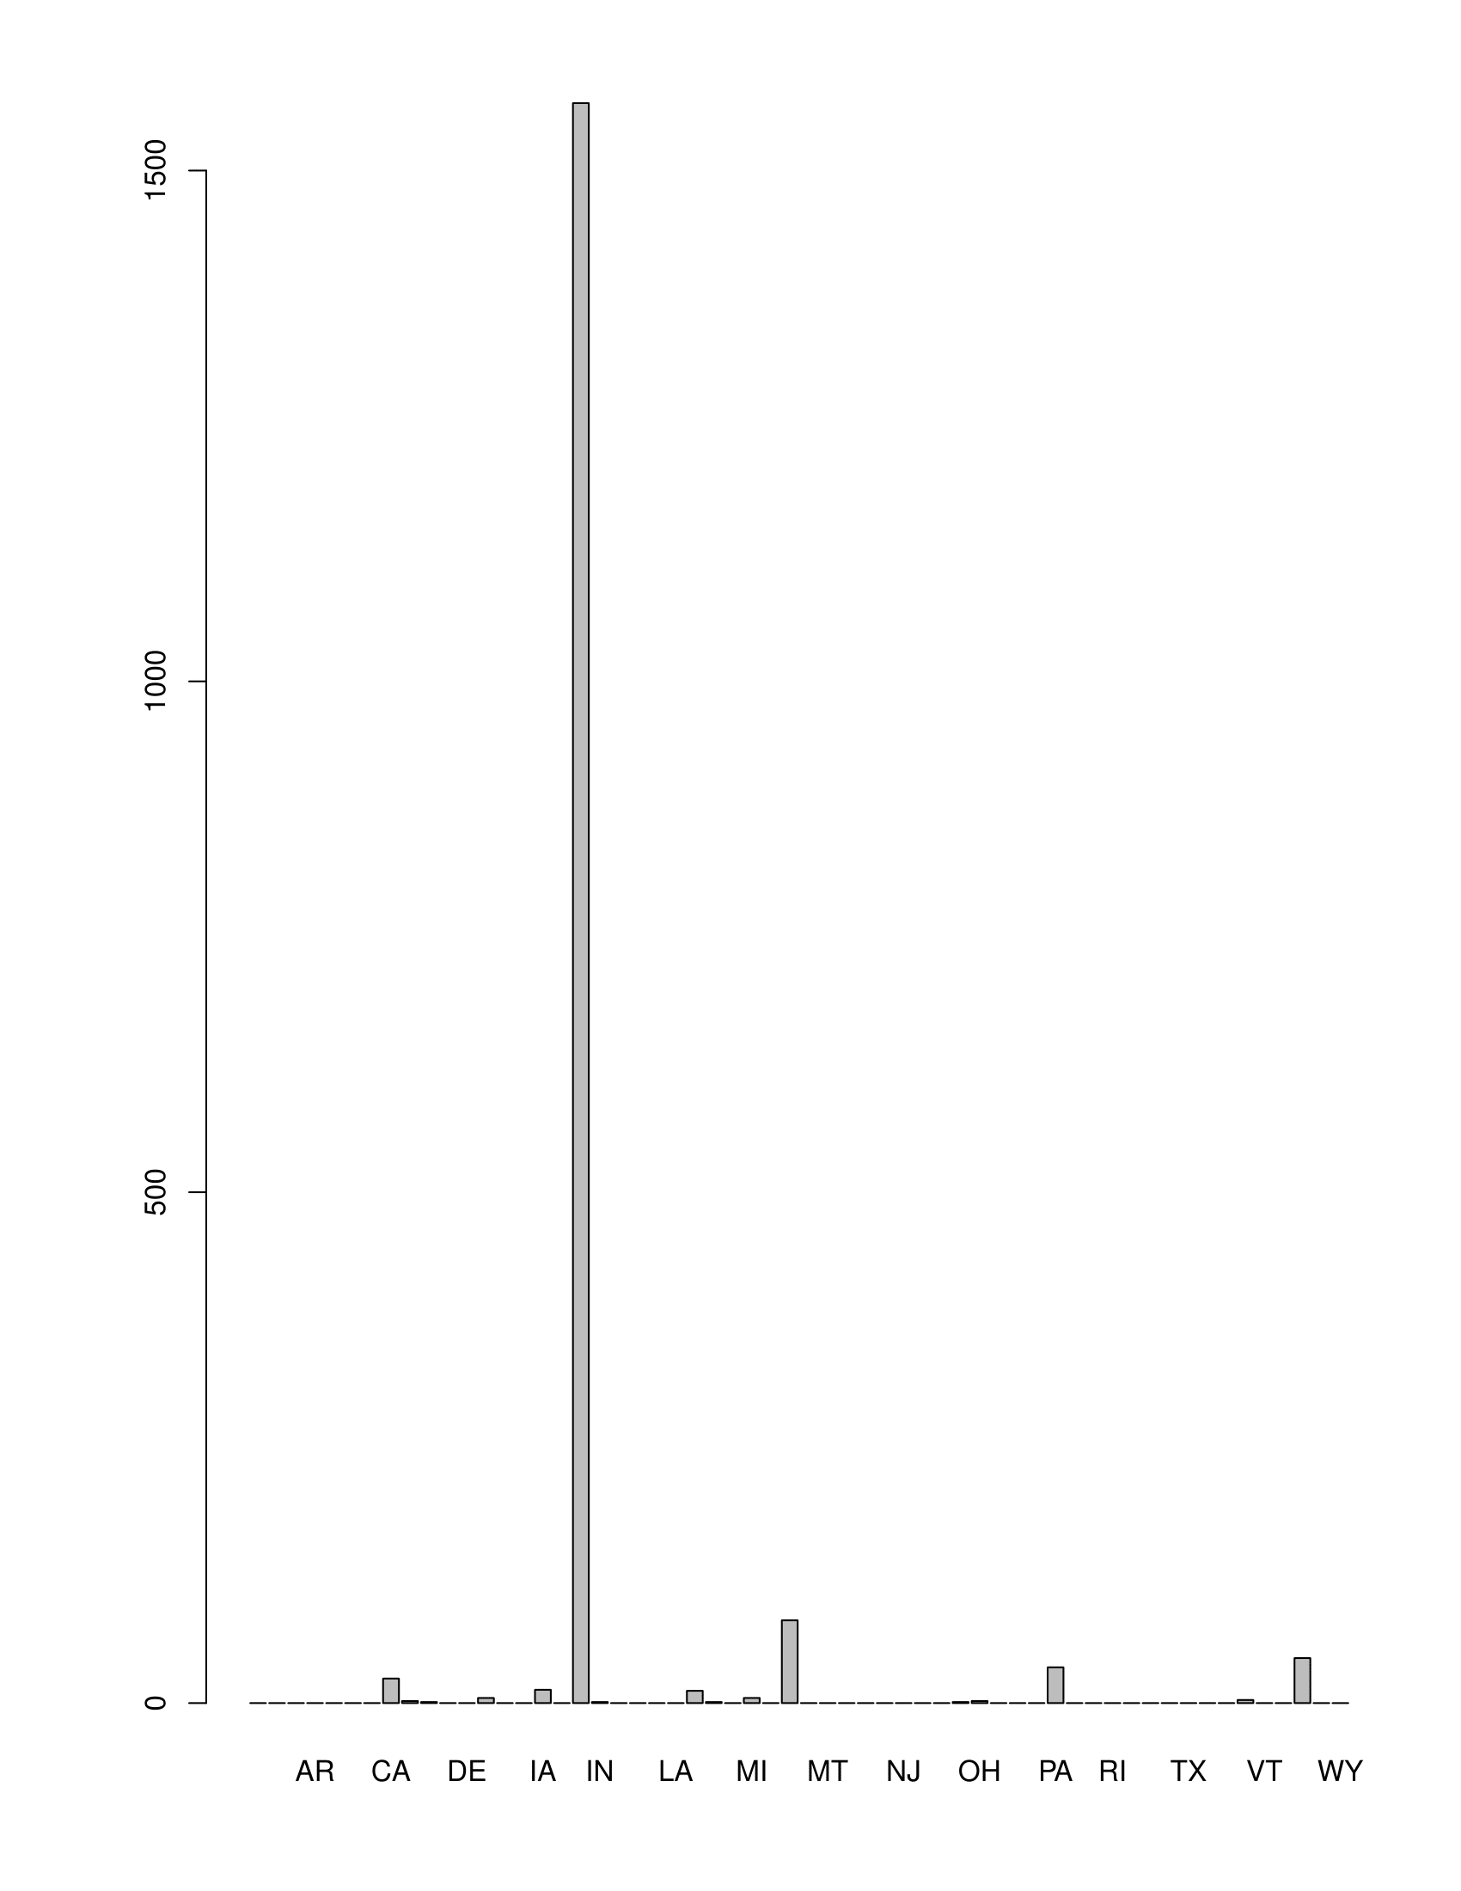

**This diagram represents: Arch/engineering stats based on states.**

**ARCH/ENGINEERING**

|  |
| --- |
| Contract.Type Vendor.Name  ARCH/ENGINEERING :1796 TENG & ASSOCIATES, INC. : 62  : 0 H D R ENGINEERING, INC. : 61  Add Line Item : 0 URS CORPORATION : 59  ARCH/ENGINEERING-AVIATION: 0 HNTB CORPORATION : 57  COMMODITIES : 0 GLOBETROTTERS ENGINEERING CORP.: 55  COMMODITIES-AVIATION : 0 CIVILTECH ENGINEERING INC : 54  (Other) : 0 (Other) :1448    Vendor.ID City State  5051328V : 74 CHICAGO :1262 IL :1566  87200994Z: 62 KANSAS CITY: 79 MO : 81  22558229L: 61 ITASCA : 54 WI : 44  27469803L: 61 SCHAUMBURG : 50 PA : 35  89508626P: 59 MILWAUKEE : 37 CA : 24  6172585P : 57 WOODRIDGE : 30 IA : 13  (Other) :1422 (Other) : 284 (Other): 33 |
|  |
| |  | | --- | |  | |

Contract.Type State

ARCH/ENGINEERING :1796 IL :1566

: 0 MO : 81

Add Line Item : 0 WI : 44

ARCH/ENGINEERING-AVIATION: 0 PA : 35

COMMODITIES : 0 CA : 24

COMMODITIES-AVIATION : 0 IA : 13

(Other) : 0 (Other): 33

**Demolition 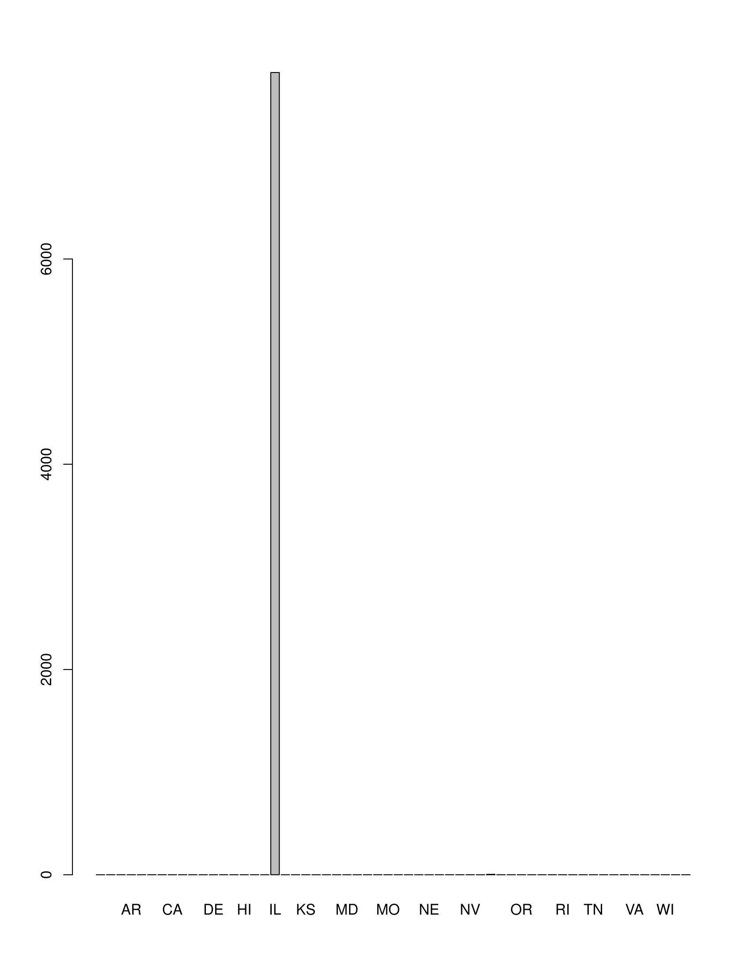This diagram represents: contracts on Demolition based on states.**

|  |  |
| --- | --- |
| Vendor.Name  JOE F. DE CICCO : 679  BONDS & ASSOCIATES, INC.SEAL : 569  UNITED DEMOLITION INC : 565  ACS, INC : 499  PAIGE ENTERPRISES : 491 G M DEMOLITION CORPORATION(seal): 476  (Other) :4542 | Vendor.ID  31294355A: 679  5707349L : 569  25965824M: 565  22950829E: 499  22048664X: 491  22757183T: 476  (Other) :4542 |
|  |  |

State

IL :7817

OH : 4

: 0

AK : 0

AL : 0

AR : 0

(Other): 0

**Youth**

**Pdf youth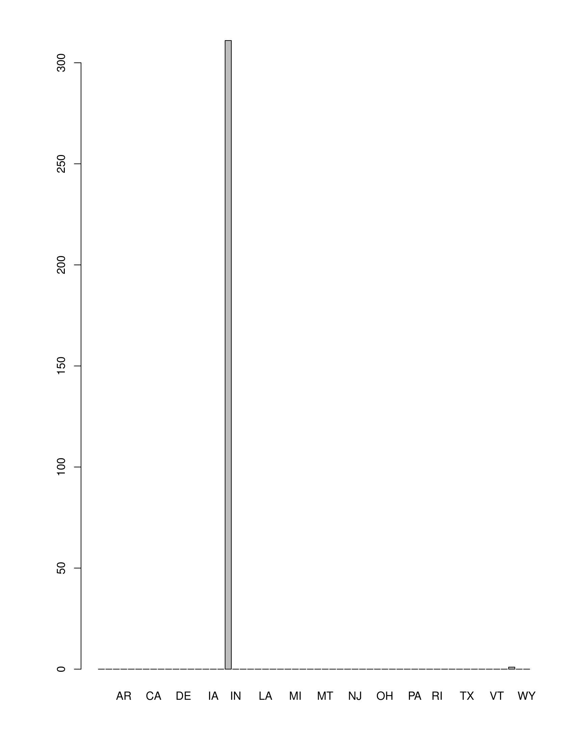This diagram represents: contracts on youth based on states.**

**Youth**

State

IL :311

WI : 1

: 0

AK : 0

AL : 0

AR : 0

(Other): 0

Vendor.Name Vendor.ID City

BOYS & GIRLS CLUBS OF CHICAGO : 24 24051664V: 24 CHICAGO :309

CHICAGO YOUTH CENTERS : 18 65101977V: 18 CHICAGO HEIGHTS : 1

CABRINI GREEN YOUTH PROGRAM : 6 12799714H: 6 ELKHART LAKE : 1

ARIEL EDUCATION INITIATIVE : 5 31316724A: 5 NORTHBROOK : 1

Y M C A METRO CHICAGO : 5 31330149X: 5 : 0

YOUTH SERVICE COMM OF THE WESTSIDE: 5 85241514X: 5 **** USE VENDOR# 64: 0

(Other) :249 (Other) :249 (Other) : 0

**Delegate agency**

**Pdf delegate agency:**

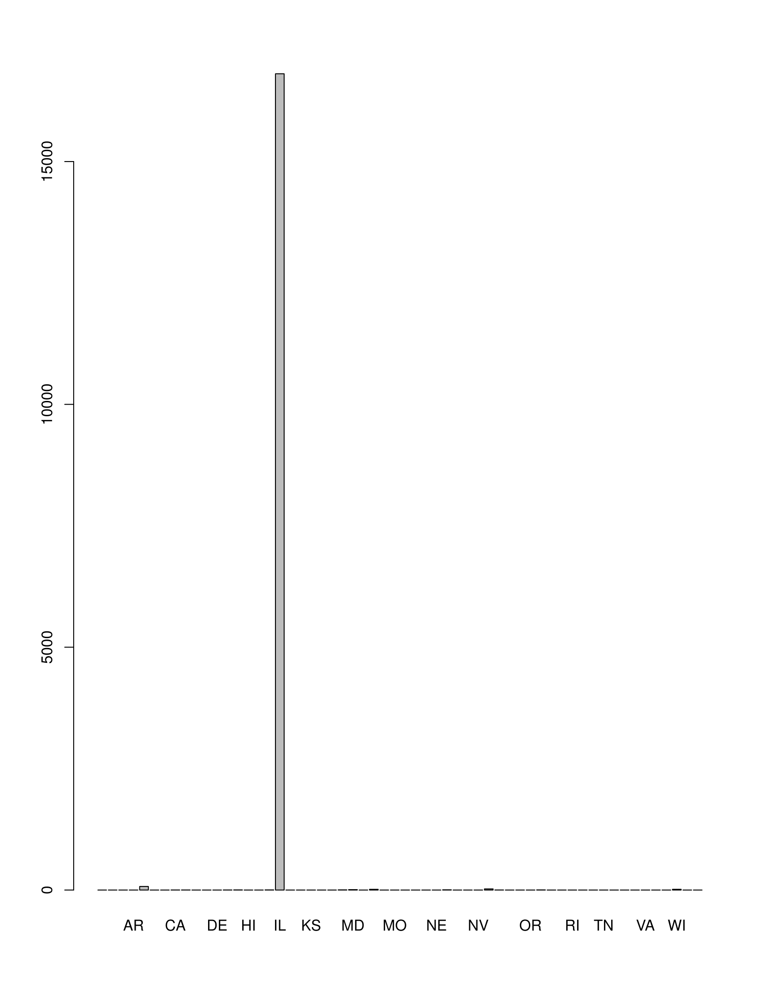

**This diagram represents: contracts on delegate agency based on states.**

**Delegate agency**

State

IL :16807

AZ : 73

NY : 23

WI : 15

MI : 14

MD : 8

(Other): 17

Contract.Type Vendor.Name

DELEGATE AGENCY:16957 JANE ADDAMS HULL HOUSE ASSOCIATION: 392

DEMOLITION : 0 BOYS & GIRLS CLUBS OF CHICAGO : 368

SCHOOLS : 0 CENTERS FOR NEW HORIZONS 01 : 324

ADVERTISEMENT : 0 CHASE HOUSE INC 02 : 236

ADVERTISING : 0 SALVATION ARMY 01 : 230

AIDS : 0 HOWARD AREA COMMUNITY.CENTER : 211

(Other) : 0 (Other) :15196

Vendor.ID State

9814851L : 392 IL :16807

24051664V: 368 AZ : 73

15427701H: 324 NY : 23

31302660X: 236 WI : 15

33665822M: 230 MI : 14

28386163V: 215 MD : 8

(Other) :15192 (Other): 17

**ADVERTISEMENT**

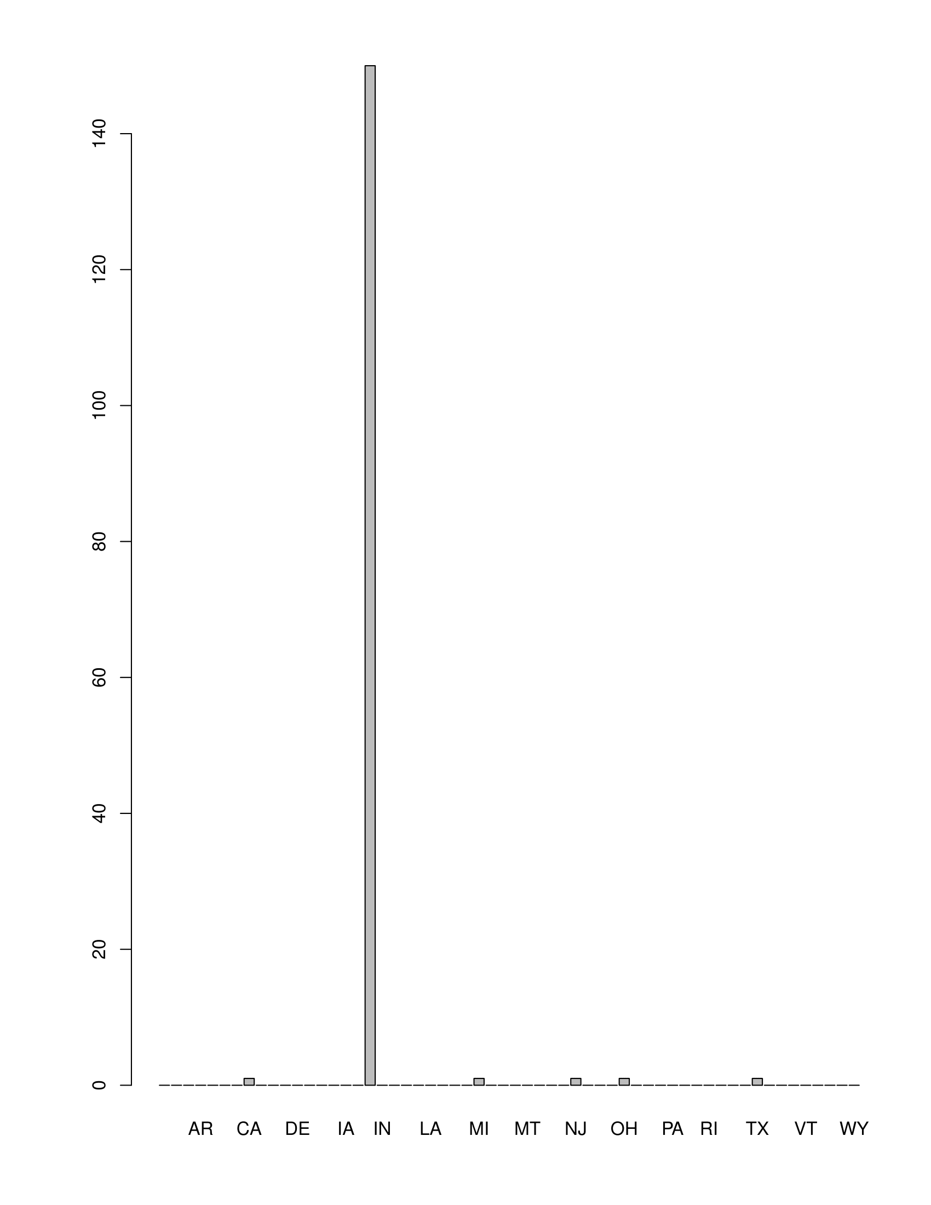**This diagram represents: advertisement contracts based on states.**

**ADVERTISEMENT**

State

IL :150

CA : 1

MI : 1

NJ : 1

OH : 1

TX : 1

(Other): 0

Vendor.Name State

N'DIGO : 9 IL :150

ROSSIS PUBLICATIONS, INC: 6 CA : 1

BEVERLY REVIEW : 4 MI : 1

CHICAGO DAILY DEFENDER : 4 NJ : 1

CHICAGO TRIBUNE 02 : 4 OH : 1

SKYLINE NEWSPAPER : 4 TX : 1

(Other) :124 (Other): 0

**COMODITIES**

**Pdf commodities**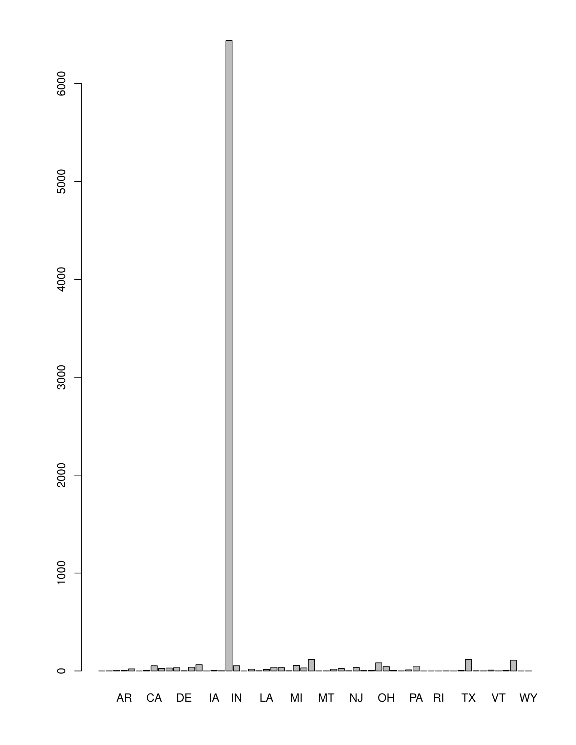

**This diagram represents: commodities contracts based on states.**

**COMODITIES**

State

IL :6439

MO : 119

TX : 116

WI : 110

NY : 83

GA : 64

(Other): 712

Contract.Type Vendor.Name

COMMODITIES :7643 CHICAGO UNITED INDUSTRIES, LIMITED : 535

DEMOLITION : 0 CHICAGO PARK DISTRICT : 121

SCHOOLS : 0 FEDERAL AVIATION ADMINISTRATN : 88

ADVERTISEMENT: 0 ROOT BROTHERS.MANUFACTURING & SUPPLY CO : 75

ADVERTISING : 0 ROOT BROTHERS.MANUFACTURING & SUPPLY CO.: 75

AIDS : 0 PRODUCTION DYNAMICS OF CHICAGO INC. : 70

(Other) : 0 (Other) :6679

Vendor.ID State

22085024V: 535 IL :6439

3620558A : 150 MO : 119

87834406A: 121 TX : 116

1004390 : 101 WI : 110

7011696A : 70 NY : 83

92439101T: 60 GA : 64

(Other) :6606 (Other): 712

**­­­­­­­­­­­­­­Conclusion**

While analyzing the data, I identified that there are several contracts that have been awarded to out of state contractors which means that there is a potential business opportunity for entrepreneurs to start up business in these defined areas.

The data was not in a numerical order and so I tried to first analyze the total type of contracts that are given out of the city of Chicago. Based on the previous outcome, I analyzed the most awarded contracts.

My first goal was to analyze it by states and concluded that if the contract were awarded out of state then it could be because contractors within the state were not able to full fill the requirements which means that there is a potential business opportunity to be accomplished.

I took the data sets that were significant in number like delegate agency, engineering, construction etc. through which I derived that there is a huge potential in construction and engineering works. As a lot of contracts are out sourced from other states that are not in the current list of contractors for the City Of Chicago.