Front/landing page
- Logo could be a bit bigger and blend with the white background. Currently, the logo background white is not the same as the sites background white. It looks pasted on it but not integrated.

- Language selection must in the order of EN, DE, FR, IT, JP, CN

Under our Businesses we should remove trading and distribution tabs and have three tabs ;

- Steel (Raw Materials & Prime)
Steel for recycling and industrial tools production across global markets with expertise in various Alloy Tool Steel and Stainless-steel grades.

- Food & Grains
Multiple products for food manufacturing industries across global markets.

- Flowers & Foliage
Fresh cut flowers and foliage from around the world for the Asian markets.

Our Global Presence (we are re-structuring DRP so new details are below which should be on our new website that should go live from 1st Jan)

Canada (Head Office)
DRP International Ltd.
Add is ok

UK (Branch)
DRP International Ltd.
Address is ok

Netherlands (Branch)
DRP International Ltd.
(we will have a new office add and I will let you know soon)

Japan (Branch)
DRP International Ltd.
Add is ok

(branches shown in order of going east from Canada HO).

Hong Kong (Subsidiary)
Silver State Limited
RM A&B, 2/F, Lee Kee Commercial Building
221-227 Queen's Road Central, Hong Kong
Email: silverstate-hk@drpgp.com

Under Always Interested please remove the line “ready to explore opportunities”
Remove www.drpgp.com from under DRP Group companies as its already mentioned under Always interested.

President’s Message

President's Message
Thank you for visiting!
I have been involved in global commodity trading and business development for over 25 years. Drawing on this experience, I established DRP International Ltd. in Ontario, Canada in 2016. Our company is a multi-commodity trading business at its core. Since our founding, we have grown into a trusted partner across three continents.
Trading is at the heart of DRP's business. Our team is highly experienced, multi-lingual, and global. We originate physical transactions that support our customers' businesses in AMER (North, Central, South America), EMEA (Europe, Middle East, Africa), and APAC (Asia-Pacific) regions.
Our global network, logistics, and distribution capabilities allow for sourcing of commodities in one location and delivery in another. Our storage and financing capabilities allow us to execute trades across time zones and delivery periods. We endeavour to identify arbitrage opportunities with our extensive market knowledge and experience.
DRP has grown by creating value through building businesses from the ground up - powered by capital, relationships, and deep expertise. Our vision of creating sustainable value through strategic partnerships continues to drive our mission forward.

Management Philosophy

A Company That Creates Businesses from Scratch

We create value by building businesses from the ground up, powered by capital, relationships, and deep expertise. By leveraging our global network, logistics, and distribution capabilities, we provide optimal solutions to customers worldwide and achieve sustainable growth.
(II will send across a different pic as THAT ISNT ME)

Our Products
Remove this line “Quality Commodities from Around the World”
Products should have a drop-down list as follows.
- Steel
- Food & Grains
- Flowers & Foliage

When someone clicks on steel a new page should open with the following details all on one page.

Raw Materials (Recyclable Ferrous & Non-ferrous)
We supply various grades of sorted recyclable ferrous and non-ferrous metals to melters in Europe and Asia. Our products are supplied as per international specifications and quality standards.
Revert industrial recyclable metals sourced through rigorous quality control processes. Our recyclable metals offer an environmentally responsible alternative without compromising on performance. Our shipments originate from AMER, EMEA and APAC regions.

Key Features
- Meets international specifications and quality standards
- Environmentally sustainable sourcing
- Cost-effective alternative to virgin steel
- Multiple grades and specifications available
- Reliable global supply chain

Recyclable Ferrous and Non-ferrous grades
- HMS & PNS
- Alloy & Tool Steel (Ni-Cr-Mo-V)
- Stainless Steel (3xx and 4xx series)
- Copper
- Aluminium

Prime Steel
We supply imported Alloy Tool Steel and Stainless Steel for tool and die production from stock to customers in the UK and EU. Our steels are produced by certified producers in Europe and Asia.
We hold stock in various grades and sizes in the UK and EU for quick turnaround on Just-in-Time (JIT) basis.

Key Features
- Meets international specifications and quality standards
- Environmentally sustainable sourcing
- Multiple grades and sizes available
- Reliable global supply chain

Prime Steel grades
1.2344 (H13)
1.2343 (H11)
1.2714
1.2329
1.2379
P20
15-5ph
17-4ph
3xx and 4xx

Lets finish till here for now and lets see how it looks,
We can update food and flower details later.
Pls feel free to amend as needed and picture for ferrous, nonferrous and prime steel as best.

Company Information
Company Name | DRP International Ltd.
Established | 2016
President & CEO | Ritesh Singh
Headquarters | 80B-135 James St. S.  Hamilton, ON, L8P 2Z6  Canada
Business Activities | • Multi-commodity trading  • International distribution and logistics  • Supply chain management services
Service Areas | AMER (North, Central, South America)  EMEA (Europe, Middle East, Africa)  APAC (Asia-Pacific)
Email | info@drpgp.com
Website | www.drpgp.com

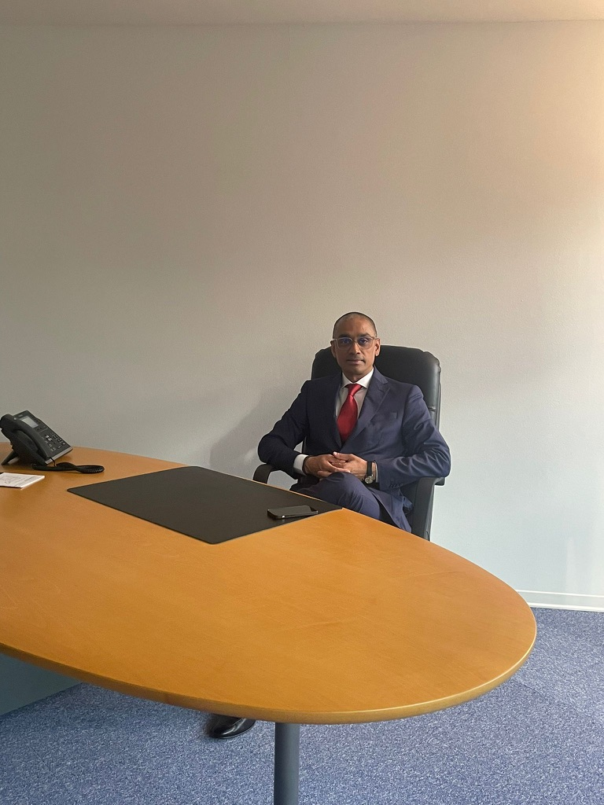
Please try to edit zoom and use this picture. If this is not perfect I will have to get ready and take a new one soon.

