Market Sentiment & Trader Performance

Summary
The study mixes trading info from Hyperliquid accounts with the Bitcoin fear and greed numbers. This is to see how market feelings connect to what traders actually do in practice. Emotions like fear or greed might shift profits and risk levels. It checks if those feelings change how traders handle positions or adjust their style over time. Five headline findings emerged:
- Traders earn the highest average daily profit during Extreme Fear and the lowest during Neutral or Greed periods. However, this is mainly because of a few traders making very large profits, not because most traders perform better.
- Win rate and profit are not the same thing: during Extreme Greed, traders win more often, but during Extreme Fear, they make larger profits per successful trade. So in fearful markets, traders win less frequently but gain more when they do.
- Traders use the highest leverage (more risk) during normal Greed periods (25.3% of trades) rather than during Extreme Greed (19.1%). This suggests people take the most risk in regular optimistic markets, not at peak excitement.
- Market sentiment does affect next-day profits, but over longer periods the results get skewed by a few extreme trades. Looking at the median profit gives a more realistic picture than using the average.
- Different trader types appear in the data: a small group of aggressive traders (“Fear whales”) earns unusually high profits during market panic, while most traders show only a small change in behavior based on market sentiment.

1.Data & Methodology

Trade data from Hyperliquid (such as trader account, coin traded, trade price, trade size, buy/sell side, leverage used, profit/loss, and time of trade) was combined and summarized for each trader per day. This was then matched with the daily Bitcoin Fear & Greed Index categories (Extreme Fear, Fear, Neutral, Greed, Extreme Greed).

Since the trade data and sentiment data used different time zones, timestamps were converted from IST to UTC to make sure each trade matched the correct day’s sentiment.

To check whether the observed patterns were meaningful and not random:

The Kruskal–Wallis test was used to compare profits across sentiment groups because profit data was uneven and had extreme values.

The Chi-square test was used to see whether trader behavior categories were related to market sentiment.

2. Sentiment and Trading Profitability

2.1 Average Daily PnL by Sentiment
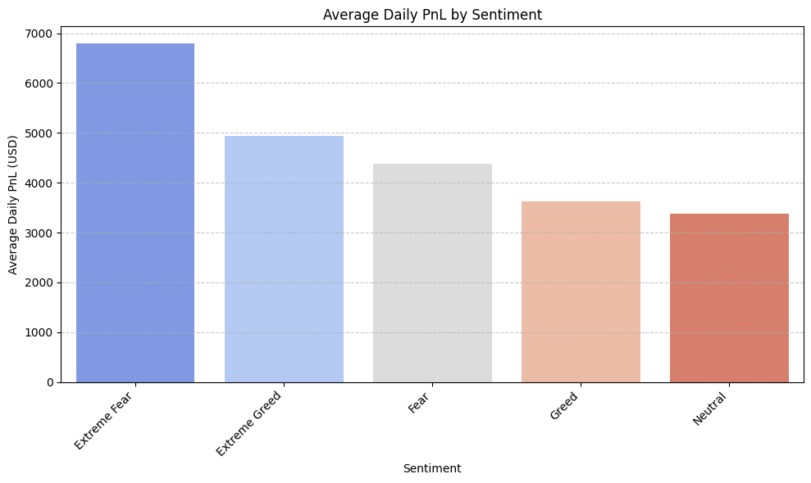
A Kruskal-Wallis test confirms the differences across sentiment classes are statistically significant (H = 20.76, p = 0.00035). Therefore, it is not noise.

2.2 Win Rate Tells a Different Story
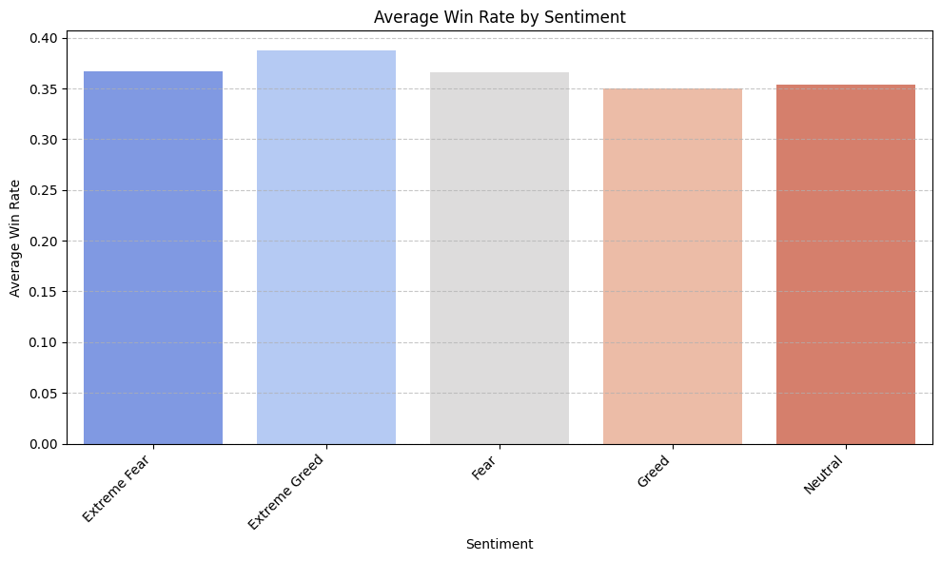
Key insight: Extreme Greed produces the highest win rate (38.8%) but a lower average profit than Extreme Fear. This means traders in Fear regimes win less often (36.7%) but capture much larger profits per win. Extreme Greed trades are more frequently correct but smaller in magnitude.

3. Risk-Taking Across Sentiment Regimes
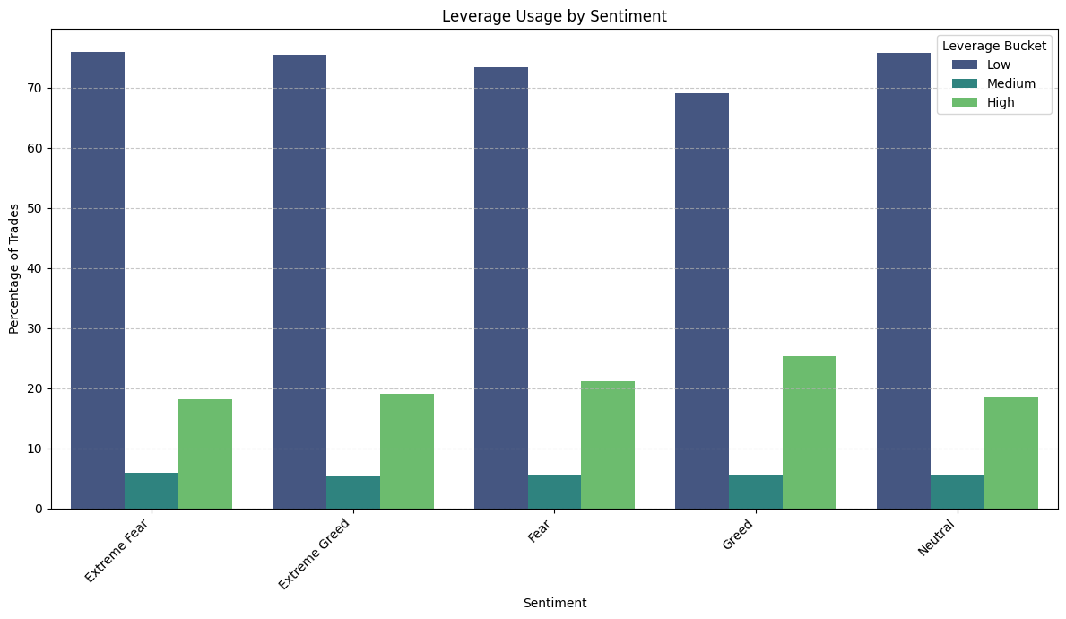
The results show that traders do not use the most leverage during Extreme Greed as expected. Instead, high-leverage trading is highest during normal Greed (25.3%), while it drops during Extreme Greed (19.1%) and is similar to Extreme Fear (18.1%). Statistical testing (Chi-square test) shows this difference is unlikely to be due to chance.
Interpretation: When the market reaches Extreme Greed, some traders may become more careful because they feel the market has already risen too much and could reverse soon. But during ordinary Greed, traders still feel confident and safe taking bigger risks. This makes regular bullish markets the period where traders tend to take the most excessive risk, rather than during obvious market excitement.

4. Does Sentiment Predict Future Performance?
To test whether sentiment's effect persists beyond the same day, daily PnL was compared against sentiment lagged by 1, 3, and 7 days.
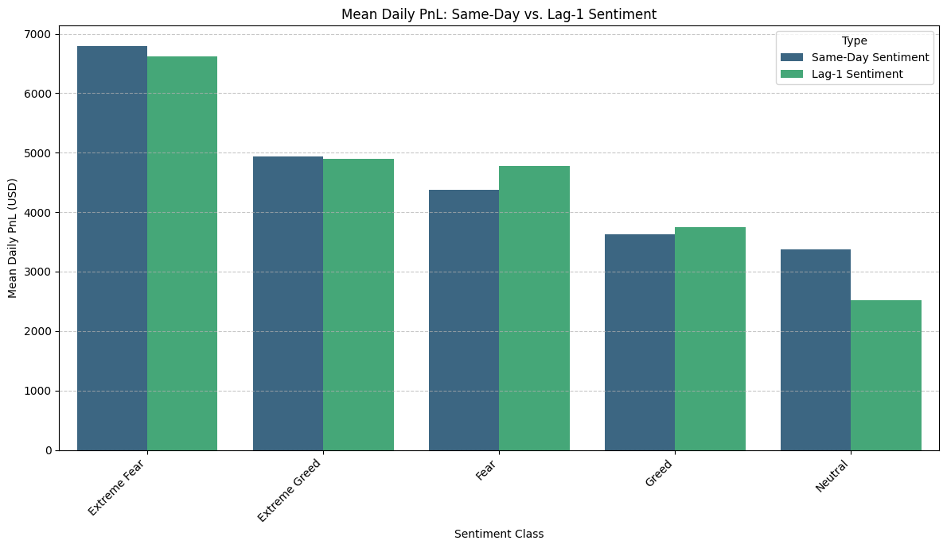

4.1 Mean vs. Median: The Critical Nuance
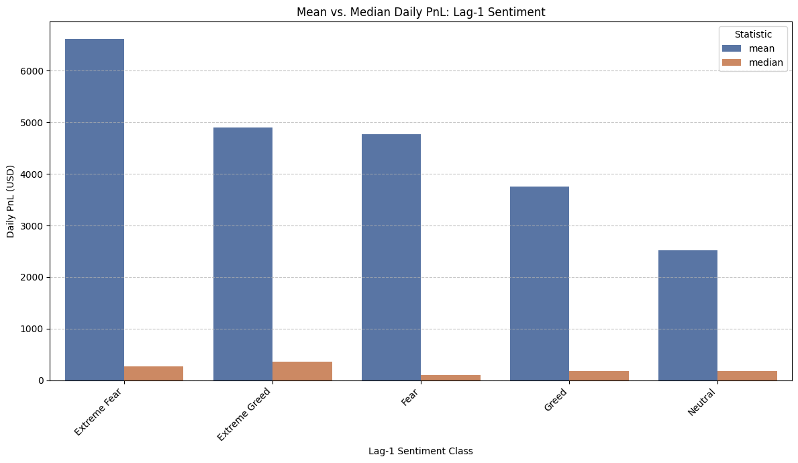

This is the most important finding of the study: average daily profit (mean PnL) is much higher than median profit in every sentiment category. For example, during Extreme Fear, the average profit is $6,621, but the median profit is only $262. More importantly, the ranking changes depending on which measure is used.

Using the mean, Extreme Fear appears to be the most profitable condition. But using the median (which better reflects a typical trader), Extreme Greed ($354) slightly outperforms Extreme Fear ($262), while Fear ($95) has the lowest typical profit.

This suggests there are two groups of traders in the dataset: a small number of high-conviction traders earn very large profits during Fear periods and strongly increase the average, while most traders achieve only slightly better results during Greed conditions.

The standard deviation is also 5–10 times larger than the average profit, showing that results are heavily influenced by a few large traders (“whales”) rather than a consistent effect across all traders.

At longer time gaps (3 and 7 days), this distortion becomes even stronger and results become less stable. Therefore, sentiment effects beyond 1 day should be treated as general indications, not firm conclusions.

5. Trader Archetypes: Behavioral Segmentation
Trader accounts were grouped into 5 clusters using k-means clustering after standardizing the data. The grouping was based on three factors: overall profit/loss (net PnL), consistency in trade size (measured relative to each trader’s usual trade size), and how their win rate changed between Fear and Greed market conditions. To decide the number of groups, silhouette analysis was used. The results showed that 5 clusters was a reasonable choice. Although 6 clusters gave a slightly higher score (0.242 vs. 0.230), the improvement was too small to justify adding another group.
In simple terms, the analysis found that traders can be divided into five meaningful behavior patterns, without making the model unnecessarily complex.

Cluster | Accounts | Net PnL (avg) | Win Rate (Fear) | Win Rate (Greed) | Fear–Greed Gap | Archetype
3 | 2 | $1.86M | 38.4% | 25.1% | +0.134 | Fear Whales
0 | 2 | $654K | 63.3% | 71.5% | -0.083 | Greed-Leaning Elite
1 | 8 | $210K | 28.3% | 24.0% | +0.043 | Mild Fear Tilt, High Conviction
2 | 15 | $177K | 44.2% | 34.6% | +0.068 | Core Population — Balanced/Fear-Leaning
4 | 5 | $137K | 17.5% | 50.2% | -0.327 | Greed Specialists

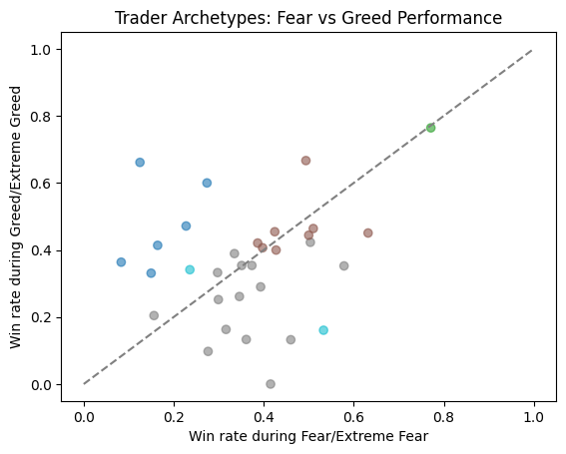

Cluster 2 (15 traders) is the only group large enough to represent a real and reliable trading pattern. This group shows a small tendency to perform better during Fear markets, which matches the earlier finding from the median profit analysis. The other groups — Clusters 0, 3, and 4 — are very small (only 2–5 traders each), so they should not be treated as broad market behavior. Instead, they are better viewed as individual trader case studies. In particular, Cluster 3 contains two “Fear Whale” accounts that make unusually large profits during Fear periods. These few traders heavily influence the overall average profit results and make Fear appear more profitable than it is for the typical trader.

