-------------------------------------------------------------------------------------------------------------------------

**Scala Lab Assignment no.12**

--------------------------------------------------------------------------------------------------------------------------------------

**Name :** Mayur Dnyaneshwar Shinde

**Roll No.:** TAI&D62

**Subject:** Data Science

**Assignment :** Scala Lab Assignment

**1.Perform Helloworld program in Scala**

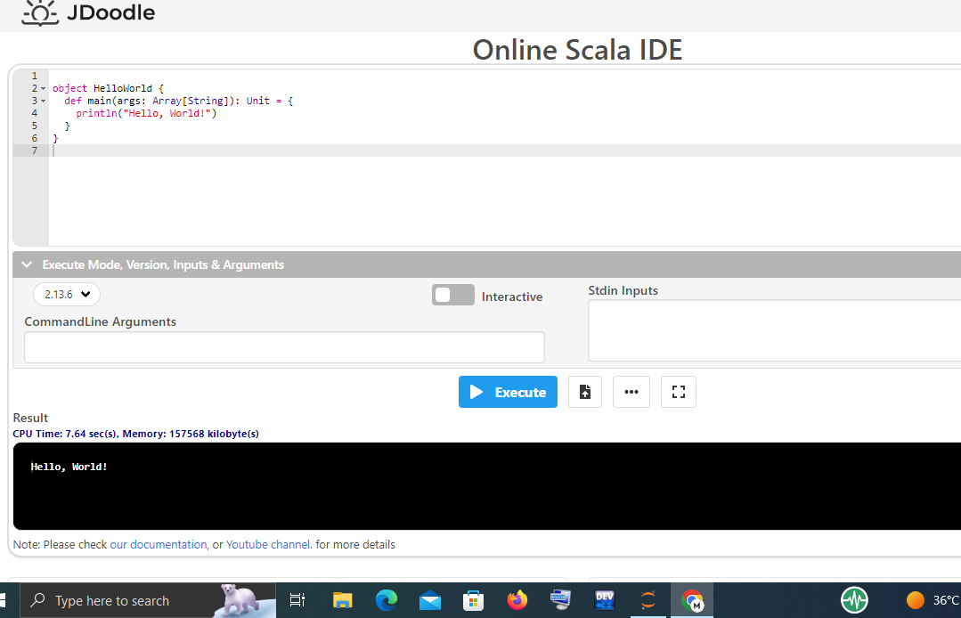

**2.Perform Addition of two numbers program in Scala**

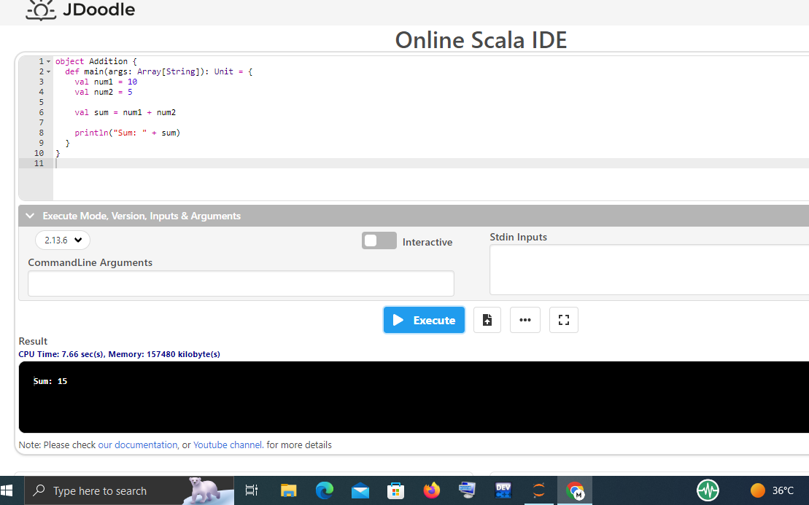

**3.Perform Multiplication table program in Scala**

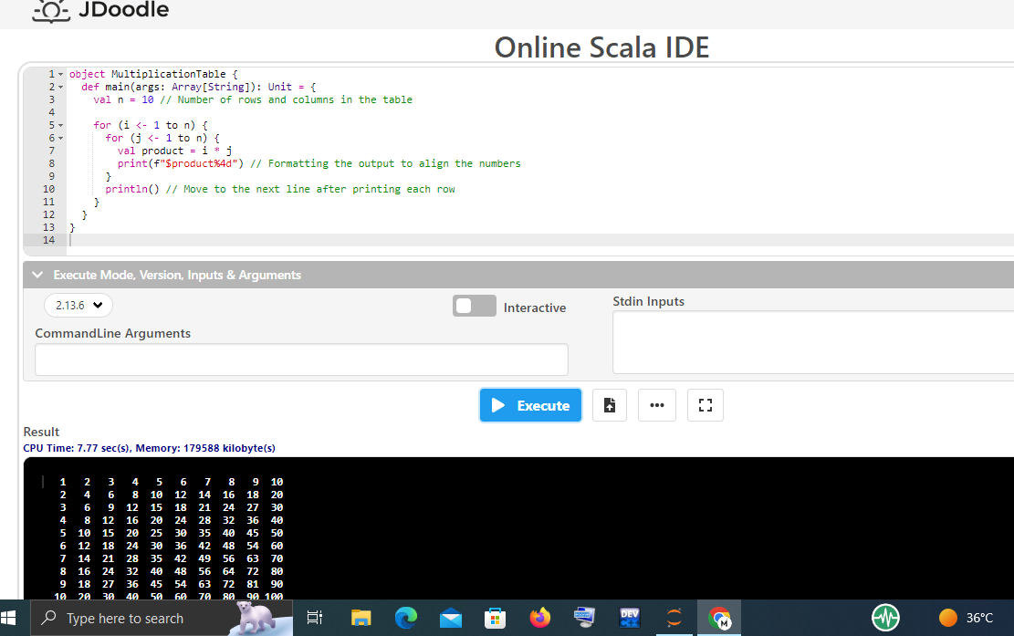

**4.Perform Odd & Even program in Scala**

