UNDERWEIGHT

***Why being underweight could be a problem***

Being underweight is not good for you. It could cause:

**Nutritional deficiencies:** if you're underweight, it's likely that you're not eating a healthy, balanced diet, which can lead to you lacking nutrients that your body needs to work properly. Calcium, for example, is important for the maintenance of strong and healthy bones. If you do not get enough calcium, you risk developing [osteoporosis (fragile bone disease)](https://www.nhs.uk/conditions/osteoporosis/). If you do not get enough iron, you may develop [anaemia](https://www.nhs.uk/conditions/iron-deficiency-anaemia/), which can make you feel drained and tired.

**Weakened immune system:** your immune system is not 100% when you're underweight, so you're more likely to catch a cold, flu or other infections.

[**Fertility problems**](https://www.nhs.uk/conditions/infertility/)**:** women who are underweight can find that their periods stop.

**How to put on weight safely**

*If diet is the cause of your low weight, changing to a*[*healthy, balanced diet*](https://www.nhs.uk/live-well/eat-well/)*that provides the right amount of*[*calories*](https://www.nhs.uk/live-well/healthy-weight/understanding-calories/)*for your age, height and how active you are can help you achieve a healthy weight.*

**Aim to gain weight gradually until you reach a healthy weight.**

Try to avoid relying on high-calorie foods full of [saturated fat](https://www.nhs.uk/live-well/eat-well/different-fats-nutrition/) and [sugar](https://www.nhs.uk/live-well/eat-well/how-does-sugar-in-our-diet-affect-our-health/) – such as chocolate, cakes and sugary drinks – to gain weight. These foods can increase body fat instead of lean body mass and increase your risk of developing [high levels of cholesterol](https://www.nhs.uk/live-well/healthy-body/lower-your-cholesterol/) in your blood.

* Instead, aim for regular meals and occasional snacks, and base your diet on the [Eatwell Guide](https://www.nhs.uk/live-well/eat-well/the-eatwell-guide/). This means:
* **Eating at least 5 portions of a variety of**[**fruit and vegetables**](https://www.nhs.uk/live-well/eat-well/5-a-day-what-counts/)**every day.**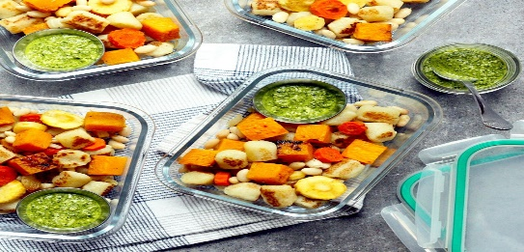 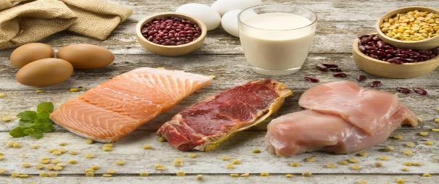
* **Basing meals on potatoes, bread, rice, pasta or other**[**starchy carbohydrates**](https://www.nhs.uk/live-well/eat-well/starchy-foods-and-carbohydrates/)**. Choose wholegrain where possible**. 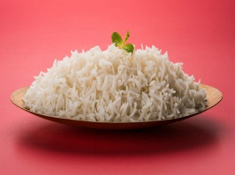 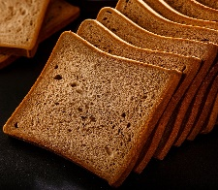 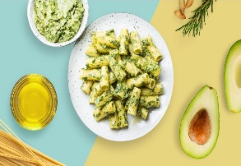
* **Having some**[**dairy or dairy alternatives**](https://www.nhs.uk/live-well/eat-well/milk-and-dairy-nutrition/)**(such as soya drinks and yoghurts). Have whole (full-fat) milk until you build your weight back up.**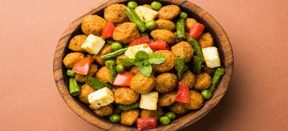 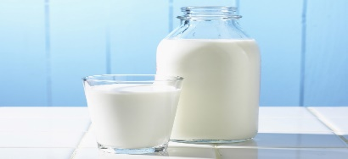
* **Eating some beans,**[**pulses**](https://www.nhs.uk/live-well/eat-well/beans-and-pulses-nutrition/)**,**[**fish**](https://www.nhs.uk/live-well/eat-well/fish-and-shellfish-nutrition/)**,**[**eggs**](https://www.nhs.uk/live-well/eat-well/eggs-nutrition/)**,**[**meat**](https://www.nhs.uk/live-well/eat-well/meat-nutrition/)**and other protein. Aim for 2 portions of fish every week – 1 of which should be oily, such as salmon or mackerel.**
* **Choosing unsaturated oils and spreads, such as sunflower or rapeseed, and eating them in small amounts.**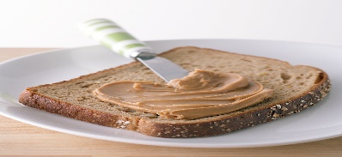 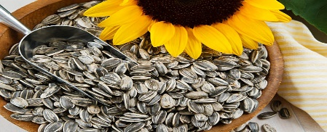
* **Drinking**[**plenty of fluids**](https://www.nhs.uk/live-well/eat-well/water-drinks-nutrition/)**. The government recommends 6 to 8 glasses a day. But try not to have drinks just before meals to avoid feeling too full to eat.If you're having foods and drinks that are high in**[**fat**](https://www.nhs.uk/live-well/eat-well/different-fats-nutrition/)**,**[**salt**](https://www.nhs.uk/live-well/eat-well/salt-nutrition/)**and**[**sugar**](https://www.nhs.uk/live-well/eat-well/how-does-sugar-in-our-diet-affect-our-health/)**, have these less often and in small amounts.**
* ***Things to remember while bulking***
* ***Don’t have to much of junk food you can have a cheat day in 2 weeks or so***
* ***Trust the process and have a high amount of carbs and a protein rich diet***
* ***Fats are essential for the body so have some good fats through nuts ghee etc.***
* ***Have a moderate exercise and do much of strength training***
* ***Try doing some basic body weight exercise and don’t go for weights early***
* ***Have a good amount of fruits in your diet***

|  |  |
| --- | --- |
| **Morning breakfast**  **(8am to 9am)** | **Eggs , brown bread, nuts (almonds, cashews, walnuts, dates etc.) Oatmeal, upma, poha, etc.**  **[Try to get some moderate carb meal ,a bit of proteins through eggs (if not eggs go with tofu, paneer or plan based proteins), and good fats through nuts ]** |
| **Mid meal**  **(11am to 12am)** | **Banana shake, mango shake, apple smoothie,**  **Buttermilk, etc.**  **[here you have to go with liquid to cool down your body try some fruit shakes or make something of curd this will reduce the heat inside the body and helps in digestion]** |
| **Lunch**  **(1.30 pm to 2.30pm)** | **Dal , potato boiled, chapati, rice, salad(cucumber, beetroot, carrots)**  **Chicken breast/ paneer or tofu, curd, rajma curry**  **[Try getting high amount of carbs and a good salad ]** |
| **Pre work out meal** | **green tea, banana, brown bread with peanut butter** |
| **Post workout meal** | **Eggs (yolk try to avoid ), boiled potato, brown rice , whey protein, pasta** |
| **Dinner**    **(9.30pm to 10.30pm)** | **Chapati , soya chunks, cucumber , sweet potato**  **[keep the dinner low -no rice]**  **Go for a walk after dinner** |

**Have 6 to 7 meals a day ( have at least 3 to 4 L of water/day )**