WORKOUT

|  |
| --- |
| At least 150 minutes every week of moderate exercise, or 75 minutes every week of vigorous exercise. That can be broken down into 30 minutes of exercise, five days a week. For an overweight beginner, that can seem like a lot. But it’s important that you see this recommendation as a goal to which you can work. If you’re physically unable to complete 30 minutes of exercise this week, do what you can, and build toward 30 minutes daily over time. In fact, three bouts of 10 minutes of exercise a day adds up to the same calorie expenditure as a continuous 30 minutes.  In the beginning, it doesn’t even matter if your exercise sessions are so short that they aren’t contributing significantly to calories burned. All that matters in the beginning is that you’re doing what you’re capable of doing. That’s how to begin preparing your body for longer workout sessions in the future.  Any kind of physical activity counts as exercise as long as you’re moving your body and burning calories.  One of the best ways to approach this is to try something that you enjoy. You’re far more likely to stick with something if you like what you’re doing, even when it’s challenging. Here are activities you might try to ease into a regular fitness routine. |

***Walking***

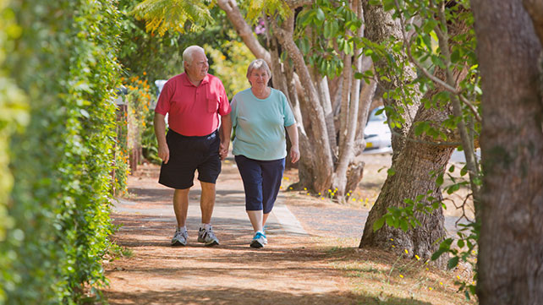Share on Pinterest

While activities like climbing stairs and jogging, one of the easiest and most effective ways to ease into a healthier lifestyle is to begin walking.

Not only is it free, it’s a low-impact exercise that you can do nearly anywhere, inside or out. For morbidly obese people, walking may be difficult. But it’s doable with assistance. Even walking slowly will burn additional calories when you’re carrying extra weight, because you’re exerting more energy to move your body.

***Water Aerobics***

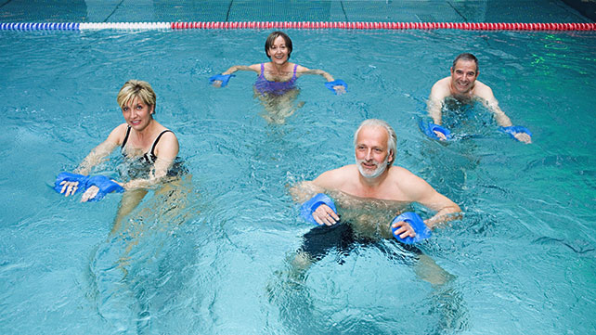Share on Pinterest

Exercising in the water can have multiple benefits.

Water helps to support your body weight, which makes you feel lighter. It also reduces the impact on your joints, which means that the pain you might feel in your hips or knees from moving on land is virtually nonexistent when you stand in the water.

Consider enrolling in a group fitness class at your local pool. You can also try learning some simple resistance exercises that can be performed in the water.

## ***Modified Push-Ups***

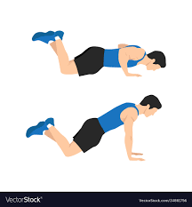

Push-ups are one of the top exercises you can use to get in shape when you're overweight or obese. Don't worry; it doesn't have to be as bad as you think!

While it [can be difficult](https://www.livestrong.com/article/398641-why-cant-some-people-do-pushups/) to do push-ups if you're overweight, you can modify the exercise to make it easier. There are several ways you can do this if a standard push-up is too difficult.

For example, to make a push-up easier, you can perform the exercise while standing up with your hands pushing against the wall instead of the floor. If you want to take it one step further, you can also try doing push-ups on the ground but with your knees down against the floor throughout the exercise.

Performing push-ups will work your entire body and will strengthen your core. Performing push-ups may also [reduce the risk](https://jamanetwork.com/journals/jamanetworkopen/fullarticle/2724778?utm_campaign=articlePDF&utm_medium=articlePDFlink&utm_source=articlePDF&utm_content=jamanetworkopen.2018.8341) of cardiovascular disease.

***Stationary Bike***

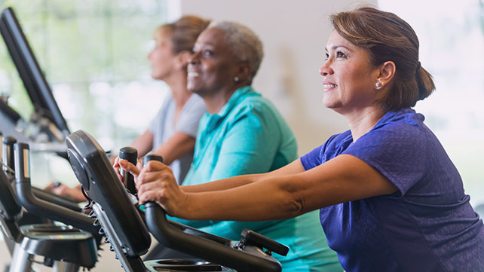Share on Pinterest

The seated, stationary bike — also known as the recumbent bike — has a backrest that makes it a good choice for obese people.

Some obese people lack a strong abdominal core, which makes it difficult to sit on an upright stationary bike. Seated bikes are also less stressful on the lower spine, which is a common complaint for people carrying extra weight.

Incorporating both walking and riding the seated stationary bike is a good way to target different muscles in the lower body.

## ***Side Leg Lifts***

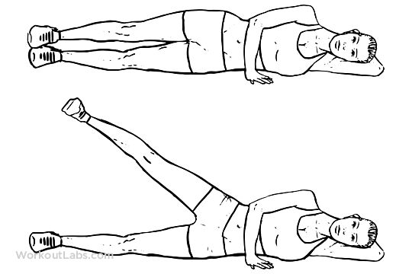

Leg lifts are a great exercise for working out your lower body, and there are several types of leg lifts you can try. Side leg lifts, or side-lying hip abduction exercises, are one of the best types you may want to give a shot.

Side leg lifts can be extremely beneficial for your lower body and will be helpful for having a well-rounded exercise session. They have been shown to reduce pain and increase muscle performance. One [2011 study](http://doi.org/10.4085/1062-6050-46.2.142), for example, showed that a hip abductor strengthening program significantly reduced pain and increased strength in patients with patellofemoral pain syndrome (PFPS).

To do these leg lifts you'll need to lay on your side, placing the hand from your elevated side onto the floor and your other behind your head. Lift your top leg up as high as it will go and then gently bring it back down. Then repeat the exercise for the opposite side of the body.

## ***Bridges***



Performing a glute bridge exercise can also be a good exercise to try when improving your personal fitness as a beginner. Performing bridges will [strengthen your core](https://www.mindbodygreen.com/0-17705/5-reasons-to-do-bridges-every-day.html) and build your lower back and gluteus muscles.

For this exercise, you'll need to get down on the floor, laying on your back with your knees bent. Then, you'll need to lift up your hips off of the floor and then slowly back down.

If done regularly, doing glute bridges can have a great effect over time and will help you to strengthen your core while also reducing knee and back pain. Because bridges can be done while lying down, they can be a great way to get started with an exercise routine.

## ***Modified Squats***

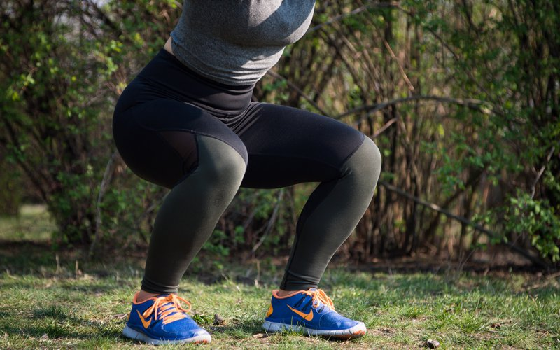

Performing squats is one of the best ways to improve personal fitness. Squats are especially beneficial for your leg muscles, but really improve every part of your body if done right. They're also functional, meaning they'll help you get better with everyday movements as well.

Squats are also one of the best exercises for burning calories. According to [this formula](https://www.livestrong.com/article/313995-calories-burned-during-squats/), a person who weighs 160 pounds and performs squats for 15 minutes will burn around 230 calories.

When performing a basic squat, you'll start standing up. Then, you'll lower your body to the ground. Then you'll slowly rise back up. Some people perform squats while holding a weight in their hands, and there are plenty of variations you can try.

If it's difficult for you to perform a full squat, you can modify it to make it easier for you. To perform a modified squat, do a squat normally. However, instead of lowering your body all the way to the ground, lower it into a chair instead, before rising back up.

## **Getting Started With These Easy Workouts**

**If you're ready to start on your path to improvement, don't put too much pressure on yourself! Consider trying the easy workouts listed above, but if there are any that you can't do, that's okay. Focus on the exercises that you can perform successfully and go from there.**

**By starting slowly and pushing yourself little by little, you'll eventually get into your new exercise routine and will start feeling better one step at a time.**