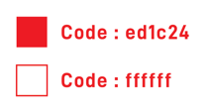

**Logo:** 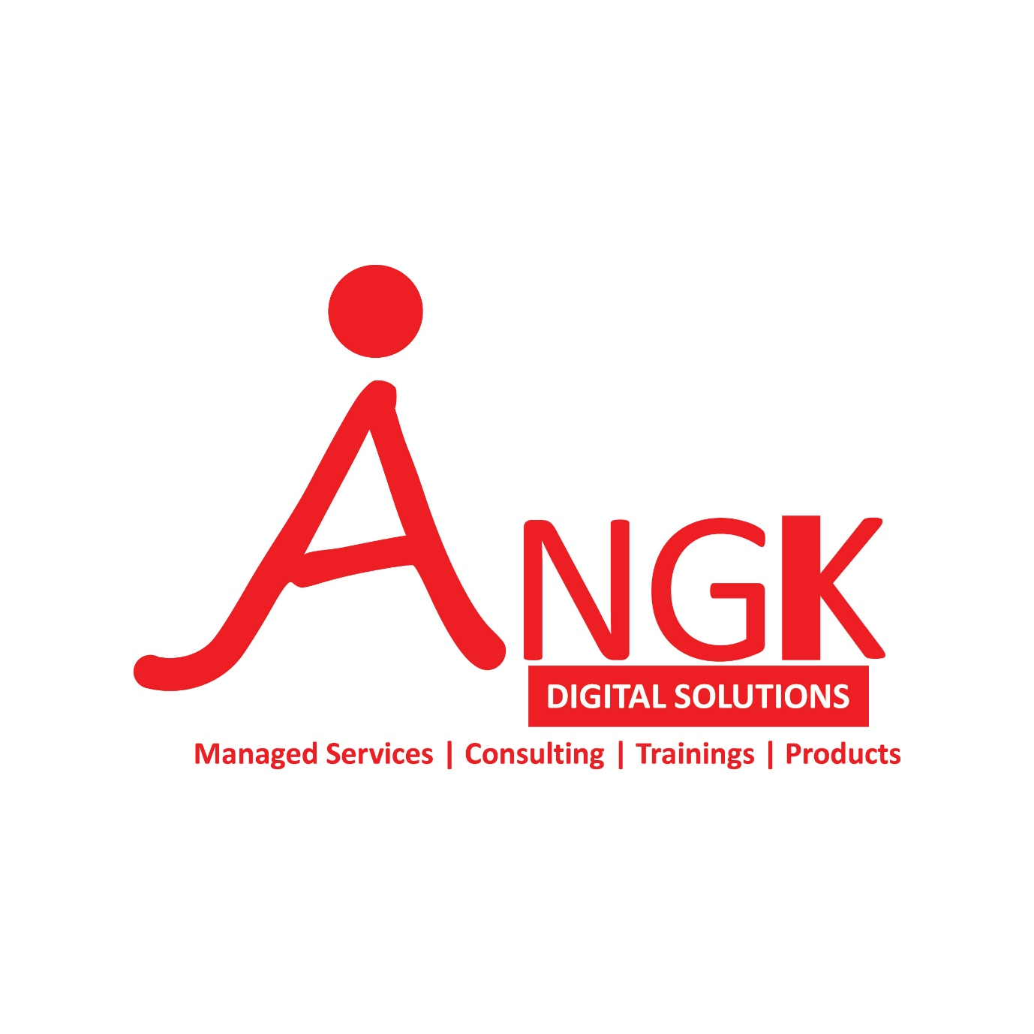

Flow: Adaptable to Web and Mobile with following pages:

1. Home Page (**Info page**) with following tabs

* Vision and Mission
* About us
* Our Services with sub Tabs
  + Managed Services
  + ANGK Products
  + Consulting
  + Training
* Contact us
* Careers

Sections on Home page

* News
* Partners
* Esteemed Clients

1. About us (**Info page – Content to be shared**)
2. Services Page (**Info page** with links for each category on the page)
3. Contact us (**Info + Form** to type a short message and email forwarding)
4. Careers (**Form** to apply for open positions with a CV and Cover letter attachments and email forwarding – **we should be able to create positions and list Job Descriptions based in a fixed template only for internal use** here)
5. News (Should **have form for us to** update news based on a standard template allowing us to type a paragraph and upload up to 2images that will become visible on home page)
6. Partners (Should **have form for us to** update partner logo that will become visible on home page)
7. Esteemed Clients (Should **have form for us to** update client logo that will become visible on home page)

ANGK DIGITAL SDN BHD

HOME PAGE Info

Over the course of the pandemic, businesses have largely embraced digitization as a key source of not only obtaining business continuity but scaling up growth. Customers needed adaptable, fast, economically viable solutions to sustain and grow their core business, while letting experts to manage their operations.

Angk Digital’s core essence is about contributing to a better working life for employees and its Customers through professional solutions designed to meet the diverse needs of local and international clients.

Its offerings include Managed Services, Consulting, Training and Products in Information Technology space.

Most clients are multinationals and large companies, making ANGK experienced in addressing various problems with customized solutions.

Local understanding enhanced by international methodology gives ANGK a greater understanding of organisations when providing suitable solutions.

The four pillars of Angk Digital :

**Sustainability :**the principle of producing goods and services while exacting minimal damage to the environment. - an important source of long-term competitive advantage.

**Cloud** : We help companies to deploy the cloud for good purpose. Optimise resources, save cost and create value.

**Talent** : Provide a better employee experience for customers through Talent Management and HR Best practises. Internally to treat employees as internal customers, making them the priority rather than a necessity,

**Speed :** We help customers to ramp up and ramp down fast to meet the dynamic needs and challenges in the fast changing environment

Angk Dgital is back up by industry leaders with 100 man years of experience to put forward the true value proposition to the industry through years of learning and deployment experience of its leaders.Graduated from ivy league schools such as Berkley, Wharton, MIT and NTU and collating experiences from Enterprise , Banking, GLCs, Consulting, the team adheres to stringent quality control measures and brand positioning across all our delivery models.

Together with the delivery team, we have been the employer of choice attracting talents from across the industry to deliver value.

Tasked with the management of the company, the  board is accountable for developing, driving, executing and achieving the approved Group strategy and strategic targets, sound business and financial controls, development of results and dealing with corporate responsibility issues, while simultaneously respecting policies that have been set.

Vision Mission statement

We aim to be the most preferred Managed Services Provider for our customers in the region.

We strive bring in economic value proposition for all our customers by driving Value, reducing Costs and providing seamless Business Continuity through our delivery models.

OUR SERVICES

Managed Services:

**Payroll and HR Outsourcing Services (HROS) :**

One of the key services of ANGK Consulting. We provide clients with a total solutions which includes time and material, Project based, one time and RPO models for using international standards, coupled with extensive local knowledge.

The domain required extensive knowledge of Employee lifecycle Management and statutory compliances, which positions Angk Ditial as one of core providers of HR Managed Services in Malaysia and across the region through its partners in Indonesia, Philippines, Cambodia , Vietnam and Middle East.

**Infrastructure and IT Managed Services :**

IT infrastructure management service (IMS) covers administering and managing technology, information and data in a proactive way. Its scope ranges from the desktop to networking, storage, data, security and cloud-based services - not forgetting the people employed to keep everything working.

Engineers from Angk Digital is available 24/7 to support on Networking, hardware and Software issues such that the customer may focus on their core business activities.

The entire support is based on Global best practises like ITIL, ITSM and ITAM .

Our Infrastructure Services include:

* Managed Desktop: for a lower cost, higher quality user experience
* Managed Network: maximise network efficiency and economy
* Service Desk: deliver a consistent and compelling IT service experience backed by a commitment to continuous improvement
* Infrastructure as a Service (IaaS)

**ANGK Products**

**To have HealthCare, Fleet Management, Real Estate, Education, Smart Devices, tabs that will be redirected to our partner products pages**

**Healthcare IT Solutions :**

To add as per ANGK content , additional feeders provided as per Triotree presentation

**ANGK IOT Solutions**

**To direct to ANGK-loconav page**

**Real Estate IT Solutions :**

Architecture, Engineering , construction Domain (follow as per ANGK Site – link to www.softech-engr.com

**Smart Devices :**

To redirect to a mart device listing page

**Education Solutions :**

To redirect to the Education products page

Consulting:

Training :

Products :