**Introduction:**

Our webshop is currently delivering special food products within the Netherlands and Belgium. One of our missions is to deliver the best user experience within our niche. This means that collecting the products, the whole experience should be seamless, as easy as possible from adding products to checking out.

As discussed before we had some bad experience with previous developer since communication was bad, and saying he was expert in lightspeed customizations but in the end could not make it work. We are looking for someone that can help us throughout the year optimising the UX of our webshop and actively comes up with solutions. We are Dutch guys, very approachable and open for suggestions that improves usability of our webshop.

To start we would like to assign one of the tasks as a test which is the log in issue we currently have

**Important to know:**

We are working with Lightspeed, using a theme called [**Access**](https://supportdmws.zendesk.com/hc/nl/articles/360017622280-Theme-Access-Hero-image-slider-)

* There have already been some minor customizations to the theme, the most important is that the cart is static. This means, when someone is adding products to their shopping cart, the page stays in the same area, previously everytime a product was added the cart popped up automatically. Another thing that has been customised is the (when hovering) under all products a red button with (in winkelwagen) shows.
* It is important to understand that those features should be in place, and that any changes will not affect the current situation in a negative way

**Customisations we would like to be implemented, and we need your expertise on how, when, how much time, and very important, what would be the consequences.**

**Log in option on the main website**

* **What**: Facebook Log In
* **When**: The user presses the heart in top right corner or Log-in or Heart
* **Outcome:** Facebook log in not seem to work
  + Can we make the facebook button work?
  + Can we add the google log in button here (see check out page)

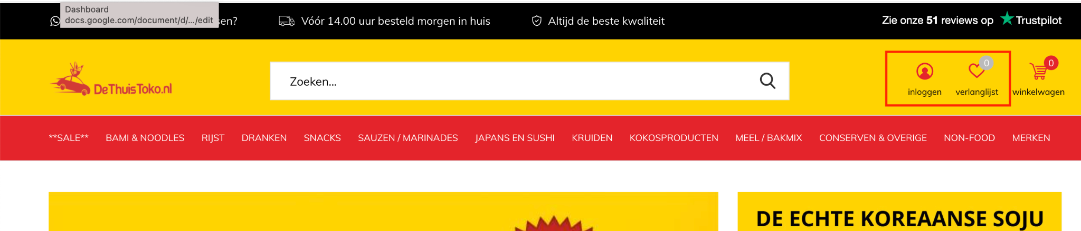

**Log in option on the check-out page**

* **What**: Google Log In check out page
* **Problem description:** When someone has filled their cart, and press log in with google on this check-out page, once logged in with google, the cart is empty. We currently are using an API from the platform. When a customer enters his or her contact details to complete the order there is a text shown log in - when the customer now decides to log in he will lose his whole basket that was just collected, this is a big issue as many visitors will leave and not order
* **When**: The user wants to simplify adding his contact details he chooses to log in with either google or facebook or his registered account.
* **Outcome:**
  + User his cart will be saved once logged in
  + Copy the cart details to the session once a user is logged in
  + Can we create a more obvious button with login in the red marked area in the screenshot below text: Inloggen
  + We are currently using an installed log in api from the lightspeed API tool store, but if your solutions can do without this, that is fine by us, no need to specifically use this api for that, as long as we can make this work

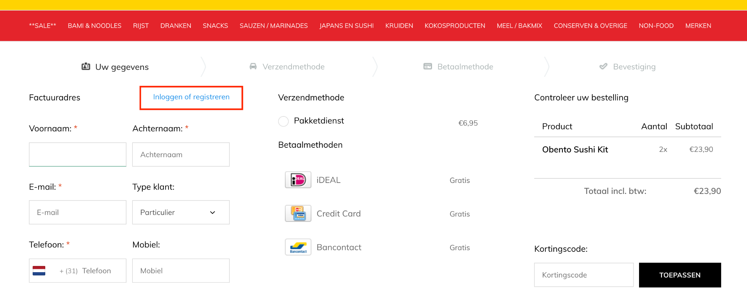

**—----------------------OTHER REQUIREMENTS AFTER TEST—---------------------------**

**Productslider**

* **What:** Product slider on the home page
* **Situation:** The current product sliders on the homepage are showing 4 products

(desktop)

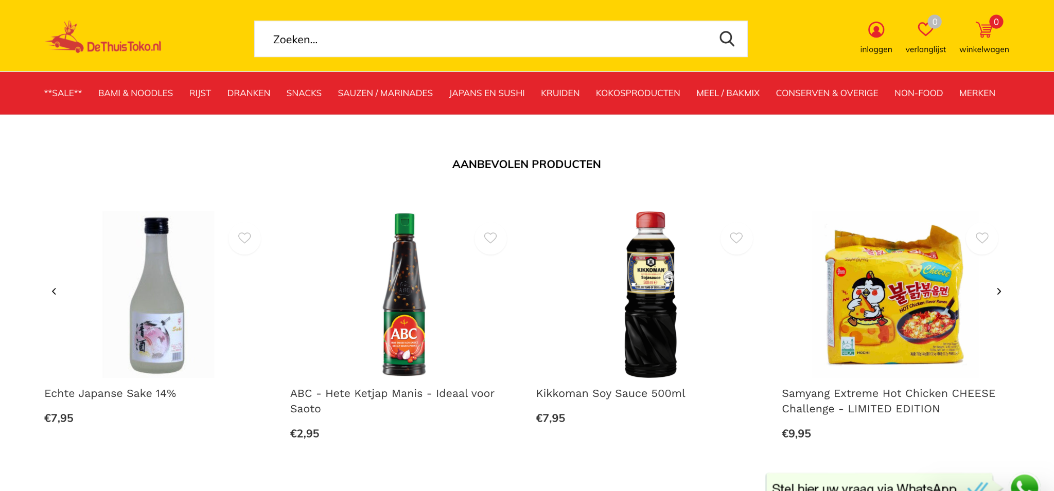

(mobile)

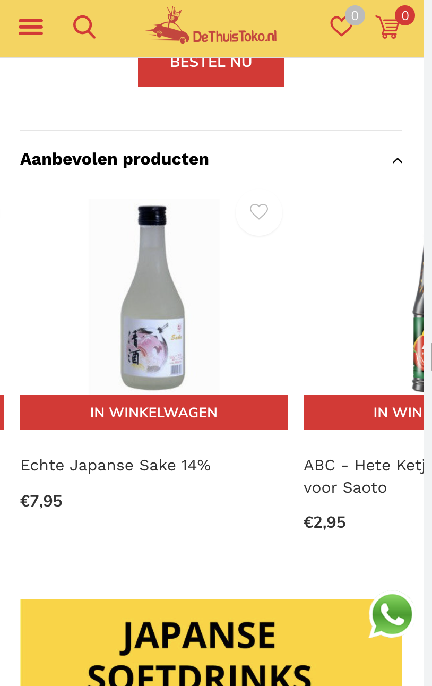

* **Outcome:** we would like to showcase here
* **In desktop version 2 rows of 6 products**
* **In mobile version 2 rows of 3 products**

Our CMS has 3 sliders options within the theme

* Featured products
* Nieuw products
* Popular products

In this case we need to be able to still add those products here ourselves, how can we make this happen?

**Related Articles Productslider**

* **What**: product slider (aanbevolen producten) which is currently shown on each product page shows only
  + 4 (on desktop)
  + 1 (on mobile) could this also show
* **When**: On any product page
* **Outcome:** Can this be changed to
  + 8 products shown on desktop
  + 4 on mobile shown on Mobile

**Category menu Mobile**

* **What**: Mobile menu pop-up buttons in the burger menu
* **When**: The user presses the burger menu button
* **Outcome:** 
  + Possibility to Swipe away the category menu
  + Mobile: The >(button) should be more clear which area to click for expansion
    - I have marked the areas with red where the are should be clickable
  + Right area is to expand, can have red highlight with yellow >(button, bold)

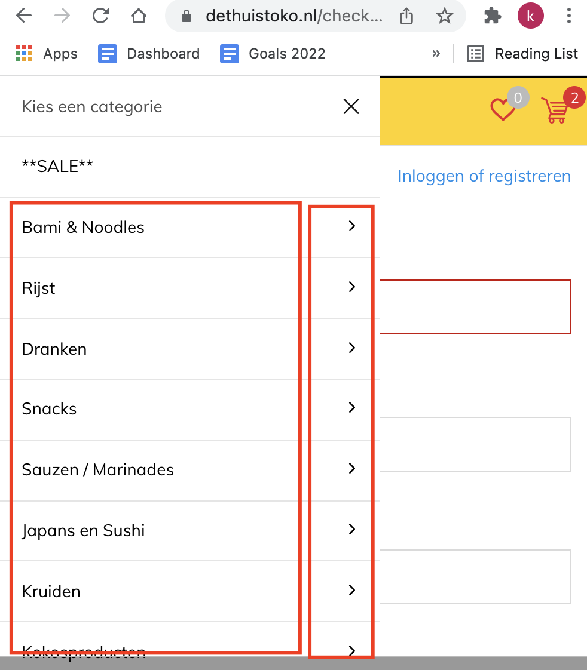

**Pop up screen when checking out**

* **What**: Pop up screen with upsell options
* **When**:When the user presses pay now in the shopping cart

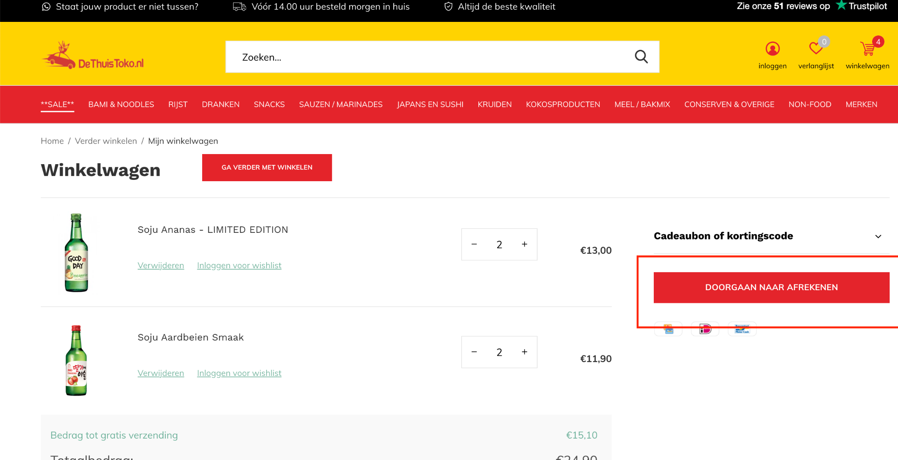

* **Outcome:**
  + **Pop-up shows Short text area:** lorum ipsum
  + **Pop-up shows Product slider:** with at least 6 products with the highest % from this page :​​<https://www.dethuistoko.nl/sale/>
    - So we show our sales products to be added to the cart, starting with the products that have highest % in sale

**Can we automate the following:**

* **What:** A note should be placed with any paid order >€50,- Note text: GRATIS DETHUISTOKO.NL GESCHENK
* **When:** When the order amount is €50,- or more
* **Optional:** could we also send out an email automated based on this criteria