Flutter PHP API – UI Screens & Description

1. Home Screen (Form Screen)
This screen allows users to enter their Name and Email. The form includes validation for both fields and only accepts Gmail addresses. Data is submitted to a PHP API and stored in a database.
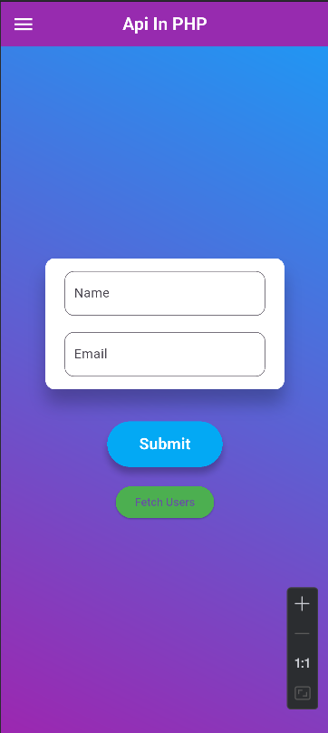

2. Users List Screen
After clicking the 'Fetch Users' button, the app retrieves all stored users from the PHP API and displays them in a DialogBox.
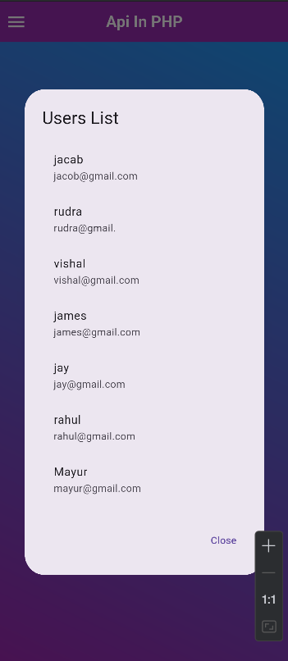

3. Validation Error Screen
If the user enters invalid information, the validator displays error messages. The example shows an incorrect Gmail format, triggering the error state.
