Team Members:
- Mayur Pokharkar (24M0840)
- MVS Sri Harsha (24M2151)

Introduction:
Sentence transformers, developed using self-attention mechanisms and encoder-only models, have transformed natural language processing (NLP) by facilitating effective semantic matching and text clustering at scale. Sentence transformers project sentences into dense vector embeddings, enabling computational systems to measure textual similarity in terms of semantic meaning instead of lexical overlap. Their ability to group texts with shared topical content has made them a good pick for tasks like document retrieval, duplicate detection, and recommendation systems and many more.

One major disadvantage, however, crops up when such models encounter stubborn disagreements, particularly when there are conflicting positions in the same area of study. Sentence transformers, for example, can cluster reviews that mention a smartphone's camera performance, but they often struggle to distinguish between a review that praises "exceptional low-light performance" and one that criticizes "inconsistent autofocus issues," even when both comments refer to the same feature. Their training objectives, which focus more on overall semantic alignment than on fine-grained sentiment or perspectival variation, are responsible for this weakness. Specifically, their embeddings may disregard context-dependent polarity, irony, negation, and other subtle opinion cues that are critical to understanding posture.

In this project, we investigate the inherent limitations of sentence transformers in differentiating between opposing stances and propose contrastive learning approaches to address this challenge. Our work focuses on two primary methods: the Siamese network and the Triplet network. The Siamese architecture employs twin networks with shared weights to learn pairwise similarities and dissimilarities, while the Triplet approach further refines the representation by ensuring that an anchor statement is more similar to a positive example than to a negative one. We fine-tune the base model (sentence-transformers/all-mpnet-base-v2) using debate data sourced from Kialo, leveraging carefully curated pairs and triples of pro and con statements to train the networks.

Model Architecture:
Our implementation builds on the powerful sentence-transformers/all-mpnet-base-v2 model, which leverages a self-attention-based transformer encoder to convert input texts into fixed-length, semantically rich embeddings. These embeddings form the backbone for both our Siamese and Triplet network architectures, enabling the model to capture nuanced differences in opinion while grouping topically similar texts.

Siamese Network:
- Structure:
  - Consists of two identical branches (i.e., twin networks) that share the same weights.
  - Each branch processes one input sentence and uses MPNet encoder to generate embeddings.
- Purpose: Designed for similarity-based tasks (e.g., comparing sentence pairs to measure agreement, contradiction, or neutrality).
- Loss Function: Often trained with contrastive loss or triplet loss to minimize distance between similar pairs (e.g., supporting arguments) and maximize distance for dissimilar pairs (e.g., opposing viewpoints).
- Weight Sharing: Ensures both branches process inputs symmetrically, enabling consistent representation learning while reducing parameters.
- Training Strategy: Input pairs/triplets are dynamically sampled (e.g., anchor-positive-negative) to refine embeddings for fine-grained opinion distinction.
Triplet Network:
- Structure:
  - Involves three inputs: an anchor, a positive sample (similar viewpoint), and a negative sample (dissimilar viewpoint).
  - All three inputs are processed by the same shared MPNet encoder.
- Weight Sharing: Ensures consistent embedding generation across all three branches, reducing model complexity and enhancing generalization.

Implementation:

Framework: Both architectures were implemented using PyTorch and the Hugging Face Transformers library. This allowed us to efficiently leverage pre-trained weights from the sentence-transformers/all-mpnet-base-v2 model.
Data Handling:
- For the Siamese network, pairs of statements (pro vs. con) were generated from debate data.
- For the Triplet network, each triplet was constructed such that the first mentioned perspective is treated as the pro statement and the latter as the con statement.
Siamese Network:
- Input: Pairs of sentences are fed into the twin branches. For example, one input might be pro or anchor and the other may be con or pro respectively. The pairs are labelled with 1 and 0 where 1 represents the pairs having similar context and 0 represents the pairs are dissimilar in context.
- Epochs and Warmup Steps:
  - num_epochs = It ranges between 3 to 10.
  - warmup_steps = int(len(train_dataloader) * num_epochs * 0.1). Warmup steps as 10% of the total training steps
- Loss Function:
  - train_loss = losses.CosineSimilarityLoss(model = model): Instantiates the cosine similarity loss function. This loss function is designed to measure the similarity between pairs of sentence embeddings. For similar pairs (e.g., pro arguments aligned with their supporting claim), the loss will encourage higher cosine similarity, and for dissimilar pairs, it will do the opposite.
- Model Training:
  - train_objectives = [(train_dataloader, train_loss)]: This specifies the training objective as a tuple consisting of the training data loader and the cosine similarity loss function. The model will use this objective to adjust its weights.

This code fine-tunes a sentence transformer model using a cosine similarity loss function, training it to generate embeddings that reflect semantic similarities (e.g., aligning related debate arguments) and dissimilarities (e.g., separating opposing viewpoints). The training loop optimizes the model to distinguish nuanced differences in opinion while preserving topical relevance, crucial for tasks like debate analysis.
Triplet Network:
- Input: Triplets are constructed from the debate data such that the anchor might be a debate statement, the positive sample is a pro perspective, and the negative sample is a con perspective.
- Epochs and Warmup Steps:
  - num_epochs = It ranges between 3 to 10.
  - warmup_steps = int(len(train_dataloader) * num_epochs * 0.1). Warmup steps as 10% of the total training steps
- Loss Function:
  - train_loss = losses.TripletLoss(model = model): A triplet loss is employed, which enforces that the embedding of the anchor is closer to the positive sample than to the negative sample by at least a defined margin. This explicit margin ensures that the model learns to distinguish subtle differences between similar yet opposing arguments.

- Model Training:
  - train_objectives = [(train_dataloader, train_loss)]: This specifies the training objective as a tuple consisting of the training data loader and the cosine similarity loss function. The model will use this objective to adjust its weights.

Beyond just learning pairwise similarities, the triplet network explicitly enforces a ranking between similar and dissimilar pairs, enhancing the model’s ability to capture nuanced contrasts in opinions.

Results:

Plots for Siamese Model: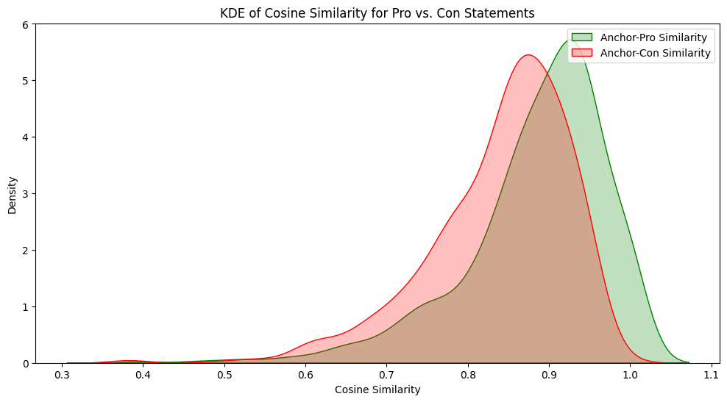
Fig1. Siamese Model

For Fig1, Training data = 2738, Validation data = 696, batchsize = 32, num_epoch = 3
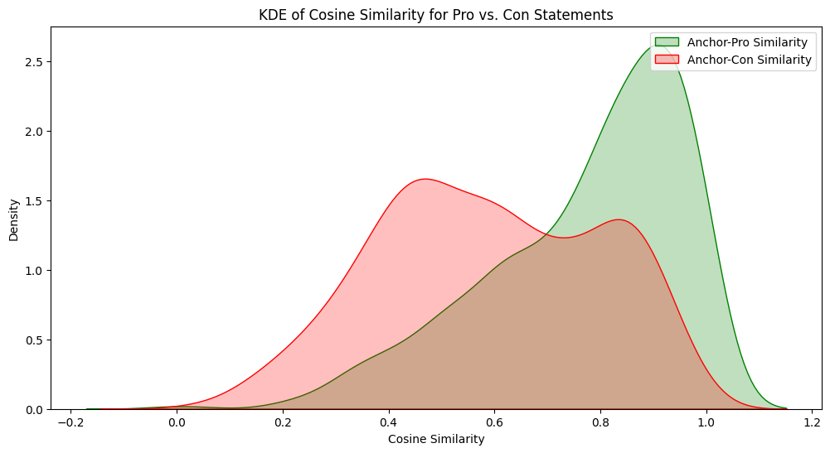
Fig2. Siamese Model

For Fig2, Training data = 9183, Validation data = 2296, batchsize = 16, num_epoch = 3
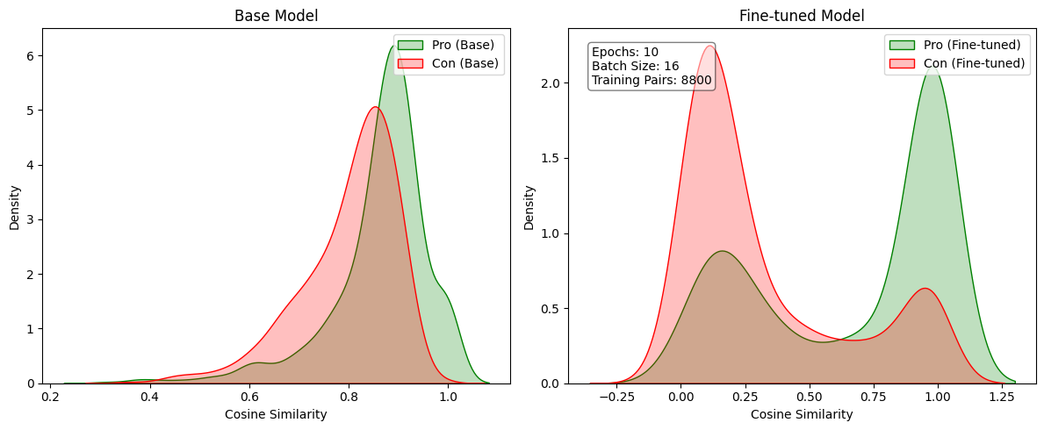
Fig3. Siamese Model

For Fig3, No. of Training pairs = 8800, No. of Validation pairs = 2200

Plots for Triplet model:
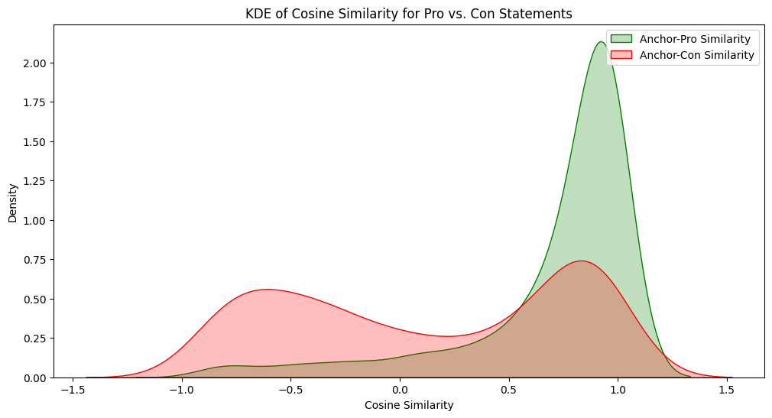
Fig1. Triplet Model

For Fig1, Training data = 1000, batchsize = 16, epochs = 3

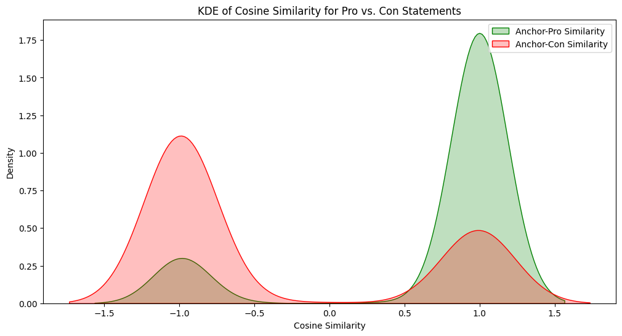
Fig2. Triplet Model

For Fig2, Training data = 10000, batchsize = 16, epochs = 3

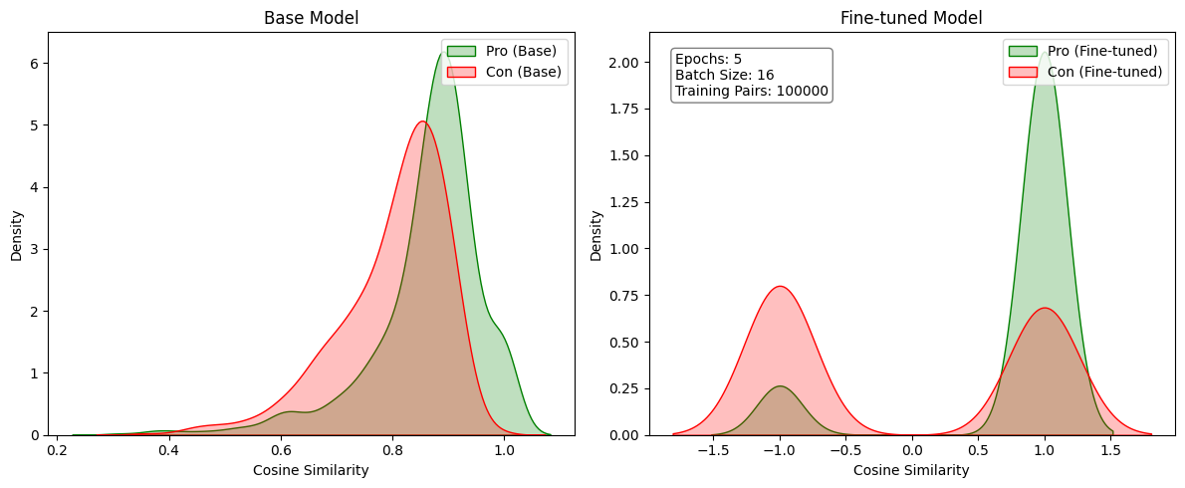
Fig3. Triplet Model

For Fig3, Training data = 100000, batchsize = 16, epochs = 3

- Cosine Similarity Distributions:
- Base Model:
  - Pro (green) and Con (red) statements exhibit considerable overlap, indicating that the original, pre-trained embeddings do not sufficiently distinguish between supporting and opposing perspectives on the same topic.
  - The distribution peaks are relatively close, suggesting that the model primarily captures topical similarity rather than stance-based differences.
- Fine-tuned Model (Siamese or Triplet):
  - The separation between Pro and Con distributions increases significantly after fine-tuning.
  - The Siamese model’s distribution typically shifts so that Pro statements show higher similarity with anchor statements, while Con statements move toward lower similarity.
  - The Triplet model further emphasizes contrast by enforcing a margin between Pro and Con embeddings. As a result, Con statements may cluster more distinctly at lower similarity scores, and Pro statements at higher scores.

- Model Comparisons:
- Siamese vs. Triplet:
  - Both methods yield improved stance separation over the base model.
  - The Triplet network often provides a more pronounced gap between Pro and Con embeddings because of its margin-based objective, which can lead to clearer decision boundaries.
  - The Siamese approach is simpler to set up and often sufficient for tasks requiring pairwise comparisons; however, the Triplet method can offer better generalization for subtle stance differences.

- Challenges Faced
- Data Imbalance and Quality:
  - Debate datasets often contain uneven distributions of Pro and Con arguments. This imbalance can cause the model to overfit to the more prevalent stance.
  - Ensuring high-quality, well-labeled data (especially for subtle arguments) is critical for robust performance.
- Overlap of Semantics and Stance:
  - Even opposing arguments may share significant topical overlap (e.g., references to the same events or entities). Distinguishing stance requires capturing sentiment or evaluative language beyond mere topic similarity.
  - Fine-tuning can still be susceptible to confusion when arguments share large lexical or semantic similarities but differ in subtle ways.
- Computational Resources:
  - Large-scale fine-tuning with extensive debate data requires substantial GPU memory and training time.
  - Efficient sampling and batching strategies are essential to keep training feasible.
Conclusion:
Our experiments indicate that contrastive learning approaches, via both Siamese and Triplet architectures, can significantly enhance sentence transformers’ ability to capture nuanced differences in opinionated texts. Fine-tuning the base sentence-transformers/all-mpnet-base-v2 model using curated debate pairs and triplets allowed us to generate embeddings that more effectively distinguish between supporting and opposing arguments. The distinct cosine similarity distributions observed for pro versus con statements underscore the potential of these methods in overcoming the baseline model's limitations.

