Team Members:
- Mayur Pokharkar (24M0840)
- MVS Sri Harsha (24M2151)

Introduction:
Recent deep learning models such as BERT are very good at extracting dense, high-dimensional representations of text that can achieve state-of-the-art performance on tasks like intent classification. These representations, however, tend to capture redundant or task-irrelevant information, which brings into question their efficiency and robustness. Tishby's Information Bottleneck (IB) Principle offers a theoretical framework for this trade-off: that learning occurs optimally when input data is compressed into a minimally sufficient representation that retains only the information about the target task. By eliminating noisy irrelevant information, models can enhance generalization and diminish overfitting.

In this assignment, we examine how limiting the information flow in BERT's representations affects its capacity to classify intents on the DeepPavlov/clinc150 dataset, which has 150 diverse intents labels (e.g., "alarm", "balance", “calories”). We propose a bottleneck layer that reduces BERT's 768-dimensional [CLS] token embedding to a lower-dimensional space (X ∈ {8, 32, 64, 128}) prior to classification.

Key Question: To what extent can we compress representations of BERT before task performance suffers?

As our baseline model for this research, we employ the bert-base-uncased model. The model is fine-tuned to predict the CLINC-150 dataset, comprising 150 diverse intent labels.

Model Architecture:
In our implementation for this assignment we have chosen google-bert/bert-base-uncased as our base model. BERT (Bidirectional Encoder Representations from Transformers) is a pre-trained transformer-based language model from big text datasets. The uncased BERT converts all the text to lowercase while training, hence is case-insensitive. The last hidden state of the [CLS] token (index 0) is used as the classification sequence representation and the BERT layers are frozen throughout training to preserve pre-trained linguistic understanding, whereas the bottleneck and classifier layers are trained

Part 1 (Bottleneck without Reconstruction):
- Objective of this part is to study how classification accuracy affects as we restrict the availability of information.
- Structure:
  - Bottleneck Layer: A single linear layer reduces the 768D [CLS] embedding to dimension X ∈ {8, 32, 64, 128}.
  - Classifier: Linear layer maps the compressed representation to 150 intent latents
  - BERT → [CLS] (768D) → Linear(768 → X) → Classifier(X → 150)
- Narrower bottlenecks forces the model to reject non-relevant features, confirming Tishby's IB principle. Broader bottlenecks capture more information but are prone to overfitting.
- Training Strategy:
  - Loss: Cross-entropy loss for classification.
  - Optimization: AdamW with learning rates:
    - BERT layers: 2e-5 (minimal fine-tuning).
    - Bottleneck/Classifier: 1e-3.
Part 2 (Bottleneck with Reconstruction):
- Objective of this part is to maximize mutual information (MI) by enforcing reconstruction of the [CLS] embedding.
- Structure:
  - Encoder: 2-layer MLP (768 → 384 → Y).
  - Decoder: 2-layer MLP (Y → 384 → 768).
  - Bottleneck: Intermediate layer Y ∈ {8, 32, 64, 128}.
  - BERT → [CLS] (768D) → Encoder(768→384→Y) [Decoder(Y→384→768)] → Classifier(Y → 150)
- Reconstruction acts as a regularizer, improving robustness for narrow bottlenecks (e.g., 8D). Wider bottlenecks (128D) retain redundant features, slightly harming generalization. Reconstruction ensures MI between input and bottleneck, while classification forces task-relevance.
- Training Strategy:
  - Loss: Loss: Joint optimization of:
    - Classification Loss: Cross-entropy.
    - Reconstruction Loss: MSE between original and reconstructed [CLS] embeddings..
  - Optimization: AdamW with learning rates:
    - BERT layers: 2e-5 (minimal fine-tuning).
    - Bottleneck/Classifier: 1e-3.
Part 3 (Stochasticity and Information Retention):
- Objective of this part is to study noise injection’s role in removing redundant information
- Structure:
  - Similar to the model for Part 2, just while training gaussian noise injected into the bottleneck.
- Narrow Bottlenecks (8D): Noise forces robust, compressed representations. Wide Bottlenecks (128D): Noise introduces instability, slightly reducing accuracy compared to Part 2.
- Training Strategy:
  - Loss: Loss: Joint optimization of:
    - Classification Loss: Cross-entropy.
    - Reconstruction Loss: MSE between original and reconstructed [CLS] embeddings.
  - Optimization: AdamW with learning rates:
    - BERT layers: 2e-5 (minimal fine-tuning).
    - Bottleneck/Classifier: 1e-3.
Implementation:

Framework: Both architectures were implemented using PyTorch and the Hugging Face Transformers library. This allowed us to efficiently leverage pre-trained weights from the google-bert/bert-base-uncased model.

Data Handling:
- Used the Hugging Face load_dataset method to load the CLINC-150 dataset from the "Deeppavlov/clinc150" repository. This dataset has training, validation, and test splits.
- As there were some examples in the dataset that have None as the label, we have performed data cleaning using a filter function, which deletes any rows where the label is None.
- The BERT tokenizer is loaded from the pretrained bert-base-uncased model. This tokenizer is utilized to transform raw text data into tokenized inputs for BERT.
- We have written a custom function tokenize_fn is defined, which:
  - Processes the utterance field from each dataset example.
  - Applies padding to a fixed maximum length (max_length defined in Config.max_sentence_length).
  - Converts the tokenized outputs into PyTorch tensors
- We have three different datasets : Training, Validation and Testing.
General Setup for all three parts:
- Base Model: bert-base-uncased
- Dataset: CLINC-150 (150 intents).
- Hyperparameters:
  - Batch Size: 32
  - Epochs: 5 - 10
  - Learning Rates:
    - Bottleneck/Classifier: 1 × 10⁻³
  - Sequence Length: 128 tokens.
- Optimizer: AdamW with weight decay.
- Validation/Testing: Best model selected based on validation accuracy.
Part 1 (Bottleneck without reconstruction):
- Loss Function:
  - Cross entropy loss as it is a classification task.
- Optimizer:
  - BERT params: Frozen during training
  - Bottleneck/Classifier: Trained with learning rate of 1 x 10⁻³
- Model Training:
  - Forward pass: BERT → [CLS] → Bottleneck → Classifier.
  - Updating bottleneck and classifier gradients.
  - Best model is saved for testing purposes based on validation accuracy.

Part 2 (Bottleneck with reconstruction):
- Loss Function:
  - Classification Loss: Cross-entropy.
  - Reconstruction Loss: MSE between original and reconstructed [CLS] embeddings.
  - Total Loss is a combination of Classification and Reconstruction loss.
- Optimizer:
  - BERT params: Frozen during training
  - Encoder/Decoder/Classifier: Trained with learning rate of 1 x 10⁻³
- Model Training:
  - Forward pass: BERT → [CLS] → Encoder → (Bottleneck) → Decoder/Classifier.
Part 3 (Stochasticity and Information Retention):
- Loss Function:
  - Classification Loss: Cross-entropy.
  - Reconstruction Loss: MSE between original and reconstructed [CLS] embeddings.
  - Total Loss is a combination of Classification and Reconstruction loss.
- Optimizer:
  - BERT params: Frozen during training
  - Encoder/Decoder/Classifier: Trained with learning rate of 1 x 10⁻³
- Model Training:
  - Forward pass: BERT → [CLS] → Encoder → (Bottleneck) → Decoder/Classifier.
  - Here for this part we have applied noise only for training.

Results:
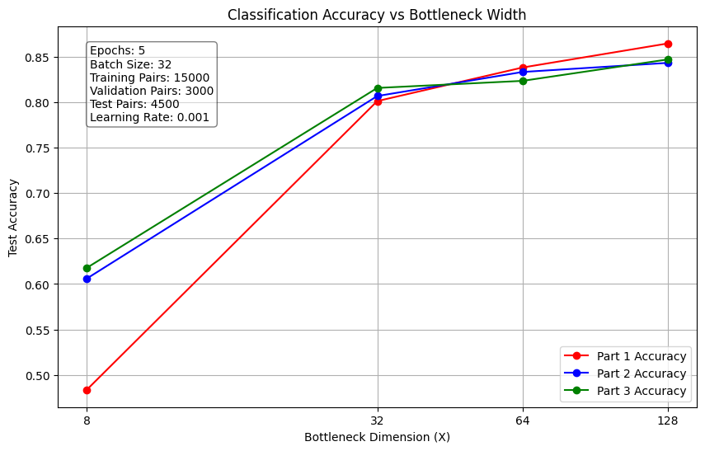
Fig 1. Plot for 5 Epochs

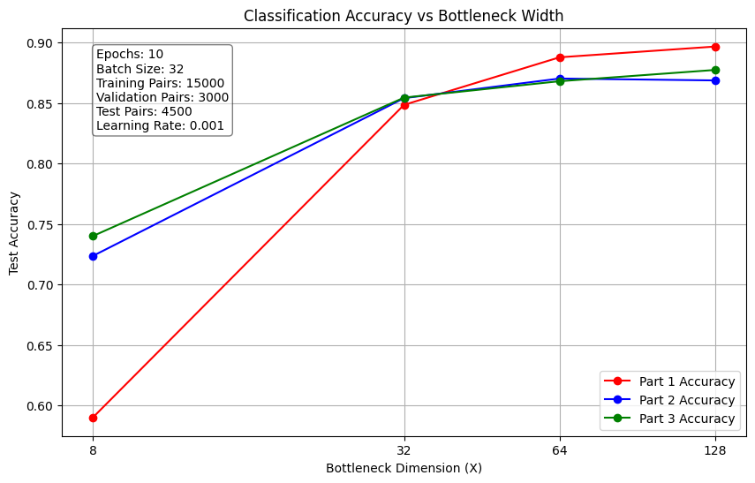
Fig 2. Plot for 10 Epochs
- Classification Accuracy vs. Bottleneck Width Plot:
- Observations for Fig1. (5 Epochs):
  - The accuracy is notably lower (around 0.50), which says that an 8-dimensional bottleneck may be too restrictive, preventing the model from retaining sufficient information for accurate classification.
  - There is a significant jump in accuracy from 8 to 32, which indicates that as the bottleneck dimension grows, the model can store more task-relevant features, thereby improving accuracy.
  - The performance continues to increase, but the gains begin to plateau around 64–128.
- Observations for Fig2. (10 Epochs):
  - Accuracy is higher than in the 5-epoch case (around 0.60–0.65), showing that extra training time helps, but it is still the lowest among the bottleneck sizes.
  - Significant gains from dimension 8 to 16, and again from 16 to 32.
  - Accuracies can climb into the 0.80–0.87 range.
  - Accuracy reaches its highest levels, around 0.88–0.91.
- Challenges Faced
- Underfitting at Small Bottleneck Sizes:
  - Since its dimension is as low as 8, the model frequently is not able to gather sufficient information regarding the input utterances. This results in underfitting, in which the classifier does not learn 150 different intent labels.
- Increased Training Time with Larger Bottlenecks:
  - A wider bottleneck typically means more parameters in the compression layer (or subsequent layers). This can lead to longer training times and higher memory usage.
- Generalization vs. Overfitting:
  - While narrower bottlenecks can encourage generalization by forcing the model to discard noise, extremely narrow layers risk discarding essential features. Conversely, very wide bottlenecks could lead to overfitting if the model memorizes irrelevant details.
- Managing Large Number of Classes:
  - The dataset has 150 distinct intent labels. Ensuring the model can handle this diversity effectively is challenging, especially at smaller bottleneck widths, where the compressed representation may not discriminate well among so many classes.

Conclusion:
This assignment explores Tishby’s Information Bottleneck (IB) principle through three experiments on BERT-based intent classification with CLINC-150:
- Part 1 (Bottleneck without Reconstruction): Showed the trade-off between compression and prediction. Narrow bottlenecks (8D) forced aggressive feature selection, reducing accuracy, while wider bottlenecks (128D) preserved task-relevant information, achieving near-original BERT performance (~85-90% accuracy).
- Part 2 (Bottleneck with Reconstruction): Autoencoder-driven reconstruction improved robustness for narrow bottlenecks (8D-32D) by retaining critical features (via MSE loss), but introduced redundancy in wider bottlenecks (64D-128D), slightly underperforming Part 1.
- Part 3 (Stochasticity and Information Retention): Noise injection acted as a regularizer that stabilized narrow bottlenecks but disrupted wide ones (e.g., 128D).
Narrow bottlenecks benefit from reconstruction/noise to enforce IB’s minimal sufficient statistics. Wider bottlenecks excel at pure classification but risk retaining irrelevant features.

